Electronics
Semiconductors, Diodes, Rectifiers, Clippers & Clampers
UTA Interview Preparation Notes
Midterm topics: Semiconductor/Diode, Diode DC Circuits, Rectifiers, Clippers (Series & Parallel), Clampers

Part 0: Energy Bands and Semiconductor Basics
Every solid material's electrical behaviour comes down to how its electrons are distributed across two key energy ranges: the valence band (where electrons are bound to individual atoms) and the conduction band (where electrons are free to move and carry current). The gap between them, the band gap, determines whether a material conducts electricity easily, not at all, or somewhere in between.

How to teach it
Analogy: think of the valence band as the ground floor of a building where electrons are 'parked' and bound to their atoms, and the conduction band as the open rooftop where electrons are free to roam and carry current. The band gap is the height of the staircase an electron must climb to get from the ground floor to the rooftop. In a conductor, the two floors overlap, electrons wander onto the roof with no effort. In an insulator, the staircase is enormous, almost no electron has enough energy to climb it. A semiconductor's staircase is just short enough that a little heat or voltage can push electrons up it.
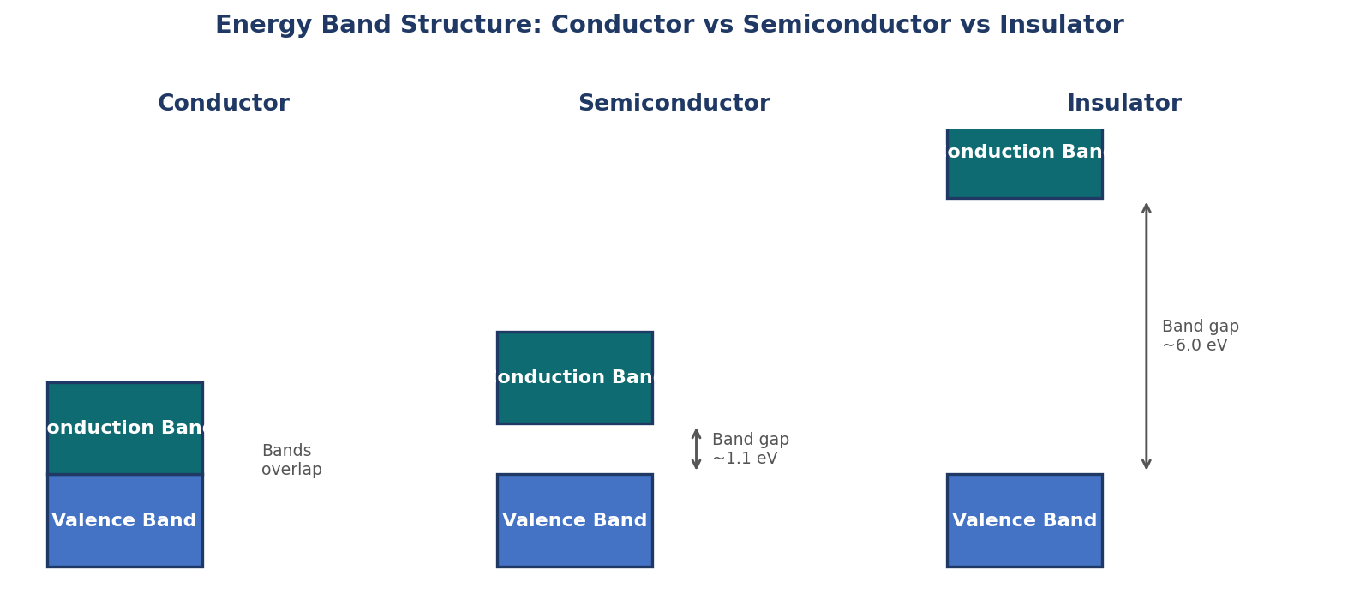
Figure 1: Energy band structure comparison. Conductors have overlapping bands (no gap), semiconductors have a small gap (~1.1 eV for silicon), and insulators have a very large gap.

Conductors, Semiconductors, and Insulators
Material type | Band gap | Behaviour
Conductor (e.g. copper) | 0 eV, bands overlap | Free electrons available at any temperature, conducts easily
Semiconductor (e.g. silicon, germanium) | Small, ~1.1 eV (Si), ~0.7 eV (Ge) | Insulator at absolute zero, conducts increasingly well as temperature rises or with added impurities
Insulator (e.g. glass, rubber) | Large, 5 eV or more | Practically no electrons can cross the gap under normal conditions

Intrinsic vs Extrinsic Semiconductors
- Intrinsic semiconductor: a pure semiconductor crystal (pure silicon or germanium) with no added impurities. At room temperature it conducts only weakly, since only a small number of electrons gain enough thermal energy to jump the band gap, each leaving behind a 'hole' (a missing electron, treated as a positive charge carrier).
- Extrinsic semiconductor: an intrinsic semiconductor with deliberately added impurity atoms (doping) to dramatically increase conductivity in a controlled way.
- N-type: doped with a pentavalent impurity (5 valence electrons, e.g. Phosphorus or Arsenic), contributing extra free electrons. Electrons are the majority carriers.
- P-type: doped with a trivalent impurity (3 valence electrons, e.g. Boron or Gallium), creating extra holes. Holes are the majority carriers.

Interview Q&A
Q: Why does a semiconductor conduct better as temperature increases, while a conductor's conductivity decreases?
A: In a semiconductor, higher temperature gives more electrons enough thermal energy to jump the band gap into the conduction band, increasing the number of charge carriers. In a conductor, carriers are already abundant regardless of temperature, so rising temperature only increases atomic vibrations that scatter electrons more, increasing resistance instead.
Q: What is the difference between doping to create n-type versus p-type material?
A: N-type doping adds pentavalent impurity atoms (5 valence electrons) which contribute an extra loosely-bound electron each, so electrons become the majority carrier. P-type doping adds trivalent impurity atoms (3 valence electrons) which create a shortage, a hole, at each impurity site, so holes become the majority carrier.
Q: Why can't an insulator be made to conduct just by heating it, the way a semiconductor can?
A: An insulator's band gap (5 eV or more) is far too large for any practically achievable thermal energy to bridge, whereas a semiconductor's much smaller gap (~1.1 eV for silicon) is within reach of ordinary thermal energy at or above room temperature.

Tips and tricks
- If asked to compare the three material types, always lead with the band gap size, it is the single fact that explains all their differing behaviour.
- Remember holes are not real particles, they are a convenient way to describe the movement of the surrounding electrons filling a vacancy, but they behave exactly like positive charge carriers for circuit analysis purposes.

Part 1: The Semiconductor (P-N Junction) Diode

1.1 What it is and how to teach it
A diode is formed by joining a p-type and an n-type semiconductor together, creating a p-n junction. Analogy: imagine two rooms, one crowded with free electrons (n-type) and one crowded with holes (p-type), connected by a doorway. Electrons near the doorway diffuse into the hole-rich room and recombine, and holes diffuse the other way, this leaves a narrow zone right at the junction stripped of free carriers, called the depletion region, with a small built-in electric field (barrier potential) that opposes further diffusion once equilibrium is reached.
- Depletion region: the narrow zone at the junction with no free charge carriers, acting as an insulating barrier.
- Barrier potential (built-in voltage): approximately 0.7V for silicon, 0.3V for germanium, the voltage that must be overcome to make the diode conduct significantly.
- Anode: the p-type terminal. Cathode: the n-type terminal (marked with a stripe on the physical component).

1.2 Forward Bias vs Reverse Bias
- Forward bias: positive terminal of the source connected to the p-side (anode), negative to the n-side (cathode). This pushes electrons and holes toward the junction, narrowing the depletion region. Once the applied voltage exceeds the barrier potential (~0.7V for silicon), the diode conducts and current flows easily.
- Reverse bias: positive terminal connected to the n-side, negative to the p-side. This pulls carriers away from the junction, widening the depletion region and blocking current, only a tiny reverse saturation (leakage) current flows, until the reverse voltage becomes large enough to cause breakdown.
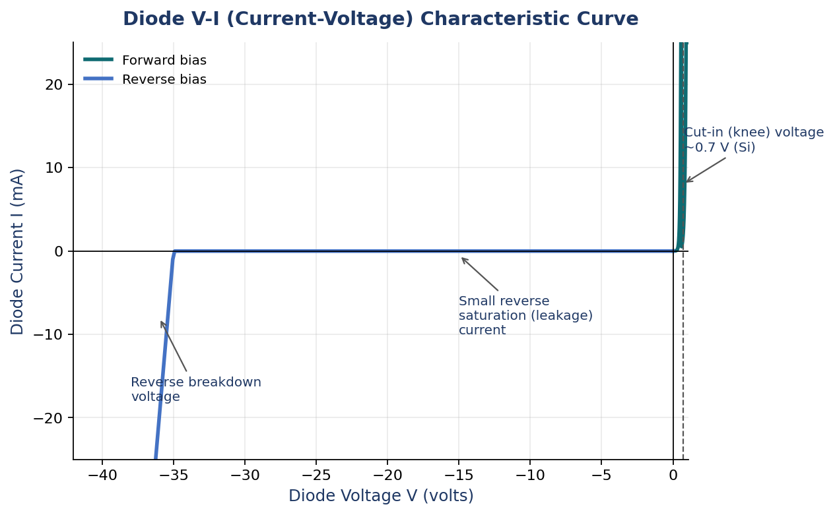
Figure 2: Diode V-I characteristic curve. Forward bias shows a sharp current rise past the cut-in voltage; reverse bias shows only a small leakage current until breakdown.

1.3 Reading the V-I Curve
- Cut-in (knee) voltage: the forward voltage (~0.7V silicon, ~0.3V germanium) below which almost no current flows, and above which current rises sharply.
- Reverse saturation current: the small, roughly constant current that flows under reverse bias before breakdown, caused by minority carriers.
- Reverse breakdown voltage: the reverse voltage at which the diode suddenly conducts heavily in reverse, this is destructive for a normal diode, but is exploited intentionally in Zener diodes for voltage regulation.

1.4 Interview Q&A
Q: Why does forward biasing a diode reduce the depletion region width, while reverse biasing widens it?
A: Forward bias pushes majority carriers (electrons from the n-side, holes from the p-side) toward the junction, where they recombine and shrink the depleted zone. Reverse bias pulls majority carriers away from the junction, widening the region left with no carriers to conduct.
Q: Why is there a cut-in voltage before the diode conducts significantly, rather than conducting at any positive voltage?
A: The built-in barrier potential at the junction (from the depletion region's internal electric field) must first be overcome by the externally applied forward voltage before carriers can cross the junction in meaningful numbers, below this point only a negligible current flows.
Q: What causes the small reverse leakage current, if the depletion region blocks majority carriers?
A: Minority carriers (a small number of electrons in the p-side and holes in the n-side, present due to thermal generation) are actually assisted across the junction by the reverse bias field, producing a small, roughly constant reverse saturation current, largely independent of the reverse voltage magnitude until breakdown.

1.5 Tips and tricks
- This topic typically carries the most marks (noted 7-8 in the syllabus), make sure you can draw the V-I curve from memory, labelling cut-in voltage, reverse saturation current, and breakdown voltage without hesitation.
- Always state the approximate cut-in voltages for silicon (0.7V) and germanium (0.3V), this number is used constantly in every downstream circuit calculation (rectifiers, clippers, clampers).

Part 2: Diode DC Circuits (Analysis Models)

2.1 What this topic covers
A real diode's V-I curve is non-linear (a curve, not a straight line), which makes exact circuit analysis by hand difficult. This topic covers the three standard approximations used to analyse diode circuits, ranging from simplest to most accurate, and how to solve a basic diode DC circuit using each.

2.2 How to teach it
Analogy: think of a diode like a one-way turnstile with a bit of initial resistance. The simplest model (ideal diode) treats it as a perfect one-way gate, either fully open (0 resistance) or fully shut (infinite resistance), with no cost to push through. More realistic models add a 'toll' (the 0.7V drop) and even a bit of friction (a small forward resistance) to better match a real diode's behaviour.

2.3 The three approximation models
Model 1: Ideal Diode
The diode is treated as a perfect switch: zero resistance (a short circuit, 0V drop) when forward biased and conducting, infinite resistance (an open circuit) when reverse biased. Simplest to use, least accurate, good for quick first-pass analysis or when the source voltage is very large compared to 0.7V.
Model 2: Constant Voltage Drop (Practical Diode)
The diode is treated as a closed switch in series with a fixed voltage source of 0.7V (silicon) when conducting, and an open circuit when reverse biased. This is the most commonly used model for hand calculations, it balances simplicity and accuracy well.
Model 3: Piecewise Linear (with forward resistance)
Adds a small forward resistance Rf in series with the 0.7V drop when conducting, modelling the real diode's slight slope past the knee voltage rather than a perfectly vertical rise. Most accurate of the three hand-calculation models, used when precision matters.
Model | Forward bias (conducting) | Reverse bias | Accuracy vs simplicity
Ideal diode | 0V drop (short circuit) | Open circuit | Simplest, least accurate
Constant voltage drop | 0.7V drop (Si), open circuit otherwise | Open circuit | Standard, good balance
Piecewise linear | 0.7V + I x Rf drop | Open circuit | Most accurate, more work

2.4 Worked example (Constant Voltage Drop model)
A circuit has a 5V DC source, a series resistor R = 1kΩ, and a silicon diode, all in series, forming a simple loop.
- Step 1: Assume the diode is forward biased and conducting (check the source polarity supports this direction), so it behaves as a 0.7V drop.
- Step 2: Apply Kirchhoff's Voltage Law around the loop: 5V = V_R + V_D = I*R + 0.7V.
- Step 3: Solve for current: I = (5 - 0.7) / 1000 = 4.3 / 1000 = 4.3 mA.
- Step 4: Verify the assumption, since I came out positive (current flows in the assumed forward direction), the diode is indeed conducting, the assumption was valid.

2.5 The assume-and-check method (general procedure)
- 1. Assume a state for the diode (either 'ON, conducting' or 'OFF, not conducting').
- 2. Replace the diode with its model for that assumed state (0.7V source if ON, open circuit if OFF) and solve the resulting simple linear circuit.
- 3. Check the assumption: if assumed ON, verify the calculated current through the diode is positive (flows in the forward direction); if assumed OFF, verify the voltage across the diode is at or below the cut-in voltage (does not exceed 0.7V) and would not forward-bias it.
- 4. If the check fails, the assumption was wrong, flip it and redo the analysis with the other state.

2.6 When to use each model
- Ideal diode model: quick estimates, or when the source voltage is much larger than 0.7V (making the 0.7V drop nearly negligible by comparison).
- Constant voltage drop model: the default choice for most homework and exam problems, a good balance of simplicity and realistic accuracy.
- Piecewise linear model: when the problem specifically gives a forward resistance value, or when precision at low currents matters.

2.7 Interview Q&A
Q: Why do we need to 'assume and check' the diode's state rather than solving directly?
A: A diode's behaviour is fundamentally non-linear and conditional, it is a completely different circuit element (0.7V source vs open circuit) depending on its bias direction, which itself depends on the very currents and voltages we are trying to solve for. Assuming a state turns the problem into a simple linear circuit we can solve directly, then we verify the assumption was self-consistent.
Q: In a circuit with multiple diodes, how does the assume-and-check method scale?
A: Every diode needs its own ON/OFF assumption, giving 2^n possible combinations for n diodes. In practice, circuit topology and source polarities usually rule out most combinations quickly, so only a few plausible combinations need to be checked, not all 2^n exhaustively.
Q: Why is the constant voltage drop model preferred over the ideal diode model for most practical calculations?
A: The ideal model ignores the very real ~0.7V threshold a silicon diode needs before conducting meaningfully, which can cause significant error in circuits where the source voltage is only a few volts, comparable in size to that 0.7V drop. The constant voltage drop model captures this at very little extra calculation cost.

2.8 Tips and tricks
- Always state which model you are using at the start of a problem, exam questions often specify it explicitly, using the wrong model is a common way to lose marks even with otherwise correct working.
- After solving, always sanity-check the sign of the current or the diode voltage against your assumption, this single habit catches most diode-circuit mistakes.

Part 3: Rectifiers

3.1 What problem it solves
A rectifier converts alternating current (AC), which periodically reverses direction, into direct current (DC), which flows in one direction only. This is the essential first stage of almost every power supply, since most electronics need steady DC power but mains electricity is supplied as AC. A diode is the natural building block for this, since it only allows current to flow in one direction.

3.2 How to teach it
Analogy: a rectifier is like a one-way valve in a pipe carrying water that sloshes back and forth (AC). The valve (diode) only lets water through when it is moving in one direction, blocking the reverse sloshes entirely, so what emerges on the other side is water that only ever flows one way, even though it still pulses in strength.

3.3 Half-Wave Rectifier
The simplest rectifier: a single diode in series with the load. During the half-cycle where the AC input is positive (forward-biasing the diode), current flows through the load. During the negative half-cycle, the diode is reverse biased and blocks current entirely, so the load sees nothing during that half.
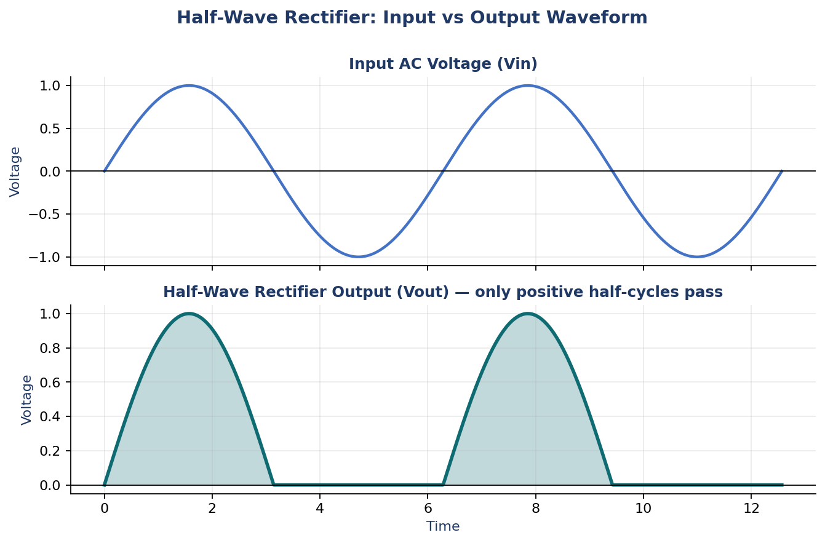
Figure 3: Half-wave rectifier input and output waveforms. Only the positive half-cycles reach the output; the negative half-cycles are completely blocked.
Key half-wave rectifier formulas
Quantity | Formula | Notes
Average (DC) output voltage | Vdc = Vm / π ≈ 0.318 Vm | Vm = peak input voltage
RMS output voltage | Vrms = Vm / 2 | -
Ripple factor | r ≈ 1.21 | High ripple, output is far from pure DC
Rectification efficiency | ≈ 40.6% | At most 40.6% of AC input power becomes DC output power
Peak Inverse Voltage (PIV) | PIV = Vm | Maximum reverse voltage the diode must withstand without breaking down

3.4 Full-Wave Rectifier (for comparison)
A full-wave rectifier uses either a centre-tapped transformer with two diodes, or a bridge configuration with four diodes, to make use of both halves of the AC cycle, the negative half-cycle is flipped rather than discarded, so current flows through the load during the entire cycle, not just half of it.

3.5 Half-Wave vs Full-Wave Comparison
Property | Half-Wave | Full-Wave (bridge)
Diodes needed | 1 | 4 (bridge) or 2 (centre-tapped)
Output during | Only one half-cycle | Both half-cycles
Average DC output | Vm / π ≈ 0.318 Vm | 2Vm / π ≈ 0.636 Vm
Ripple factor | ≈ 1.21 (high) | ≈ 0.48 (lower, smoother)
Efficiency | ≈ 40.6% | ≈ 81.2%
PIV per diode | Vm | Vm (bridge) or 2Vm (centre-tapped)

3.6 When to use half-wave vs full-wave
- Half-wave: acceptable only where simplicity and low cost matter far more than efficiency or smoothness, for example very low-power, non-critical applications, or simple signal-envelope detection.
- Full-wave: the standard choice for any real power supply, significantly better efficiency, lower ripple, and easier to smooth with a filter capacitor into usable DC.

3.7 When rectifiers alone are not enough
- A rectifier alone produces pulsating DC (a series of humps), not smooth DC, a filter capacitor (or more elaborate filter) is needed afterward to smooth the ripple into something closer to constant voltage, this is a natural next step beyond this syllabus section but worth mentioning if asked 'is this ready to power a circuit?'

3.8 Interview Q&A
Q: Why is the ripple factor of a half-wave rectifier so much higher than a full-wave rectifier?
A: A half-wave rectifier's output is zero for half of every cycle, creating a large gap between pulses, which corresponds to a large AC component relative to the DC average. A full-wave rectifier fills in that gap using the other half-cycle, keeping the output closer to its average value throughout, hence a much lower ripple factor.
Q: What is Peak Inverse Voltage (PIV), and why does it matter when selecting a diode?
A: PIV is the maximum reverse voltage the diode experiences during the blocking half-cycle. If a diode's rated maximum reverse voltage is exceeded, it can suffer reverse breakdown and be damaged, so the diode chosen for a rectifier must have a PIV rating comfortably above the circuit's calculated PIV.
Q: Why is a full-wave rectifier's efficiency exactly double that of a half-wave rectifier (81.2% vs 40.6%)?
A: Both rectifiers have the same fundamental loss mechanism per conducting half-cycle, but the half-wave rectifier only conducts, and therefore only delivers power, during half of the input cycle, wasting the other half entirely. The full-wave rectifier makes use of both halves, doubling the average power delivered for the same input, which doubles the efficiency.

3.9 Tips and tricks
- Memorise the Vdc formulas (Vm/π for half-wave, 2Vm/π for full-wave) cold, they are used to derive almost every other quantity (ripple, efficiency) in rectifier problems.
- Always state PIV explicitly when asked to 'design' or 'select a diode for' a rectifier circuit, it is a very common mark-scoring detail that is easy to forget.
- If asked to draw the output waveform, get the shape right first (which half is missing/present) before worrying about exact voltage labels, the shape is what is usually being tested.

Part 4: Clipper Circuits

4.1 What problem it solves
A clipper (also called a limiter) is a wave-shaping circuit that removes (clips off) the part of a signal above and/or below a certain voltage level, while leaving the rest of the waveform unchanged. It is used to protect circuits from voltage spikes, to shape waveforms (for example converting a sine wave toward a square wave), and in signal limiting applications.

4.2 How to teach it
Analogy: a clipper is like a ceiling in a room, anything below the ceiling height passes through untouched, but anything that would go above it gets physically stopped at the ceiling level and flattened there. The diode acts as a switch that 'turns on' exactly at the clipping voltage, diverting or blocking the signal beyond that point.

4.3 Series vs Parallel (Shunt) Clippers, the key structural distinction
This is the first classification to master: where the diode physically sits in the circuit relative to the signal path.
- Series clipper: the diode sits directly in the main signal path, between the input and the output. When the diode is OFF (reverse biased), no signal reaches the output at all during that portion of the cycle. When ON, the signal passes through nearly unchanged (minus the small diode drop).
- Shunt (parallel) clipper: the diode branches off to the side, connected in parallel across the output, not in the direct path. When the diode is OFF, the signal passes through the series resistor to the output largely unaffected. When ON, the diode acts as a low-resistance short to the reference level, pulling the output down to (or clamping it at) that level, this is what does the actual clipping.
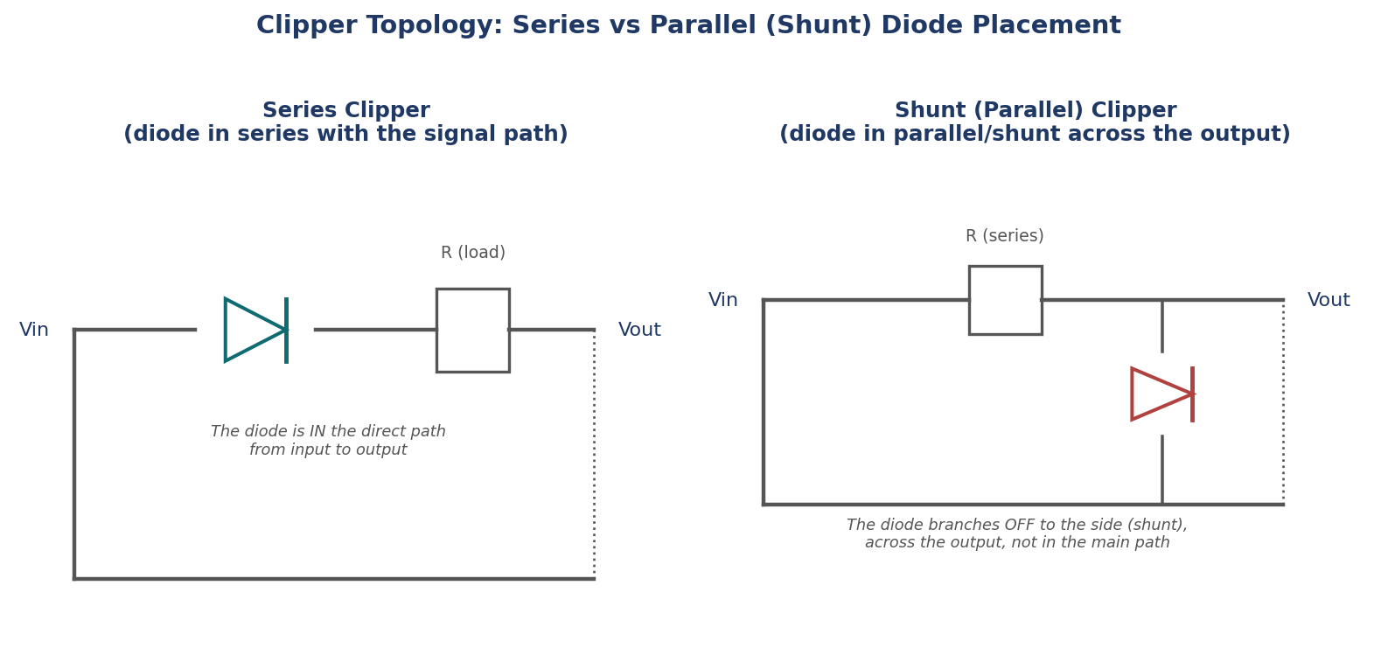
Figure 4: Circuit topology comparison. In a series clipper the diode is in the direct signal path; in a shunt clipper the diode branches off in parallel across the output.
Aspect | Series Clipper | Shunt (Parallel) Clipper
Diode position | In the main signal path | Branches off, parallel to the output
When diode is OFF | Output = 0 (signal fully blocked) | Output ≈ input (passes through)
When diode is ON | Output ≈ input (passes through) | Output clamped to the reference level (clipped)
Output impedance when not clipping | Depends on load, diode is out of the path | Set mainly by the series resistor

4.4 Positive vs Negative Clippers
- Positive clipper: removes (flattens) the portion of the waveform above a chosen positive reference level, leaving the rest of the waveform, including everything below that level, unchanged.
- Negative clipper: removes the portion of the waveform below a chosen negative reference level.
- Biased clipper: adds a DC reference voltage (a battery or voltage divider) in series with the diode, allowing the clipping level to be set to any desired voltage, not just 0V.
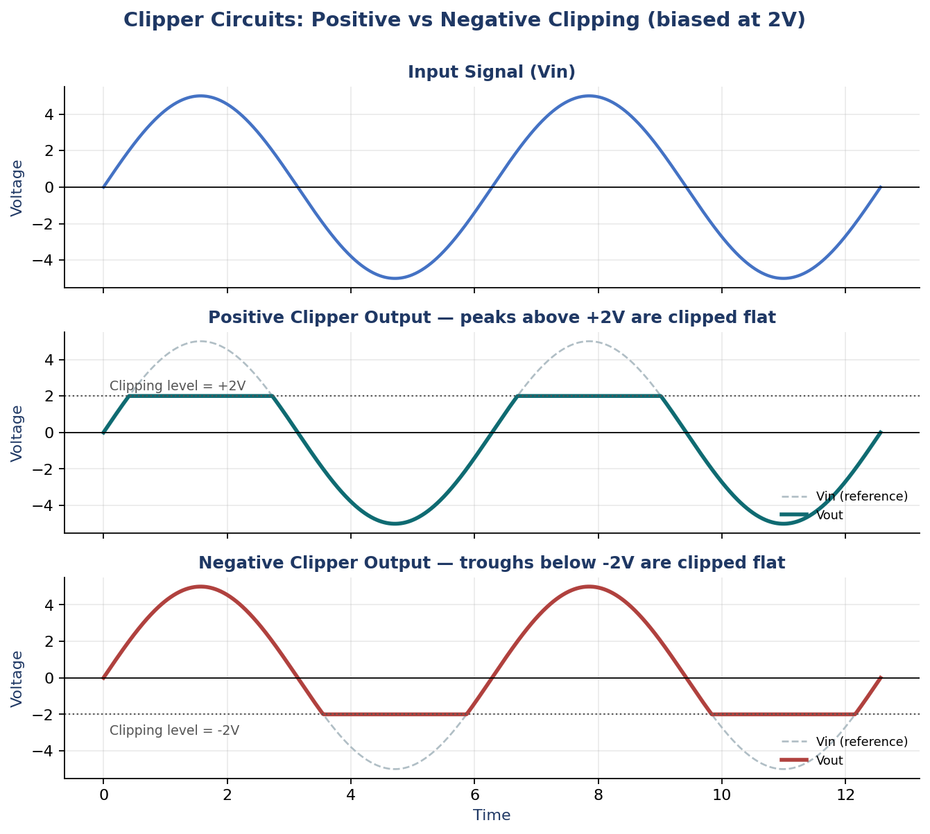
Figure 5: Positive clipper output (top clipped flat at +2V) and negative clipper output (bottom clipped flat at -2V).

4.5 When to use clippers
- Protecting sensitive circuit inputs from voltage spikes exceeding a safe threshold.
- Wave-shaping: converting a sine wave into something closer to a square wave by clipping both peaks heavily.
- Amplitude limiting in communication and signal processing circuits.

4.6 When clippers are not the right tool
- If the goal is to shift a waveform's DC level without changing its shape at all (rather than cutting off part of it), a clamper is the correct circuit, not a clipper, see Part 5.
- If full-wave AC-to-DC conversion is needed (not just limiting peaks), a rectifier is the correct circuit, not a clipper.

4.7 Interview Q&A
Q: What is the fundamental structural difference between a series and a shunt (parallel) clipper?
A: In a series clipper, the diode is placed directly in the signal path between input and output, so when it is OFF, the signal is completely blocked. In a shunt clipper, the diode branches off in parallel across the output, so when it is OFF, the signal passes through the series resistor largely unaffected, and it is the diode turning ON that actively pulls the output down to the clipping level.
Q: How would you design a clipper that removes voltage above +5V, using a shunt configuration?
A: Place a series resistor between input and output, then a diode in parallel across the output in series with a 5V reference battery, oriented so the diode only conducts (turns ON) once the output tries to exceed 5V, at which point it clamps the output at that level. Below 5V the diode stays OFF and the signal passes through unaffected.
Q: Why does a clipper distort a signal's shape, while a clamper does not?
A: A clipper actively removes (cuts off) part of the waveform whenever it crosses the reference level, changing its shape. A clamper instead adds a fixed DC offset to every point of the waveform equally, shifting the entire waveform up or down as a whole without altering its shape at all.

4.8 Tips and tricks
- Always identify series vs shunt first, before positive vs negative, it is the more fundamental classification and the one most commonly tested first.
- When drawing the output waveform, draw the unclipped input lightly first as a reference, then draw the clipped output over it, flat at the clipping level wherever the input would have exceeded it.

Part 5: Clamper Circuits

5.1 What problem it solves
A clamper (also called a DC restorer) shifts an entire AC waveform up or down by a fixed DC level, without changing its shape at all. This is used to reposition a signal so that it sits entirely above 0V, or entirely below 0V, which is often needed before feeding a signal into circuitry that requires a particular DC operating point.

5.2 How to teach it
Analogy: imagine a boat bobbing up and down on waves (the AC waveform's shape), a clamper is like raising or lowering the entire sea level underneath it, the boat's up-and-down motion (the shape) stays exactly the same relative to the water, but its absolute height relative to the ground shifts entirely. The core component is a capacitor that charges up to a voltage during one part of the cycle and holds that charge, which is what performs the level shift.
- A clamper circuit consists of a diode, a capacitor, and typically a resistor (the load).
- The capacitor charges (through the diode, when it is forward biased) to approximately the peak voltage of the input during one part of the cycle.
- Once charged, the capacitor acts as a DC battery of that voltage, added in series with the input, shifting the whole waveform by that amount for the rest of the cycle where the diode is reverse biased.
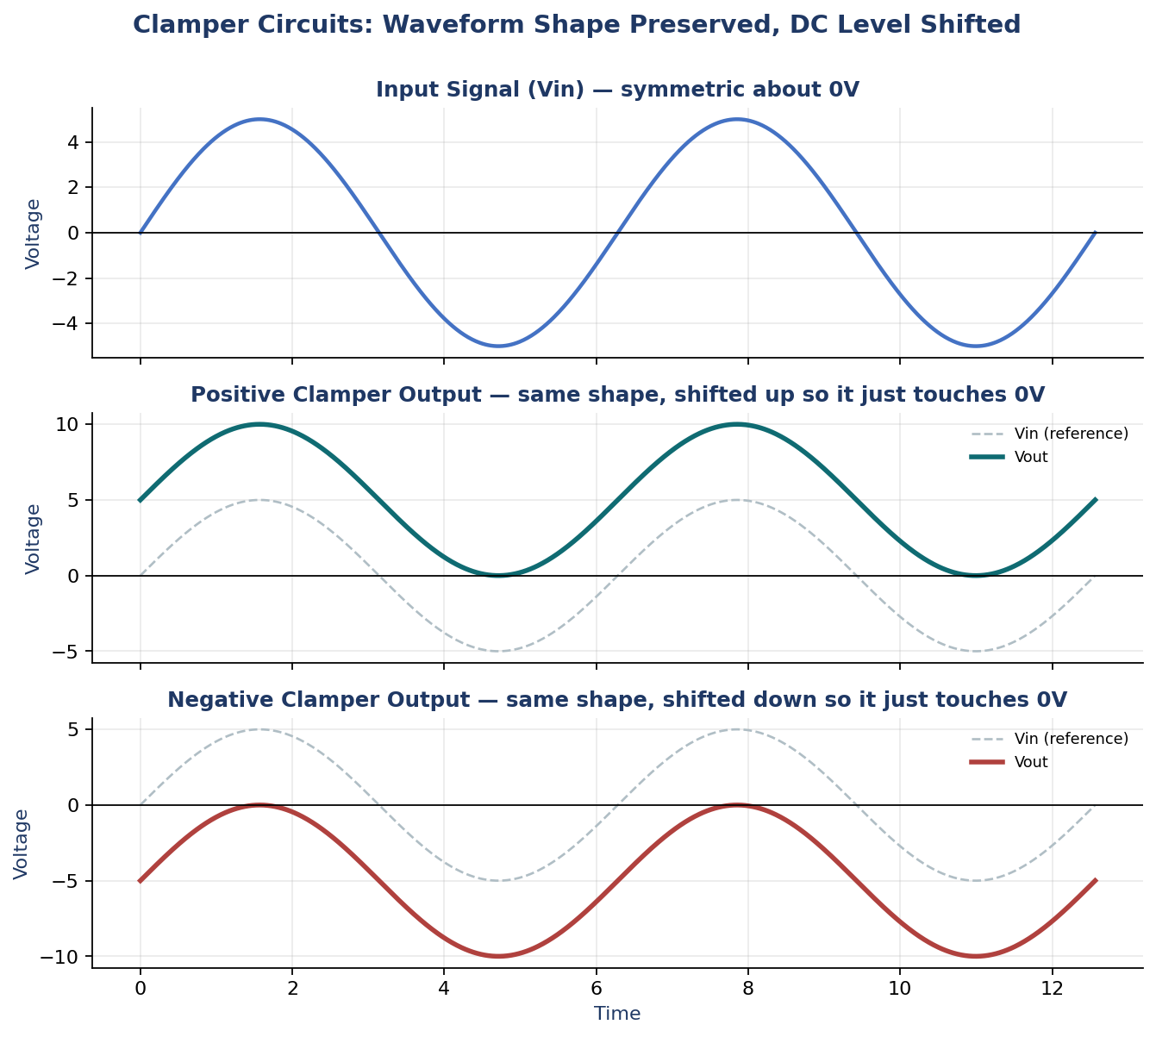
Figure 6: Positive and negative clamper outputs. The waveform shape is preserved exactly; only its DC level (vertical position) is shifted.

5.3 Positive vs Negative Clampers
- Positive clamper: shifts the entire waveform upward, so that its lowest point sits at (or just above, accounting for the diode drop) 0V, and the rest of the waveform sits entirely in the positive region.
- Negative clamper: shifts the entire waveform downward, so that its highest point sits at (or just below) 0V, and the rest of the waveform sits entirely in the negative region.
- Biased clamper: adds a reference DC voltage in series with the diode, allowing the waveform to be clamped to any chosen level, not just 0V.

5.4 Clipper vs Clamper, the essential distinction
Aspect | Clipper | Clamper
What it changes | The waveform's shape (removes part of it) | The waveform's DC level only (shifts it)
Shape preserved? | No, part of the signal is cut off | Yes, the shape is completely unchanged
Key component | Diode (and resistor, and optional reference voltage) | Diode, capacitor, and resistor (capacitor is essential)
Typical use | Voltage limiting, protection, wave-shaping | Repositioning a signal's DC operating point

5.5 Relation to rectifiers
A clamper is sometimes described as a circuit that performs a similar charging action to a rectifier's diode-capacitor combination, but for the purpose of DC level-shifting rather than AC-to-DC conversion. Both rely on a diode charging a capacitor to the peak voltage, but a rectifier's output is meant to be used directly as DC power, while a clamper's output is still a full AC-shaped waveform, just repositioned vertically.

5.6 When to use clampers
- Restoring the DC level of a signal that has passed through an AC-coupling capacitor elsewhere in a circuit (which strips the original DC component).
- Preparing a signal to sit within a specific voltage range required by downstream circuitry, for example ensuring a signal never goes negative before feeding it into a circuit that cannot handle negative voltages.
- Television and video signal processing, historically a very common application for DC restoration.

5.7 When clampers are not the right tool
- If any part of the waveform needs to be removed or limited rather than just repositioned, use a clipper instead.
- If the goal is genuine AC-to-DC power conversion (a steady output voltage, not a shifted AC waveform), use a rectifier (with filtering) instead.

5.8 Interview Q&A
Q: What is the essential difference between what a clipper does and what a clamper does?
A: A clipper removes part of a waveform, cutting off whatever crosses a reference level, which changes the waveform's shape. A clamper adds a constant DC offset to the entire waveform, shifting it up or down as a whole, without changing its shape at all.
Q: Why is a capacitor essential to a clamper circuit, but not to a basic clipper?
A: The capacitor is what stores the charge (approximately the input's peak voltage) that provides the constant DC offset added to the signal for the rest of the cycle. A clipper does not need to store or add any DC offset, it only needs to conditionally block part of the signal, which a diode and resistor alone can do.
Q: In a positive clamper, why does the waveform end up with its minimum point at approximately 0V rather than exactly 0V?
A: The capacitor charges to the peak input voltage only up to the point where the diode stops conducting, which happens once the diode's own forward voltage drop (~0.7V for silicon) is reached, so the capacitor's charge, and therefore the resulting shift, is slightly less than the full peak voltage, leaving the waveform's minimum sitting about 0.7V above where an ideal (0V-drop) diode would place it.

5.9 Tips and tricks
- The one-sentence answer that nails the clipper-vs-clamper distinction in an interview: 'a clipper cuts the shape, a clamper shifts the level.'
- Remember the capacitor is the defining component of a clamper, if a circuit diagram has no capacitor, it cannot be a clamper, however it may look otherwise.
- Practice sketching both a positive and a negative clamper output starting from the same input sine wave, side by side, it is a very common exam request.

Part 6: Summary and General Notes

6.1 Rectifier vs Clipper vs Clamper, at a glance
Circuit | Purpose | Changes shape? | Changes DC level? | Key component
Rectifier | Convert AC to (pulsating) DC | Yes, blocks half or none of each cycle | Yes, produces a one-directional output | Diode(s)
Clipper | Remove part of a waveform above/below a level | Yes, flattens part of the wave | Not directly, only as a side effect of clipping | Diode + resistor (+ optional reference voltage)
Clamper | Shift a waveform's DC level up or down | No, shape is fully preserved | Yes, that is its entire purpose | Diode + capacitor + resistor

6.2 Structuring your answer when asked to explain any of these circuits
- 1. State its purpose in one sentence (rectify, clip, or shift level).
- 2. Draw the circuit topology, and explicitly state where the diode sits (series or shunt, if relevant).
- 3. Walk through what happens during each half of the input cycle: when is the diode ON, when is it OFF, and why.
- 4. Draw the input and output waveforms together, aligned, so the transformation is visually obvious.
- 5. State any relevant formulas (Vdc, ripple factor, PIV for rectifiers) and the real-world application.

6.3 Frequently repeated cross-cutting questions
Q: All three circuits (rectifier, clipper, clamper) use diodes. What single property of the diode is being exploited in each case?
A: In every case it is the diode's one-directional conduction (current flows freely one way, is blocked the other) that does the work. A rectifier uses this to block one polarity of the AC cycle entirely, a clipper uses it to conditionally short or block part of the signal at a threshold, and a clamper uses it to selectively charge a capacitor during one part of the cycle to create a DC offset.
Q: As a UTA, how would you help a student who keeps mixing up clippers and clampers?
A: Have them sketch the same input sine wave three times, then draw a clipped version (flatten the top), a positive-clamped version (shift the whole wave up, same shape), and a negative-clamped version (shift the whole wave down, same shape) right next to each other. Seeing the clipped version visibly lose its peak shape while both clamped versions keep the exact same curve, just repositioned, makes the distinction immediate rather than a rule to memorise.

6.4 Final checklist before the interview
- Can you draw the energy band diagram for a conductor, semiconductor, and insulator, and explain the conductivity difference in one sentence each?
- Can you draw the diode V-I curve from memory, labelling cut-in voltage, leakage current, and breakdown voltage?
- Can you solve a basic diode DC circuit using the assume-and-check method, stating which model (ideal, constant voltage drop, piecewise linear) you are using?
- Can you draw the half-wave rectifier circuit and its input/output waveforms, and state its Vdc, ripple factor, and PIV formulas?
- Can you distinguish a series clipper from a shunt clipper by diode placement, and draw a positive and negative clipper output?
- Can you explain, in one sentence, why a clamper preserves shape while a clipper does not, and why a capacitor is essential to a clamper?

