Learning Transferable Visual Models From Natural Language Supervision

(1) Contrastive pre-training

(2) Create dataset classifier from label text

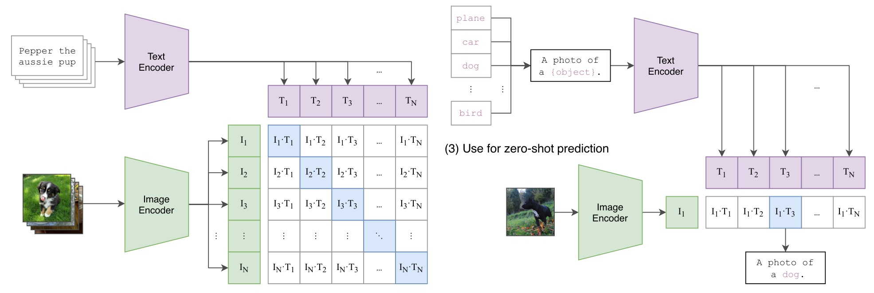

Figure 1. Summary of our approach. While standard image models jointly train an image feature extractor and a linear classifier to predict some label, CLIP jointly trains an image encoder and a text encoder to predict the correct pairings of a batch of (image, text) training examples. At test time the learned text encoder synthesizes a zero-shot linear classifier by embedding the names or descriptions of the target dataset's classes.

classification datasets by scoring target classes based on their dictionary of learned visual n-grams and predicting the one with the highest score. Adopting more recent architec- tures and pre-training approaches, VirTex (Desai & Johnson, 2020), ICMLM (Bulent Sariyildiz et al., 2020), and Con- VIRT (Zhang et al., 2020) have recently demonstrated the potential of transformer-based language modeling, masked language modeling, and contrastive objectives to learn im- age representations from text.

While exciting as proofs of concept, using natural language supervision for image representation learning is still rare. This is likely because demonstrated performance on com- mon benchmarks is much lower than alternative approaches. For example, Li et al. (2017) reach only 11.5% accuracy on ImageNet in a zero-shot setting. This is well below the 88.4% accuracy of the current state of the art (Xie et al., 2020). It is even below the 50% accuracy of classic com- puter vision approaches (Deng et al., 2012). Instead, more narrowly scoped but well-targeted uses of weak supervision have improved performance. Mahajan et al. (2018) showed that predicting ImageNet-related hashtags on Instagram im- ages is an effective pre-training task. When fine-tuned to ImageNet these pre-trained models increased accuracy by over 5% and improved the overall state of the art at the time. Kolesnikov et al. (2019) and Dosovitskiy et al. (2020) have also demonstrated large gains on a broader set of transfer benchmarks by pre-training models to predict the classes of the noisily labeled JFT-300M dataset. This line of work represents the current pragmatic middle ground between learning from a limited amount of super- vised “gold-labels” and learning from practically unlimited amounts of raw text. However, it is not without compro-

mises. Both works carefully design, and in the process limit, their supervision to 1000 and 18291 classes respectively. Natural language is able to express, and therefore supervise, a much wider set of visual concepts through its general- ity. Both approaches also use static softmax classifiers to perform prediction and lack a mechanism for dynamic out- puts. This severely curtails their flexibility and limits their "zero-shot'’ capabilities.

A crucial difference between these weakly supervised mod- els and recent explorations of learning image representations directly from natural language is scale. While Mahajan et al. (2018) and Kolesnikov et al. (2019) trained their models for accelerator years on millions to billions of images, VirTex, ICMLM, and ConVIRT trained for accelerator days on one to two hundred thousand images. In this work, we close this gap and study the behaviors of image classifiers trained with natural language supervision at large scale. Enabled by the large amounts of publicly available data of this form on the internet, we create a new dataset of 400 million (im- age, text) pairs and demonstrate that a simplified version of ConVIRT trained from scratch, which we call CLIP, for Con- trastive Language-Image Pre-training, is an efficient method of learning from natural language supervision. We study the scalability of CLIP by training a series of eight models spanning almost 2 orders of magnitude of compute and ob- serve that transfer performance is a smoothly predictable function of compute (Hestness et al., 2017; Kaplan et al., 2020). We find that CLIP, similar to the GPT family, learns to perform a wide set of tasks during pre-training including OCR, geo-localization, action recognition, and many others. We measure this by benchmarking the zero-shot transfer performance of CLIP on over 30 existing datasets and find