NOSTRADAMUS input preparation
This document should provide a brief overview on the usage and capabilities of the NOSTRADAMUS input preparation code provided as NOSTRADAMUS_1_input_prep.py. The algorithm flow charts are updated automatically when the PowerPoint file Algorithm_flow_charts.pptx﻿ is edited.

Goal of the code
- Read data from various sources and time steps into uniform numpy arrays.
- Spatially displace the data from past time steps along flow path to the most recent time step t0.
- Evaluate the displacement by calculating skill scores for the displacement accuracy.

Technical specifications
- Code written in Python 2.7.15, making use of __future__ package to ensure compatibility with Python 3.x, but this is not tested.
- Script to call from command line is NOSTRADAMUS_1_input_prep.py, which calls all the functions from NOSTRADAMUS_1_input_prep_fun.py.
- Most specifications and settings for the code are provided in a config text file (.cfg). See Table 1 for the description of the parameters.
- All the settings made in the config text file are passed amongst the functions in a cfg_set dictionary.
- The derivation of the optical flow field the displacement are conducted using the respective functions of the package pySTEPS.

Capabilities
- The reader functions are able to read
  - radar data from original ELDIS files using the metranet function
(/data/COALITION2/database/radar/ccs4/python/metranet.py).
  - parallax corrected satellite data from NetCDF file.
  - lightning count data from original .prd file or from pre-processed .nc file (done in swisslightning_jmz.py code in mpop).
  - wind and convection COSMO model data.
- Saving and reading the data (variables in original and displaced locations as well as the flow field data) as numpy (.npy/.npz) or NetCDF4 classic (.nc) files. The respective functions load_file and save_file are used, but not explicitly mentioned in the following flow charts.
- The time step (e.g. 5min, 10min..) between single observations can be adjusted, as well as the number of time steps which should be imported from the past and displaced along the flow field to t0.
- For the Lucas-Kanade algorithm, the number of past frames to be included to derive the specific motion field can also be adjusted (also for the derivation of the residual movement flow field separately).
- The correction of the residual flow field can be switched on and off.
- The calculation of skill scores for the evaluation can also be switched on and off.

Restrictions
- Spatial dimensions of input data must comply with each other (so far, it was only tested for ccs4 grid, as no interpolation step is included).
- The reader functions are specifically written for the format provided in the input paths, no dynamical adjustment for other file types.
- If the evaluation skill scores should be calculated, so far the min-, max-, mean-, 90th quantile values and the number of non-nan pixels are extracted (which is hard-coded at the moment).
- So far, the flow field derivation is only implemented using the rain rate (RZC) as input data source.

Work flow (general)
Overall, the procedure in NOSTRADAMUS_1_input_prep.py can summarised into the following steps, starting with the initialisation:
- Read settings form config file and pass via cfg_set dictionary.
- Read the data from their original data sources for the past “n_integ” time steps, bring them into unform numpy array format and store them as .npy or .nc files to the disk.
- Derive the optical flow field for the respective time period (from precalculated daily motion field or computed using optical flow). The residual movement is corrected in each time step the first order flow is determined.
- Displace past observations along optical flow field to current location at t0, or displace the TRT cell centres against (to the past) or along (to the future) the flow.
- (DEPRECATED: If a correction for residual movement should be conducted, derive optical flow field from displaced observations and again displace along this residual flow field.)
- (If the displacement should be evaluated, calculate skill scores.)
- Obtain the pixel indices in the domains surrounding the displaced TRT cells (where to get the data for the statistics from).
- Read the statistics and pixel counts and write to xarray object.
After this process has been conducted once, the following updating steps are taken:
- Analgous step 2., read in most current observations from original data files whilst forgetting about the last one.
- Analgous step 3., derive optical flow field for the time between t0 and t-“timestep” minutes.
- Analgous step 4., Displace the observations along new flow field to new t0 location.
- (Analogous step 5., correct for residual movement.)
- (Analogous step 6., calculate skill scores.)

The algorithmic flow chart for the overall process is shown in Figure 1 and Figure 2. The symbols in the flow charts have the following meaning, as shown in Table 1.

Table 1 – Symbols in flow charts.
Symbol | Explanation
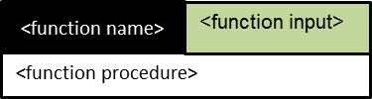 | Function with <function name>, <function input> and <function procedure>.
 | Variable in RAM.
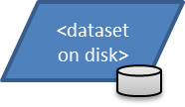 | Dataset on disk (often example file names are shown).
 | Objects within red framing (or text in red) is only produced or executed if required by the used. If statement in code.
 | Loop (mostly over time steps or over variables).
 | Deleting certain file on disk.
 | Comment on specific process step or file.

Read settings from config file (Figure 3)
Get information from configuration file and return in a dictionary "cfg_set".

Read the observational data (Figure 5)
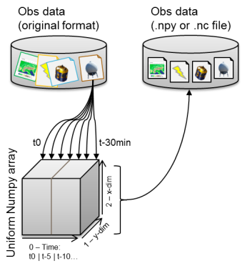 | Read observational data, create uniform numpy arrays and save those to disk as .npy or .nc files. Furthermore, initiate the numpy arrays for saving the skill scores and statistics and store these as .npy file on the disk. Several helper functions are needed to create the path according to the variable to be read and to the current time step. Then, variable-specific functions are called which are tailored to read the observational data type.  TRT cell centres are also stored like that (the pixel value of the location filled with the respective trajectory ID*), but with the centre being at the location of t0 in all layers (which are later displaced against the flow). See also Step 8, where it is explained how the domain around the centres is derived.
  0 | 0 | 0 | 0 | 0
  0 | $$*$$ | 0 | 0 | 0
  0 | 0 | 0 | 0 | 0
  0 | 0 | 0 | 0 | 0
  0 | 0 | 0 | 0 | 0

Deriving optical flow field (Figure 4)
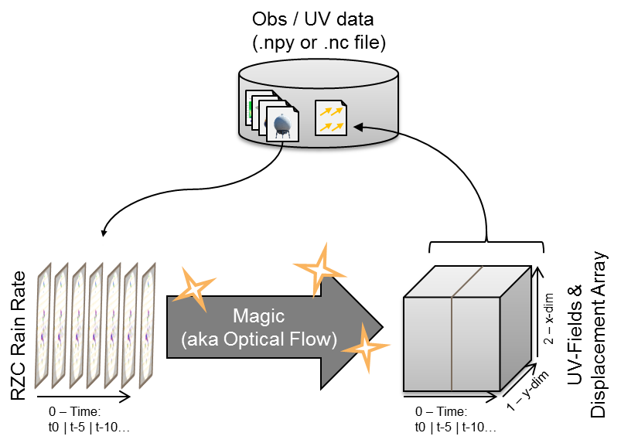 | In case no precalculated daily motion files are available, calculate the motion field from the RZC field as described below. Otherwise extract from the daily motion field.  Using rain rate (RZC) as optical flow source data infer flow field and displacement arrays and save those to the disk (as .npy or .nc file). It works by filling up the time dimension time step by time step, reading the respective source data, applying the lucaskanade function of pySTEPS.

Displace past observations (Figure 6)
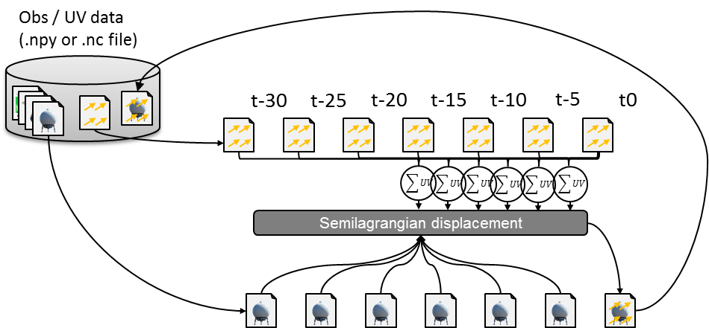

First, the algorithm loops over the variables, then calculates the cummulative sum of the displacement arrays over time. These are provided with the most current UV-field (not the displacement field!) to the function semilagrangian of the pySTEPS package, receiving the displaced data, which is stored in a numpy array analogous to the non-displaced one. If option “use_precalc_XYW” is set to true, the semilagrangian function returns the XYW array when displacing the first variable, which can be reused for the following variables to speed up the displacement.
If required, the functions calculating the skill scores are called to evaluate the displacement.
0 | 0 | 0 | 0 | 0
0 | $*$ | 0 | 0 | 0
0 | 0 | 0 | 0 | 0
0 | 0 | 0 | 0 | 0
0 | 0 | 0 | 0 | 0

Alternatively (current default), observed variables are not displaced, but TRT cell centres (at the respective location at t0) are displaced against the flow (backward in time) or with the flow (forward in time).

Correcting for residual movement (Figure 7)
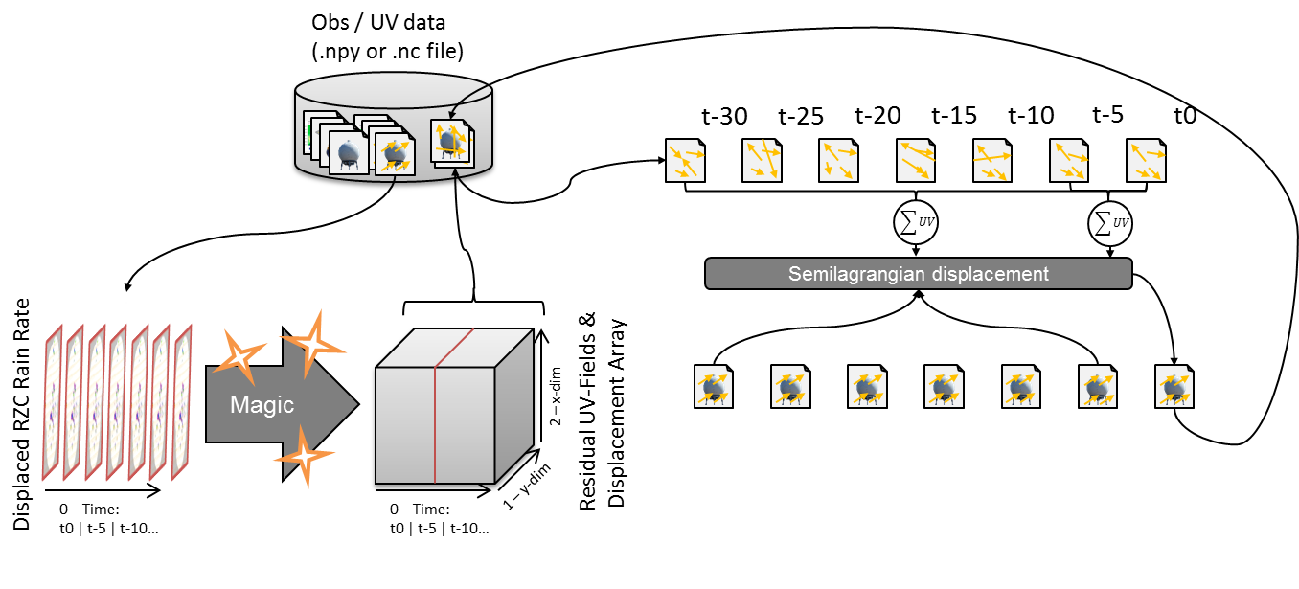

For residual movement correction, the displaced optical flow source data field (RZC) are again used to derive the optical flow field of the residual motion, which is then used analogously to displace the already displaced variables again (option “Twostep”). If the option “Onestep” is chosen, the primary (large-scale) flow fields are added to the secondary (residual) flow field before displacing the original observations. This avoids a some numerical diffusion as the observations are only displaced once.
Alternatively (current default), the RZC field is displaced at every time step the optical flow is derived (Step 3), and the residual movement is obtained solely from two consecutive images. The correction is also performed right after the first order flow derivation and added to the first order motion field.

Calculate skill scores (Figure 10)
After the displacement, different skill scores are calculated for all variables and for all time steps (different skill scores for the displacement from t-30min to t0 as for t-15min to t0). After the updating is stopped, these can be compared and visualised.

Updating step (Figure 8 and Figure 9)
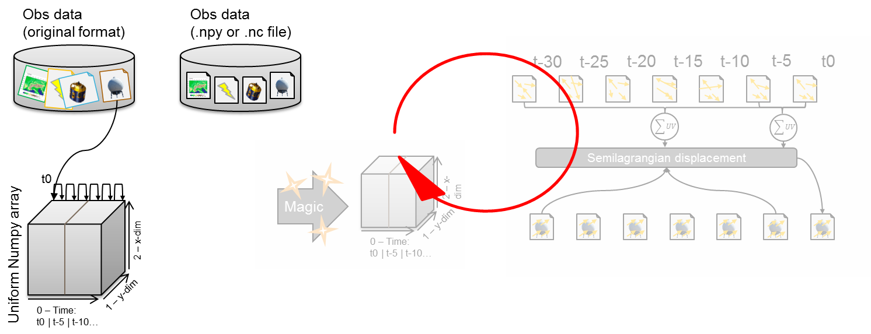

The updating consists in a first place of a step where the observations from the old time t0 to the second last time step are copied to the time slices from the old t-“timestep” (e.g. t-5min) to the last time step. Then, the current observation is read and written into the first slice. In a second step, the flow field from t-“timestep” to the new t0 is calculated, and appended the same way to the UV- and displacement fields. After this step, the same procedure is followed as in the steps above. In case not set otherwise, the old files on disk (with the old observations and flow fields) are deleted.

Deriving the domains around the TRT cell centres
0 | 0 | 0 | 0 | 0 | 0 | 0
0 | 0 | $$*$$ | $$*$$ | $$*$$ | 0 | 0
0 | $$*$$ | $$*$$ | $$*$$ | $$*$$ | $$*$$ | 0
0 | $$*$$ | $$*$$ | $$*$$ | $$*$$ | $$*$$ | 0
0 | $$*$$ | $$*$$ | $$*$$ | $$*$$ | $$*$$ | 0
0 | 0 | $$*$$ | $*$ | $$*$$ | 0 | 0
0 | 0 | 0 | 0 | 0 | 0 | 0
The following steps are only implemented for the case where the TRT cell centres are displaced against (to the past) and along (to the future) the flow, but not when the variables are displaced (i.e. in conctradiction to most that’s been written above).
The function “get_vararr_TRT_t0” writes some information (mainly the location) of the current TRT cells (at time step t0) into a pandas dataframe and saves it to the disk. Further the function. Furthermore, the function “read_TRT_area_indices” then asigns the pixels surrounding the (displaced) cell centre pixel the respectiv values (either in the form of a square or of an approximated circle).
It then saves the indices of the indices of the pixels contained in a domain (circle or squre) of the flattened array (as below for example an array of [9,10,11,15,16,17,18,19, …]).
0 | 0 | 0 | 0 | 0 | 0 | 0 | 0 | 0 | $$*$$ | $$*$$ | $$*$$ | 0 | 0 | 0 | $$*$$ | $$*$$ | $$*$$ | $$*$$ | $$*$$ | 0
0 | 1 | 2 | 3 | 4 | 5 | 6 | 7 | 8 | 9 | 10 | 11 | 12 | 13 | 14 | 15 | 16 | 17 | 18 | 19 | 20
These indices are then saved in an 3D xarray object, where one dimension is the indices per domain (length = number of pixels within square or circle), a second one the number of timesteps (i.e. for 45min with 5min time step a length of 10), and a third with the number of TRT cells within the scene at t0.

Reading the statistics and pixel counts
The function “append_statistics_pixcount” wraps the function “calculate_statistics_pixcount”, where of the different variables, the optical flow (U_OFLOW and V_OFLOW) and the variable combinations (e.g. WV_062 - IR_108) the number of NaN pixels, of the minimum-value pixels (e.g. -32dBZ for CZC), and the statistics are calculated and saved in an xarray object. Certain variables (e.g. WSHEAR_0-6km, see first row below) are first interpolated at locations where there are NaN-values (e.g. due to topography), some variables are smoothed (e.g. tropopause_height, see second row below), or the local standard deviation is calculated (e.g. for POT_VORTIC_70000, see third row below).
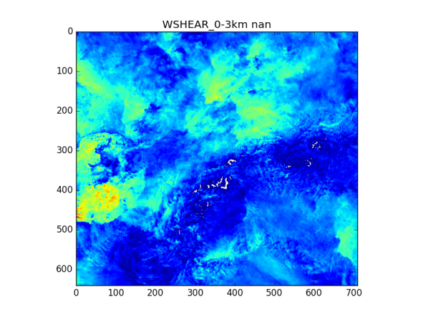 | 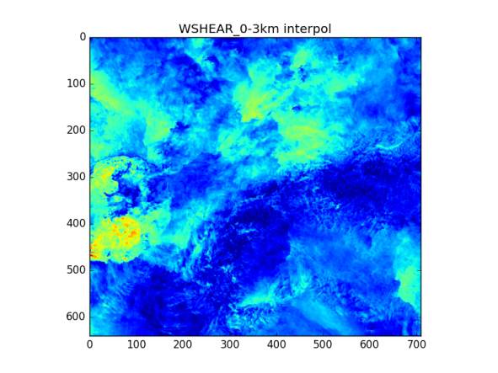
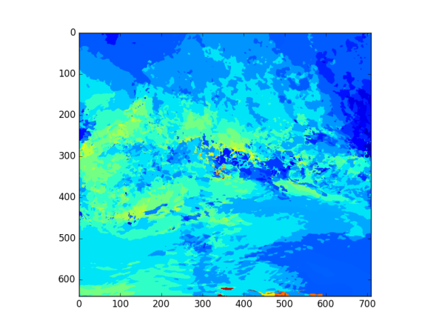 | 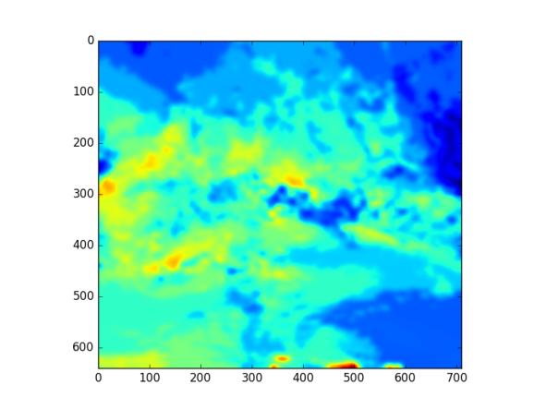
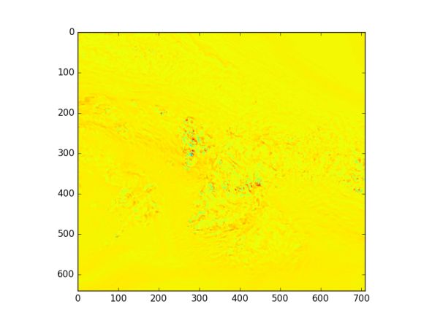 | 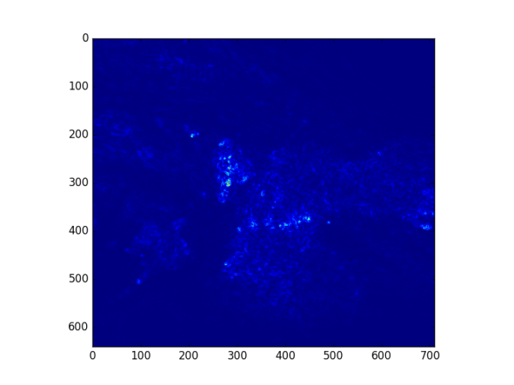
After these corrections, the statistics (sum, mean, standard deviation, min, 01-, 05-, 25-, 50-, 75-, 95-, 99-percentiles, max) are computed and appended to the 3D xarray-object, where one dimension are the statistics (length = 12), a second one the number of timesteps (i.e. for 45min with 5min time step a length of 10 or for the training of length 20), and a third with the number of TRT cells overall. The same setup is chosen for the pixel counts (minimum-values and NaN-values), but where the coordinate “statistic” is replaced by “pixel_count”:

<xarray.Dataset>
Dimensions: (CHi_CHj: 2, DATE_TRT_ID: 32819, pixel_count: 2, pixel_indices: 421,
statistic: 12, time_delta: 20)
Coordinates:
* pixel_indices (pixel_indices) int32 0 1 2 3 4 5 6 7 8 ...
* CHi_CHj (CHi_CHj) |S3 'CHi' 'CHj'
* statistic (statistic) |S6 'SUM' 'MEAN' 'STDDEV' ...
* pixel_count (pixel_count) |S9 'PC_NONNAN' 'PC_NONMIN'
* DATE_TRT_ID (DATE_TRT_ID) |S29 '201805091505_2018050915050003' ...
* time_delta (time_delta) int64 -45 -40 -35 -30 -25 ...
Data variables:
CG (time_delta, DATE_TRT_ID) int16 ...
CG_minus (time_delta, DATE_TRT_ID) int16 ...
…
Border_cell (time_delta, DATE_TRT_ID) bool ...
TRT_domain_indices (DATE_TRT_ID, time_delta, pixel_indices) uint32 ...
TRT_cellcentre_indices (DATE_TRT_ID, time_delta, CHi_CHj) uint16 ...
RZC_pixc (DATE_TRT_ID, time_delta, pixel_count) int64 ...
RZC_stat (DATE_TRT_ID, time_delta, statistic) float64 ...
BZC_pixc (DATE_TRT_ID, time_delta, pixel_count) int64 ...
…

Not yet implemented is the count of categorical variables (like the number of pixels of a certain cloud type). But so far, the count of pixels with ≥57dBZ.

Work flow (training)
First it should be noted that for the training dataset, also statistics for thunderstorm after t0 (in the “future”) must be considered (for which we train the model for). Thus also “future” observations have to be read, and the flow field in the “future” has to be calculated. Since observations would have to be displaced along a “reversed” flow, files containing observations, UV flow fields etc for time points after (and including!) t0 have the ending “_rev” (e.g. the resulting pickle files containing the statistics and pixel counts):
201808061545_stat_pixcount.pkl |  | Time t0: | 201808061545_stat_pixcount_rev.pkl
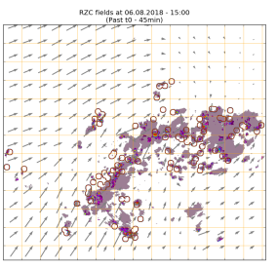 |  | 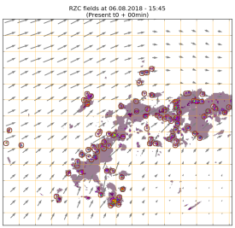 |  | 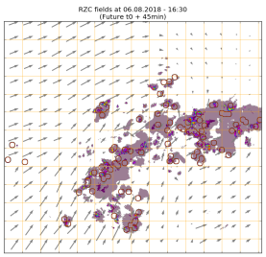

Specifically, the training dataset generation process is done in an iterative way, adding statistics per time step analysed (as in the operational framework). But first, the script NOSTRADAMUS_0_training_ds_preparation.py is used to set up the files needed for the training dataset generation, and also the script NOSTRADAMUS_0_check_inputdata.py checks the availability of the respective input data.
- First the settings for the training dataset generation have to be specified in the file NOSTRADAMUS_0_training_ds.cfg (for the entries see also Table 3). Specify the start and the end date of the training period (e.g. tds_period_start = 20180401 when starting on April 1, 2018). Furthermore, define the temporal spacing between the sampling time points (e.g. 30min if the sampling should be at April 1, 2018, 00:00/00:30/01:00) and the temporal daily shift between the sampling time points (so that for 5min it would be April 1, 23:00/23:30 and then April 2, 00:05/00:35...). Furthermore, the paths and names of the config files containing the general settings (not training dataset specific) and information on the variables and variable combinations (set in Excel spreadsheet and saved as .csv).
- After reading in these config specifications, the NOSTRADAMUS_0_training_ds_preparation.py script creates a list of time steps according to the specifications. In a second, quite time consuming step the function get_TRT_cell_info(..) reads the respective TRT files (.trt) to first derive whether any and if so how many TRT cells are present at the specific time step. If non are present, it checks the time steps ±2 times the temporal shift (e.g. ±10min for 5min time shifts) whether there are any TRT cells present, and if so include those. Of those TRT cells, it reads some basic data and writes it into the pandas dataframe samples_df saved on the disk as TRT_sampling_df_testset.pkl. The function change_append_TRT_cell_info(..) adds and changes some information read from the TRT files (e.g. converting the lat/lon coords to Swiss coords, adjusts data types and adds the severity classes). The function exploit_TRT_cell_info(..) mainly plots the histogram plots (e.g. number of cells in severity class 3) and the map (location of TRT cells during the training period).
- Finally, the function setup_log_file sets up a log-file containing all the TRT cells, identified by their trajectory ID (traj_ID), the respective time steps (saved as datetime-object), and their respective union DATE_TRT_ID (concatenation of the date/time and the traj_ID, e.g. 201804040845_2018040408450034). Also further TRT info is saved.
In a second part, it adds empty columns for the notification of the following information:
- Is the timepoint/TRT-cell currently processed (“Processing”), if so, when has it started (“Processing_Start”), and has the process sucessfully inded (“Processed”) and if so, when has it ended (“Processing_End”).
- It also sets up boolean columns for the information whether all the necessary input data is present (e.g. SEVIRI_missing=True), or the displaced TRT cell with the surrounding domain is exceeding the observational borders.
The respective pandas dataframe (see below) is saved as pickle log file to the disk (Training_Dataset_Processing_Status.pkl).

<class 'pandas.core.frame.DataFrame'>
Int64Index: 19329 entries, 37 to 89938
Data columns (total 22 columns):
traj_ID 19329 non-null object ---
date 19329 non-null object |
RANKr 19329 non-null uint8 |
area 19329 non-null uint32 |
lat 19329 non-null float32 |
lon 19329 non-null float32 |--> TRT-info
iCH 19329 non-null uint32 |
jCH 19329 non-null uint32 |
LV03_x 19329 non-null float32 |
LV03_y 19329 non-null float32 |
... ... :
category 19329 non-null object ---
Processing 19329 non-null bool ---
Processing_Start 19268 non-null object |
Processing_End 19060 non-null object |
Processed 19329 non-null bool |
COSMO_CONV_missing 19329 non-null bool |--> Info on processing
SEVIRI_missing 19329 non-null bool |
RADAR_missing 19329 non-null bool |
THX_missing 19329 non-null bool |
Border_cell 19329 non-null bool |
Non_NAN_stat 19329 non-null bool ---
DATE_TRT_ID 19329 non-null object --> TRT-info
dtypes: bool(8), float32(4), object(6), uint32(3), uint8(1)
memory usage: 1.7+ MB

- The last function, get_empty_tds, is deprecated.

Besides the script NOSTRADAMUS_0_training_ds_preparation.py also the script NOSTRADAMUS_0_check_inputdata.py should be run. This one checks the availability of the input data at all time points needed (e.g. t0 ± 45min), i.e. all the RADAR eldis files for the different RADAR products (RZC, BZC, etc.), the parallax corrected SEVIRI NetCDF dataset (containing all channels), the COSMO_CONV NetCDF dataset (containing all the COSMO products) and the THX NetCDF dataset (containing all the lightning products). The respective pandas dataframe is saved as pickle file to the disk (Missing_InputData.pkl), as well as two .csv files only containing the dates of missing COSMO_CONV and SEVIRI data (Missing_InputData_COSMO_CONV.csv & Missing_InputData_SEVIRI.csv). The missing dates are analysed by the function analyse_df_missing(..).
An optional but highly recommended step is to precalculate the UV fields (as daily files). For this purpose run the bash script UV_precalc_loopscript.sh, looping over a period stated in the system arguments (excluding the end date, i.e. one has to set the next date, e.g. /.UV_precalc_loopscript.sh 20180401 20181001 if one wants it to be calculated until the end of September). This script calls the python function NOSTRADAMUS_1_input_prep_disparr_training.py which precalculates the daily UV motion arrays and saves it to the path specified in the config setting UV_precalc_path (see Table 2). The function read_disparray_from_precalc(..) then checks and reads, or calculates the daily motion files.

These scripts are only run once, before the setup of the training dataset. In order to generate the actual xarray objects containing the statistics and pixel counts, for all time steps containing TRT cells the script NOSTRADAMUS_0_training_ds.py is run.

- The script NOSTRADAMUS_0_training_ds.py is initialised by the bash script training_script.sh, which runs it as often as necessary to cover all the time steps (based on a while loop, which stops as soon as the exit code of the python script returns the value 200). The bash script can be run in parallel, and also detached from the respective shell, using: nohup training_script.sh > nohup_whatevername.out 2>&1&.
- Within the script NOSTRADAMUS_0_training_ds.py, again, first the config settings are read, providing the config settings for the input data generation (cfg_set_input) and the information on the variables (cfg_var) and the varibale combinations (cfg_var_combi).
- Then, the dataframe containing the log of the training data generation process saved as Training_Dataset_Processing_Status.pkl is opened by the function read_edit_log_file(..,”start”) (with argument process_point=”start”) to randomly select a time step which is not yet processed (Processed=False) and is not currently being processed (Processing=False). Furthermore, the entry in „Processing_Start“ is set to the currenty time. If all the input data is available (checking in the dataframe saved in Missing_InputData.pkl) it sets the entry “Processing” to True and returns the datatime object of the selected data and time point. Else, it sets the respectiv entry of the missing datasource to True (e.g. SEVIRI_missing=True), sets “Processed” to True and returns None (in this case, the executation of the python file NOSTRADAMUS_0_training_ds.py terminates).
- Then the text file is created, wherein the standard output (stdout and stderr) is written for the specific time step, where the location is specified in the cfg_set_tds entry PATH_stdout_output).
- Finally, the process as explained in Section Work flow (general) is executed, finally providing xarray pickle objects for the past and the future (for training). The function move_statistics(..) moves these pickle files out of the tmp/ directory to a permanend location.
- The option exists to change the width of the form surrounding the TRT cell centres, from whose the statistics are calculated, using the function change_form_width_statistics(..).
- Before exiting, the function read_edit_log_file(..,”end”) with argument process_point=”end” is called again to set the dataframe (saved in Training_Dataset_Processing_Status.pkl) entry “Processing” to False, the entry “Processed” to True and „Processing_End“ to the currenty time. The return value of the function is the percentage of processed timepoints plus 100, which makes the while loop in the shell script training_script.sh break if it receives the value 200.

During the process, run the python script NOSTRADAMUS_0_training_ds_logfile_check.py <path_to_log_file>, which prints some diagnostics on the current progress (fraction of TRT cells and fraction of time points processed (there usually are several TRT cells per time point), latest generation of a statistics/pixel count xarray object, number of such objects generated in the past two hours and the average time in between the generation of these datasets in the past two hours).
Due to potential disk failures some processes will be aborted before the statistics and pixel count xarray objects are written as pickle file to the disk. Therefore, also the last step is not taken (“Processed” is still False, but “Processing” is still True). To rerun the shell script training_script.sh for these cases, first run the script NOSTRADAMUS_0_training_ds_logfile_reset.py <path_to_log_file>, which resets the entries in the column “Processing” to False.

To finally concatenate all the xarray pickle objects containing the statistics and pixel counts into two files containing all the past and future (_rev) data, and to combine these into one big training dataset, run the script NOSTRADAMUS_0_training_ds_concat_timepoints.py <path_to_files>, where <path_to_files> corresponds to the path the xarray objects are saved in (as specified in the move_statistics(..) function). This script also converts the pickle into NetCDF files (if desired by the user) and produces some overview plots. Furthermore, the TRT Rank and the difference in TRT Rank to t0 are appended in this function. To check the correct implementation of the TRT Rank calculation procedure, the script NOSTRADAMUS_0_check_TRTRank_calc.py <%Y%m%d%H%M> can be run, which produces a scatter plot showing the TRT Ranks as provided in the TRT file, and the Ranks calculated with the respective formula.

If one wants to concatenate two datasets (e.g. with the training data of summer 2018 and summer 2019 along the dimension DATE_TRT_ID), the script NOSTRADAMUS_0_training_ds_concat_datasets.py can be used (if there is overlapping data, e.g. common DATE_TRT_ID indices, it also checks for the equality of the data). There are several checks the user has to do, so it is adviseable to run the script as ipython –i NOSTRADAMUS_0_training_ds_concat_datasets.py, since like that if one does not want to procede, one gets into the interactive mode to work on the datasets.

Existing datasets
This subsection gives a short overview on the existing datasets with some additional information (see version date at the top rightcorner of the page):
- Single files of two runs (once with 30min, once with 5min sampling density, the latter only for TRT-cells with Rank ≥ 2) are in directory, and concatenated in directory (one containing the data for 16km and one for a 23km (double the size) circle from which the statistics were taken).
- Both did not include the calculation of the radar statistics conditional on non-minimum value pixels, which were gathtered in a run in directory.
- The combination of these files can be found in directory (16km and 23km), which are then used for the training.

Figure 1 – Flow chart of NOSTRADAMUS_1_input_prep.py (first page)
Figure 2 - Flow chart of NOSTRADAMUS_1_input_prep.py (second page)

Figure 3 – Flow chart oft he function get_config_info

Figure 4 – Flow chart of the function check_create_disparray

Figure 5 – Flow chart of the function create_new_vararry

Figure 6 – Flow chart for the function displace_fields

Figure 7 – Flow chart for the function residual_disp

Figure 8 - Flow chart for the function update_fields (first page)

Figure 9 – Flow chart for the function update_fields (second page)

Figure 10 – Flow chart for the functions analyse_skillscores and compare_skillscores_help

Parameters for the NOSTRADAMUS input code
In cfg_set dictionary and in configuration file .cfg

Table 2 – Table showing all the parameters which can be set in the configuration file and are passed within the cfg_set dictionary.
Variable name | Type | Description | Options, Restrictions and Warnings
t0 | Datetime | Datetime object of current time zero
t0_str | String | String of current time zero | Format: "%Y%m%d%H%M"
t0_doy | Int | Day of the year of time zero
t0_orig | Datetime | Datetime object copy of current time zero
colorscale | String | Image colorscale | “MeteoSwiss” / “STEPS-BE”
motion_plot | String | Motion field visualisation | “streamplot” / “quiver”
root_path | String | Absolute path to project data
output_path | String | Absolute path to QC output (plots)
UV_precalc_path | String | Absolute path to precalculated UV displacement fields
RZC_path,  BZC_path … | String | Absolute path to radar input data (RZC, BZC, LZC, MZC, EZC)
wind_path | String | Absolute path to COSMO wind input data
conv_path | String | Absolute path to COSMO convection input data
THX_path | String | Absolute path to lightning input data
SAT_path | String | Absolute path to SEVIRI input data
oflow_source_path | String | Absolute path to optical flow input data | Only tested for RZC_path
path_fmt | String | Path setup in addition to absolute input path
fn_pattern | String | File name setup
fn_ext | String | File extension
etop_EZC | String | Which EchoTop data to be read | “15” / “20” / “40” / “45”
unfold | Boolean | Boolean stating whether lighting data should be unfolded | “True” / “False”
unfold_form | String | Form of lightning data unfolding | “gauss” / “gaussgauss” / “circle” / “square”
dx_unfold | Float | Spatial scale of unfolding form (different meaning, e.g. edge length of square, standard deviation of Gaussian kernel etc.)
smooth_conv | Boolean | Boolean stating whether convective variables should be smoothed | “True” / “False”
smooth_sig | Float | Kernel width for Gaussian smoothing
oflow_method_name | String | Method to derive optical flow motion field | “lucaskanade” / “DARTS”  Only tested for “lucaskanade”
adv_method | String | Method for displacement of variables to t0 | “semilagrangian”
oflow_source | String | Source variable from which optical flow motion field is derived | Only tested for “RZC”
timestep | Int | Time step between input datasets in minutes | Only tested for 5 minutes
n_integ | Int | Number of time steps which should be displaced to current time step t0
n_past_frames | Int | How many additional frames should be used for calculating the derivation of the motion field | Lucas-Kanade: Min 1  DARTS: Min 9
xy_ext_x | Int | Domain extension in x (matrix coordinates!) | Only tested for 710
xy_ext_y | Int | Domain extension in y (matrix coordinates!) | Only tested for 640
displ_TRT_cellcent | Boolean | Should variables be displaced along the flow, or should the TRT cell centres displaced against the flow | “True” / “False”
xy_ext | Tuple of ints | Domain extension in x and y (matrix coordinates!) | Only tested for (640, 710)
R_thresh_meth | String | Method to restrict optical flow input data (oflow_source) to high values. “fix” refers to a constant value, “perc” to a percentile. | “fix” / “perc”  Only tested for RZC optical flow input
R_threshold | Float | Threshold to restrict optical flow input data (oflow_source) to high values. If R_thresh_meth = “fix”, value is interpreted as constant value (for RZC in mm/h), if R_thresh_meth = “perc” it is interpreted as percentile value. | If R_thresh_meth = “perc”, R_threshold must be between 0 and 100.
UV_inter | Boolean | Boolean value stating whether UV motion vectors should be provided and plotted during the optical flow derivation. | “True” / “False”
save_type | String | Save results (variable arrays and displacement arrays) as NetCDF (nc) or Numpy array (npy) files. | “nc” / “npy”
delete_prec | Boolean | Boolean value stating whether succeeding displacement and variable arrays when updating for now time zero. | “True” / “False”
future_disp_reverse | Boolean | Boolean value stating whether future observations (from a t0 perspective) should be displaced to t0 (for the generation of the training dataset) | “True” / “False”
timestep_future | Int | Time step between future input datasets in minutes (if future_disp_reverse is true) | Only tested for 5 minutes
n_integ_future | Int | Number of time steps which should be displaced from the future to current time step t0 (if future_disp_reverse is true)
generating_train_ds | Boolean | Boolean value stating whether the current run is done for generating a training dataset. | “True” / “False”
precalc_UV_disparr | Boolean | Boolean value stating whether precalculated day-long UV field should be used (and if not available, should be calculated). It is automatically set to False if generating_train_ds is False. | “True” / “False”
future_disp_reverse | Boolean | Boolean value stating whether future observations should be displaced to t0 (and not past ones), which is necessary for the generation of the training dataset. It is automatically set to False if generating_train_ds is False. | “True” / “False”
resid_method  (config) | String | Method stating how residual movement should be corrected for. If “None”, no residual displacement is conducted (resid_disp is set to False), if “Onestep” resid_disp_onestep is set to True, if “Twostep” it is set to False. | “None” / “Onestep” / “Twostep”
resid_disp  (cfg_set) | Boolean | Boolean value stating whether a second motion field derivation and displacement should be conducted for residual movement. | “True” / “False”
resid_disp_onestep  (cfg_set) | Boolean | Boolean value stating whether the displacement based on the residual movement should (if True) be conducted on the original data (together with initial displacement) or on the already displaced field. | “True” / “False”
n_past_frames_resid | Int | How many additional frames should be used for calculating the derivation of the residual motion field
R_thresh_meth_resid | String | Analogous to R_thresh_meth for residual movement derivation. | “fix” / “perc”  Only tested for RZC optical flow input
R_threshold_resid | Float | Analogous to R_threshold for residual movement derivation. | If R_thresh_meth = “perc”, R_threshold must be between 0 and 100.
decl_grid_resid | Int | Edge length of motion vector declustering grid cell.
inter_fun_resid | String | Interpolation function for residual motion field. | “gaussian" / “inverse” / “nearest”
epsilon_resid | Int | Kernel width for interpolation methods “gaussian" and “inverse”.
zero_interpol | Boolean | Boolean value stating whether zero vectors should be introduced to obtain zero values far from motion vectors after interpolation. | “True” / “False”
verif_disp | Boolean | Boolean value stating whether the displacement should be verified by calculating predictive skill scores. | “True” / “False”
verif_param | String | Parameter which is changed to analyse the respective skill. | Only tested for R_treshold
scores_list | List of strings | List of skill scores which should be calculated. | Only tested for “csi”, “hk”, “sedi”
n_stat | Int | Number of statistics to calculated per variable as auxiliary data for skill analysis. | Only implemented for 5 (Min, Max, Mean, 90% quantile, Number of Pixels)
var_list | List of strings | Variables which should be displaced etc. | “RZC” / “BZC” / “LZC” / “MZC” / “EZC” / “EZC15” / “EZC45” / “HRV” / “VIS006” / “VIS008” / “IR_108”, “IR_120” / “WV_062” / “THX” / “Wind” / “Conv” / “TWATER” / “CAPE_MU” / “CAPE_ML” / “CIN_MU” / “CIN_ML” / “SLI” and others.
conv_vars | List of strings | Convection variables which should be read from NetCDF file. | “TWATER” / “CAPE_MU” / “CAPE_ML” / “CIN_MU” / “CIN_ML” / “SLI” and others.
abbrev_dict | Dict of strings | Long names of abbreviations of skill scores and variables.
sat_long_names | Dict of strings | Long names of SEVIRI channels.
sat_units | Dict of strings | Units of SEVIRI channels.
type_dict | Dict of np data types | Datatypes used for the saving of the respective variables.

Parameters for the NOSTRADAMUS input code (training-dataset generation algorithm)
In cfg_set_tds dictionary and in configuration file NOSTRADAMUS_0_training_ds.cfg

Table 3 – Table showing all the parameters which can be set in the configuration file and are passed within the cfg_set_tds dictionary (specific for the generation of the training dataset).
Variable name | Type | Description | Options, Restrictions and Warnings
root_path_tds | String | Path where the variables and UV arrays should be saved during the generation of the training dataset.
CONFIG_PATH_set_input | String | Path to the config file
CONFIG_FILE_set_input | String | Name of the config file
CONFIG_PATH_var_input | String | Path to the file containing the variable and combi variable info
CONFIG_FILE_var_input | String | Name of the variable info file (.csv)
CONFIG_FILE_var_combi_input | String | Name of the combi variable file (.csv)
PATH_stat_output | String | Path to where the resulting xarray objects with the statistics and the pixel counts should be moved to permanently
PATH_stdout_output | String | Path to where the text file with the standard output should be saved to
tds_period_start | String | String stating the start of the training period | Format: "%Y%m%d"
tds_period_end | String | String stating the end of the training period | Format: "%Y%m%d"
dt_samples | Int | Time difference between the sampling time points in minutes | Must be a multiple of 5 (minutes)
dt_daily_shift | Int | Temporal shift in the sampling time in minutes | Must be a multiple of 5 (minutes)

Either the interpolation function interpolate.griddata or spatial.cKDTree can be chosen, as default spatial.cKDTree is used due to efficiency reasons.

