# Chapter 1 Problems

Sam Quinn

CS327

1/9/2016

**Review Questions**

**R1 - What is the difference between a host and an end system? List several different types of end systems. Is a Web server an end system?**

Both Hosts and end systems are the same within the network jargon. Every device that is connected to the internet is an end system, Computers phones, cars, and even toasters. Yes a web server is an end system.

**R23 - The word protocol is often used to describe diplomatic relations. How does**

**Wikipedia describe diplomatic protocol?**

“A protocol is a rule which describes how an activity should be performed, especially in the field of diplomacy.” - Wikipedia.

**R28 - Why are standards important for protocols?**

Without protocols the information being sent all over the world would be garbage. Protocols define a certain way in which that communication should be sent. Without protocols and standards you would not know how to receive different communications.

**Problems**

**P1 -**

|  |  |  |  |
| --- | --- | --- | --- |
| Human Readable | | Network | |
| **Human** | **Bank** |  |  |
| Hi → | ← Hi | TCP connection request → | ← TCP connection reply |
|  | ← Who are you? |  | ← display login |
| Sam → |  | (user card, password) sent → |  |
|  | ← Ok, how can I help? |  | ← display user bank info |
| How much do I have? → |  | Balance query → |  |
|  | ← here is your balance. |  | ← Display query results |
| Can I have $200 please? → |  | Withdraw $200 if funds are available → |  |
|  | ← Here is $200 |  | ← Disperse $200 from cash dispenser. |
| Thank you! → |  | TCP termination → |  |

**P4 -**

The Maximum simultaneous connections at once is 9.

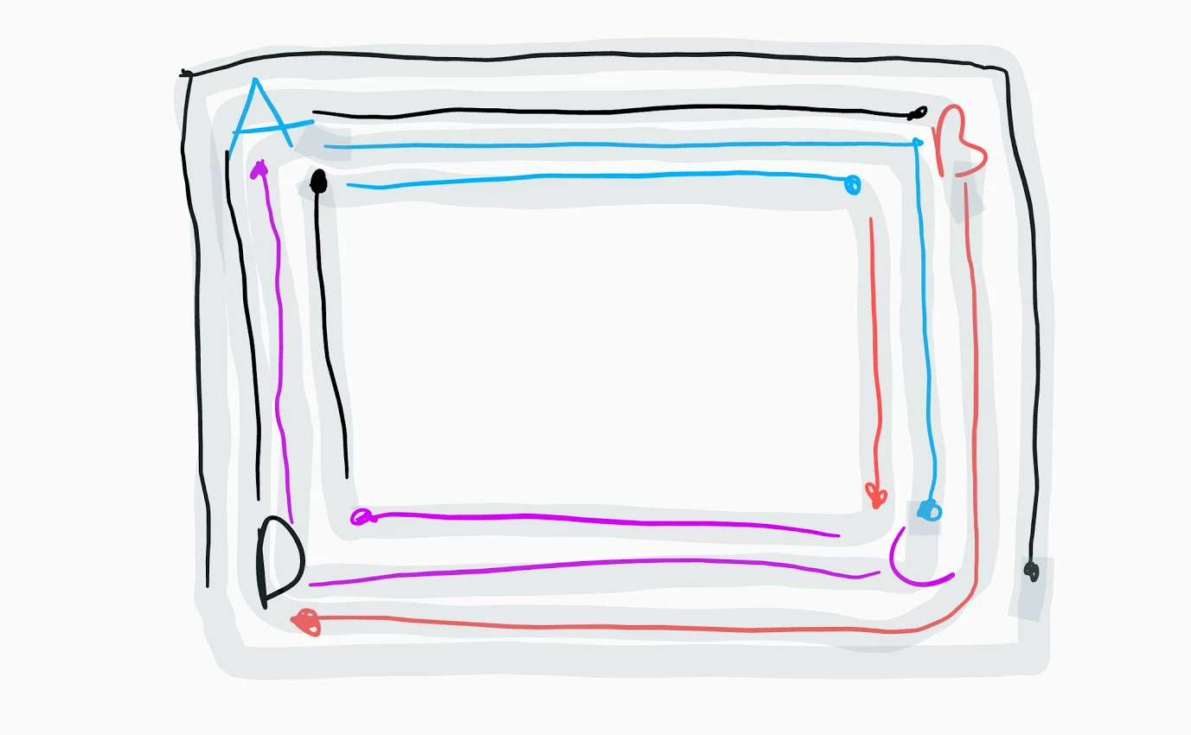

With all connections linking to A and C there would be at maximum 8 connections.

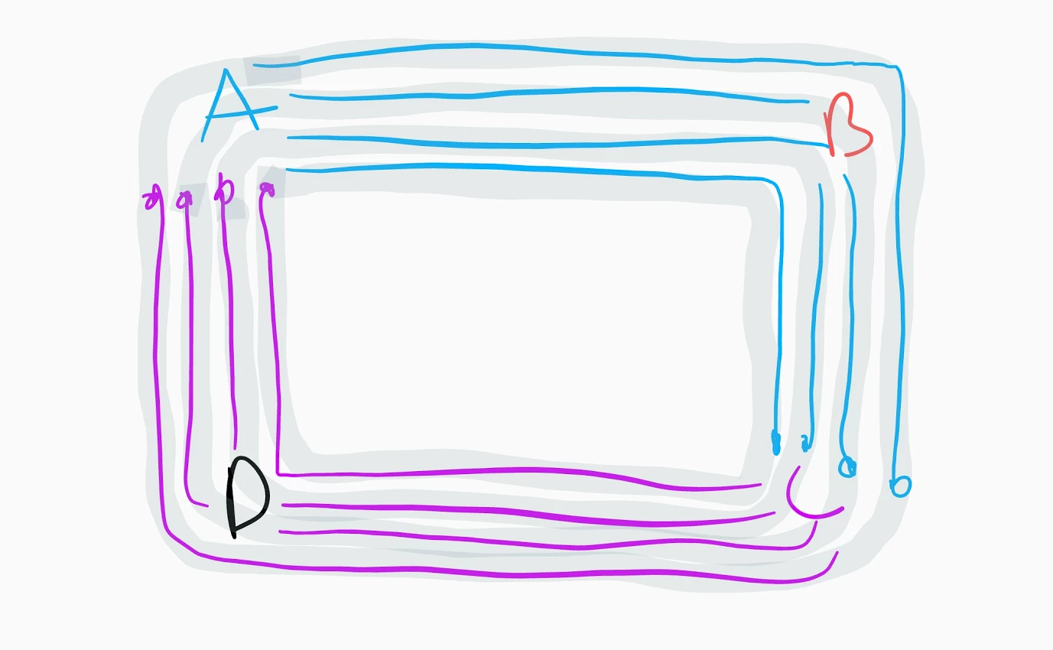

No, the most connections that A - C and B - D can have each is 2.

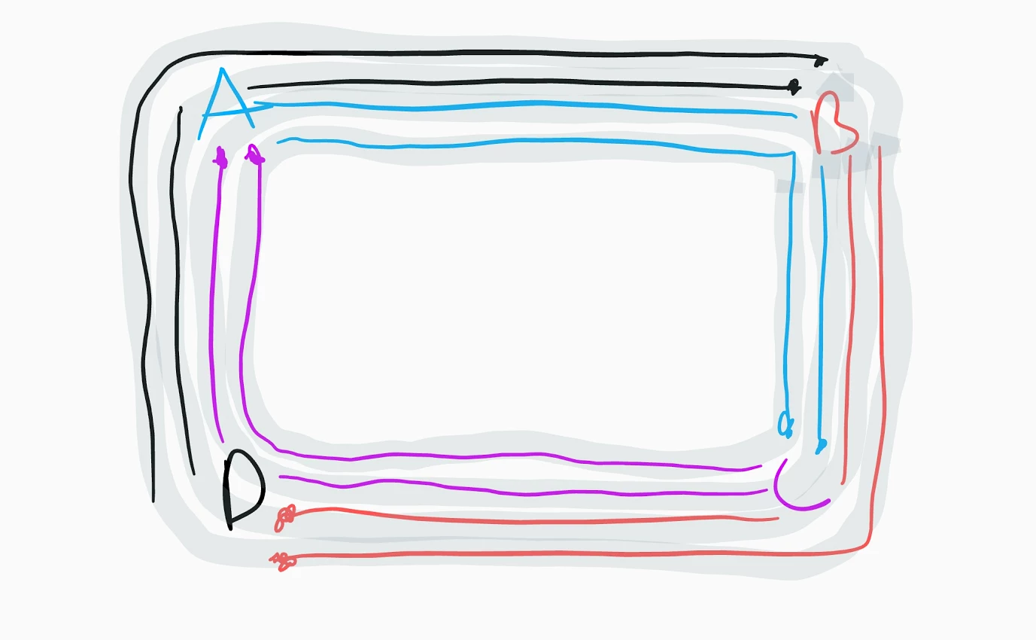

**P6 -**

1. **;** ignoring
2. At the last bit of information has just entered the link.
3. The first bit of information would be waiting at **Host B** for the rest of the bits in the packet.
4. The bits would be queued up at **Host A** waiting to transfer on the link.

**P7 -**

17.224ms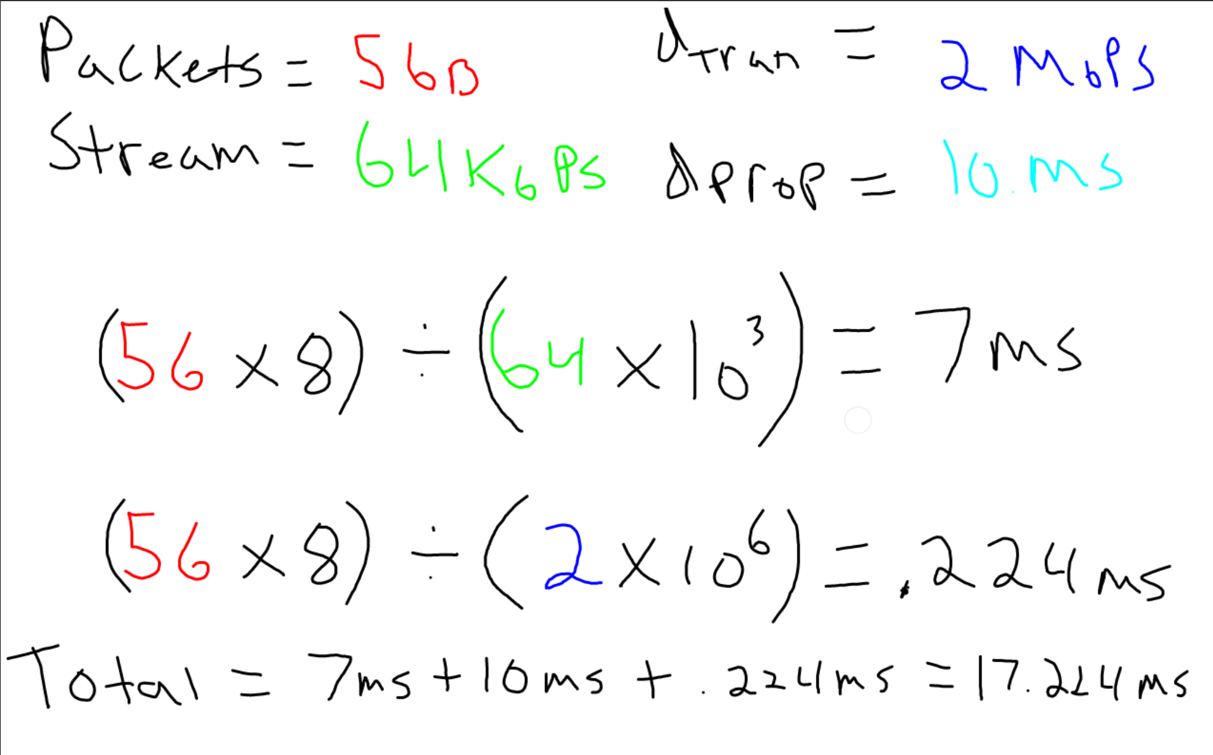

**P10 -**

**P11 -**

**P18 -**

|  |  |  |  |
| --- | --- | --- | --- |
|  | 1st 4PM | 2nd 6PM | 3rd 8PM |
| STD (ms) | 11.98323 | 11.31656 | 10.809 |
| AVG (ms) | 24.98731818 | 22.07584848 | 25.45681818 |

1. In all three of the tests there were exactly 11 hops each.
2. There were 7 different ISP on this route. The time to transfer to the other ISPs does not seem to be where the greatest delays are. The delays are pretty similar with a normal distribution.
3. The “local” was clearly much faster but I was surprised that the international one did not require more hops. It actually took one less that when I pinged Nytimes.com. The round trip delay crossing the ocean from California to Japan took approximately 1883.720 ms which was much greater than anything you would find in the local continent.

|  |  |
| --- | --- |
| STD (ms) | 565.71715 |
| AVG (ms) | 263.5946 |

**P29 -**

**P30 -**

Headers could relate to the airplane analogy during the airplane routing stages. Headers determine where the packet should go next just like airplane routing.