Phase I Source Code Report
CMSC 495 Capstone Project Group 4

Team Members
Welsh, Gavyn
Maxey, Brandon
Smith, Natquane
Rogers, Eric

1. Introduction
For our Phase I of the Class Registration System, our capstone project for UMGC CMSC 495 we got the development environment set up, built out the core features, wrote our unit tests, and made sure we documented everything as we went. The system we put together lets students create accounts, log in securely, search for courses, enroll in or drop them, and check their schedule, and we make sure all input gets validated before anything hits the database so we're not dealing with bad or incomplete data. By the end of Phase I we had the core architecture in place, all the main workflows running and tested, and the rest of this report breaks down how we set everything up, the design decisions we made, how we built each feature, our test results, how we handled documentation, and what we're looking at for the next phase.
2. Project Overview
The Class Registration System is designed to replicate the core functionality of a university course-registration portal.
Project Goals
- Develop a user-friendly GUI that allows students to securely create accounts by entering their name, phone number, email address, and other required profile information.
- Enable students to search for available courses, enroll in classes, and view their current schedule through the registration system.
- Implement middleware input validation between the frontend and backend to prevent invalid or incomplete data from being submitted to the database.
- Deliver a fully functional registration application with backend database connectivity, complete source code, and supporting project documentation.
- Produce system documentation including design diagrams, testing results, installation instructions, and a user guide for operating the system.
- Maintain the project through a Git repository to support version control and team collaboration throughout development.
- Present a live demonstration of the completed system to clients, stakeholders, and the instructor showcasing the registration process, enrollment features, schedule management, and overall application functionality.

Technologies Used

Technology | Purpose | Version
Python | Backend application logic | 3.x
Flask | Web framework / routing | Latest
SQLite | Relational database | Built-in
HTML/CSS | Frontend templates (Pico.css) | CDN
Git | Version control | Latest
GitHub | Remote repository hosting

3. Project Setup
We went with Flask over a heavier framework like Django because our project scope didn't need an ORM or admin panel out of the box, and Flask let us keep the structure lean and easy to follow for the whole team. SQLite made sense for Phase I since we're not dealing with concurrent users yet and it runs without any server setup, which kept the environment simple across different machines.

Set Up Instructions:
- Install Python 3 from python.org.
- Clone the repository: git clone https://github.com/metersploit/CMSC495.git
- Navigate to the src/ directory.
- Install dependencies: pip install -r requirements.txt
- Build the database (one-time): python3 db/build_db.py
- Seed sample data: python3 seed.py
- Start the development server: python3 app.py
- Open http://127.0.0.1:5000 in a browser.

Repository Structure:

src/ (project root — run all commands from here)
├── app.py Flask routes (the web UI)
├── seed.py inserts sample courses + a test student
├── requirements.txt Python dependencies (Flask)
├── templates/ HTML pages rendered by Flask
│ ├── base.html
│ ├── register.html
│ ├── login.html
│ ├── courses.html
│ └── schedule.html
├── models/ data objects shared across layers
├── db/ database connection, schema builder, the .db file
├── dao/ data-access layer (CRUD)
├── service/ backend business logic
├── validator/ input-validation middleware
└── ui/ abstract View

4. Software Architecture and Design
For our software architecture we went with a layered design that keeps everything separated by responsibility, meaning each layer has one job and a request moves through all of them in order from the browser down to the database and back up. The way we set it up, no layer gets skipped, so raw user input never touches the database without going through validation and business logic checks first. Here is a breakdown of each layer and what it handles:
- Browser / Templates: Renders HTML using Jinja2 templates and sends form data via HTTP POST.
- Flask Routes (app.py): Receives HTTP requests, extracts form data, delegates to the Validator, and renders the appropriate template back to the user.
- Validator: Checks that all required fields are present and formatted correctly. If something is off it throws a ValidationError with a map of which fields failed and why.|
- BackendController (Service): Handles the business rules like seat capacity checks, duplicate enrollment prevention, and password hashing. Throws a RegistrationError if anything on that end fails.
- DAO Layer: Executes the actual SQL queries against SQLite. Write operations don't commit on their own since the service layer owns the transaction boundary.
- SQLite Database: Stores all students, courses, and enrollments. The schema enforces a UNIQUE constraint on student and course combinations and a NOT NULL DEFAULT 0 counter for available seats.
The following diagram illustrates how a request flows through each layer:
Browser (HTML Templates)
↓ HTTP Request / HTTP Response ↑
Flask Routes (app.py)
↓
Validator (input validation)
↓
BackendController (business logic)
↓
DAO Layer (SQL queries)
↓
SQLite Database

5. Core Functionality Implementation
For Phase I we got all five core user workflows built out and working. Each one is accessible through the Flask web interface and runs through our full validation, service, and DAO pipeline.

User Registration
For registration, new students fill out a form with their name, email address, and password. Our Validator checks that all the fields are filled in, the email is properly formatted, and that it hasn't already been registered. Before anything gets stored the BackendController hashes the password using a secure hashing function. If anything fails validation the form gets re-rendered with error messages pointing to the specific fields that need to be fixed.

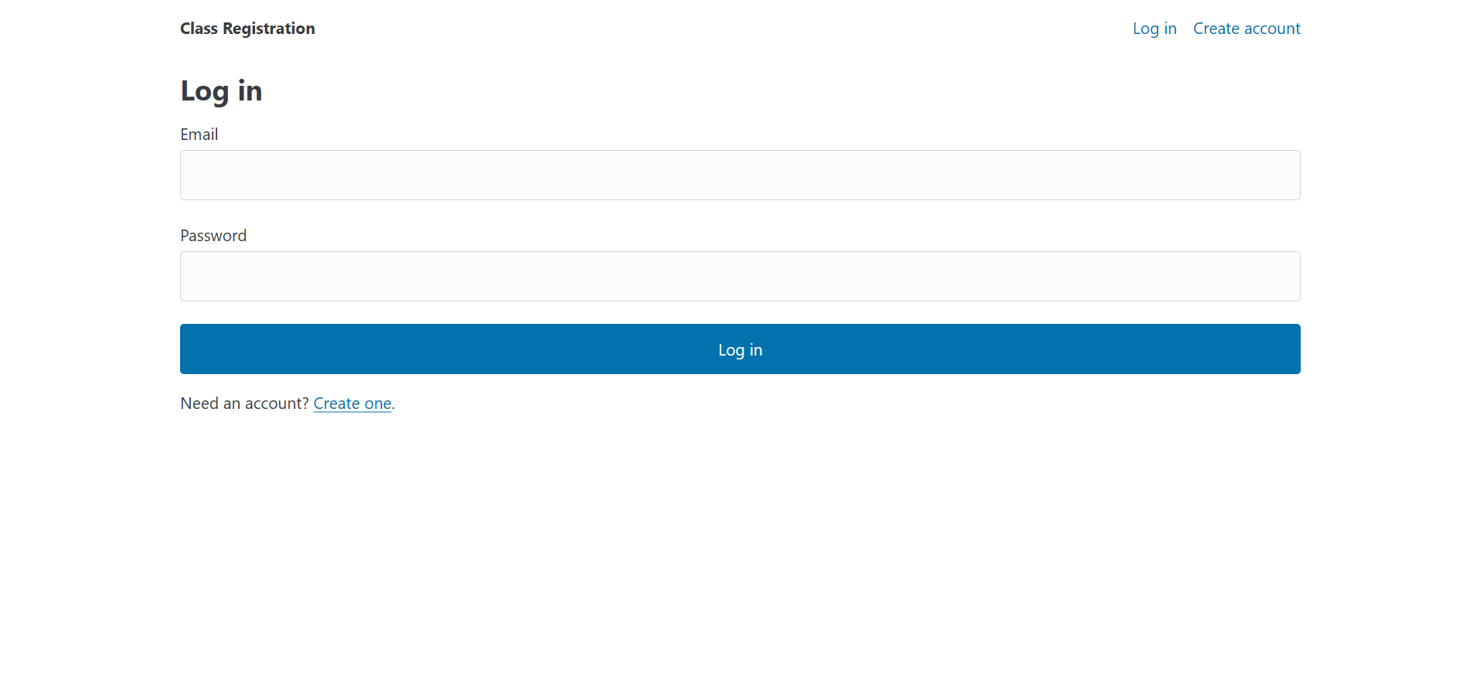
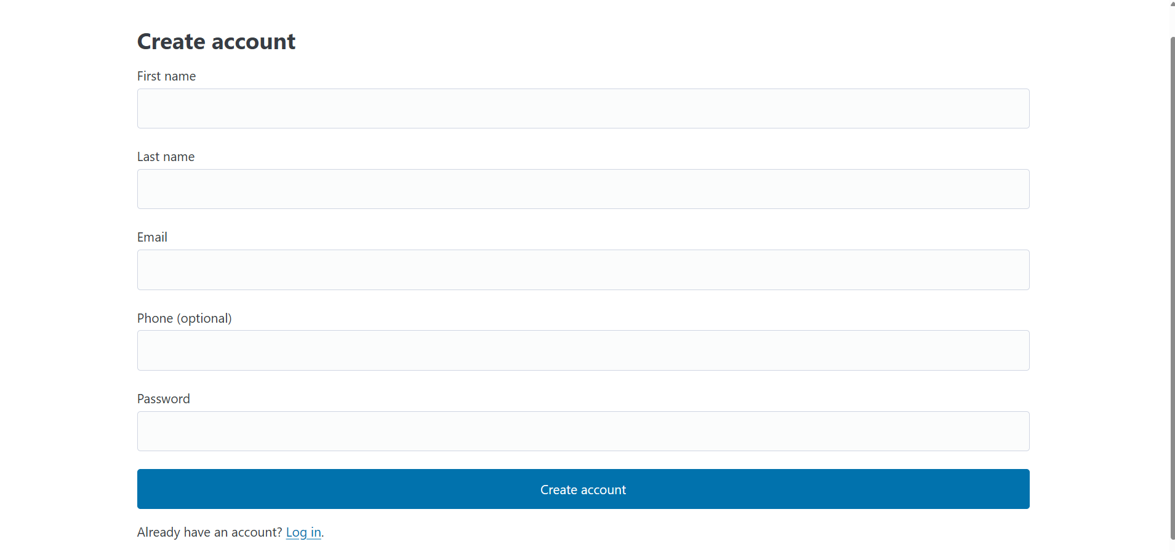
User Login and Authentication
For login, students enter their email and password. The Validator makes sure both fields are there, then the BackendController pulls the stored password hash for that email and checks it against what the student submitted. If it matches, we store the student's ID in the Flask session and send them to the course listing. If it doesn't, we show a generic error message on purpose so we're not giving away whether an email is registered or not.

Course Search and Enrollment
Once logged in, students can browse or search the course catalog. Each course shows the title, credits, instructor, schedule, and how many seats are still available. When a student tries to enroll, the BackendController checks that there are open seats and that they aren't already enrolled in that course. If either of those checks fails it throws a RegistrationError and shows an error message. If everything looks good, the enrollment gets recorded and the seat count is decremented all within a single transaction.

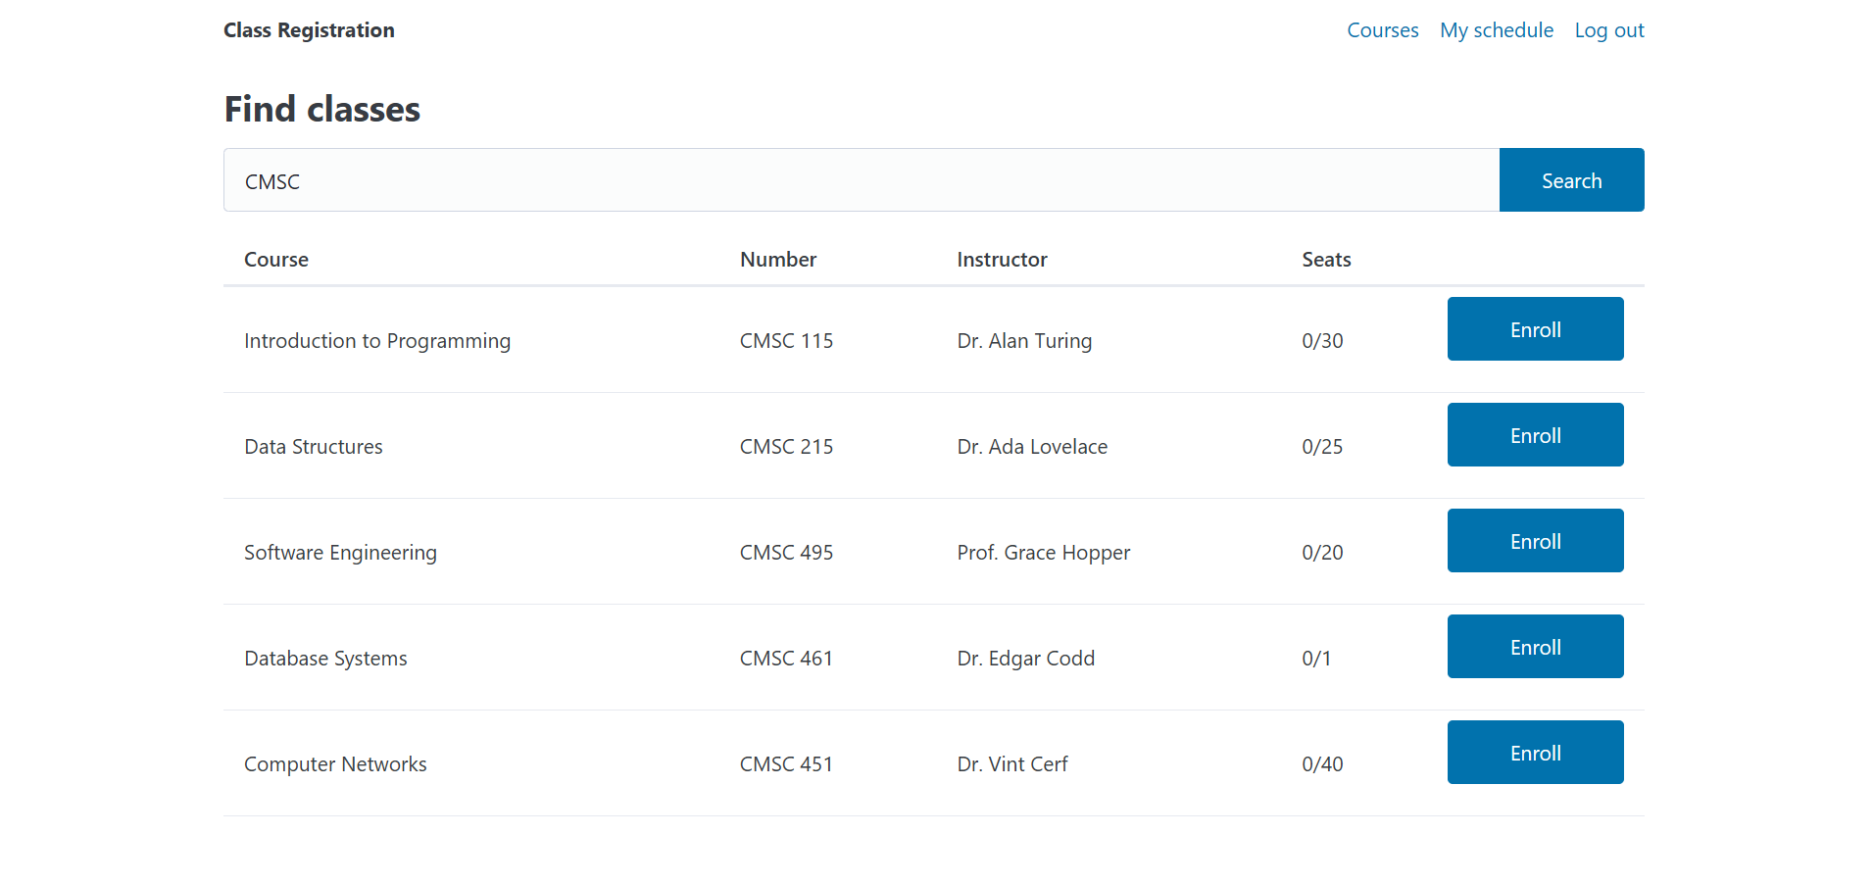
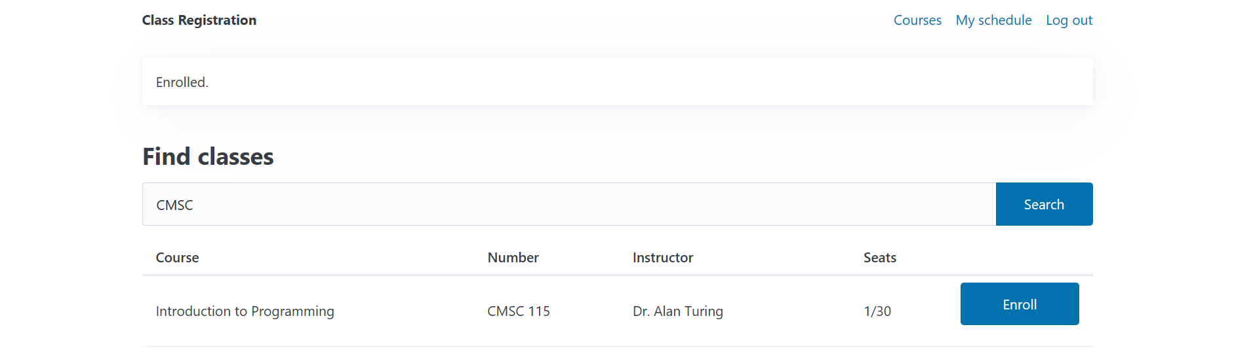

Course Drop
Students can drop any course from their schedule. When they do, we remove the enrollment record and increment the seat count back up, and we do both of those in a single transaction to keep everything consistent. The updated schedule shows up right away after the drop goes through.

Schedule View
The schedule page pulls up every course the logged-in student is currently enrolled in. We get that data through EnrollmentDAO.find_by_student(), which joins the enrollments and courses tables together. Each row shows the course title, credits, instructor, meeting days and times, and a Drop button in case they want to remove it.

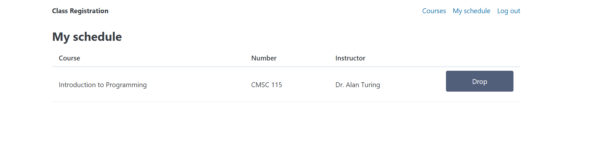
6. Unit Testing
For unit testing we tested each layer of the system separately so we could pinpoint exactly where something went wrong without other parts getting in the way. We used Python's built-in unittest framework and focused on three main areas: input validation in the Validator layer, business rule enforcement in the BackendController, and data access operations in the DAO layer using an in-memory SQLite database. The Flask web layer was left out of Phase I unit testing, routes mix HTTP handling with business logic in a way thats better validated end-to-end rather than in isolation, so we made a deliberate call to save that for integration testing in Phase II once the full workflows are locked in.
Validator Tests We made sure the Validator correctly blocks bad or incomplete input before it touches the database. We tested things like a missing email on registration, a password that's too short, and a blank username on login. Every case came back with the right ValidationError.
Service Layer Tests We tested that the BackendController enforces our business rules correctly. Enrolling in a full course throws a RegistrationError, duplicate enrollments get blocked before hitting the database, and password hashing works correctly end to end.
DAO and Database Tests For DAO testing we used an in-memory SQLite database built from the same schema we use in production. We tested inserting and retrieving student records, keyword course searches, schedule retrieval after enrollment, and confirmed the UNIQUE constraint rejects duplicate enrollment rows at the SQL level.

Test Results
# | Test Case | Input | Expected Output | Actual Output | Pass/Fail
1 | Register – missing email | Email: (blank), Password: Test123! | ValidationError: field='email' | ValidationError raised | ✅ Pass
2 | Register – short password | Email: test@umgc.edu, Password: abc | ValidationError: field='password' | ValidationError raised | ✅ Pass
3 | Login – empty username | Email: (blank), Password: Test123! | ValidationError: field='email' | ValidationError raised | ✅ Pass
4 | Enroll in full course | student_id: 1, course_id: 3 (0 seats) | RegistrationError raised | RegistrationError raised | ✅ Pass
5 | Duplicate enrollment | student_id: 1, course_id: 2 (already enrolled) | RegistrationError raised | RegistrationError raised | ✅ Pass
6 | Password hash round-trip | Password: Test123! | verify_password() returns True | True returned | ✅ Pass
7 | Insert / find student by email | Email: new@umgc.edu | Correct Student object returned | Correct record returned | ✅ Pass
8 | Course keyword search | Keyword: "CMSC" | Matching courses returned | Correct results returned | ✅ Pass
9 | find_by_student after enroll | student_id: 1, course_id: 2 (enrolled) | List includes enrolled course | Correct list returned | ✅ Pass
10 | DB rejects duplicate row | Insert enrollment (1, 2) twice | IntegrityError raised | IntegrityError raised | ✅ Pass

7. Documentation
We treated documentation as a real deliverable throughout Phase I and kept both internal and external docs up to date alongside the source code the whole way through.
Internal Documentation Every module, class, and public method has a docstring covering what it does, what it takes in, and what it returns or throws. For example, the enroll() method in BackendController is documented like this:
def enroll(self, student_id: int, course_id: int) -> None:
"""
Enrolls a student in a course after validating seat availability
and checking for duplicate enrollment.

Args:
student_id: The ID of the student enrolling.
course_id: The ID of the course to enroll in.

Raises:
RegistrationError: If the course is full or the student
is already enrolled.

Note:
Caller is responsible for committing the transaction.
"""
We kept inline comments minimal and only added them where the reasoning behind a design decision wasn't obvious from the code itself. The standards we stuck to as a team were:
- Google-style docstrings on all public classes and methods
- Module-level docstrings describing each file's role in the architecture
- Consistent naming using snake_case for variables and functions and PascalCase for classes
- No magic numbers, using named constants for things like minimum password length instead
External Documentation Our README.md covers everything someone would need to get the app running including the required commands, the project directory layout, test login credentials, and platform notes like the macOS port conflict on port 5000. We also put together a database schema doc, a step-by-step installation guide, and an architecture overview that is included in this report.

8. Collaboration and Version Control
We used Git and GitHub to manage our code and keep everyone on the same page throughout Phase I. Everything including source code, documentation, and config files is tracked at https://github.com/metersploit/CMSC495.git

Repository and Branch Strategy We committed everything to the main branch during Phase I and each team member was assigned specific modules to work on like the validator, service, DAO, or templates. We committed frequently to keep a clear history of progress and kept our commit messages consistent using short descriptions of what changed, something like "Add capacity check to enroll service" or "Fix email validation regex." For Phase II we are planning to move to a feature branch workflow where each new feature gets its own branch and gets merged into main through a pull request after a teammate reviews it.
Code Review For Phase I we kept code review informal through pair walkthroughs and group discussions. We checked each other's work to make sure we were following our naming conventions and docstring standards and flagged anything that looked like it was skipping the validation layer. Anything that came up in review got fixed before it was committed to main.

9. Future Goals
Phase I got the core workflows and architecture in place and Phase II is where we plan to build on top of that. Here is what we are looking at adding:
- Advanced course search: filtering by day, time, instructor, and credits — the current keyword search works but students have already asked for more control over results.
- Better security: CSRF protection on forms, rate limiting on login, and moving the secret key out of the source code and into environment variables.
- Integration testing: end-to-end tests using Flask's test client to cover the full request/response cycle, which we punted on this phase.
- UI improvements: the frontend does the job but its pretty bare, we want to do a proper redesign in Phase II with a more responsive layout.
- Expanded validation: more edge cases, stricter formatting rules, and clearer error messages. Some of the current ones are a bit vague.
10. Conclusion
For our Phase I testing we got a fully working and tested foundation built out, the development environment is set up and documented, and all five core workflows including registration, login, course search, enrollment, drop, and schedule view are up and running the way we wanted them to. All ten unit tests passed, every layer is behaving correctly, and we kept our documentation clean and consistent the whole way through.
Going into Phase II we feel good about where things are at. The way we structured the architecture means we can keep adding features without touching what we already have tested and working, and we are looking forward to building on everything we put together in Phase I.

References:
Flask development team. (2024). Flask documentation (3.x). Pallets Projects. https://flask.palletsprojects.com/

Python Software Foundation. (2024). Python 3 documentation. https://docs.python.org/3/

SQLite Consortium. (2024). SQLite documentation. https://www.sqlite.org/docs.html

PicoCSS. (2024). Pico CSS — minimal CSS framework for semantic HTML. https://picocss.com/

