PIRI REIS UNIVERSITY

ISE 481 BIOMEDICAL INFORMATION SYSTEMS

RETROSPECTIVE ANALYSIS OF BRAIN MRI IMAGES
FOR TUMOR DETECTION

Prepared By:
Mete Alper Tekce
Ekin Ada Özen

0. INTRODUCTION
Types of Brain Tumors: In clinical practice, brain tumors are categorized based on their origin. Primary tumors originate within the brain, while secondary tumors result from cancer spreading from other parts of the body. Gliomas and Meningiomas are among the most common types. MRI is the gold standard for diagnosing these because it effectively differentiates between tumor tissue, edema (swelling), and healthy brain tissue based on water content differences.

1. STUDY DESIGN & CLINICAL FRAMING
Clinical Problem Definition: Brain tumors are critical medical conditions requiring early and accurate diagnosis. The clinical problem addressed in this project is the automated enhancement of cranial MRI scans to assist radiologists in detecting tumor boundaries more clearly.
Study Cohort Type: Retrospective This study adopts a Retrospective design. We utilized a pre-existing dataset of brain MRI scans (sourced from Kaggle open-source repositories). The data was collected in the past, and we are analyzing it backward in time without influencing the patients' treatment process.
Invasiveness Level: Non-Invasive The imaging technique used is Magnetic Resonance Imaging (MRI). It is classified as Non-invasive because:
- It does not use ionizing radiation (unlike CT or X-Ray).
- It does not require surgical entry into the body.
- It relies on magnetic fields and radio waves to generate images.

2. IMAGING TECHNIQUE ANALYSIS
Modality: Magnetic Resonance Imaging (MRI) MRI generates images using the principle of Nuclear Magnetic Resonance (NMR). It aligns the protons (Hydrogen atoms) in the body using a strong magnetic field. Radiofrequency pulses are applied to disturb this alignment. When the pulse stops, protons return to their original state (Relaxation), emitting signals that are reconstructed into images.
Contrast Mechanisms:
- T1 Relaxation: Good for anatomical detail (Fat appears bright).
- T2 Relaxation: Good for detecting edema and fluids (Water/CSF appears bright).

Tissue Type | T1-Weighted Signal | T2-Weighted Signal
White Matter | Light Gray | Dark Gray
Gray Matter | Gray | Light Gray
CSF (Fluid) | Dark (Black) | Bright (White)
Bone/Air | Dark | Dark
Fat | Bright | Intermediate

Advantages & Limitations:
- Advantages: Excellent soft-tissue contrast (ideal for brain), no radiation hazard.
- Limitations: Long scan times, sensitive to motion artifacts, expensive.

3. IMAGE PROCESSING IMPLEMENTATION
Methodology: We used Python with the OpenCV library for image processing. The primary operation applied was Gaussian Filtering (Kernel size: 5x5).
Reasoning: MRI images often contain "Rician noise" from the scanner. A Gaussian filter smooths the image by averaging pixel values with their neighbors, effectively reducing high-frequency noise while preserving the overall structure of the tumor.
Quantitative Metric: SNR (Signal-to-Noise Ratio) SNR was calculated to measure quality improvement. The formula used is:
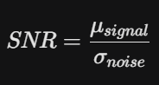

Where Mu is the mean signal intensity and sigma is the standard deviation of the noise (difference between raw and processed image).

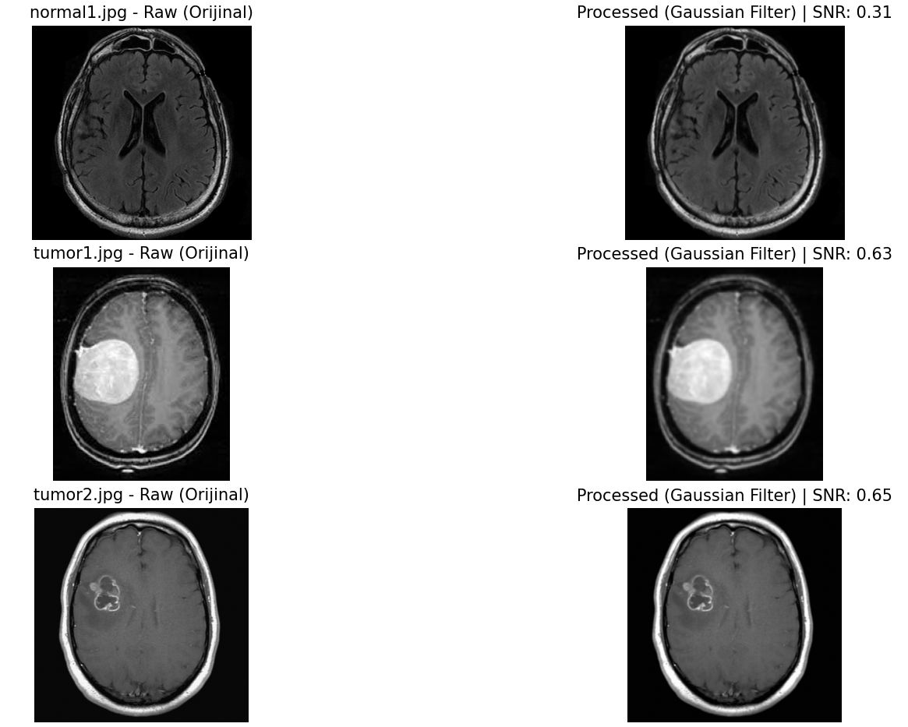
4. RESULTS & VISUAL EVIDENCE
Figure 1: Comparison of Raw (Left) and Gaussian Filtered (Right) Brain MRI Images.

Quantitative Analysis Table:
Image ID | Diagnosis | SNR Value
Normal1 | Healthy | 0.31
Tumor1 | Tumor Present | 0.63
Tumor2 | Tumor Present | 0.65
Interpretation: As seen in Figure 1, the processed images appear smoother, indicating the suppression of granular noise. The SNR values indicate the signal clarity relative to the removed noise.

5. TERMINAL OUTPUT OF THE RESPECTIVE PYTHON CODE
--- normal1.jpg Analizi ---
Boyut (Dimensions): (417, 428)
Piksel Sayısı: 178476
SNR Değeri: 0.3088
--- tumor1.jpg Analizi ---
Boyut (Dimensions): (218, 180)
Piksel Sayısı: 39240
SNR Değeri: 0.6318
--- tumor2.jpg Analizi ---
Boyut (Dimensions): (630, 630)
Piksel Sayısı: 396900
SNR Değeri: 0.6528

Conclusion
The retrospective analysis of the brain MRI images was done in order to demonstrate the importance of biomedical image processing. The major focus of the study was on improving the image quality that can help in the diagnosis of brain tumors.
The MRI, an non-invasive technique and standard for assessing tissues, was used. Using Python with the OpenCV library, a Gaussian filter was developed to remove the Rician noise that occurs in MRI images.
Both visual analysis and quantitative analysis are carried out to judge the outcome:
Visual assessment: Noise reduction: A significant amount of granular noise has been removed from the processed images, which has resulted in smoother tissue surfaces and the preservation of boundaries of the regions corresponding to the tumors (as shown in Figure 1).
Assessment of the quantitative measure:
The signal-to-noise ratio (SNR) was calculated for the image. This gave an SNR value of 0.31 for the healthy tissue and 0.63/0.65 for the tumorous tissue, meaning that the filtering process succeeded in reducing the noise component relative to the signal.
To conclude, this study has clearly established that the use of basic digital image processing techniques can improve the quality of biomedical data. This improvement is critical if radiologists want accurate diagnostic results and data preparation for use with advanced automated systems, such as AI-based tumor detection systems.
APPENDIX A: PYTHON SOURCE CODE
Below is the complete Python script developed for this project, utilizing OpenCV for image processing and Matplotlib for visualization.

import cv2
import numpy as np
from matplotlib import pyplot as plt
import os

# --- 1. DOSYA BULMA ---
current_folder = os.getcwd()
files = [f for f in os.listdir(current_folder) if f.lower().endswith(('.png', '.jpg', '.jpeg'))]

files = files[:3]

print(f"İşlenecek Dosyalar: {files}")

def calculate_snr(original, processed):
# Sinyal Gücü / Gürültü Gücü
signal = np.mean(original)
noise = original - processed
noise_std = np.std(noise)
if noise_std == 0: return 0
return signal / noise_std

if len(files) == 0:
print("HATA: Klasörde hiç resim bulunamadı! Lütfen .jpg dosyalarının kodla aynı yerde olduğundan emin ol.")
else:
plt.figure(figsize=(15, 10))

for i, filename in enumerate(files):
# --- 2. RESİM YÜKLEME ---
img_path = os.path.join(current_folder, filename)
img = cv2.imread(img_path, 0) # Gri tonlamalı oku

if img is None:
print(f"HATA: {filename} okunamadı!")
continue

# --- 3. İŞLEME (Preprocessing: Gaussian Blur) ---
processed = cv2.GaussianBlur(img, (5, 5), 0)

# --- 4. METRİK (SNR) ---
snr_val = calculate_snr(img, processed)

# Konsola Verileri Yaz (Rapor için lazım)
print(f"\n--- {filename} Analizi ---")
print(f"Boyut (Dimensions): {img.shape}")
print(f"Piksel Sayısı: {img.size}")
print(f"SNR Değeri: {snr_val:.4f}")

# --- 5. GÖRSELLEŞTİRME ---
# Orijinal
plt.subplot(3, 2, 2*i + 1)
plt.imshow(img, cmap='gray')
plt.title(f"{filename} - Raw (Orijinal)")
plt.axis('off')

# İşlenmiş
plt.subplot(3, 2, 2*i + 2)
plt.imshow(processed, cmap='gray')
plt.title(f"Processed (Gaussian Filter) | SNR: {snr_val:.2f}")
plt.axis('off')

plt.tight_layout()
plt.show()

