

DSA 210
Climate Effects on Global Coffee Prices
Project Report
Mete Yılmazbaş
34349
Date: 01.09.2026

Instructor
Özgür Asar

1. Introduction & Motivation
Coffee is one of the most widely traded agricultural commodities and a critical export product for many tropical economies. Coffee production is highly sensitive to climatic conditions, particularly temperature changes, which can directly affect crop yield, quality, and long-term sustainability. In recent decades, climate change has introduced increasing uncertainty into agricultural markets, raising concerns about price volatility and supply stability.
The motivation of this project is to investigate whether climate-related factors, together with production dynamics, play a measurable role in determining coffee prices in major producer countries. Understanding this relationship is important not only from an economic perspective but also for anticipating the long-term impacts of climate variability on global commodity markets.
This study focuses on three major coffee-producing countries — Brazil, Colombia, and Indonesia — and examines how average annual temperature and production volumes are associated with coffee price movements between 1996 and 2024.

2. Research Questions
The project addresses the following research questions:
- How do changes in average temperature affect coffee prices in major producer countries?
- Does coffee production volume have a significant relationship with coffee prices?
- Can coffee prices be modeled as a function of climate and production variables using a supervised learning regression approach?

3. Hypotheses
Null Hypothesis (H₀):
Average temperature and coffee production do not have a statistically significant effect on coffee prices in producer countries.
Alternative Hypothesis (H₁):
Changes in average temperature and coffee production significantly influence coffee prices in producer countries.

4. Data Sources
The datasets used in this project are summarized below:
Data Type | Source | Time Range
Coffee Production | FAOSTAT | 1996–2024
Coffee Prices (Brazil) | CECAFÉ / CEPEA-ESALQ | 1996–2024
Coffee Prices (Colombia) | Federación Nacional de Cafeteros | 1996–2024
Coffee Prices (Indonesia) | CEIC / Wholesale Price Index | 1996–2024
Climate Data (Temperature) | Berkeley Earth | 1950–2024
All datasets were aggregated to annual frequency to ensure consistency across sources.

5. Data Collection & Preparation
Raw datasets were collected from multiple sources in different formats (Excel and CSV). Several preprocessing steps were applied to ensure data quality and alignment:
- Climate data were extracted from structured Excel files and converted into numeric annual average temperature values.
- Coffee price datasets with heterogeneous formats were standardized into a common structure.
- FAOSTAT production data were filtered to include only coffee production for the selected countries.
- All datasets were restricted to the common time interval 1996–2024.
- Datasets were merged using Year and Country as keys.
After preprocessing, a clean yearly panel dataset was obtained, containing the following variables:
- Year
- Country
- Coffee price
- Coffee production (tons)
- Average annual temperature (°C)

6. Exploratory Data Analysis (EDA)
6.1 Summary Statistics
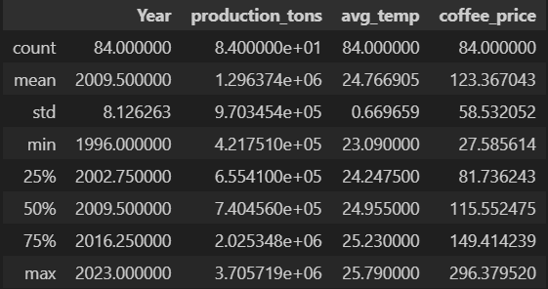
This table summarizes the central tendencies and dispersion of coffee prices, production levels, and temperature across countries.
6.2 Temporal Trends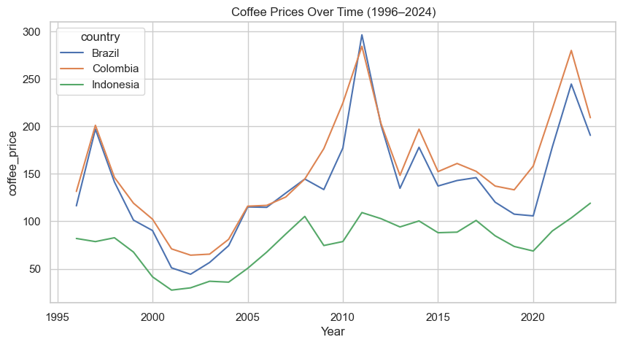 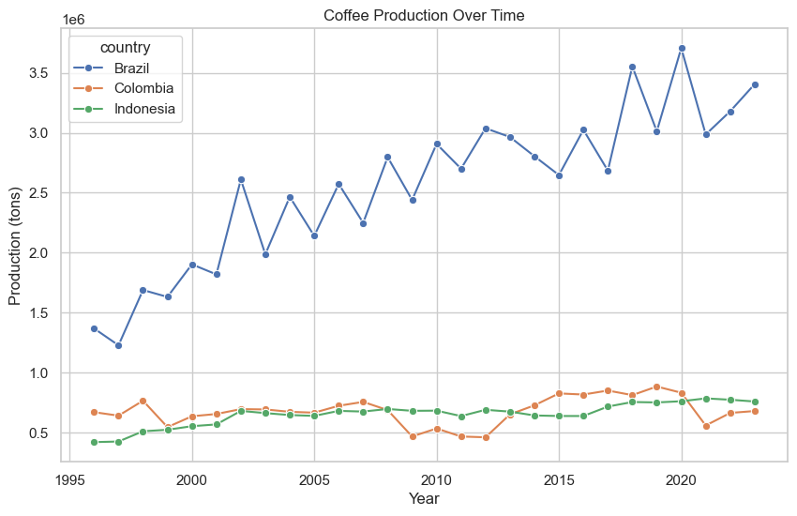
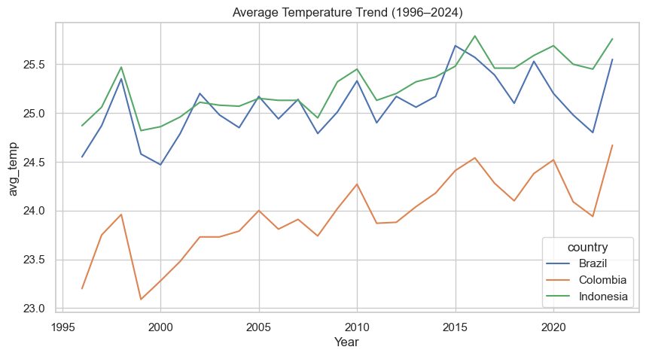
These visualizations reveal strong price volatility, country-specific production patterns, and a gradual upward trend in average temperature consistent with long-term climate change.

6.3 Relationship Exploration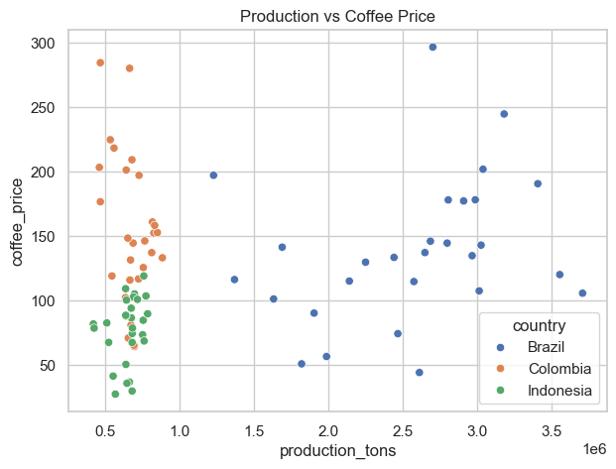 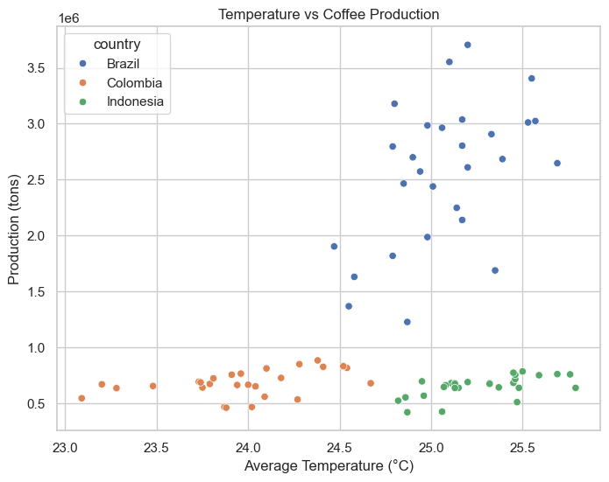
Scatter plots are used to explore the relationship between coffee production and coffee prices. Figure 2 illustrates the relationship between average annual temperature and coffee production. The scatter plot suggests heterogeneous patterns across countries, indicating that temperature effects on production differ by regional and structural characteristics.
7. Methodology
7.1 Problem Formulation
The analysis is formulated as a supervised learning regression problem, where the objective is to model coffee prices using climate and production-related variables.
- Target variable: Coffee price
- Input features:
  - Coffee production (tons)
  - Average annual temperature (°C)
Given the continuous nature of the target variable, a linear regression model is appropriate.

7.2 Model Specification
An Ordinary Least Squares (OLS) regression model is used:
$$\text{Coffee} \text{Price}=β_{0}+β_{1}(\text{Production})+β_{2}(\text{Average Temperature})+ϵ$$
The model is estimated using pooled data from all three countries.
8. Machine Learning Analysis & Results
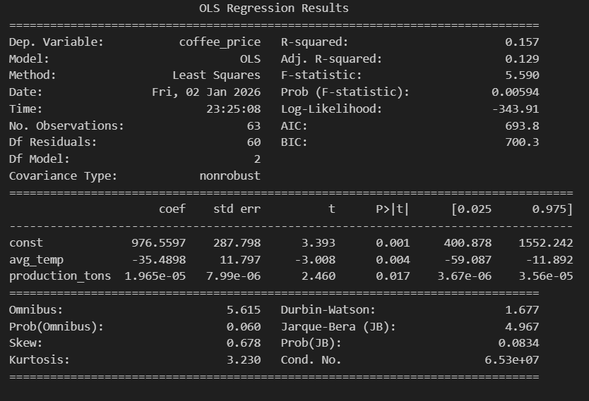
- R² = 0.157
- Production coefficient: positive and statistically significant
- Temperature coefficient: negative and statistically significant
Interpretation
The pooled regression results indicate that both production and temperature are statistically significant predictors of coffee prices. Higher production levels are associated with higher prices, while increases in average temperature are associated with lower prices, suggesting climate-related stress effects on supply conditions.

8.1 Country-Level Analysis (Robustness Check)
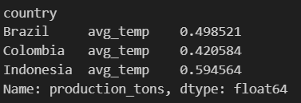
This table reports the correlation between average annual temperature and coffee production for Brazil, Colombia, and Indonesia over the period 1996–2024. The results indicate a moderate positive correlation in all three countries. The strongest association is observed in Indonesia (r ≈ 0.59), followed by Brazil (r ≈ 0.50) and Colombia (r ≈ 0.42).
These findings suggest that higher average temperatures are associated with higher levels of coffee production during the observed period. However, the magnitude of the relationship varies across countries, highlighting the role of country-specific climatic, agronomic, and structural factors.

9. Model Diagnostics & Visualization
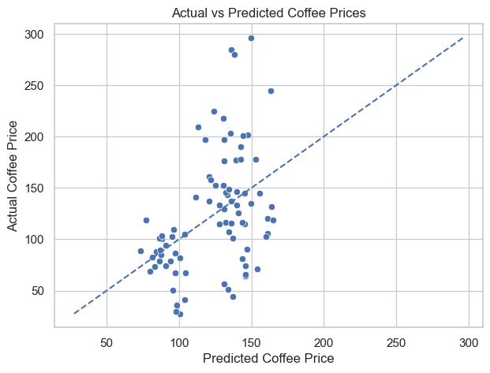
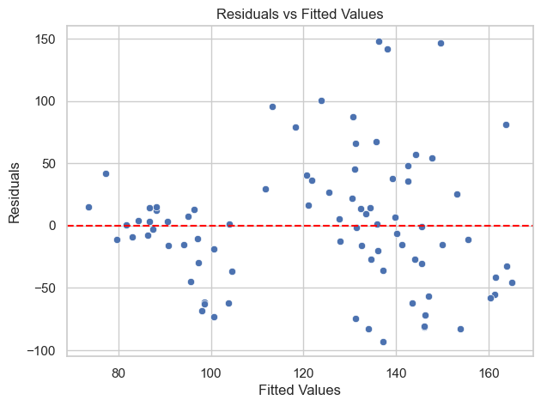
These diagnostics confirm that the model captures meaningful structure in the data, although unexplained variability remains due to unobserved market factors.
10. Key Findings
- Coffee prices exhibit substantial volatility across time and countries.
- Average temperature has a statistically significant relationship with coffee prices.
- Production volume also contributes to price dynamics.
- Climate impacts are not uniform across countries, with Colombia showing the strongest sensitivity.

11. Limitations & Future Work
Limitations
- Annual aggregation may mask short-term climate shocks.
- The linear model cannot capture nonlinear climate effects.
- Other relevant factors (exchange rates, global demand, policy interventions) are not included.
Future Work
- Incorporating rainfall and extreme weather indicators.
- Applying nonlinear or tree-based machine learning models.
- Extending the analysis to additional producer countries.

12. Conclusion
This project demonstrates that coffee prices can be partially explained by climate and production-related variables using a supervised learning regression framework. The findings support the hypothesis that climate variability plays an important role in shaping commodity price dynamics, while also highlighting significant country-level heterogeneity.

