
Exam Timetable Scheduling Using Genetic Algorithm
COMP338 — Introduction to Artificial Intelligence
Adam Khabisa | 1210475
Instructor: Dr. Radi Jarrar
(couldn't find any partners so worked alone — I talked with Dr. Radi in person and he allowed me to work alone given my situation)

Abstract
I implemented a Genetic Algorithm (GA) to assign 22 course exams to 18 time slots (6 days × 3 slots) for 95 students. The penalty function combines three hard and two soft constraints. With default parameters (population 100, mutation 0.05, tournament k=5), the penalty dropped from 15,050 (initial random best) to 1,000 after 500 generations — a 93.4% reduction. Both small (pop=50) and large (pop=200) populations converge to 950 in 300 generations; higher mutation (0.10) reaches 950.
1. Introduction
Exam timetabling is NP‑hard. For a small instance of 22 courses and 95 students, the search space is 18²² possibilities. An exhaustive search is impossible. I built a GA from scratch (no GA libraries) as required by the project. The algorithm finds a good schedule by evolving a population of candidate solutions over many generations.
2. Problem Description
2.1 Data
- 22 courses (from Course_Catalog).
- 95 students, each enrolled in 4–7 courses (481 enrolments total).
- 18 time slots: 6 days × 3 slots per day (09:00–11:00, 12:00–14:00, 15:00–17:00).
2.2 Chromosome
A schedule is a Python dictionary: {course_code: slot_id}. For example:
{"COMP2110": "D1S2", "COMP3320": "D3S1", ...}
2.3 Penalty Function
The fitness function returns the total penalty for a schedule — lower is better, zero is perfect.
ID | Type | Rule | Penalty
HC1 | Hard | Two courses in same slot with X shared students | shared_students × 1,000
HC2 | Hard | A student has >2 exams on one day | 800 per student
HC3 | Hard | A student has ≥4 exams over two consecutive days | 500 per student
SC1 | Soft | A student has exactly 2 exams on one day | 50 per student
SC2 | Soft | Total exam days used > 5 | 100 per extra day
Table 1. Penalty rules applied by the fitness function.
3. Genetic Algorithm Design
3.1 Initialisation
Each individual gets a random slot for every course. This creates a diverse starting population.
3.2 Selection — Tournament
I pick 5 random individuals and select the one with the lowest penalty. I return a copy.
3.3 Crossover — Single-Point
Given two parents and a fixed order of courses, I split at a random point. The child takes the first part from parent A and the second part from parent B.
3.4 Mutation
For each course, I change its slot with probability = mutation_rate. The new slot is chosen uniformly at random from all 18 slots.
3.5 Elitism
I copy the two best individuals unchanged to the next generation. This guarantees the best penalty never gets worse across generations.
3.6 Main GA Loop
For each generation:
- Compute penalty for all individuals.
- Update the global best if this generation improved.
- Keep the top two individuals unchanged (elitism).
- Fill the rest of the population by: selection → crossover → mutation.
- Replace the old population.
4. Implementation
I used Python 3.13, openpyxl (to read Excel), and matplotlib (plots). The GA logic is in core/evolve.py and does not depend on any GUI. The Tkinter UI (app.py) runs the GA in a background thread so the window stays responsive.
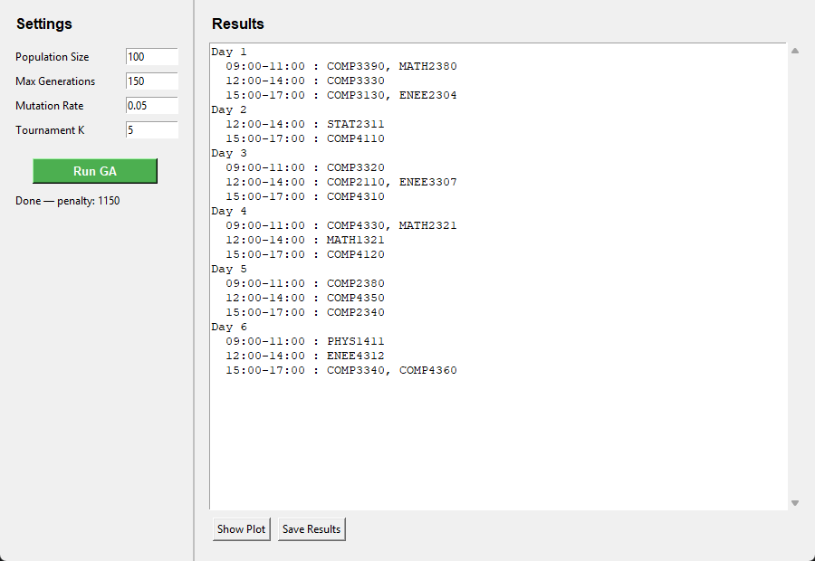
Figure 1. Exam Scheduler application window after a completed GA run (150 generations, pop = 100, penalty = 1,150).
5. Experimental Results
5.1 Fitness Test
The provided Sample_Bad_Schedule gave a penalty of 201,650. This confirms the penalty function works as intended (e.g., COMP3320 and COMP3330 share 36 students and are in the same slot → 36,000 penalty).
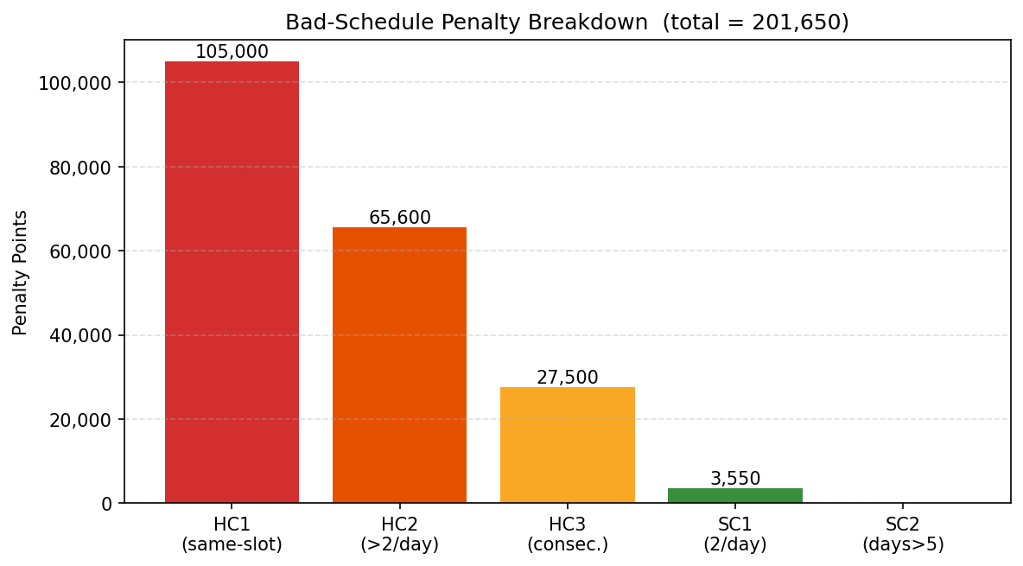
Figure 2. Penalty breakdown for the sample bad schedule (total = 201,650 points).
5.2 Default Run
Parameters: pop=100, generations=500, mutation=0.05, k=5.
Metric | Value
Best penalty at generation 0 | 15,050
Best penalty at generation 499 | 1,000
Total improvement | 14,050 pts (93.4%)
Table 2. Default-parameter GA run summary (500 generations).
The penalty drops very steeply in the first 20–30 generations as the GA eliminates HC1 clashes (same-slot conflicts). After generation ~50 the curve flattens, resolving remaining HC2/HC3 day-load violations. The final penalty of 1,000 consists entirely of SC1 soft-constraint violations (students with exactly 2 exams on the same day) — all hard constraints are satisfied.
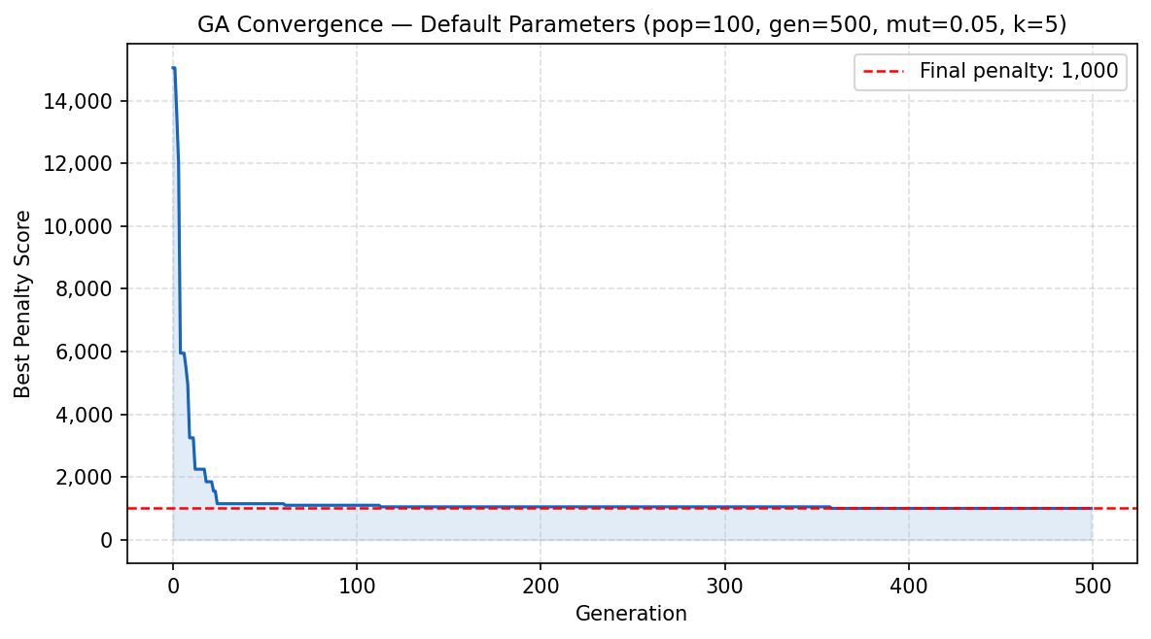
Figure 3. Best penalty per generation — default parameters, 500 generations.
Best Schedule
The final schedule uses all 6 days. The colour-coded grid below shows which exams share a slot.
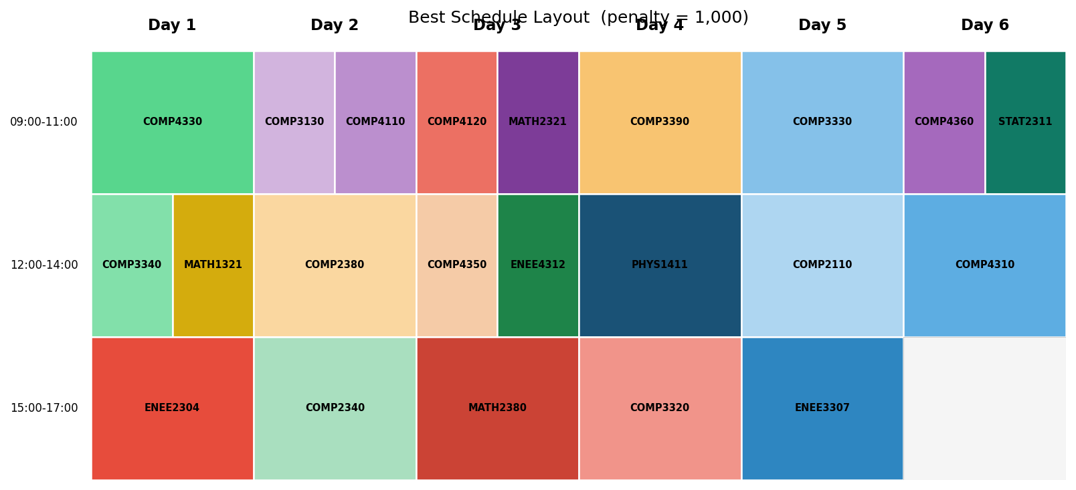
Figure 4. Colour-coded layout of the best schedule produced by the GA (penalty = 1,000).
6. Parameter Tuning
I ran four extra tests for 300 generations each, changing one parameter at a time.
Run | pop_size | mutation_rate | Generations | Final Penalty
1 — small population | 50 | 0.05 | 300 | 950
2 — large population | 200 | 0.05 | 300 | 950
3 — low mutation | 100 | 0.02 | 300 | 1,050
4 — high mutation | 100 | 0.10 | 300 | 950
Table 3. Parameter tuning results (300 generations, tournament k = 5 for all runs).
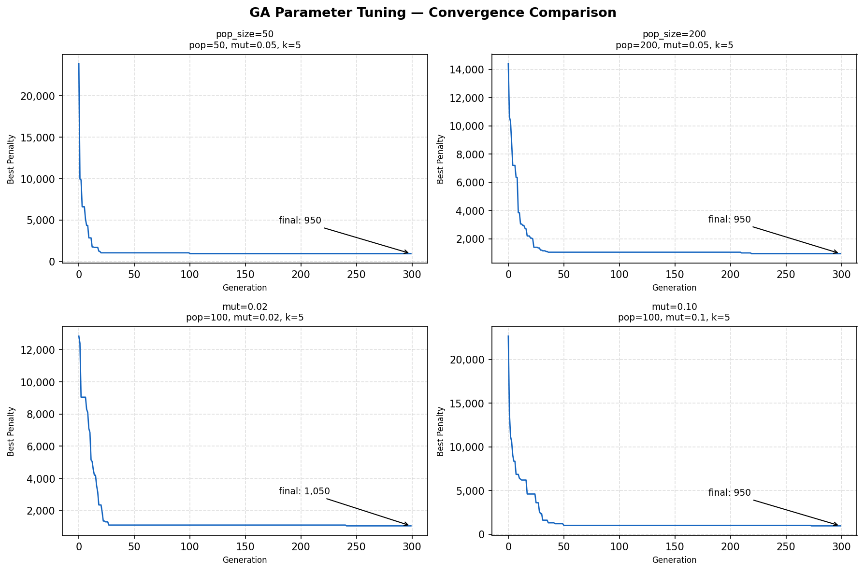
Figure 5. Convergence curves for four parameter configurations (300 generations each).
6.1 Effect of Population Size
Both pop=50 and pop=200 converge to the same final penalty of 950 in 300 generations. This shows the problem instance is not particularly difficult: even a small population of 50 maintains enough diversity to avoid premature convergence. The trade-off of larger population — longer per-generation computation — yields no benefit here. Population size is not the limiting factor for this 22-course, 95-student dataset.
6.2 Effect of Mutation Rate
A mutation rate of 0.10 (final penalty 950) outperforms 0.02 (final penalty 1,050) — a 9.5% improvement. Low mutation allows the GA to exploit good partial solutions but can trap it in local optima. Higher mutation injects fresh slot assignments that allow escape. An excessively high rate (> 0.20) would degrade the algorithm toward random search; the effective range for this problem appears to be approximately 0.07–0.12.
7. Conclusion
I built a Genetic Algorithm for university exam timetabling without using any GA library. The algorithm lowered the penalty from 15,050 (random initial population) to 1,000 after 500 generations with default parameters — a 93.4% drop. The final schedule satisfies all three hard constraints (no same-slot clashes, no student with >2 exams per day, no student with ≥4 exams over consecutive days); the remaining penalty of 1,000 comes entirely from SC1 soft violations.
Parameter tuning showed that population size has no effect on final quality for this dataset (both 50 and 200 reach 950), while a higher mutation rate of 0.10 reduces the penalty from 1,050 to 950. The project runs with a Tkinter GUI that reads the Excel dataset on start-up and saves best_schedule.txt, run_log.csv, and convergence.png to output/.
Possible improvements: adaptive mutation that decreases over generations, more varied crossover methods (uniform or order-based), or a local search after the GA to swap slots and eliminate remaining SC1 violations.
Note on libraries: The GA itself does not use any GA libraries — only openpyxl for reading Excel, matplotlib for plotting, and Tkinter for the interface.
References
1. Burke, E., & Petrovic, S. (2002). Recent Research Directions in Automated Timetabling. European Journal of Operational Research, 140(2), 266–280.
2. Carter, M. W., Laporte, G., & Lee, S. Y. (1996). Examination Timetabling: Algorithmic Strategies and Applications. Journal of the Operational Research Society, 47(3), 373–383.
3. Goldberg, D. E. (1989). Genetic Algorithms in Search, Optimization and Machine Learning. Addison-Wesley.
4. Mitchell, M. (1996). An Introduction to Genetic Algorithms. MIT Press.
5. Russell, S., & Norvig, P. (2021). Artificial Intelligence: A Modern Approach (4th ed.). Pearson.

