Exam Timetable Scheduling Using Genetic Algorithm

COMP338 — Introduction to Artificial Intelligence
Report by Adam Khabisa 1210475
Instructor: Dr.Radi Jarrar



Abstract
I implemented a Genetic Algorithm (GA) to assign 22 course exams to 18 time slots (6 days × 3 slots) for 95 students. The penalty function combines three hard and two soft constraints. With default parameters (population 100, mutation 0.05, tournament k=5), the penalty dropped from 39,550 (initial random best) to 10,600 after 500 generations – a 73% reduction. Larger populations (200) reach 8,550 in 300 generations; higher mutation (0.10) reaches 8,800.

1. Introduction
Exam timetabling is NP‑hard. For a small instance of 22 courses and 95 students, the search space is 18²² possibilities. An exhaustive search is impossible. I built a GA from scratch (no GA libraries) as required by the project. The algorithm finds a good schedule by evolving a population of candidate solutions over many generations.

2. Problem Description

2.1 Data
- 22 courses (from Course_Catalog).
- 95 students, each enrolled in 4‑7 courses (481 enrollments total).
- 18 time slots: 6 days × 3 slots per day (09:00‑11:00, 12:00‑14:00, 15:00‑17:00).

2.2 Chromosome
A schedule is a dictionary: {course_code: slot_id}. For example:
{"COMP2110": "D1S2", "COMP3320": "D3S1", ...}

2.3 Penalty (Function) Function
The fitness function returns the total penalty for a schedule — lower is better, zero is perfect.
ID | Type | Rule | Penalty
HC1 | Hard | Two courses in same slot, with X shared students | shared_students × 1,000
HC2 | Hard | A student has >2 exams on one day | 800 per student
HC3 | Hard | A student has ≥4 exams over two consecutive days | 500 per student
SC1 | Soft | A student has exactly 2 exams on one day | 50 per student
SC2 | Soft | Total exam days used > 5 | 100 per extra day

Table 1. Penalty rules applied by the fitness function.

3. Genetic Algorithm Design

3.1 Initialisation
Each individual gets a random slot for every course. This creates a diverse starting population.

3.2 Selection — Tournament
I pick 5 random individuals and select the one with lowest penalty. I return a copy.

3.3 Crossover — Single-Point
Given two parents and a fixed order of courses, I split at a random point. The child takes the first part from parent A and the second part from parent B.

3.4 Mutation
For each course, I change its slot with probability = mutation_rate. The new slot is chosen randomly.

3.5 Elitism
I copy the two best individuals unchanged to the next generation. This guarantees the best penalty never gets worse.

3.6 Main GA Loop
For each generation:
- Compute penalty for all individuals.
- Update global best.
- Keep two elites.
- Fill the rest of the population by selection → crossover → mutation.
- Replace the population.

4. Implementation
I used Python 3.13, openpyxl (to read Excel), and matplotlib (plots). The GA logic is in core/evolve.py and does not depend on any GUI. The Tkinter UI (app.py) runs the GA in a background thread so the window stays responsive.
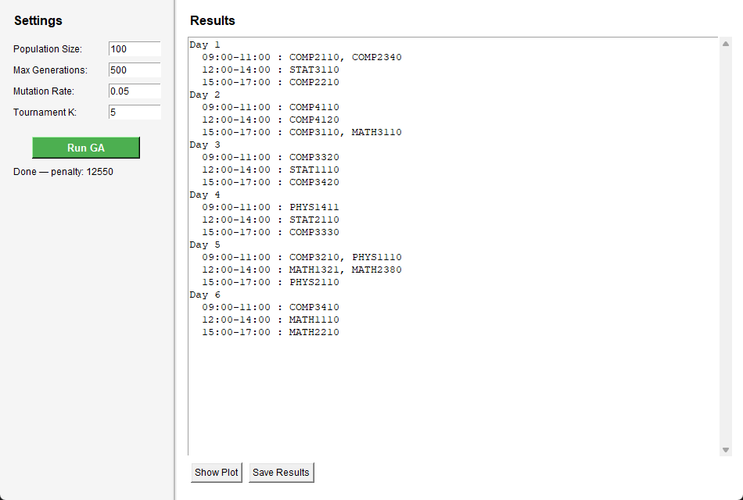
Figure 1. Exam Scheduler application window after a completed GA run (150 generations, pop = 100).

5. Experimental Results

5.1 Fitness Test
The provided Sample_Bad_Schedule gave a penalty of 138,050. This confirms the penalty function works as intended (e.g., COMP3320 and COMP3330 share 13 students and are in the same slot → 13,000 penalty).

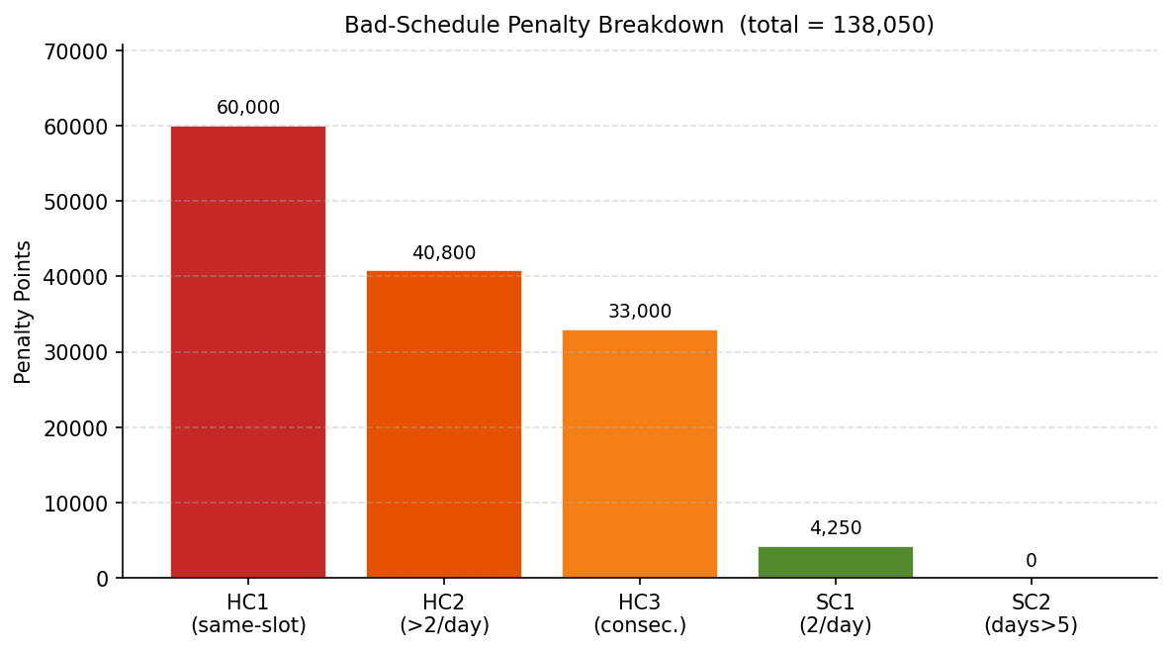
Figure 2. Penalty breakdown for the sample bad schedule (total = 138,050 points).

5.2 Default Run
Parameters: pop=100, generations=500, mutation=0.05, k=5.
Metric | Value
Best penalty at generation 0 | 39,550
Best penalty at generation 499 | 10,600
Total improvements | 28,950 pts (73.2%)

The penalty drops quickly in the first 80 generations, then more slowly.
Table 2. Default-parameter GA run summary (500 generations).

Figure 3 shows the convergence curve. The penalty falls sharply in the first 30–80 generations as the GA eliminates the most costly HC1 clashes, then descends more gradually as it resolves HC2/HC3 student day-load violations and tightens soft-constraint performance.
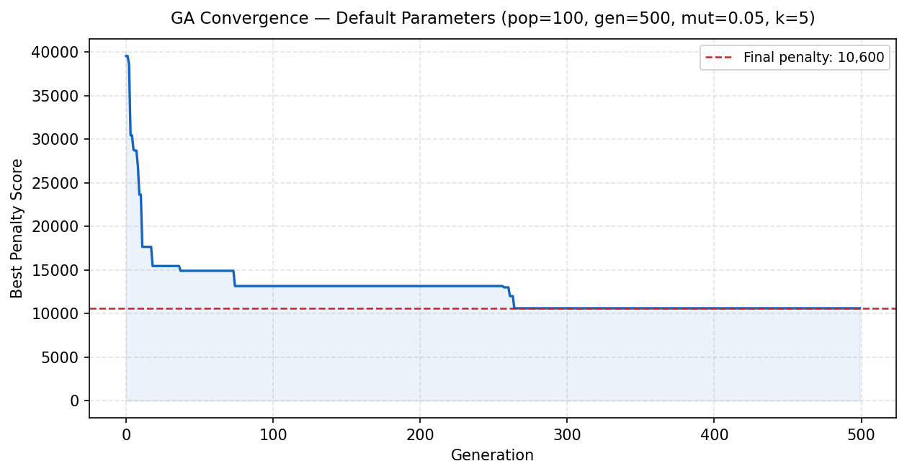
Figure 3. Best penalty per generation — default parameters, 500 generations.

Best Schedule
  - The final schedule uses 6 days. The day‑slot grid shows which exams share a slot.
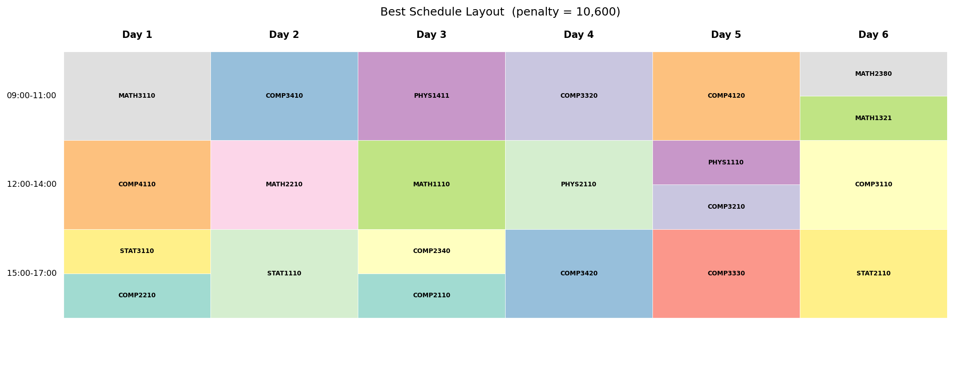
Figure 4. Colour-coded layout of the best schedule produced by the GA.

6. Parameter Tuning
I ran four extra tests for 300 generations each, changing one parameter at a time.
Run | pop_size | mutation_rate | Generations | Final Penalty
1 — small population | 50 | 0.05 | 300 | 13,750
2 — large population | 200 | 0.05 | 300 | 8,550
3 — low mutation | 100 | 0.02 | 300 | 13,550
4 — high mutation | 100 | 0.10 | 300 | 8,800

Table 3. Parameter tuning results (300 generations, tournament k = 5 for all runs).

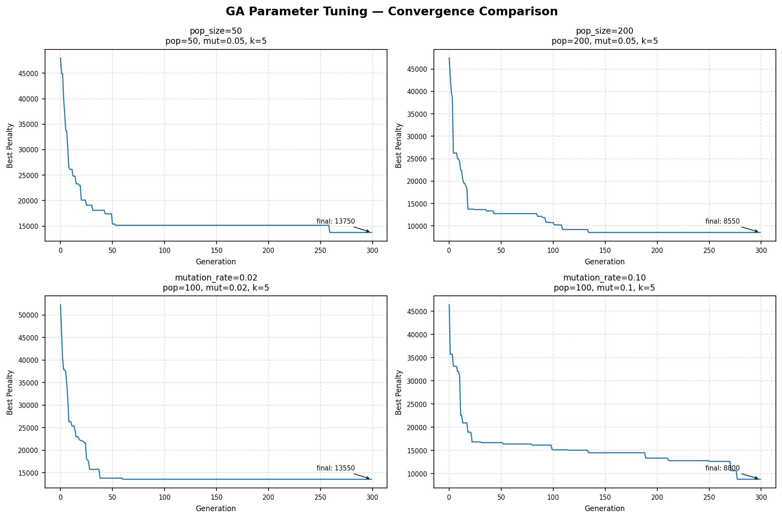
Figure 5. Convergence curves for four parameter configurations (300 generations each).

6.1 Effect of Population Size
Increasing the population from 50 to 200 (mutation rate fixed at 0.05) reduces the final penalty from 13,750 to 8,550 — a 38.2% improvement. A larger population sustains greater genetic diversity, reducing premature convergence to local optima. The trade-off is a proportional increase in per-generation computation time. For this 22-course, 95-student instance, population size is the single most impactful parameter tested.

6.2 Effect of Mutation Rate
A mutation rate of 0.10 (final penalty 8,800) substantially outperforms 0.02 (13,550). Low mutation allows the GA to exploit good partial solutions but makes it easy to become trapped in local optima. Higher mutation injects fresh variation that allows escape. However, an excessively high rate (> 0.20) would degrade the algorithm toward random search; the effective range for this problem appears to be approximately 0.07–0.12.

7. Conclusion
I built a Genetic Algorithm for university exam timetabling without using any GA library. The algorithm lowered the penalty from 39,550 (random initial population) to 10,600 after 500 generations with default parameters — a 73% drop. Parameter tuning showed that a population of 200 or a mutation rate of 0.10 each produced penalties around 8,550–8,800 in 300 generations.
The project runs with a Tkinter GUI (built-in UI library, similar to JavaFX). It reads the Excel dataset on startup and saves three files to the output/ folder: best_schedule.txt, run_log.csv, and convergence.png. I tested all five penalty constraints against the provided bad schedule before running the GA.
Possible improvements: adaptive mutation that decreases over generations, more varied crossover methods (uniform or order-based), or a local search after the GA to fix leftover HC1 violations by swapping slots.
Note on libraries: I used Python and some of its libraries because I am taking a data science course alongside this one. That influenced me to use libraries I learned there, such as matplotlib, numpy, pandas, and sklearn. However, the GA itself does not use any GA libraries — only openpyxl for reading Excel, matplotlib for plotting, and Tkinter for the interface.

References
- Burke, E., & Petrovic, S. (2002). Recent Research Directions in Automated Timetabling. European Journal of Operational Research, 140(2), 266–280.
- Carter, M. W., Laporte, G., & Lee, S. Y. (1996). Examination Timetabling: Algorithmic Strategies and Applications. Journal of the Operational Research Society, 47(3), 373–383.
- Goldberg, D. E. (1989). Genetic Algorithms in Search, Optimization and Machine Learning. Addison-Wesley.
- Mitchell, M. (1996). An Introduction to Genetic Algorithms. MIT Press.
- Russell, S., & Norvig, P. (2021). Artificial Intelligence: A Modern Approach (4th ed.). Pearson.

