APPENDIX
Application Screenshots
This appendix contains comprehensive screenshots of the Library Management System
application, organized module-wise. These screenshots demonstrate the user interface,
functionality, and responsive design of the developed system.

A.1 Authentication Module

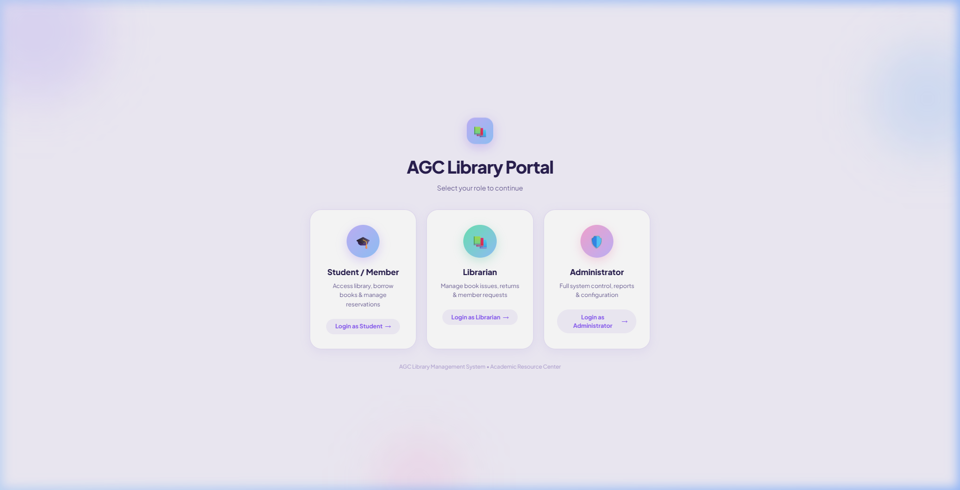
Figure A.1: Login Portal – Role Selection Page

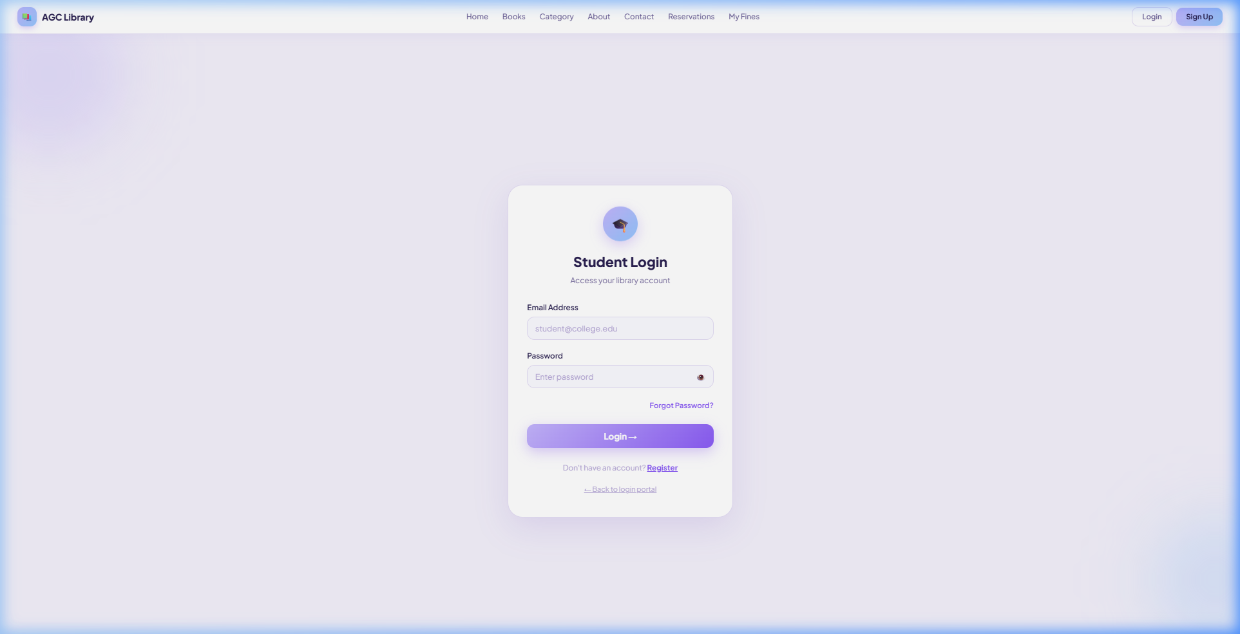
Figure A.2: Student Login Page

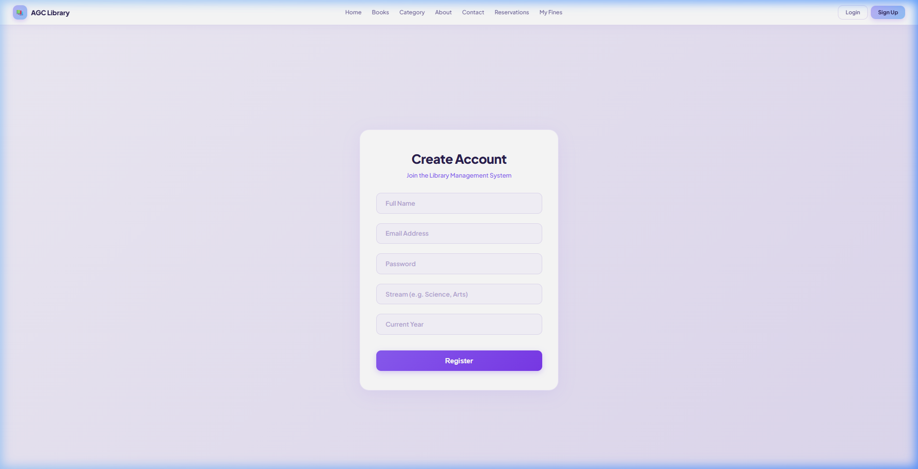
Figure A.3: Student Registration Page

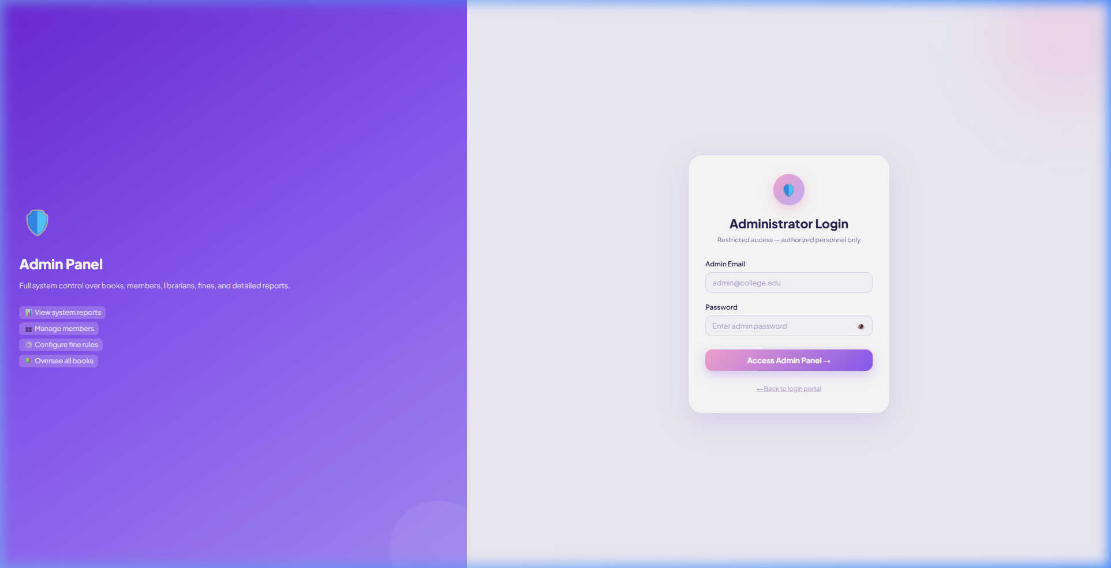
Figure A.4: Administrator Login Page

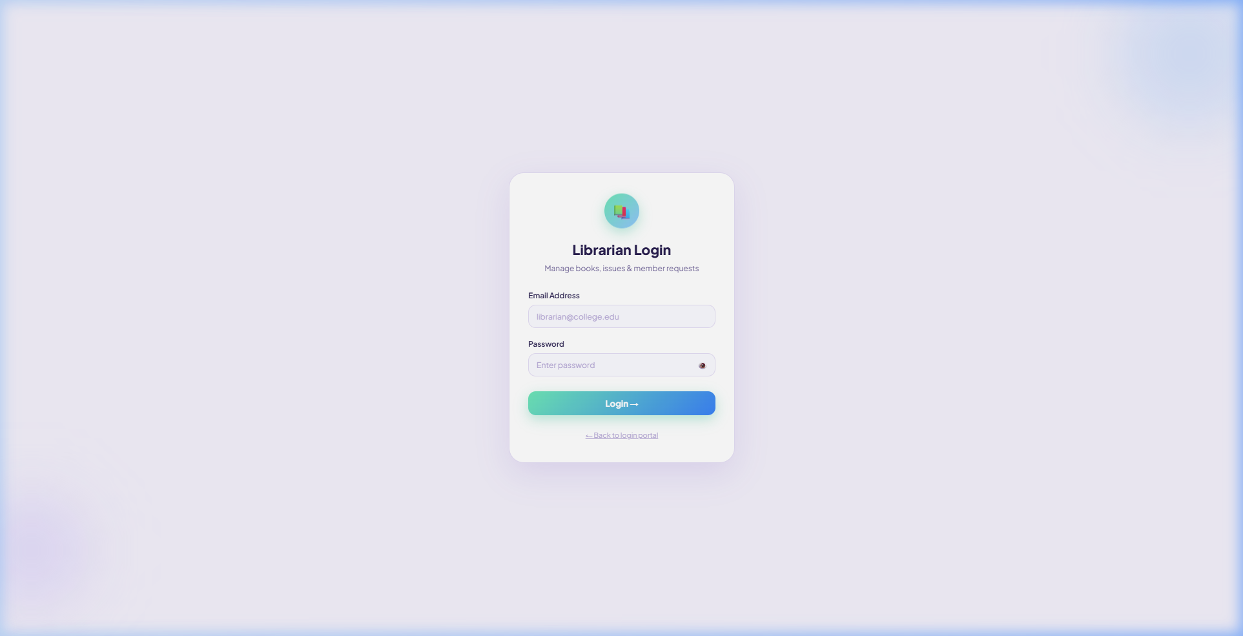
Figure A.5: Librarian Login Page

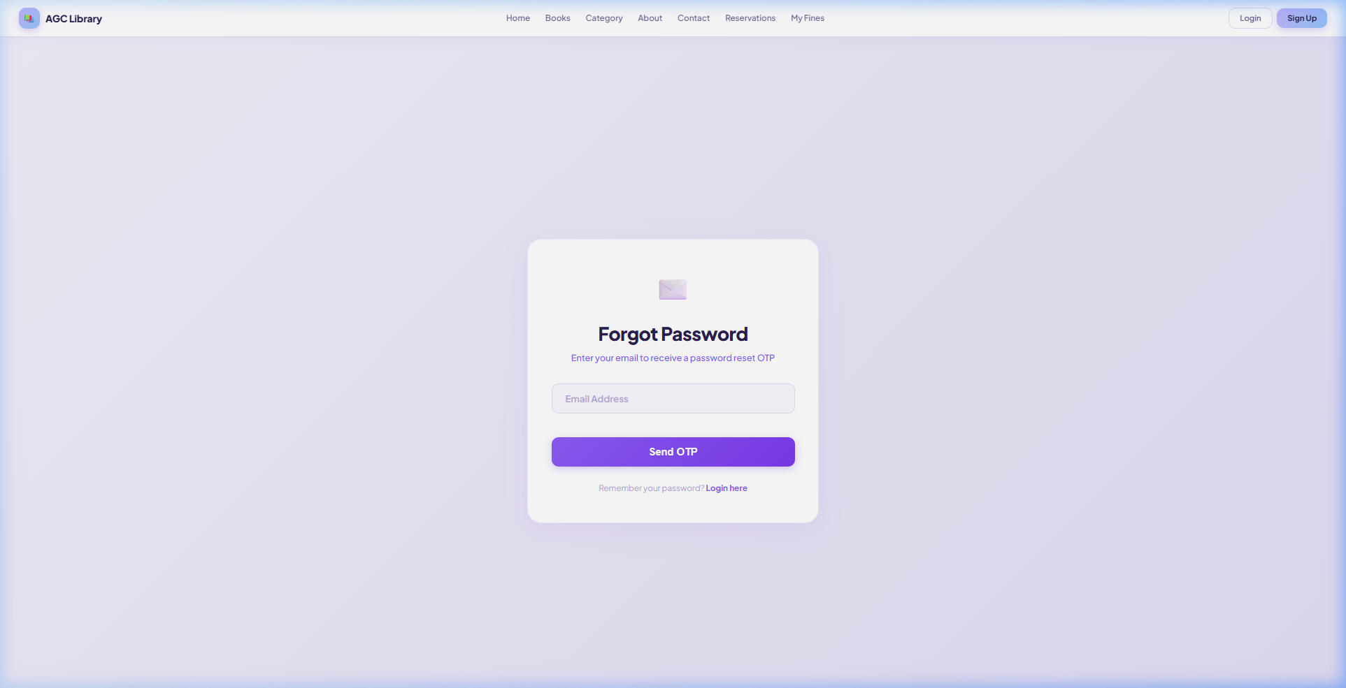
Figure A.6: Forgot Password Page

A.2 Home Page

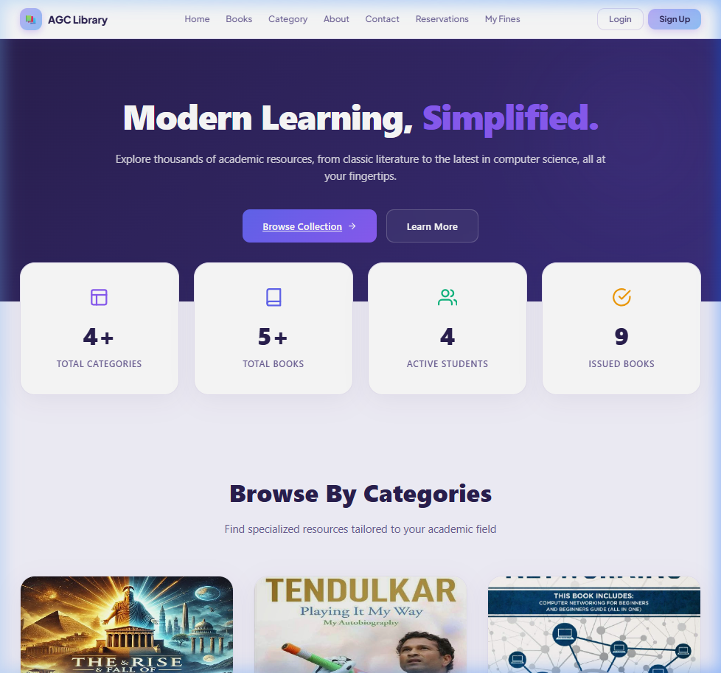
Figure A.7: Home Page – Hero Section with Navigation Bar

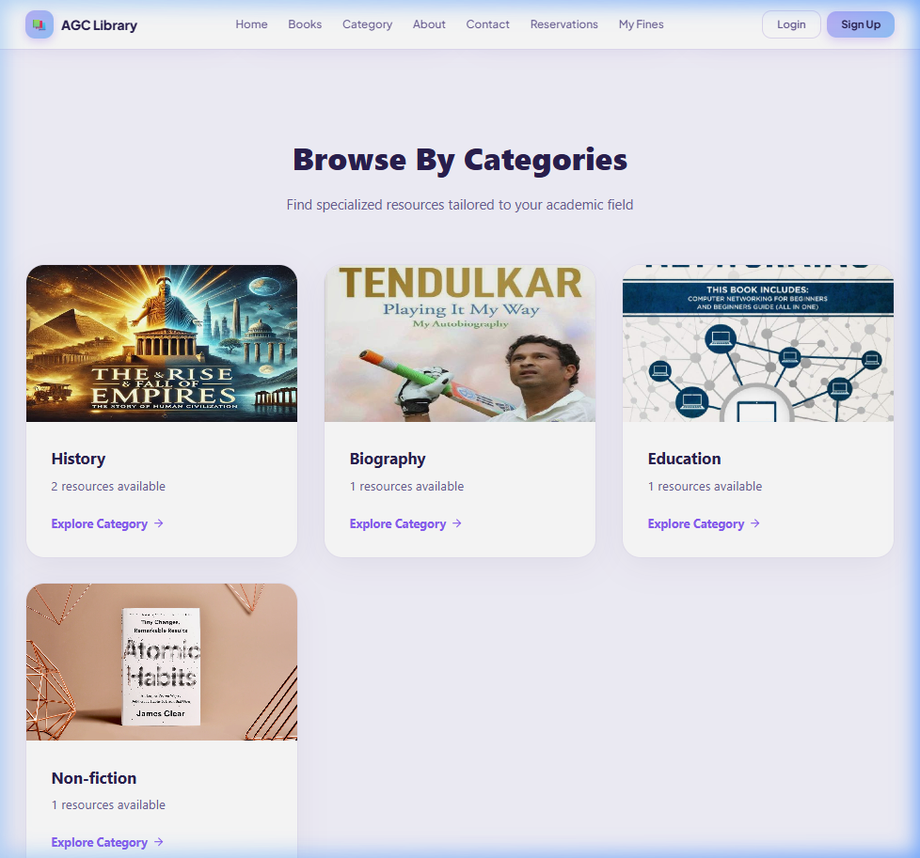
Figure A.8: Home Page – Browse by Categories Section

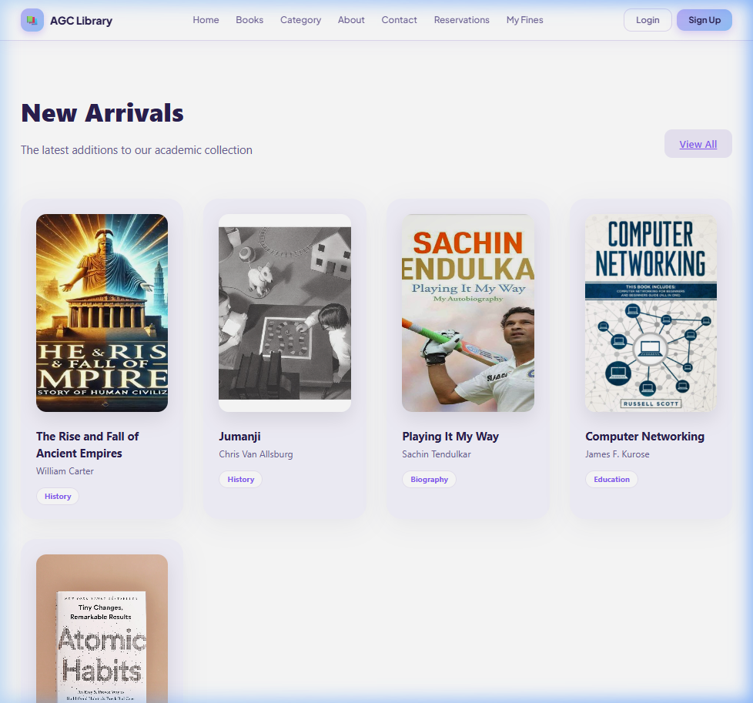
Figure A.9: Home Page – New Arrivals Section

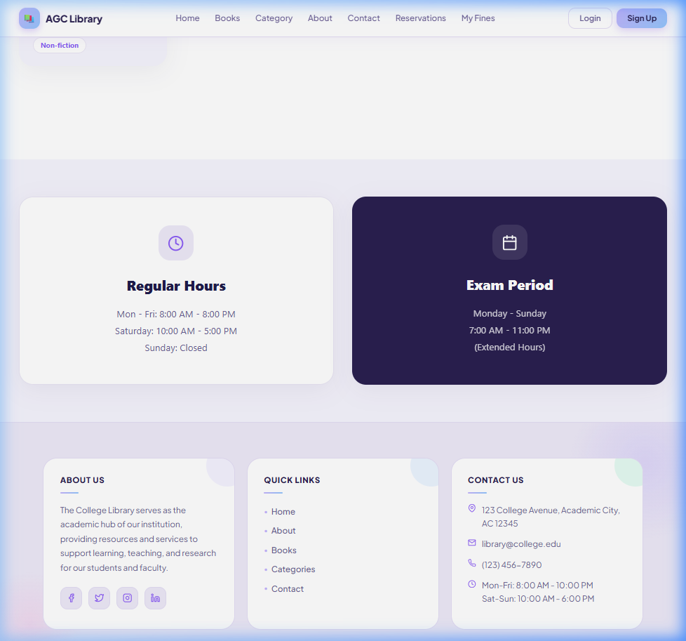
Figure A.10: Home Page – Library Hours and Footer Section

A.3 Books Catalogue

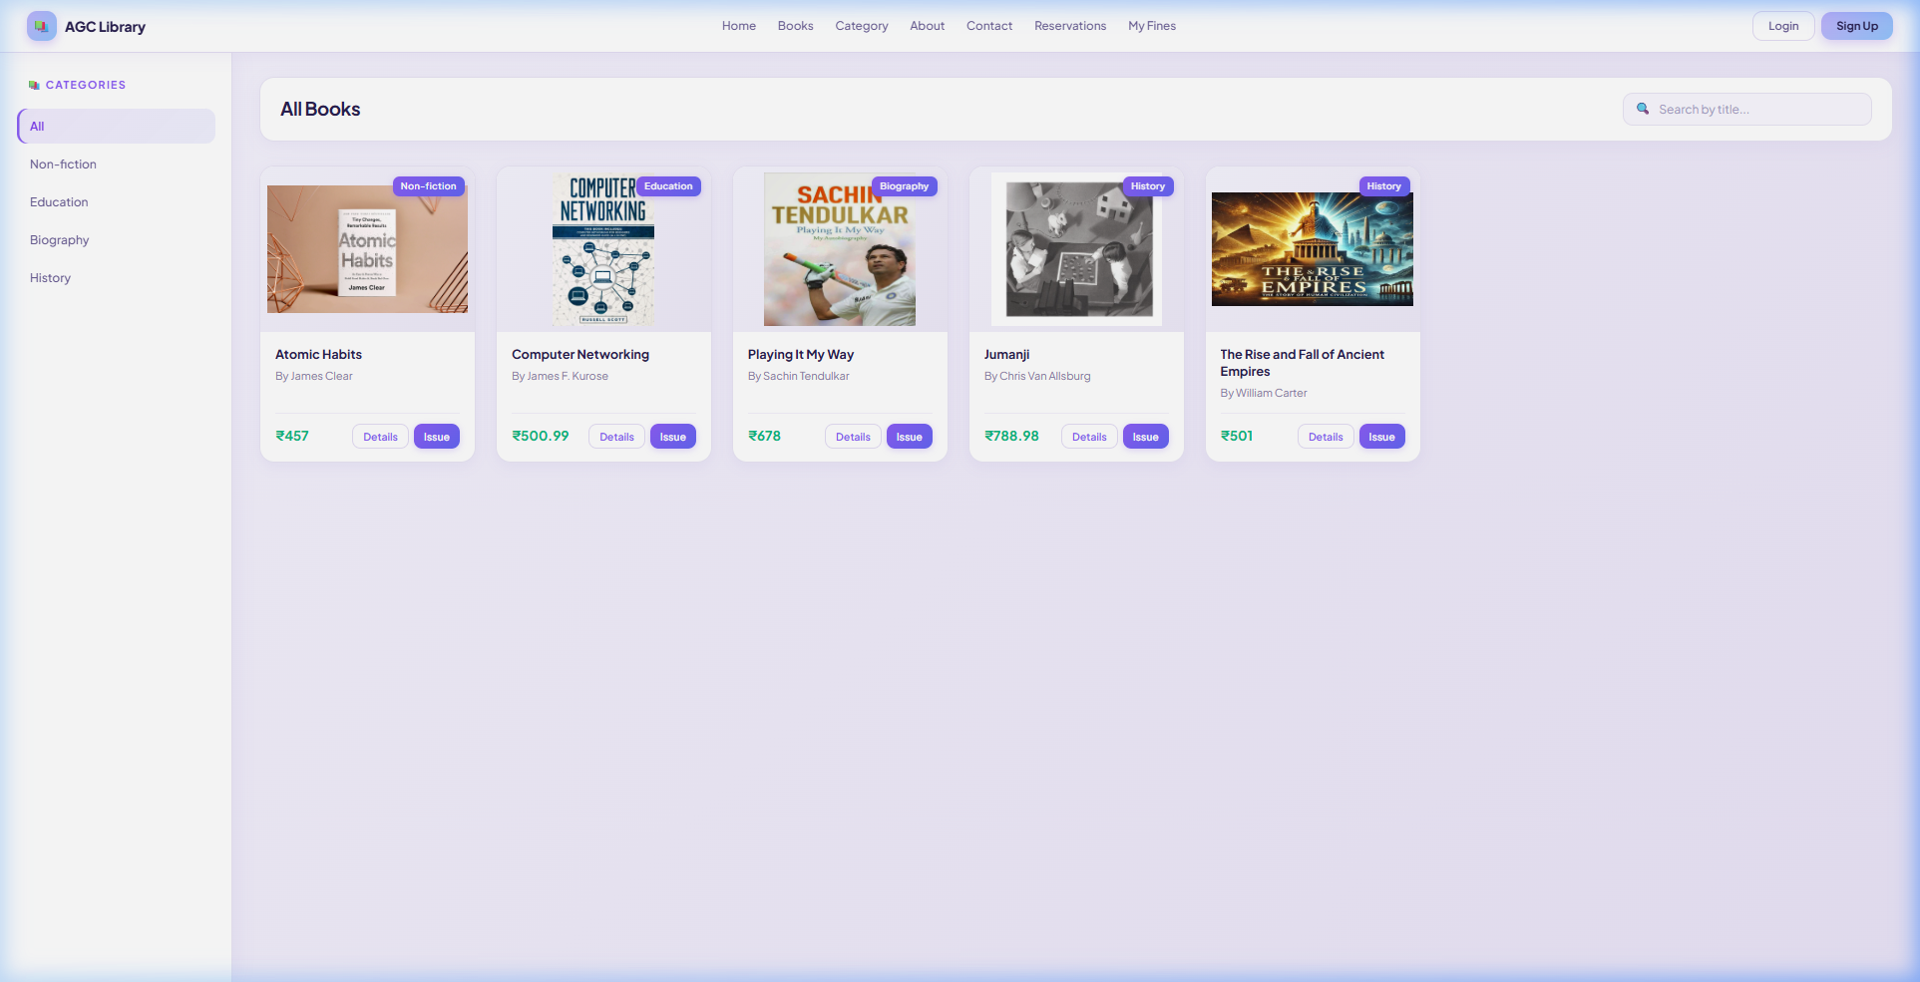
Figure A.11: All Books Listing with Category Sidebar and Search

A.4 Categories Page

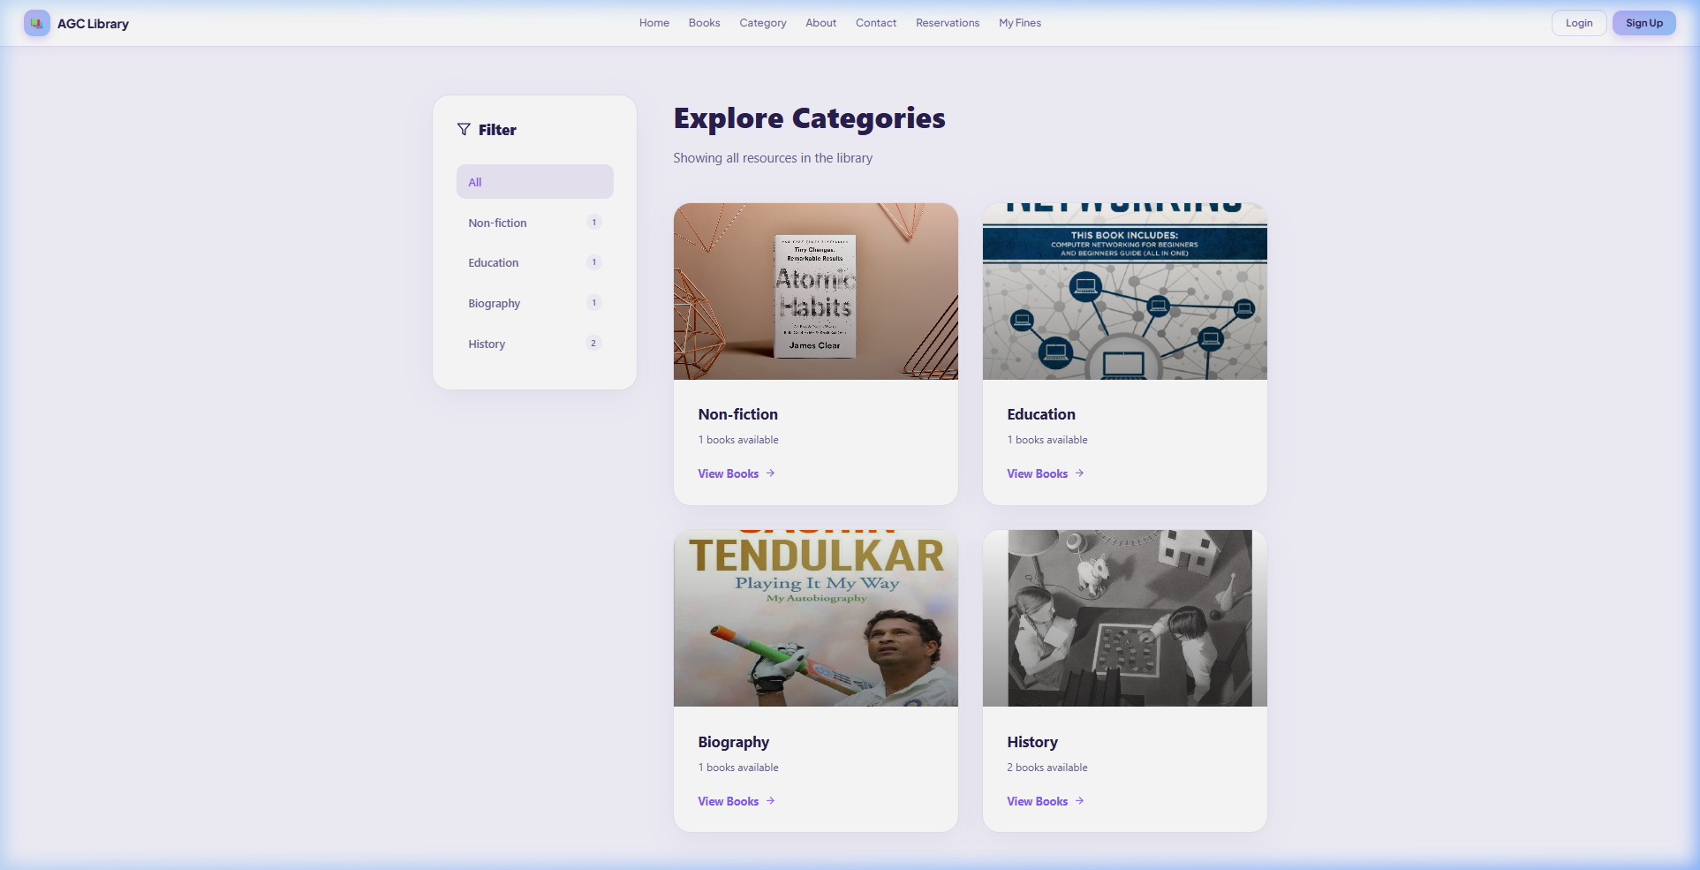
Figure A.12: Browse All Categories Page

A.5 About Us Page

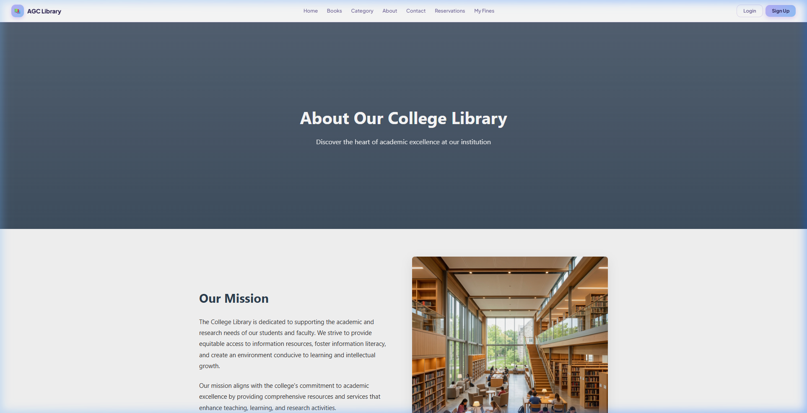
Figure A.13: About Us Page – Header and Mission Section

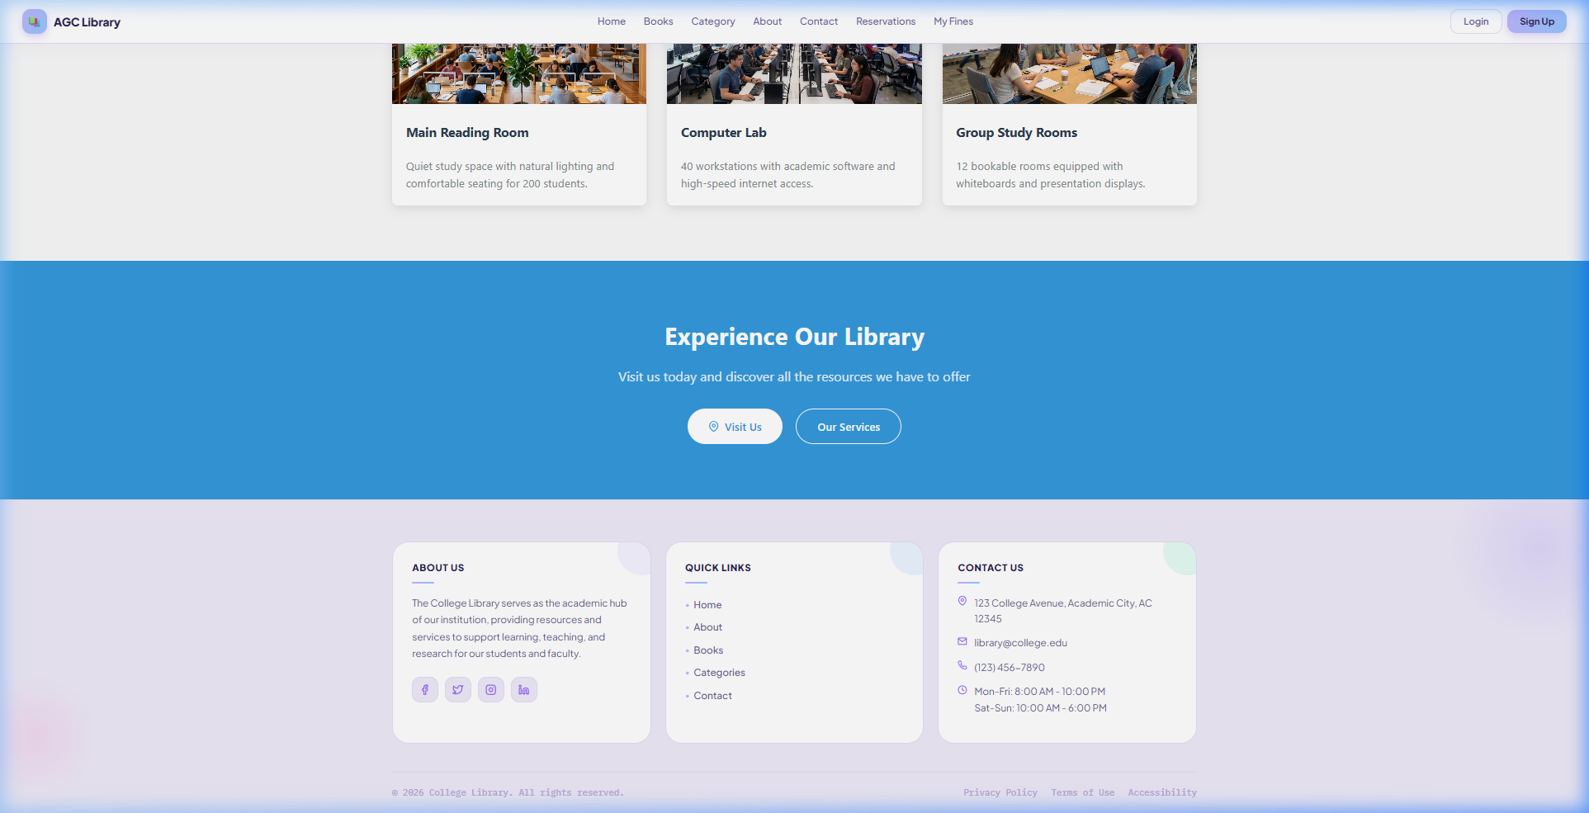
Figure A.14: About Us Page – Services and Team Section

A.6 Contact Us Page

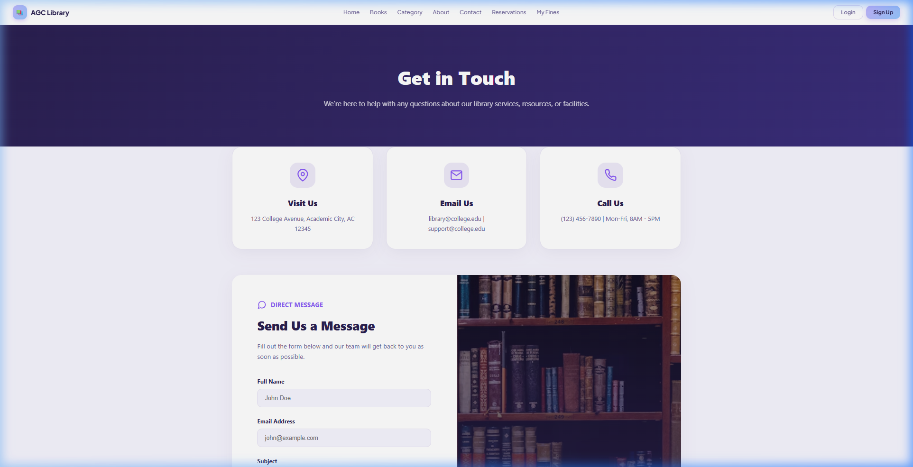
Figure A.15: Contact Us Page – Information Cards and Message Form

A.7 Admin Dashboard

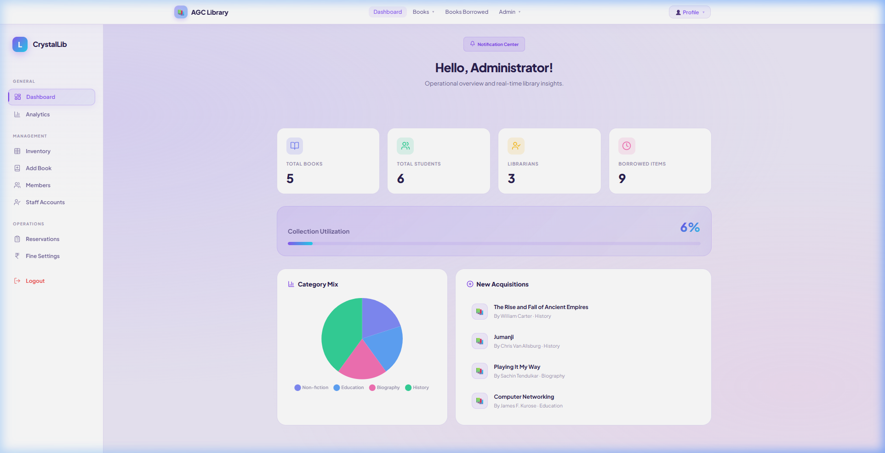
Figure A.16: Admin Dashboard – Overview with Statistics, Category Mix Chart, and New Acquisitions

A.8 Add Book Module

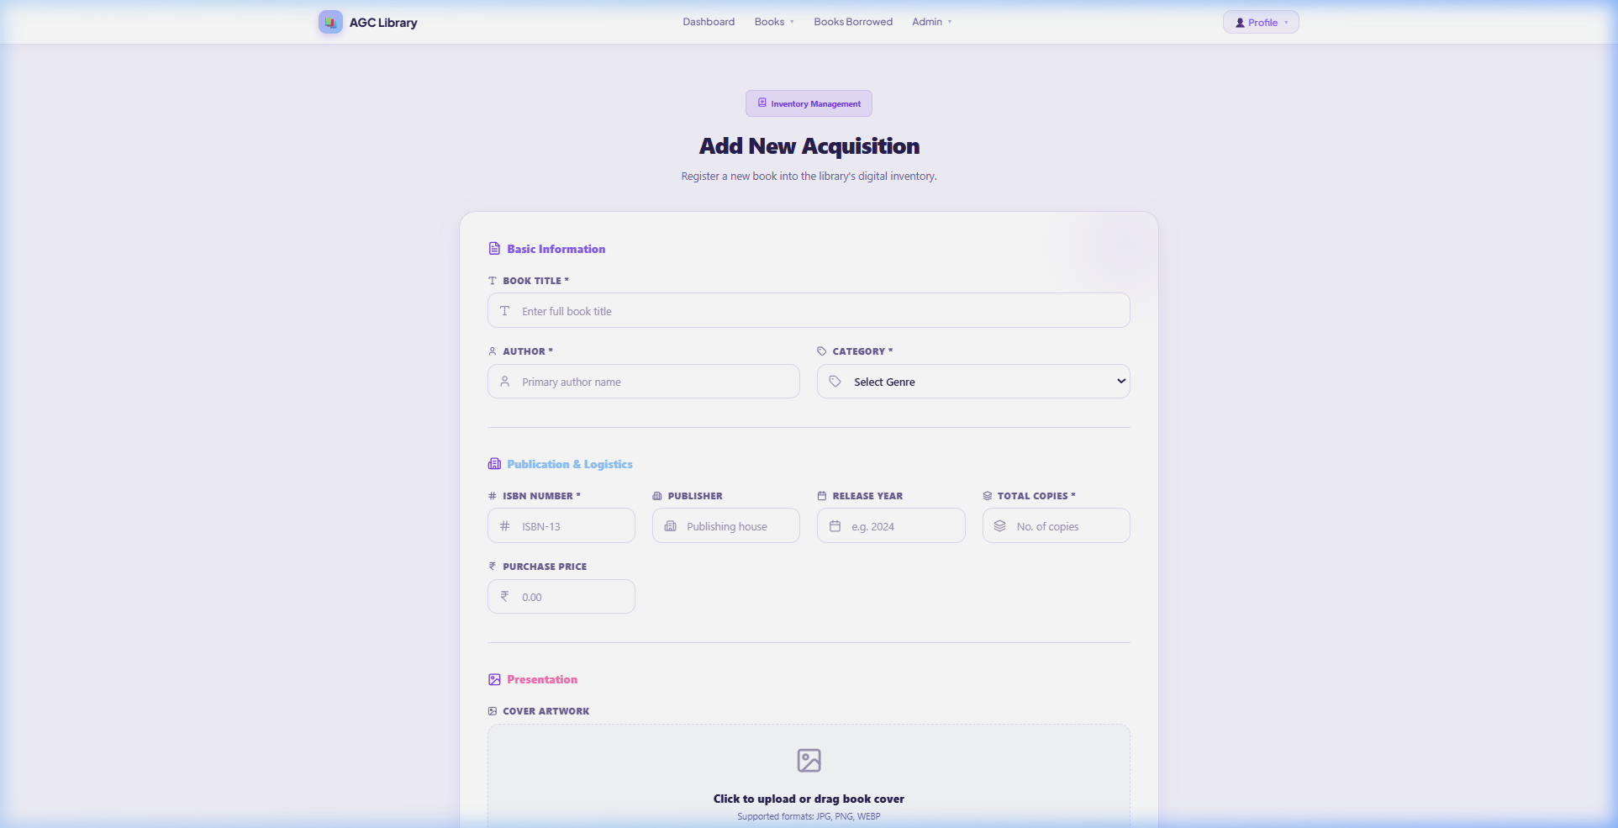
Figure A.17: Add New Acquisition Form – Basic Information and Publication Details

A.9 Inventory Management

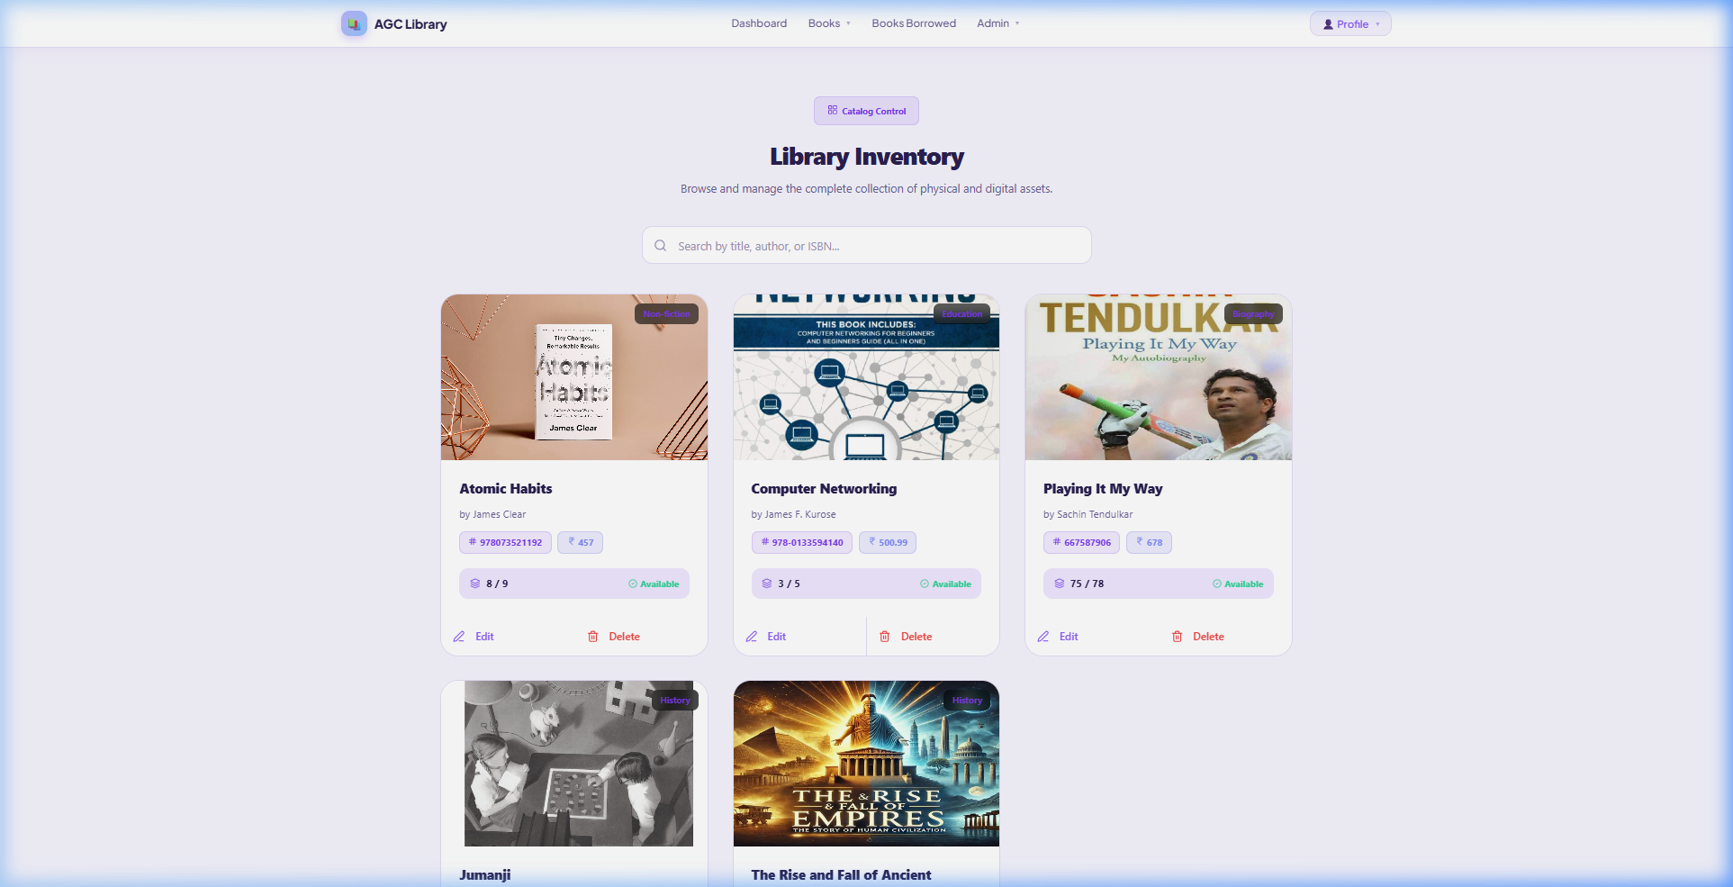
Figure A.18: Library Inventory – Book Cards with Edit/Delete Controls

A.10 Member Management

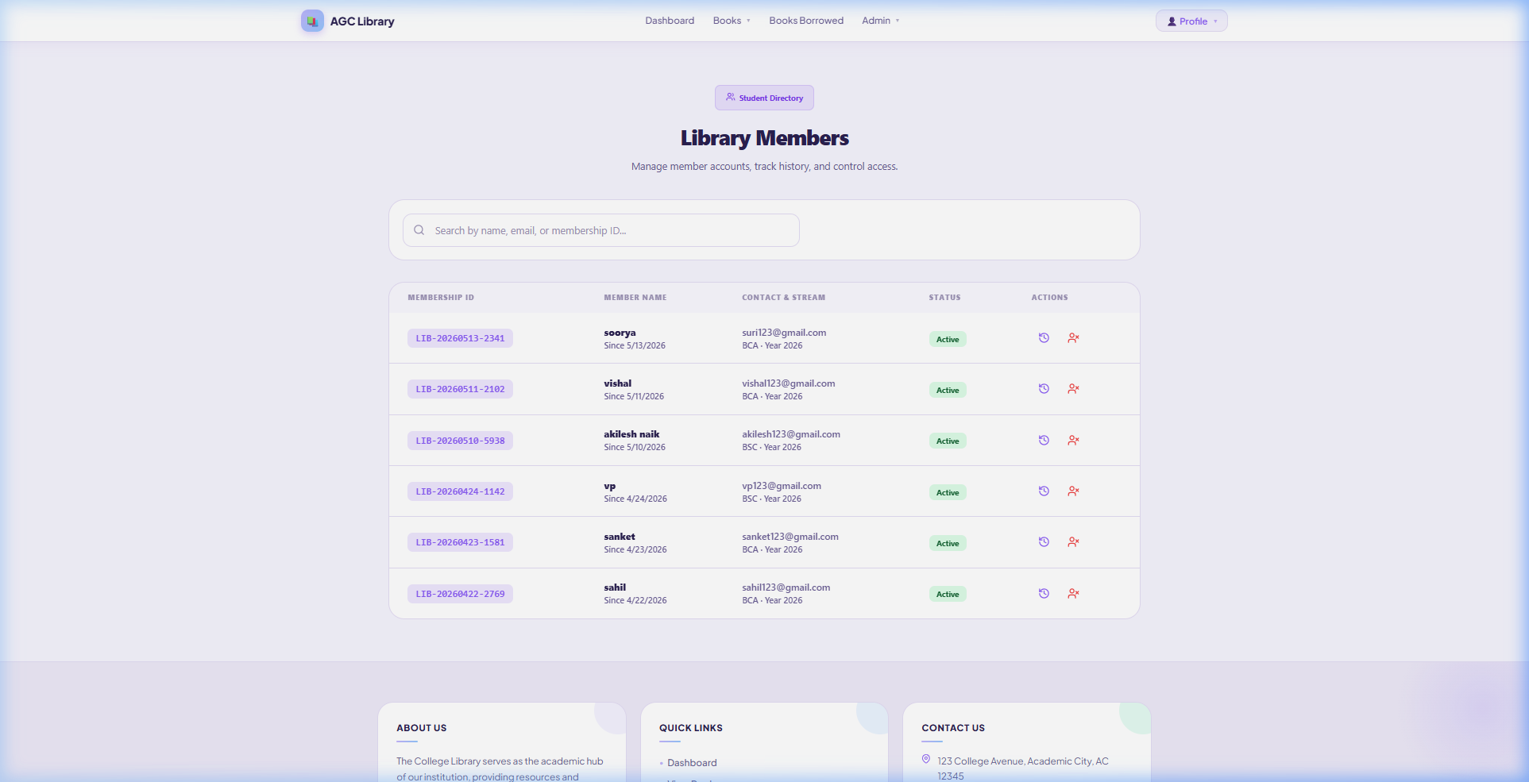
Figure A.19: Library Members Directory – Member List with Status and Actions

A.11 Librarian / Staff Management

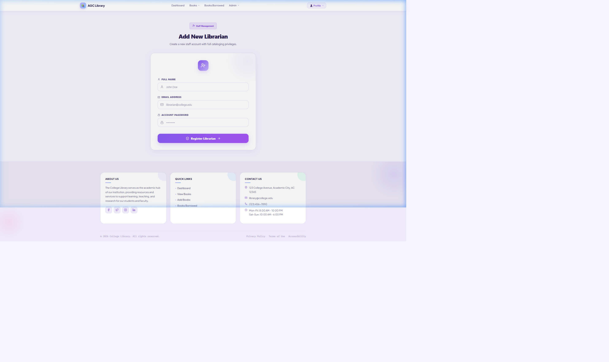
Figure A.20: Add New Librarian – Staff Registration Form

A.12 Book Issue and Return

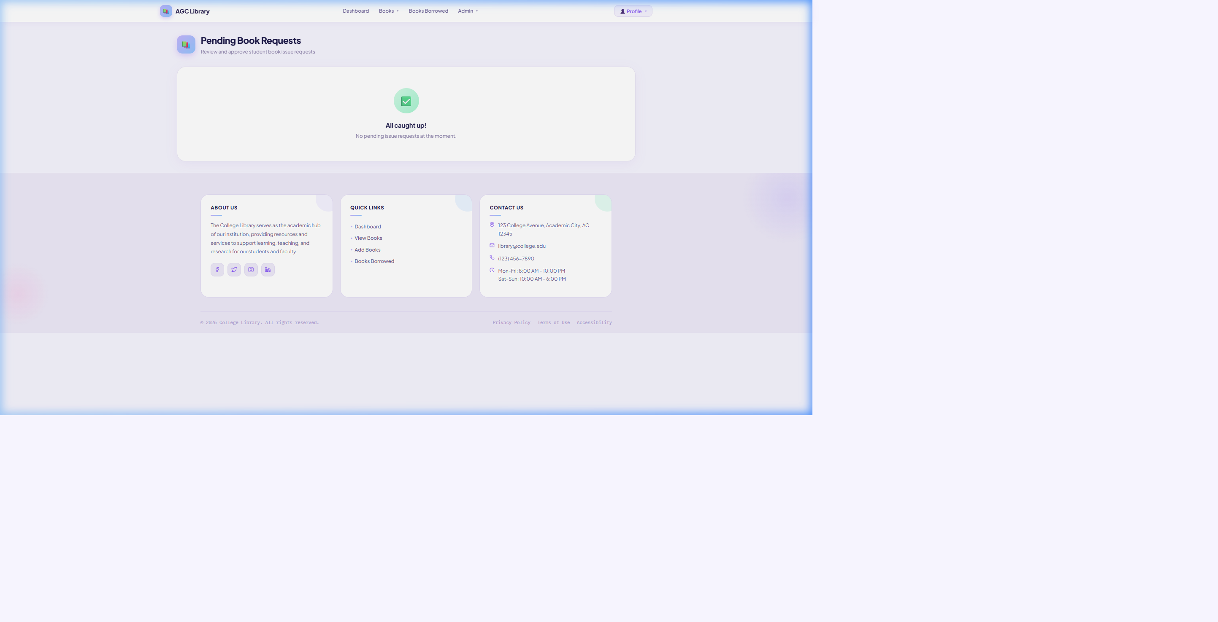
Figure A.21: Pending Book Issue Requests Page

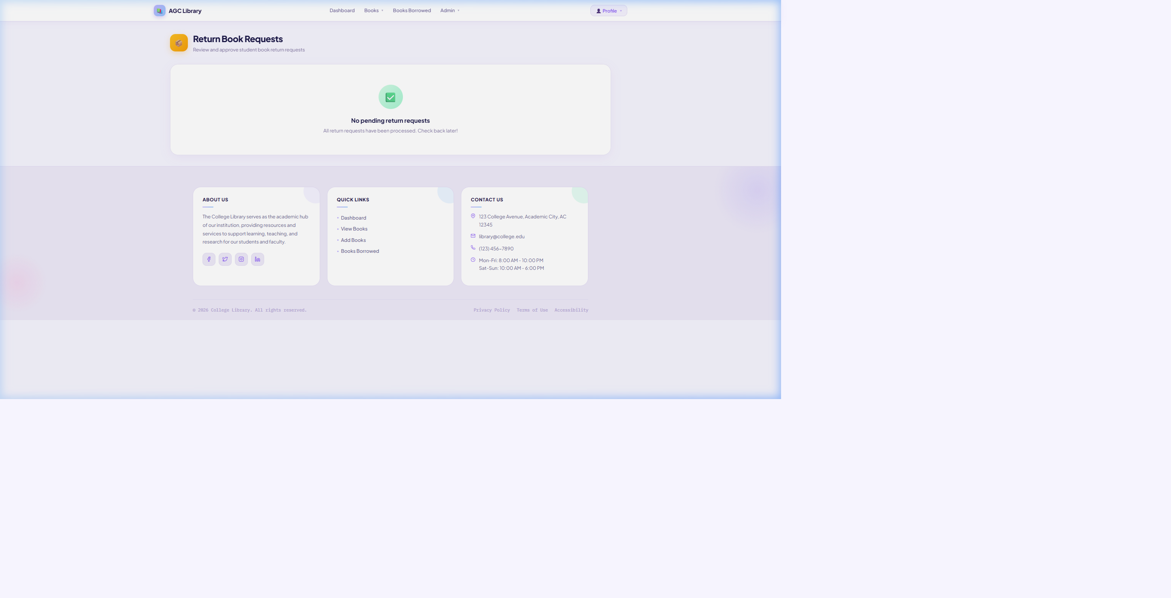
Figure A.22: Return Book Requests Page

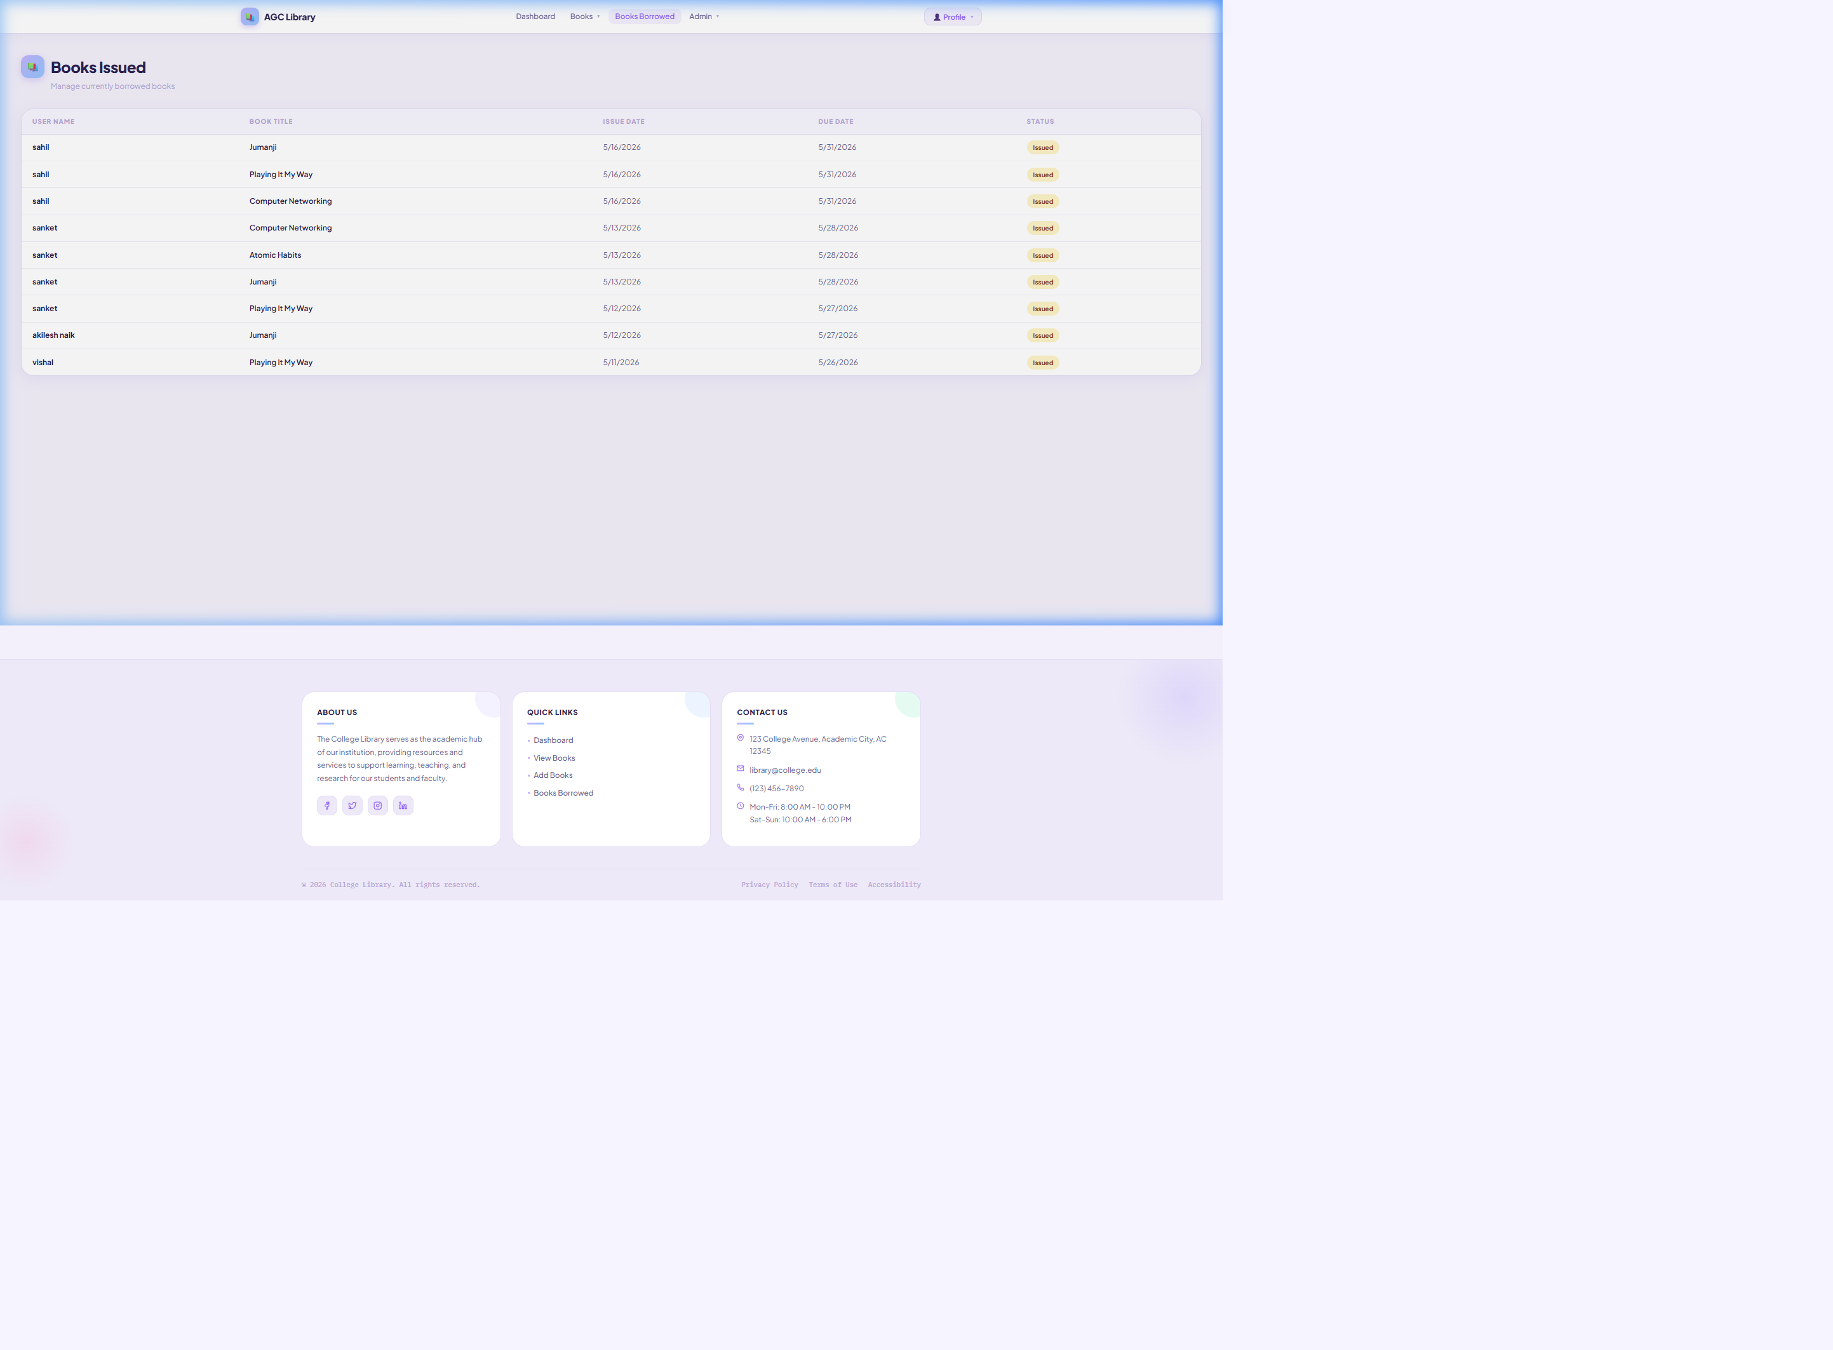
Figure A.23: Books Issued – Currently Borrowed Books List

A.13 Reservation Management

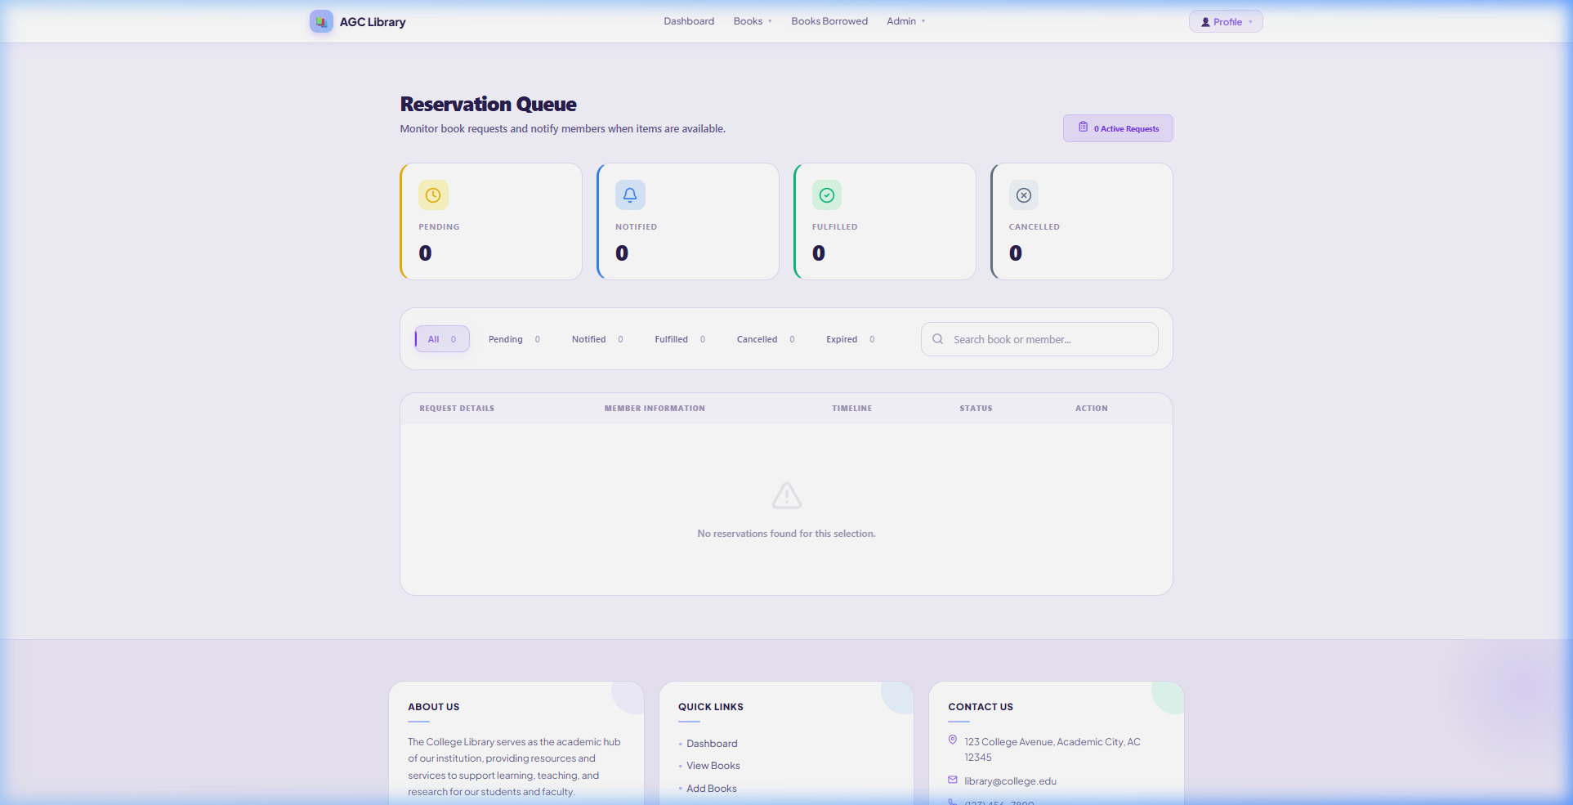
Figure A.24: Reservation Queue – Status Cards and Filter Tabs

A.14 Reports and Analytics

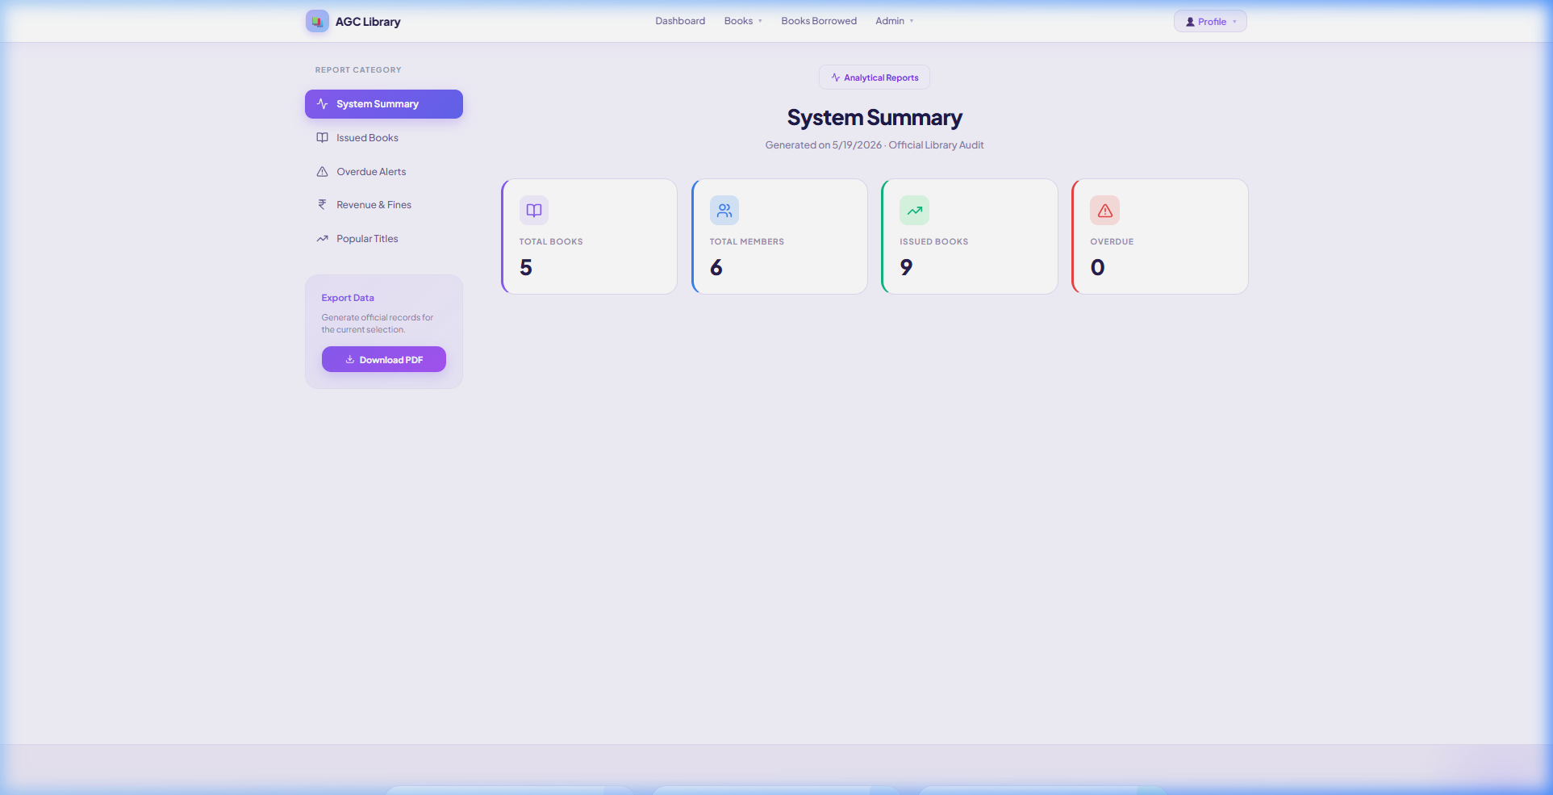
Figure A.25: Reports Module – System Summary with Export Option

A.15 Fine Management

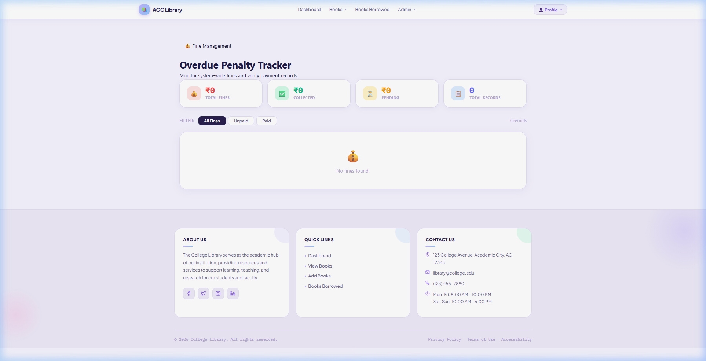
Figure A.26: Fine Management – Outstanding Fines Dashboard

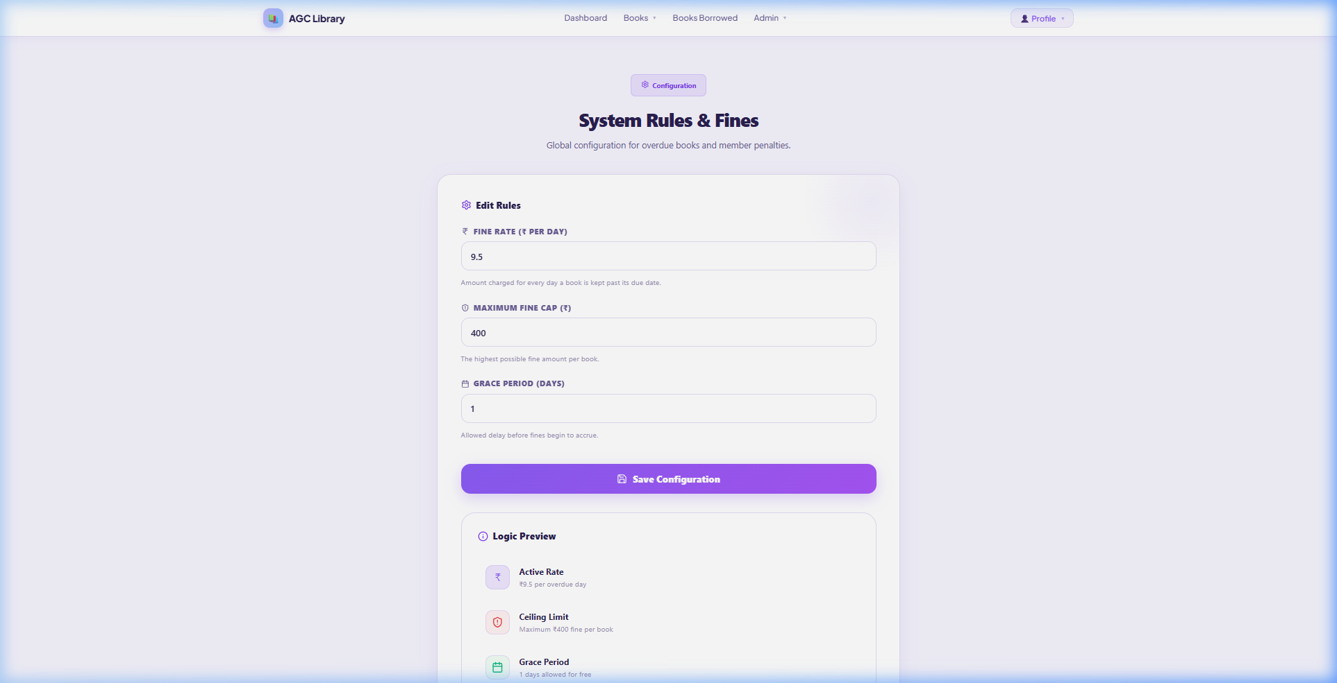
Figure A.27: Fine Configuration – Rules and Settings

A.16 Responsive / Mobile Views

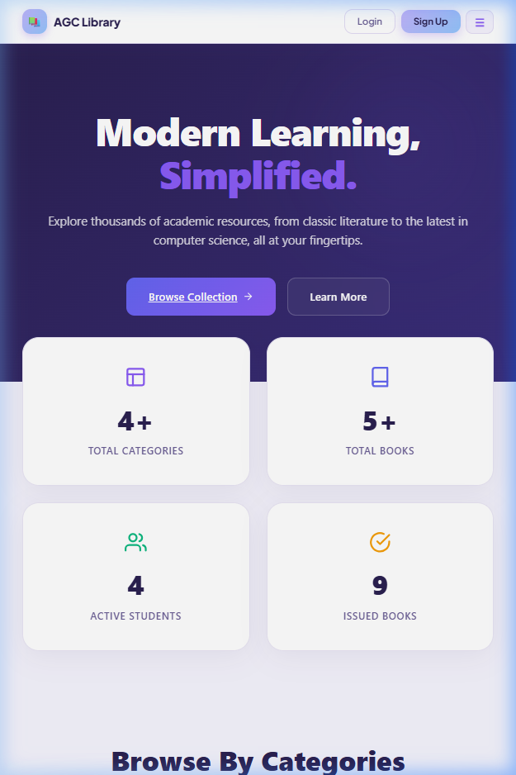
Figure A.28: Mobile Responsive View – Home Page

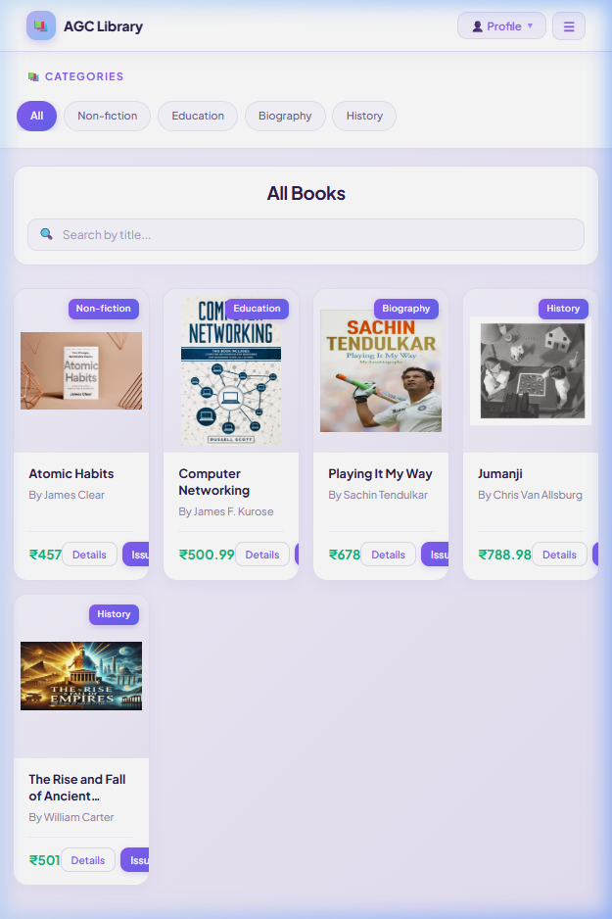
Figure A.29: Mobile Responsive View – Books Catalogue

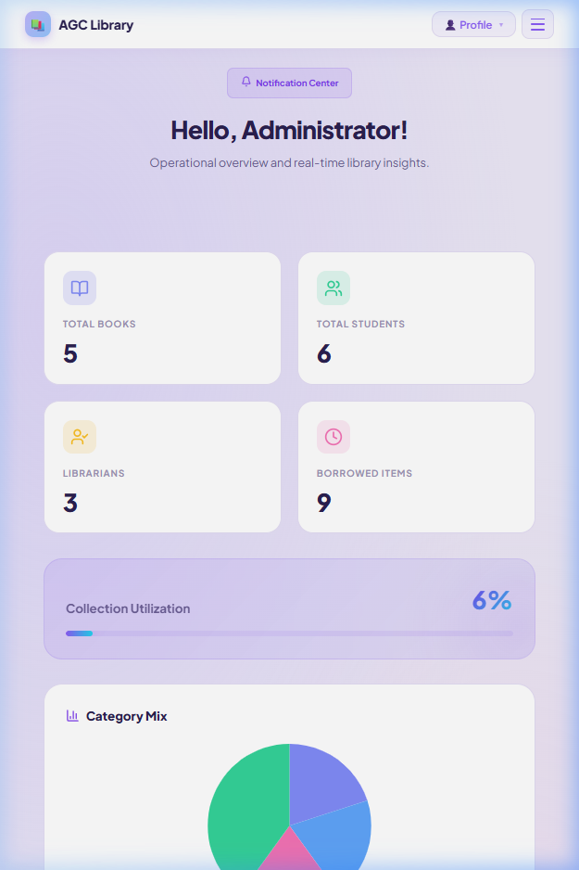
Figure A.30: Mobile Responsive View – Admin Dashboard

A.17 Summary of Application Screenshots
Table A.1 provides a consolidated summary of all application screenshots included in this appendix, organized by module.
S.No. | Module | No. of Screenshots
1 | Authentication Module | 6
2 | Home Page | 4
3 | Books Catalogue | 1
4 | Categories Page | 1
5 | About Us Page | 2
6 | Contact Us Page | 1
7 | Admin Dashboard | 1
8 | Add Book Module | 1
9 | Inventory Management | 1
10 | Member Management | 1
11 | Librarian / Staff Management | 1
12 | Book Issue and Return | 3
13 | Reservation Management | 1
14 | Reports and Analytics | 1
15 | Fine Management | 2
16 | Responsive / Mobile Views | 3
 | Total | 30
Table A.1: Summary of Application Screenshots by Module

