# **4VWX Atlantic Herring**

**Background on Fishery**

The Atlantic herring (*Clupea harengus*) is a small pelagic species found on both sides of the North Atlantic Ocean. Herring are a schooling fish that form predictable aggregations for feeding, overwintering, and spawning. The 4VWX herring stock is divided in multiple management components for the purposes of evaluation and management (Figure 1):

* Southwest Nova Scotia/Bay of Fundy (SWNS/BoF) spawning component
* Offshore Scotian Shelf banks spawning component
* Coastal Nova Scotia spawning component
* Southwest New Brunswick (SWNB) migrant juveniles (weir fishery)

Each spawning component has several spawning areas and there is mixing of herring among the 4VWX spawning components and the 5YZ (US stock) during annual feeding and overwintering migrations. The assumption that herring exhibit spawning-area fidelity has been the basis of the definition of herring stocks and fisheries management. Spawning areas in close proximity with similar spawning times share a common larval distribution area and are considered part of the same component. Although the SWNB “migrant juvenile” weir fishery occurs within the spatial bounds of the SWNS/BoF management area (Figure 1), it is considered a separate component and includes a mixture of herring from 4VWX and 5YZ spawning areas.

The SWNS/BoF management component is the largest by landings (~75%) for the 4VWX stock. The primary spawning areas for the SWNS/BoF management component are German Bank, Scots Bay, and Trinity Ledge (collapsed ~ 1990) (Figure 1). 4VWX herring are caught by multiple gear types, including purse seine which accounts for ~ 90% of the current total catches for SWNS/BoF, with gillnet, weir, and other gear types making up the remaining fraction of the catch. The majority of herring in this region are fall spawners, forming large aggregations on the spawning grounds that are targeted by the purse seine fleet. The purse seine fleet also targets summer feeding aggregations and historically (pre-2002) targeted overwintering aggregations. The SWNS/BoF management component is managed by a TAC and excluded catches from weirs in SWNB.

The Offshore Scotian Shelf management component is data limited and has an arbitrary TAC. Fishing activity offshore is limited due to the distance offshore and spawning times and specific spawning locations are not known.

The coastal NS management component has acoustic surveys in two spawning areas (South Shore and Eastern Shore). TACs are currently set separately for each area based on the survey index. No surveys are conducted for Cape Breton and there is currently no fishing activity in Cape Breton.

The SWNB weir management component is effort controlled (max number of weirs) without a TAC. Landings are primarily juveniles and are counted towards the US herring stock (although an unknown portion of the juveniles are from the 4VWX stock).



CB

Offshore Scotian Shelf

Figure A. Map of herring fishing areas in NAFO area 4VWX.

Summary of management components for the 4VWX herring stock:

* SWNS/BoF management component: the Canadian area west of the green vertical line in 4X and 5Y is the SWNS/BoF herring fishery management area (the orange polygon). SB = Scots Bay spawning area; GB = German Bank spawning area; TL = Trinity Ledge (spawning area collapsed ~ 1990);
* Offshore Scotian Shelf management component – area in 4VWX west of the green vertical line and > 25 miles from shore.
* Coastal NS management component: area in 4VWX west of the green vertical line and < 25 miles from shore. SS = South Shore; ES = Eastern Shore; CB = Cape Breton.
* SWNB Weir management component = Southwest New Brunswick (herring landed by weir in SWNB). Note: herring landed in SWNB by other gear types are included in the SWNS/BoF management component

**Exercise 1. Spatial Definition of Stock/Data-limited Methods**

The 4VWX herring stock consists of 4 different management components (Figure A). The 4VWX herring stock will be prescribed to the Fish Stocks Provisions as a single stock and a single LRP will be required for the stock, despite being managed by separate components. Data availability differs among the four components. The majority of the 4VWX herring fishery is within the SWNS/BoF management area (~75% by landings) so the focus of data collection and reported has been focused primarily on this component.

Consider the following two approaches of defining an LRP for the 4VWX stock:

* An LRP based on the SWNS/BoF management component
* An LRP based on the entire 4VWX stock (all 4 management areas)

**Workshop Goal:**

Get participant feedback on the approach to defining an LRP for the 4VWX stock, where the management area < stock area. What approach would you use to define an LRP when data are limited for the entire stock area? What are the implications for defining an LRP based only on data for a portion of the stock area?

**Data availability:**

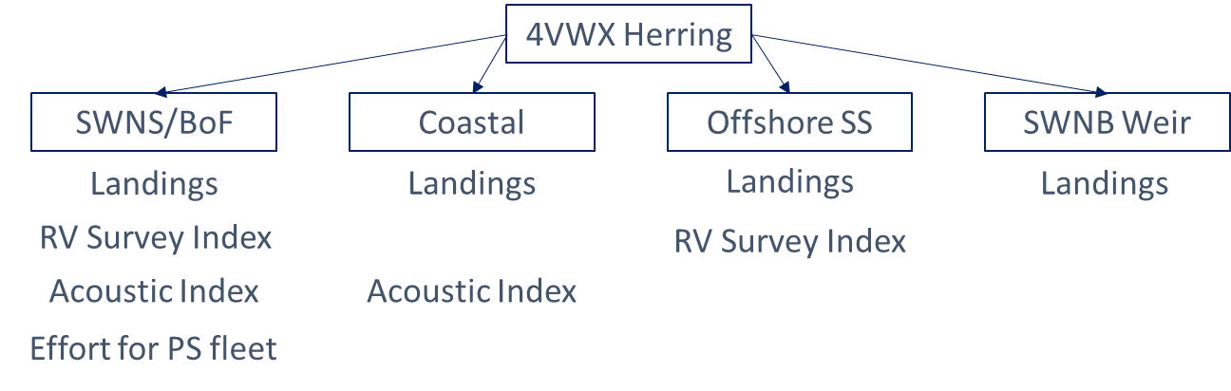

Exercise Questions

1. Evaluate the suitability (e.g. representativeness of the indicator, proportionality of the indicator and stock attribute it represents) of various data sources (catch, CPUE, RV survey index, acoustic survey Index) that differ in terms of spatial coverage, time frame, and type of indicator.
2. Select a spatial area (all 4VWX or the SWNS/BoF management component or an alternative spatial area) and define an LRP for that area using an indicator generated from the dataset provided.
3. As a group, prepare a 1-2 slide (< 5 minute) presentation to explain the choice of indicator (including spatial scale) and method of defining the LRP and rationale for the choice. Include a time series plot of the indicator and add a line to represent the LRP.

Datasets: landing.csv ; ex1.csv

4VWX

* Total annual catch by management area (1968-2020) in t [landings.csv]
* A total biomass index from the groundfish RV survey (1981-2020). The survey is conducted in the summer using a bottom trawl. The biomass is calculated based on swept area biomass by strata (Figure 1.1). The index is a relative index of biomass.

SWNS/BoF management component

* Total annual catch from the purse seine fleet (1968-2020) in t. The purse seine fleet comprises generally > 90% of the SWNB/BoF landings.
* Total annual effort (1977-2020) for the purse seine fleet as number of fishing trips
* An index of spawning stock biomass (SSB) (1999-2020) from acoustic surveys conducted during the spawning season on the German Bank (Aug-Oct) and Scots Bay (June-Sept) spawning grounds (see Figure 1). These surveys involve ~ 6-18 transects through a standardized survey area on each spawning ground (Figure 1.2) and surveys are conducted ~6-8 times per season (14 days apart to avoid double counting). The biomass for a fixed area is estimated for each survey based on the estimated density of herring. The biomass is summed over each survey and the annual index is the total sum of the German Bank and Scots Bay surveys over the spawning period. The index is a relative index of SSB.

Costal NS management component

* An index of spawning stock biomass (SSB) (1998-2020) from acoustic surveys conducted during the spawning season for Eastern Shore and South Shore (no data for Cape Breton). These surveys do not follow a standard study design and only target schools of herring. Multiple surveys are conducted throughout the spawning period (at least 14 days apart to avoid double counting) and the annual index is the total sum of the surveys over the spawning period. The index is a relative index of SSB.

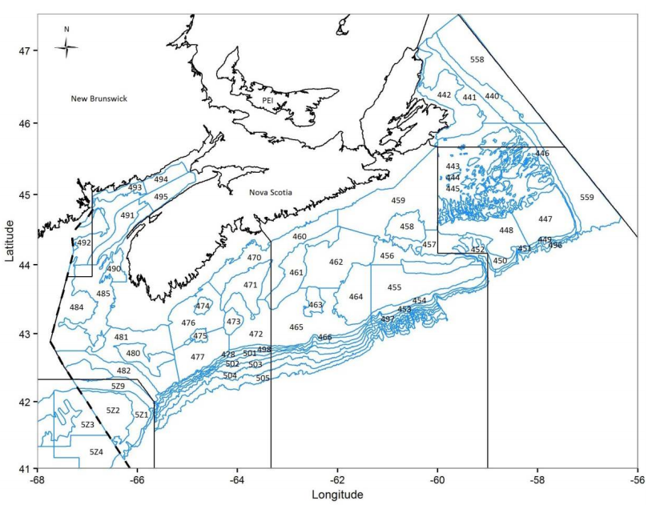

4V

5Z

5Y

4W

4X

GB

SB

*Figure 1.2. Groundfish RV survey strata. The SWNS/BoF herring fishery management area is captured in the orange polygon. Primary spawning grounds are GB = German Bank and SB = Scots Bay (see Figure 1).*

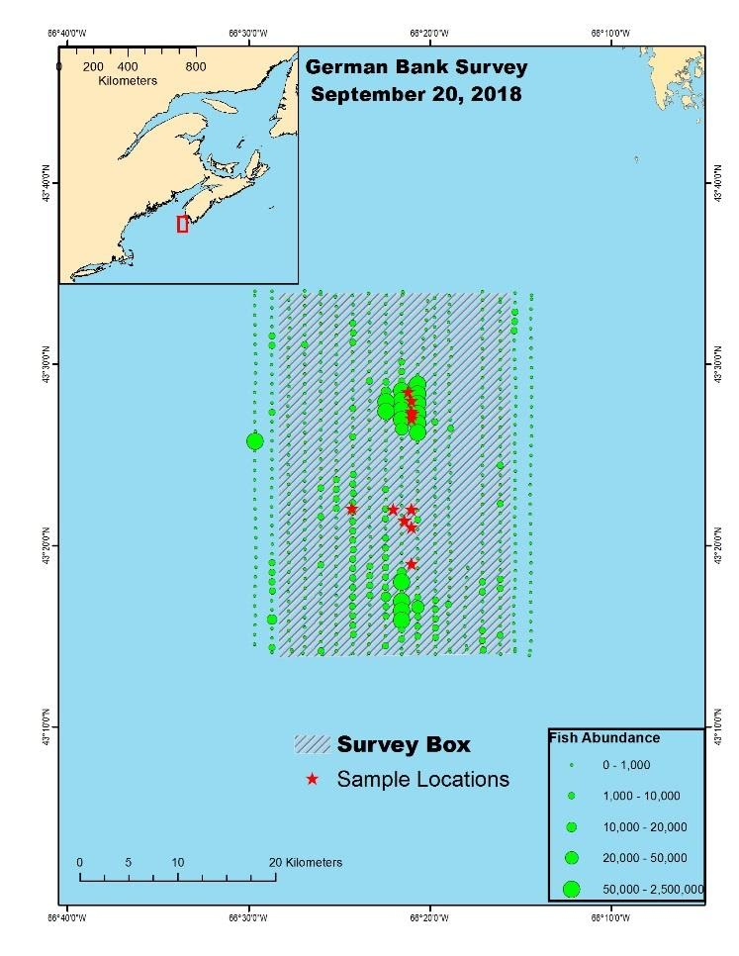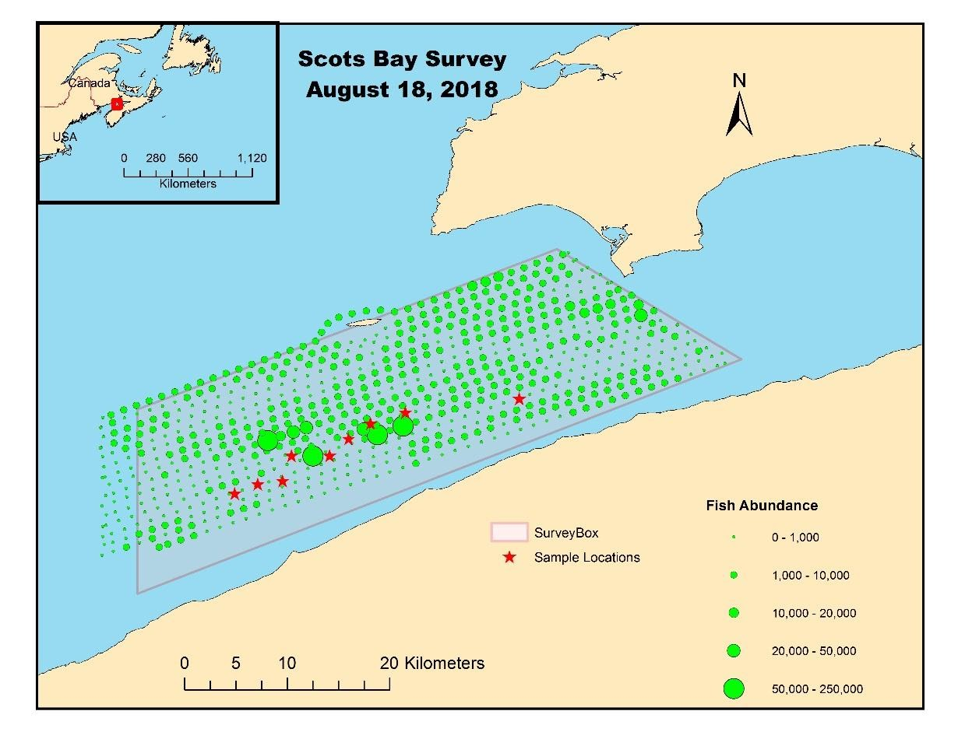

*Figure 1.2. Survey design for the acoustic survey on the German Bank (top) and Scots Bay (bottom) spawning grounds showing parallel transects and herring abundance estimates for each nautical mile (circles) along the transects.*

**Exercise 2. Data-rich Methods (SWNS/BoF herring)**

The goal of this exercise is to evaluate the suitability of various methods of defining an LRP for a data-rich stock. As a group, evaluate at least 3 candidate LRPs and identify the LRP that you feel is most defensible. Prepare a 1-2 slide (< 5 minute) presentation that includes:

* some pros/cons of each candidate LRP;
* the “most defensible” LRP and the rationale;
* a time series plot of the indicator used to define the LRP and add a line representing the LRP.

Background:

An age structured model for SWNS/BoF herring “stock” (a management component of the 4VWX herring stock) has been fit. The model is a multi-fleet Stock Reduction Analysis (SRA, Walters et al. 2006) fit using the Rapid Conditioning Model in [SAMtool](https://cran.r-project.org/web/packages/SAMtool/SAMtool.pdf). The SRA model applied here is comparable to other statistical catch-at-age (SCA) models such as iSCAM (Martell 2017). As an SRA, the model assumes historical catches are known exactly. The model assumes a Beverton-Holt stock recruitment (SR) relationship with steepness of 0.75 and a constant natural mortality rate of 0.35. The models were conditioned to catch and size composition data (1968-2018), an acoustic survey of spawning stock biomass (1999-2018), and a larval survey used as an index of spawning stock abundance (1972-1998, 2009). The fleets consist of a purse seine fleet (generally > 90% of landings) with logistic selectivity, a gillnet fleet with dome shaped selectivity, and an “other” fleet that consists of all other gear types with dome shaped selectivity.

Dataset:

* Model estimated total biomass, spawning stock biomass, recruitment, apical F
* Mean weight-at-age, maturity-at-age, and selectivity-at-age over the historical time period
* How to bring in dynamic unfished biomass? Need to project model with F=0 and obs rec devs. I can fit and provide the output. Or do we let the group fit the models. Objective is not to learn software – it is to estimate ref pts
* Tie in uncertainty? Multiple simulations. Can this be done in the short time period?

For the purpose of this exercise, vital rates are assumed to be at equilibrium. The variability in annual estimates of weight-at-age, maturity-at-age, and selectivity-at-age is assumed to be random variation about the mean. The time series means are plotted below:

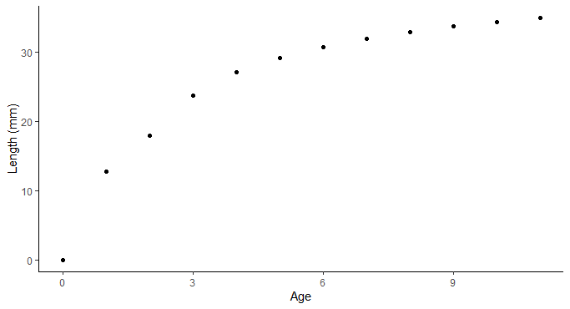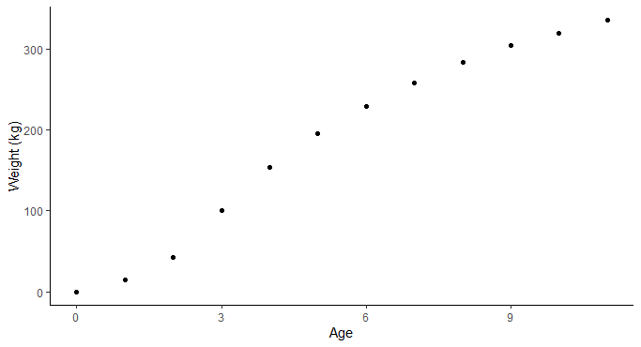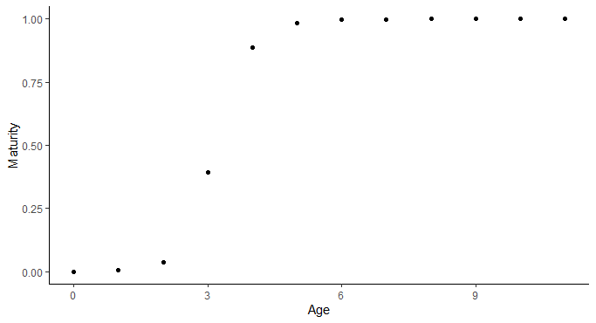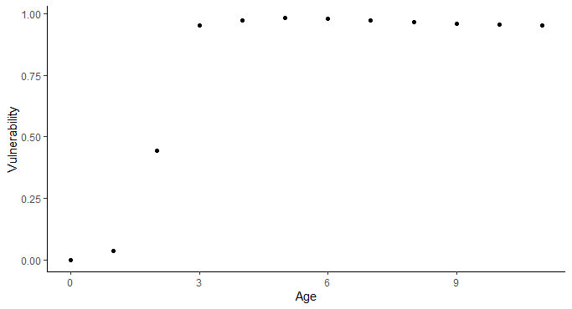

*Figure 2.1 Plots of the mean length-, weight-, maturity-, and vulnerability -at-age over the historical time period*

**Exercise 3. Time-varying productivity (SWNS/BoF herring)**

The goal of this exercise is to consider different conservation objectives that are consistent with the PA Policy and the definition of serious harm and consider the changes in biological parameters (weight-at-age, maturity-at-age) over time.

Part 1. Select a conservation objective that you feel is most representative of the definition of serious harm in the PA Policy:

Part 2. Identify an LRP that is consistent with one of the conservation objectives that you defined in Part 1.

Part 3. Suppose projections are conducted for the next 2 generations (~10 years for herring). What biological parameters (weight-at-age and maturity) and recruitment do you assume for the projections?

As a group, prepare a 1-2 slide (< 5 minute) presentation that includes:

* your conservation objective(s);
* description of approach to defining an LRP and rationale for the approach;
* a time series plot of the indicator used to define the LRP and add a line representing the LRP. Extend the LRP line 10 years into the future to reflect the LRP used in the projection period.

Background:

An age structured model for SWNS/BoF herring stock has been fit. This is the same model that was used for exercise 2. For this exercise, consider that a spawning ground (Trinity Ledge: Figure 1) that was historically important to the SWNS/BoF stock collapsed between 1985-1990 and has not recovered and that there is variability in the biological parameters over time.

Dataset:

* Model estimated total biomass, spawning stock biomass, recruitment, apical F
* **Annual** estimates of weight-at-age, maturity-at-age, and vulnerability-at-age over the historical time period
* How to bring in dynamic unfished biomass? Several options of parameters to vary in F=0 projection.

**Exercise 4. Stock status in non-traditional stock assessments (SWNS/BoF herring)**

The goal of this exercise is to consider a situation when there is more than one model that is considered an acceptable characterization of the population dynamics. Suppose the key uncertainty for the SWNS/BoF fishery is the assumed resilience of the stock and a management strategy evaluation (MSE) is being conducted to identify a management procedure that is robust to this uncertainty. Suppose three operating models are defined to characterize the uncertainty in resilience using different assumed steepness values for the stock recruitment relationship. Given an empirical indicator of SSB and the three operating models, define an LRP for the stock.

As a group, prepare a 1-2 slide (< 5 minute) presentation that includes:

* description of approach to defining an LRP and rational for the approach;
* a time series plot of the indicator used to define the LRP and add a line representing the LRP.

Background:

An age structured model for SWNS/BoF herring stock has been fit. This is the same model that was used for exercise 3. For this exercise, 3 operating models are fit:

* Base Case OM: h = 0.75
* Low Resilience: h = 0.65
* High Resilience: h = 0.95

Dataset:

* Empirical indicator of SSB (acoustic index of SSB from 1999-2020)
* Model estimated total biomass, spawning stock biomass, recruitment, apical F for each of the 3 models
* **Annual** estimates of weight-at-age, maturity-at-age, and vulnerability-at-age over the historical time period