77065599

Base URL: http://www.ysxb.ac.cn/en/aps

Firstly, change the language in the website Chinese to English.

Make sure to have English converted from here.



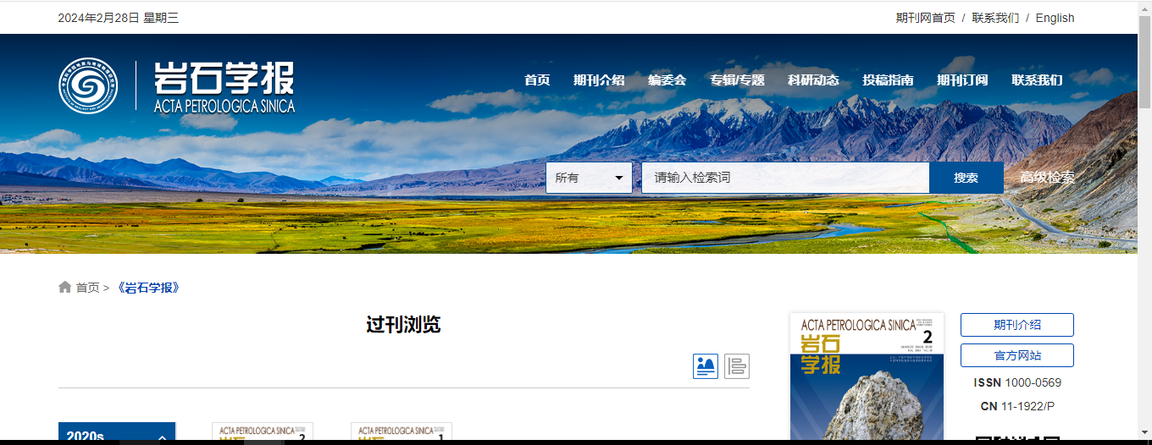

1)Select current issue from here

Articles will be appeared like below.

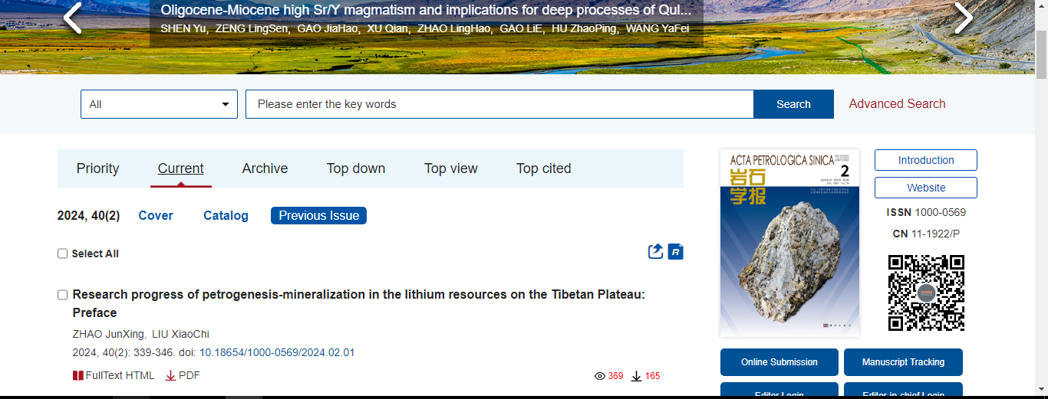



Select archive to find volume issue for download.

5)Capture volume from here

5)Capture issue from here

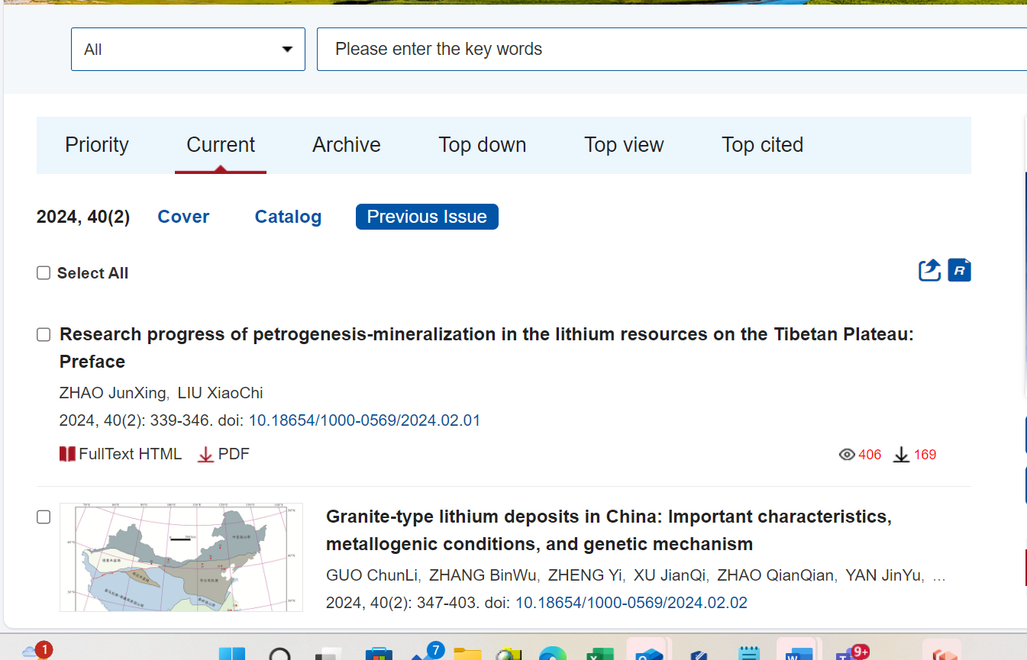

4)Capture article year from here.

2)Capture article title from here.



3)Capture article Doi from here.



6)Capture page range

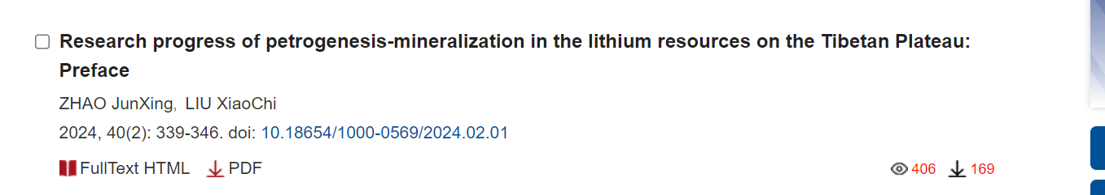

7)Click pdf button. The file will download.

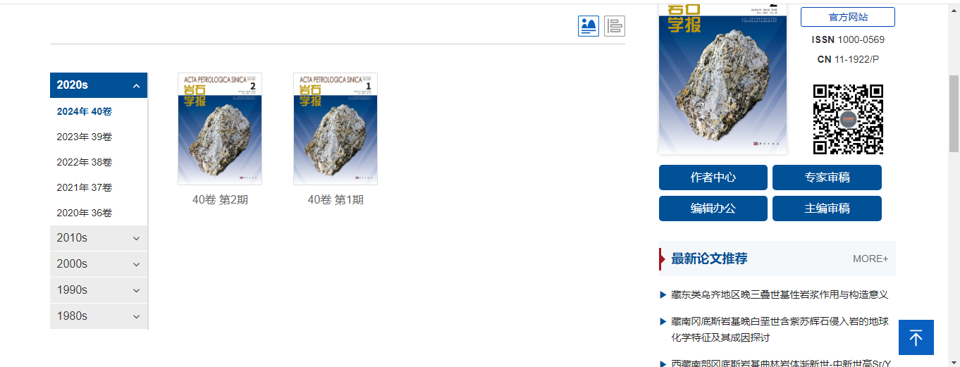



After selecting volume issue all required articles will be listed here.

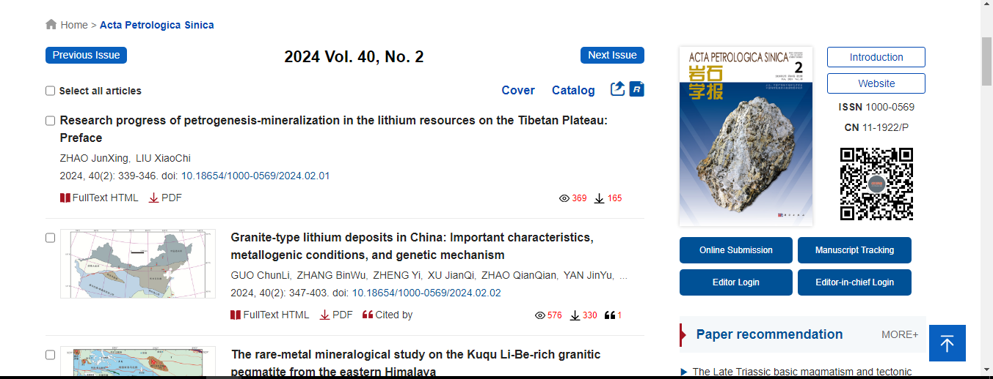

Click the article name to open the article info page to download the PDF.





Article names



Apply following step to download the PDF.

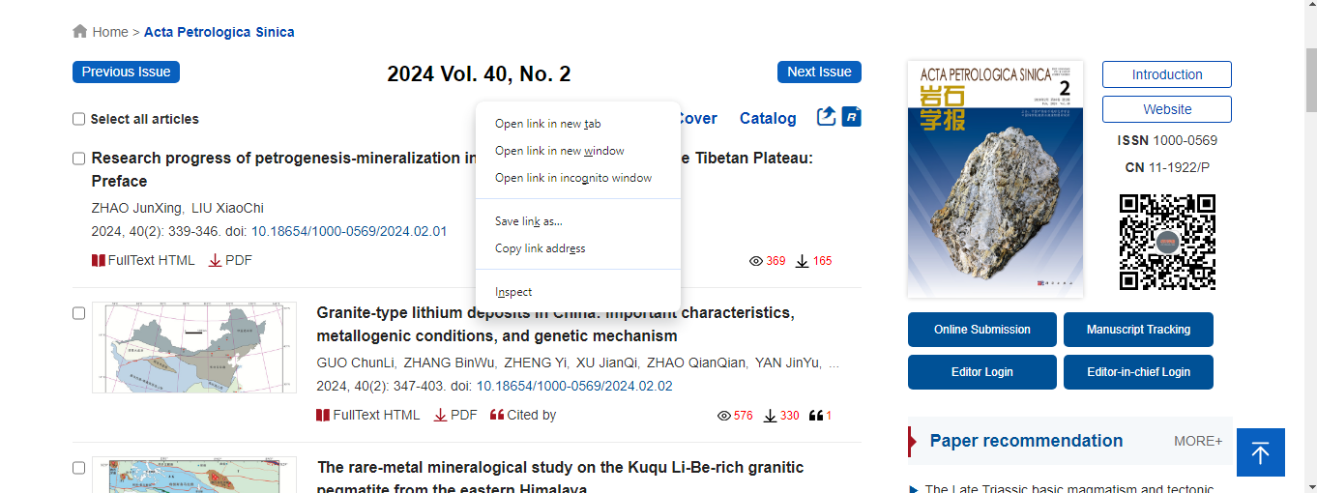



Click the open link in the new tab.



The article open with new tab.

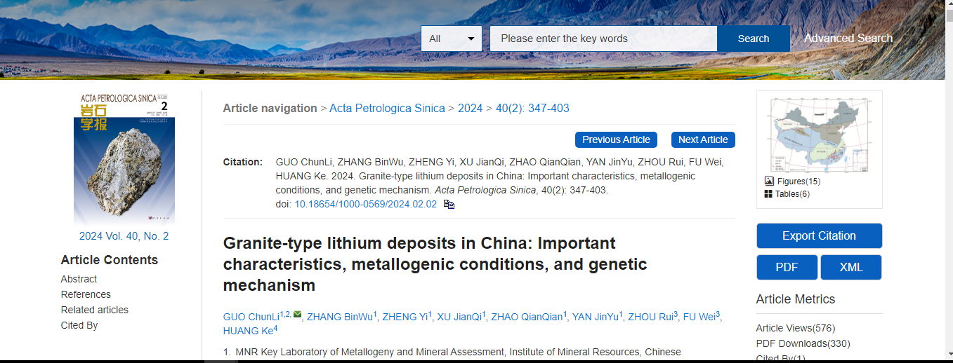



Click pdf button download pdf.



And download the pdf.

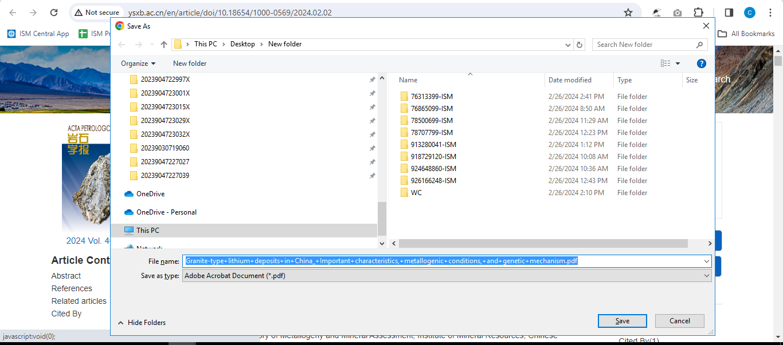



Meta data can be captured as below.

* Year
* Volume and issue

Volume issue



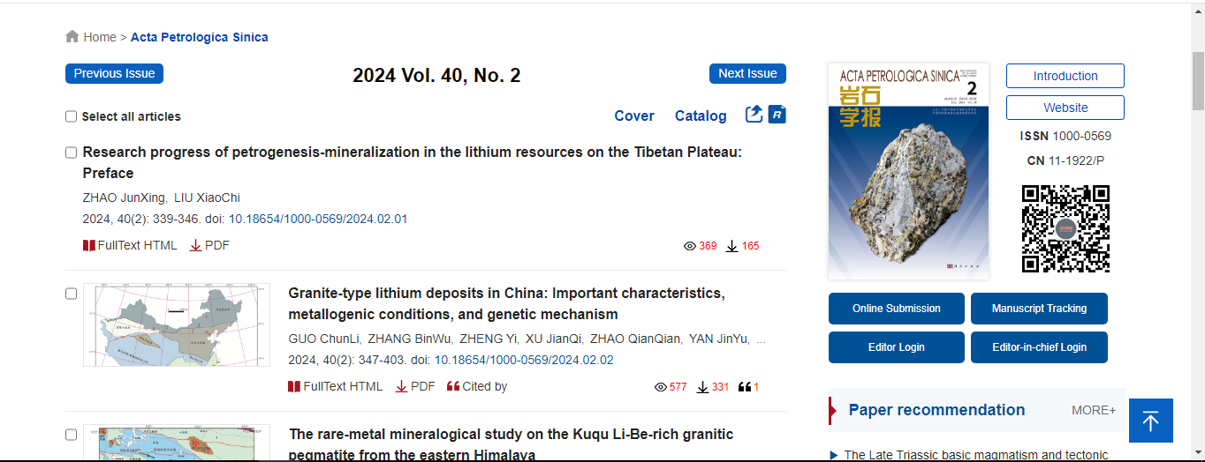



Year

* Doi
* Page range

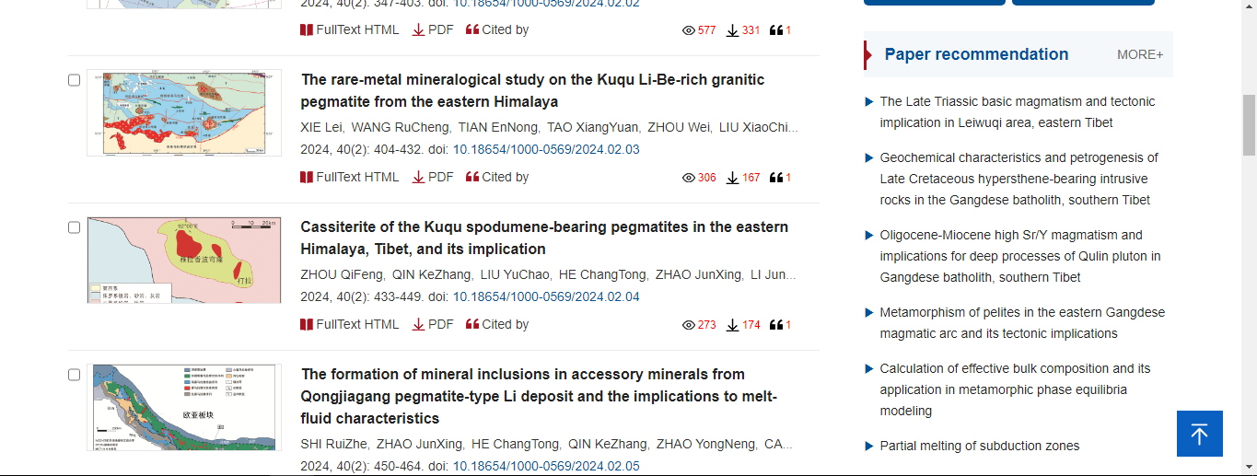



Page range



Doi

