|  |  |
| --- | --- |
| <https://www.ingentaconnect.com/content/scimed/mppa> | 76906799 |
| <https://www.ingentaconnect.com/content/lse/jtep#Supp> | 77144599 |
| https://www.ingentaconnect.com/content/ahs/jahs | 77638299 |
| https://www.ingentaconnect.com/content/wfbi/sim | 78064499 |
| https://www.ingentaconnect.com/content/cuny/cp | 78066099 |
| https://www.ingentaconnect.com/content/png/ajhb | 78204099 |
| http://www.ingentaconnect.com/content/aapd/pd | 78225999 |
| <https://www.ingentaconnect.com/content/oekom/gaia/> | 78298599 |
| http://www.ingentaconnect.com/content/klos/rofo | 79370399 |
| https://www.ingentaconnect.com/content/klos/zphf | 79370499 |
| http://www.ingentaconnect.com/content/uwp/stce | 79482499 |
| https://www.ingentaconnect.com/content/1942-258x | 2.99E+08 |

Please note above websites having same structure of website.

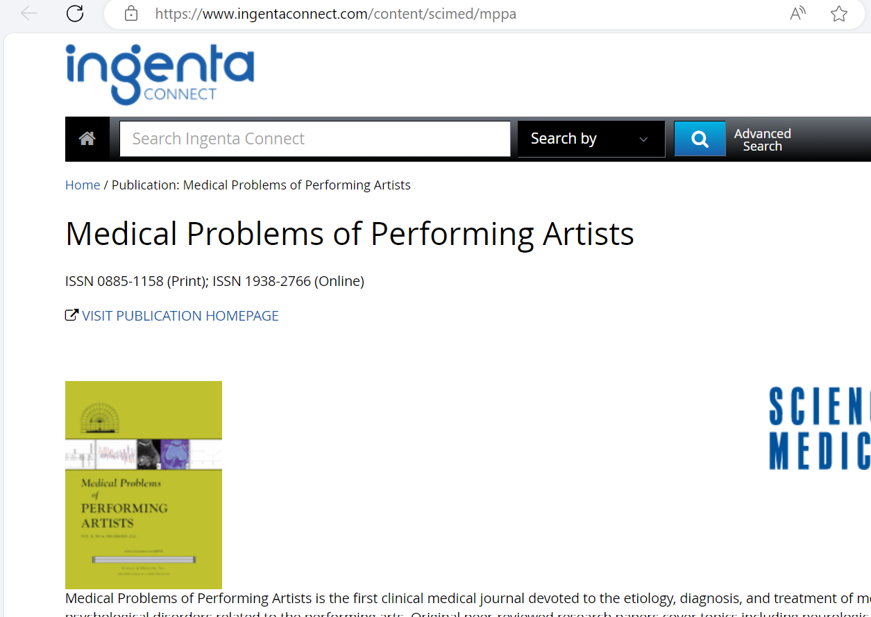1)Go to the website using base url,Then you will direct to landing page like below

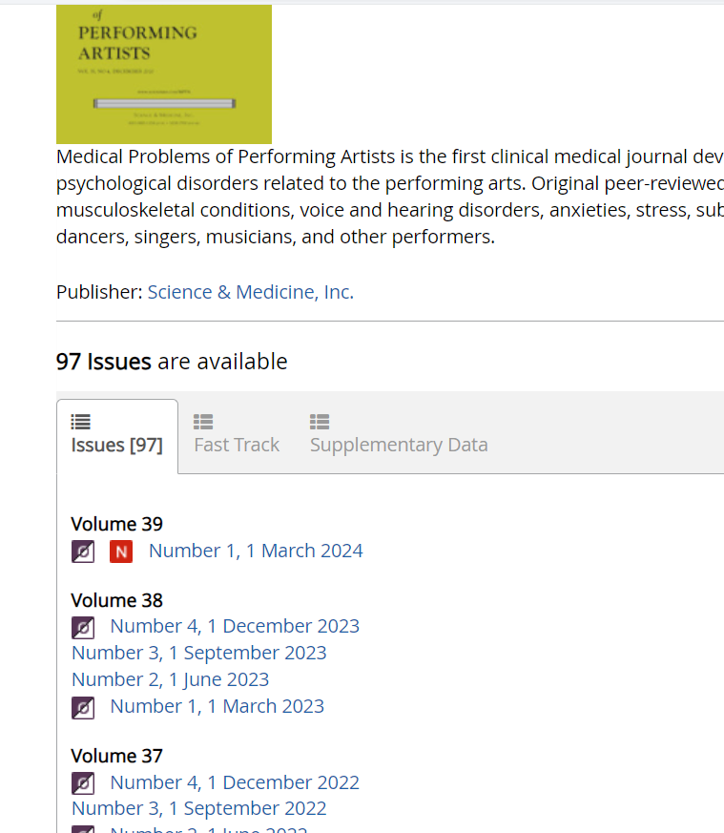

2)Select latest issue from the list

7)Capture month from here

6)Capture date from here

5)Capture month from here

4)Capture issue from here

3)Capture volume from here

8)Click the latest issue

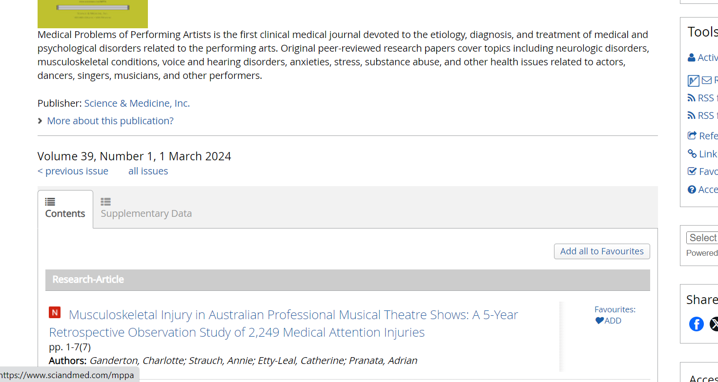Then articles will appear like below

9)Click the article title

You will direct to article page like below



12)Click the download button

11)Capture page range

10)Capture doi from here

When you click download button you will get pop pu window with pdf download page like below

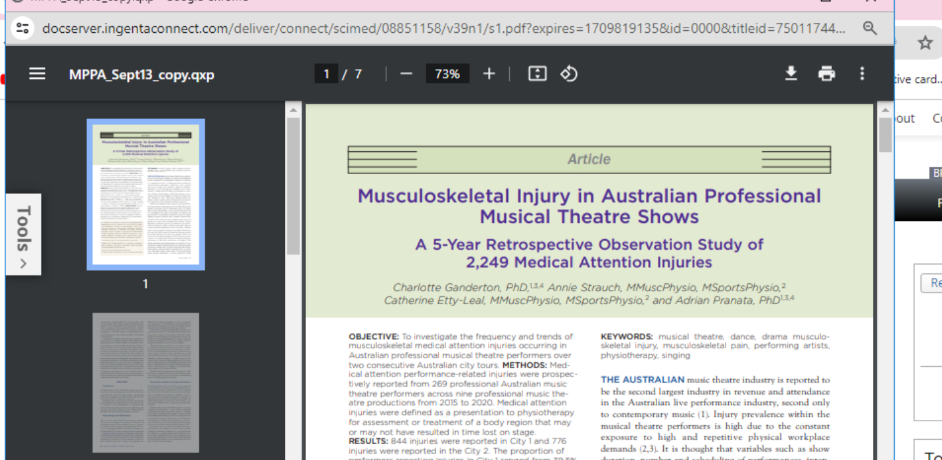

12)Click the button to download the button