|  |  |
| --- | --- |
| Source id | BASED |
| 934000907 | https://shc.amegroups.org/ |
| 934000908 | https://tro.amegroups.org/ |
| 934000909 | https://aob.amegroups.org/ |
| 934000910 | https://aoe.amegroups.org/ |
| 934000911 | https://aes.amegroups.org/ |
| 934000912 | https://apc.amegroups.org/ |
| 934000913 | https://aot.amegroups.org/ |
| 934000915 | https://www.theajo.com/ |
| 934000916 | https://jhmhp.amegroups.org/ |
| 934000918 | https://ls.amegroups.org/ |
| 934000919 | https://med.amegroups.org/ |
| 934000920 | https://mps.amegroups.org/ |
| 934000921 | https://ncri.amegroups.org/ |
| 934000922 | https://pm.amegroups.org/ |
| 934000923 | https://pcm.amegroups.org/ |
| 934292510 | https://mhealth.amegroups.org/ |
| 936337400 | https://jlpm.amegroups.org/ |

Please note above url based website having same structure of websites.

1)Go to the website using base url so will get landing page like below

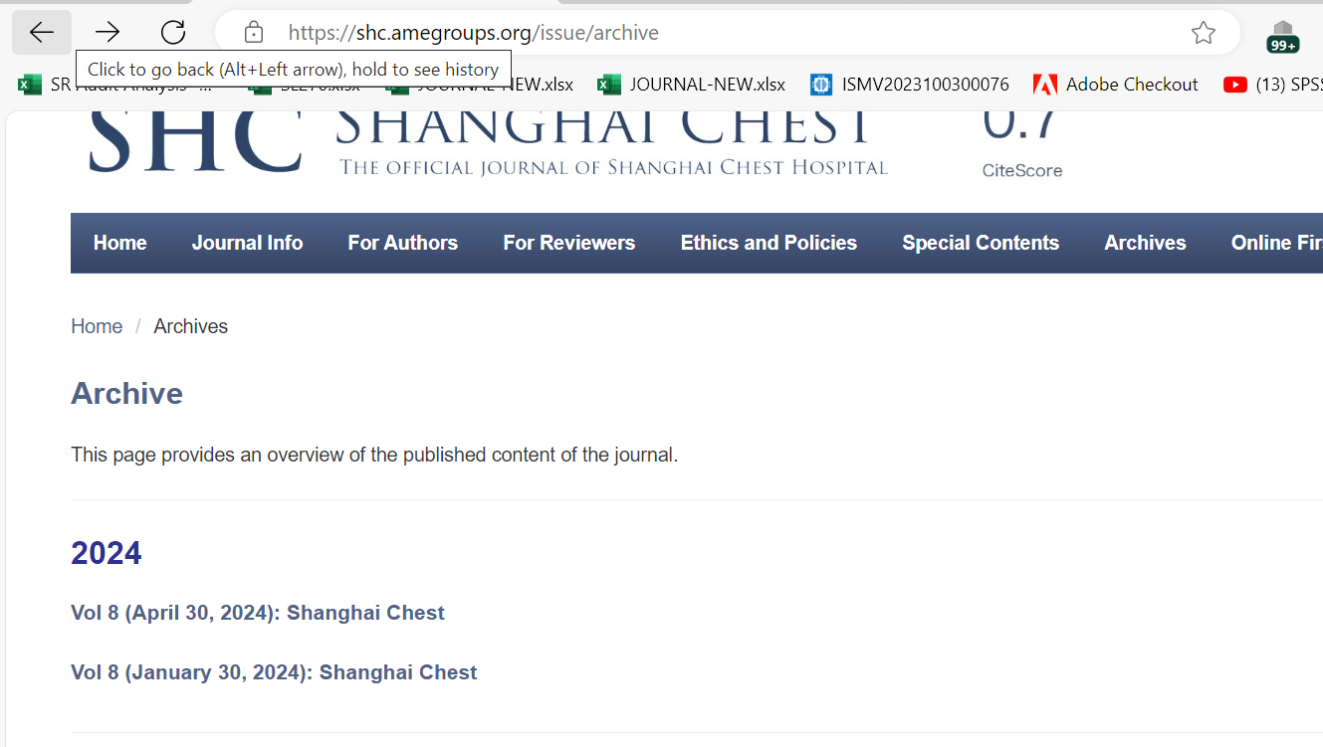

Volume

date

Capture month

Year

Click the volume text to got to the article list.

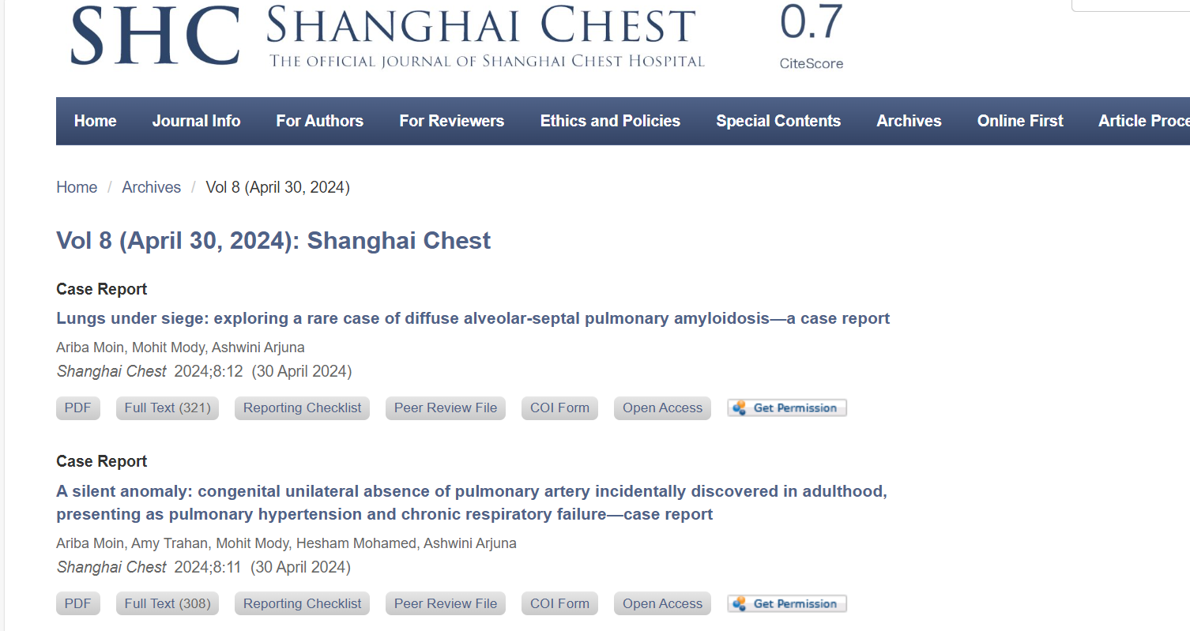

Capture article and click

You will direct to article page like below.

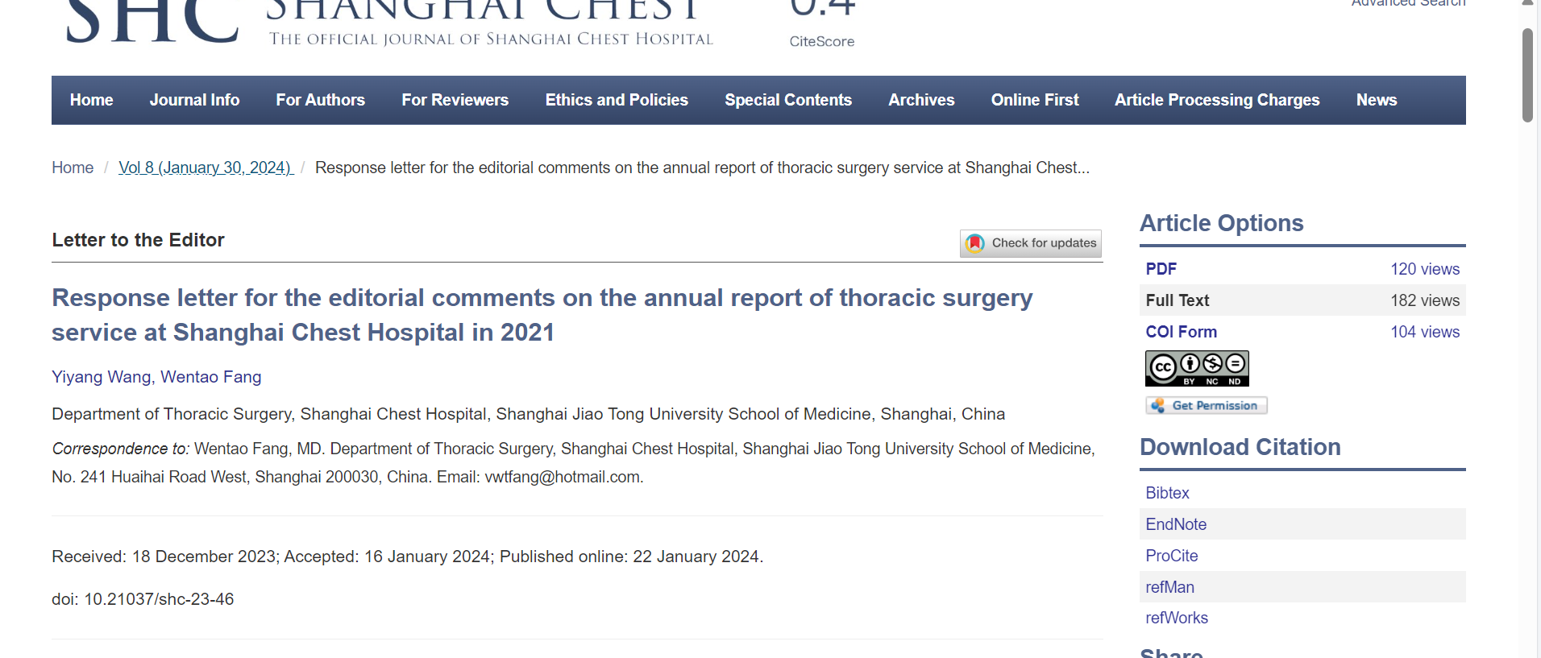

Click here to download

3)Capture Doi number

3)Capture article title from