**947344603**

Base URL:

**Agreement URL:** http://www.chinjmap.com/en/article/current

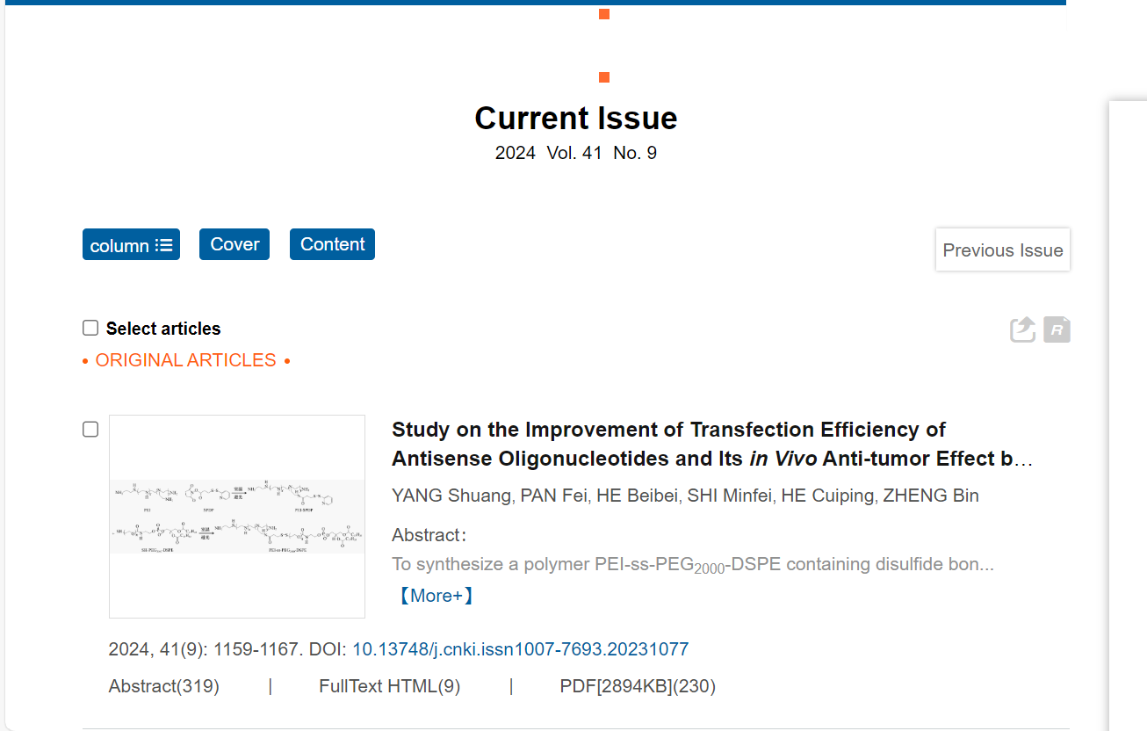

Year

Issue

Volume

Article title

Page range

Click here to Download pdf

Doi number

* In here both English and non roman toc needs to be captured so choose language option from website language conversion . then go to the Table of content page right click and save as pdf and merge in to one.