|  |  |
| --- | --- |
| SOURCE ID | Based url |
| 76814799 | https://www.scielo.br/j/csp/grid |
| 78645799 | https://www.scielo.br/j/po/grid |
| 78676499 | https://www.scielo.cl/scielo.php?script=sci_issues&pid=0716-5455&lng=es&nrm=iso |
| 78686999 | https://www.scielo.br/j/rbent/grid |
| 78688599 | https://www.scielo.br/j/gp/grid |
| 78688799 | https://www.scielo.br/j/ce/grid |
| 78690099 | https://www.scielo.br/j/jvatitd/grid |
| 78915199 | https://www.scielo.cl/scielo.php?script=sci_issues&pid=0071-1713&lng=es&nrm=iso |
| 78915499 | https://www.scielo.cl/scielo.php?script=sci_issues&pid=0718-2295&lng=es&nrm=iso |
| 79126299 | https://www.scielo.br/j/agora/grid |
| 79126399 | https://www.scielo.br/j/alea/grid |
| 79127899 | https://www.scielo.cl/scielo.php?pid=0716-5811&script=sci_issues |
| 79128899 | https://www.scielo.cl/scielo.php?script=sci_issues&pid=0718-3437&lng=es&nrm=iso |
| 79130399 | http://www.scielo.org.ar/scielo.php?script=sci_issues&pid=1666-485X&lng=es&nrm=iso |
| 79130599 | https://www.scielo.cl/scielo.php?script=sci_issues&pid=0718-2376&lng=es&nrm=iso |
| 273550599 | https://www.scielo.br/j/bolema/grid |
| 657092715 | https://www.scielo.br/j/jbn/grid |
| 835359965 | http://www.scielo.org.co/scielo.php?script=sci_issues&pid=2248-6046&lng=en&nrm=iso |
| 76594699 | https://www.scielo.cl/scielo.php?script=sci_issues&pid=0717-7526&lng=en&nrm=iso |
| 76616299 | http://www.scielo.org.ve/scielo.php?script=sci_issues&pid=0048-7732&lng=en |
| 640460702 | https://www.scielo.br/j/rpp/grid |
| 644487443 | https://www.scielo.cl/scielo.php?script=sci_issues&pid=0718-8471&lng=en&nrm=iso |

Above mentioned websites having same structure of websites.

2)Go to the website using base url so you will direct to this type of webpage

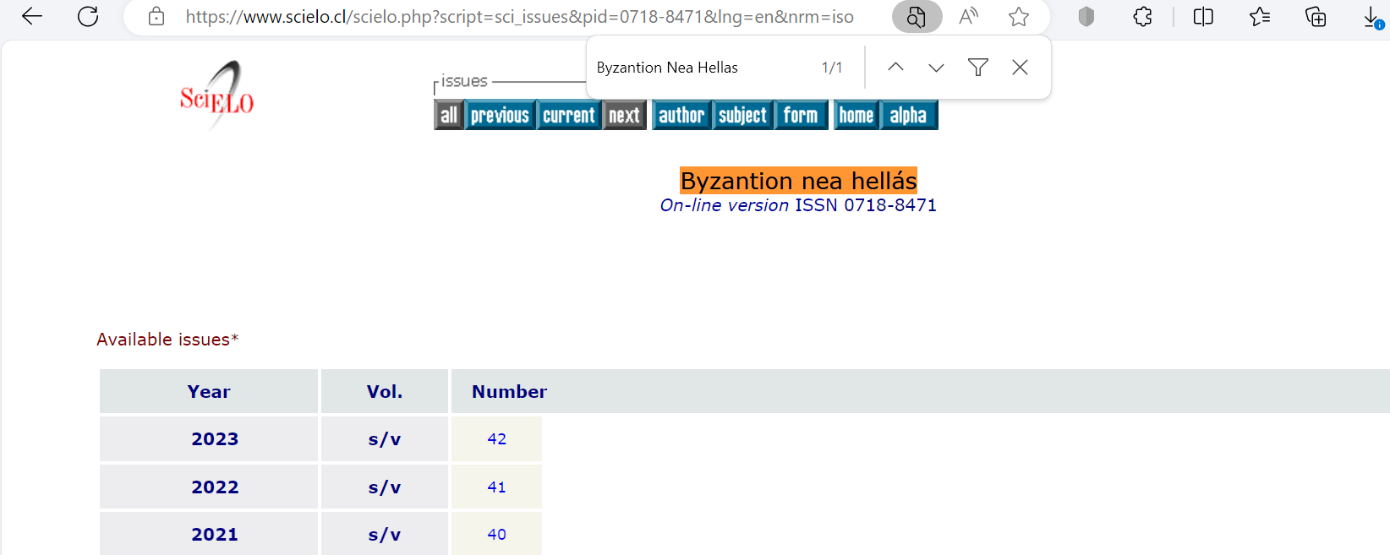

2)Click here

Figure-01

For this example, website no volume number available but there are volume numbers in websites within this id list so if have capture as Figure -01 column.

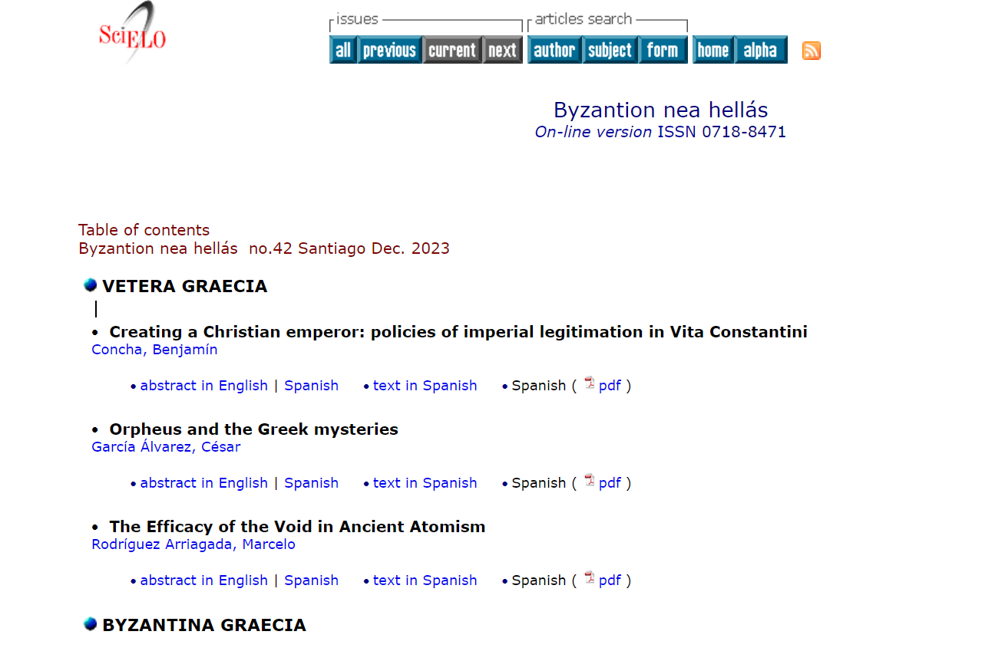

7)Click this button

6)Capture article title

5)Capture Volume

4)Capture Month. Take full month.

Dec.=December

3)Capture year

You will direct to the article page

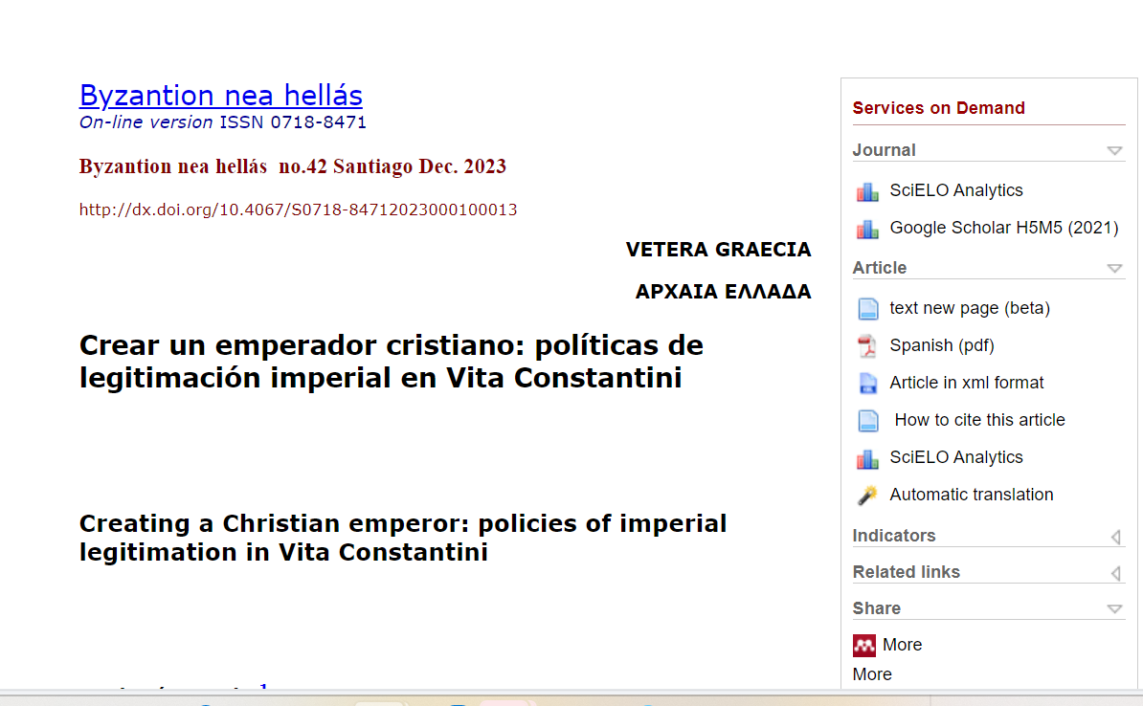

8)Click this button to download pdf

8)Capture doi number