78978499

Base URL: https://medic.upm.edu.my/our_journal-3046

Select the latest issue available.

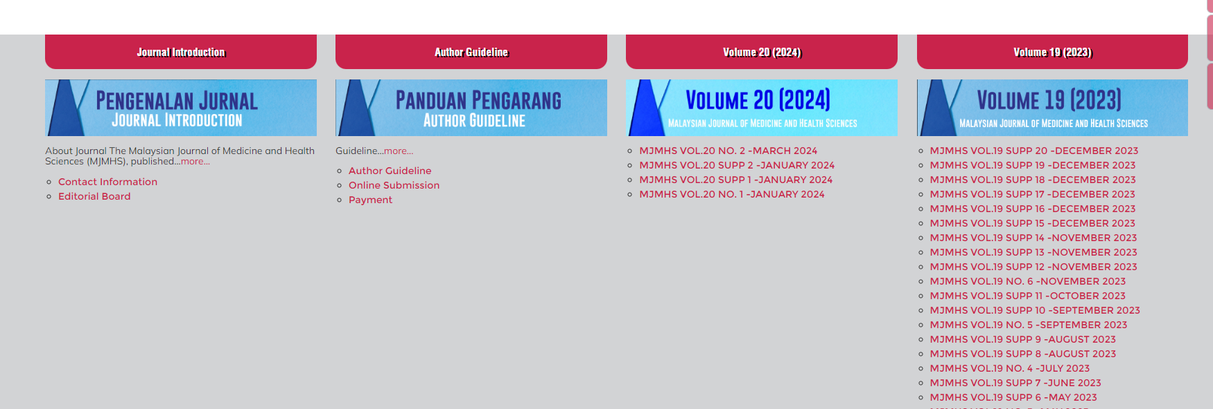

All the required articles will be listed here.

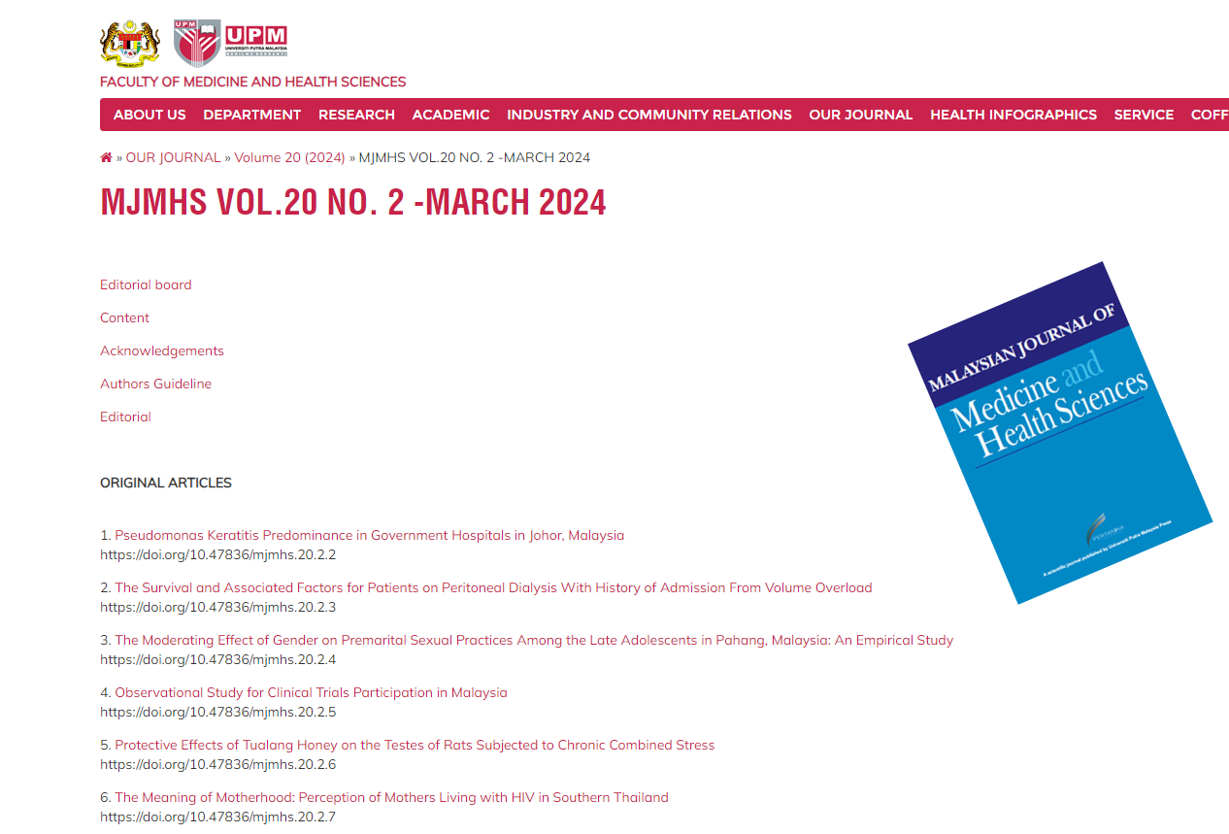

Below are some of the meta-data that can be extracted from the website.

Articles marked below in green should also captured but those articles dosen’t have a DOI.

DOI

Title

Month and Year

Issue

Volume

After extracting the data click the title.

**Note: Editorial Article which is marked above in yellow should also be captured the DOI of the article is available in the PDF.**

**DOI of the Editorial Article**

After clicking the title it will Load the PDF.

URL

Download

Click the marked button to download the pdf.

**Note: there are supplement issues available in this SID.**

Articles in supplements does not have DOIs.

Instead of the issues Supplement is captured in those as marked below.

In this case it is – Supplement 1

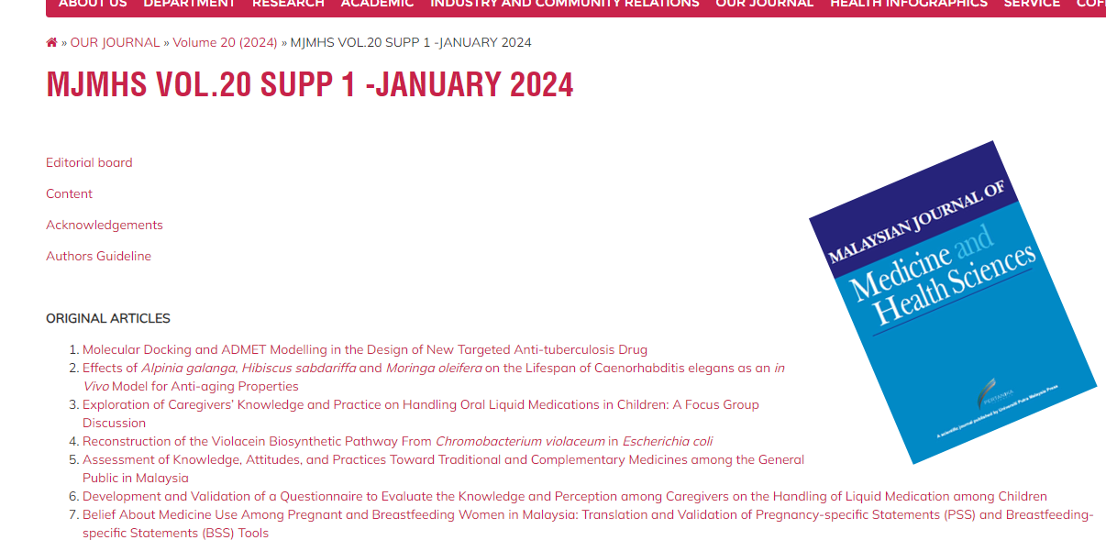

Supplement