**951527214**

Base URL:

[**https://www.hjgcjsxb.org.cn/indexen.htm**](https://www.hjgcjsxb.org.cn/indexen.htm)

* Select the issue from the issue list.

**Select the Current issue from here.**

* All required articles will be listed here.

* Meta data can be captured as below.

**Volume, issue and Year**

**DOI**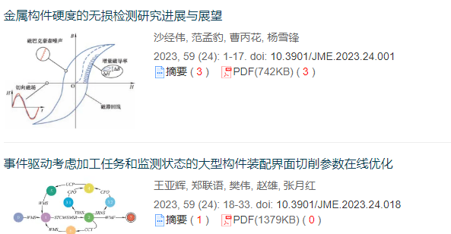

**Article Name**

**Page Range**

**Click here to download the pdf**

Month