933052861

<https://fsct.modares.ac.ir/browse.php?sid=7&slc_lang=en>

1)Go to the website and make sure to change the language version in to English in website conversion

You will direct to archive page

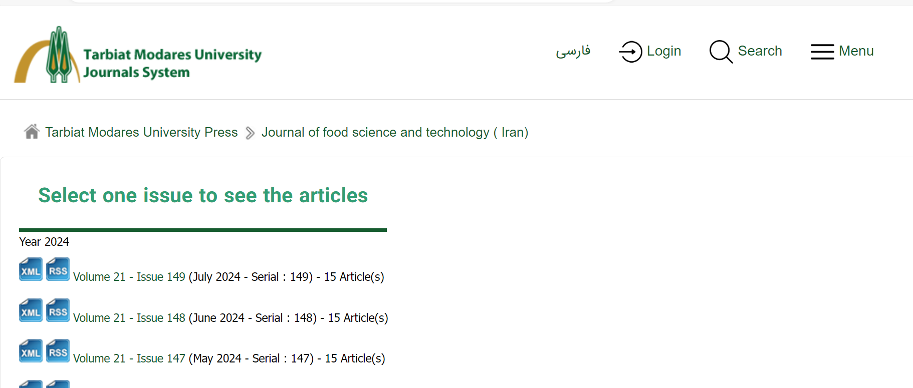

2) Go to the latest issue

4)Capture issue

You will get the issue page.

6)Capture article

3)Capture volume

9)Click here to download pdf

8)Capture doi

7)Capture page range

5)Capture year

Need to capture both English and Arabic language toc. For that right click in existing page and save as pdf with language convertion and save as pdf and merge in to one.