**76688499**

Base URL:

Agreement URL: http://www.cjco.cn/archive_list.htm

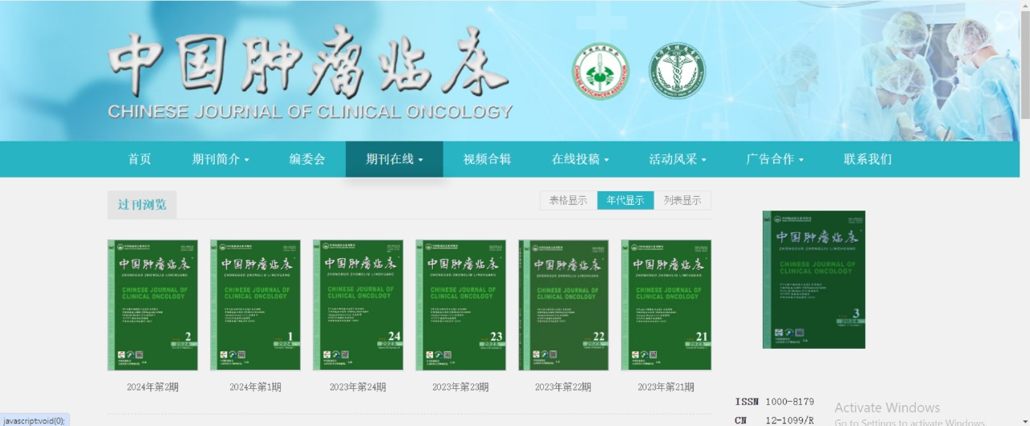

Go to the website by using the agreement URL and search the source title in the search bar

Archive catalog display like this

Select the current issue

Select the previous issue

Page range

Volume and issue number & year

Title

Click on download to open the pdf

Doi

Click on the title and open the page to get the URL.

Download the pdf