**76571499-** [**https://www.pnas.org/toc/pnas/current**](https://www.pnas.org/toc/pnas/current)

**1)Go to the website using base url. You will direct to the current issue of source title.**

7) Capture date

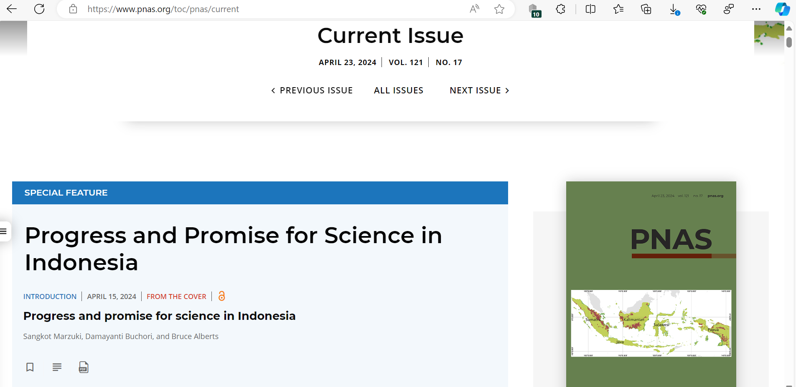

8)Capture title and click

6)Capture month

5)Capture year

2)Capture volume

3)Capture issue number

9)you will direct to the article page like below.

11)Capture DOI

12)Click here to download

10)Capture identifier