927676437

Base URL: https://formative.jmir.org/

Select Issues from Browse Journal drop down.

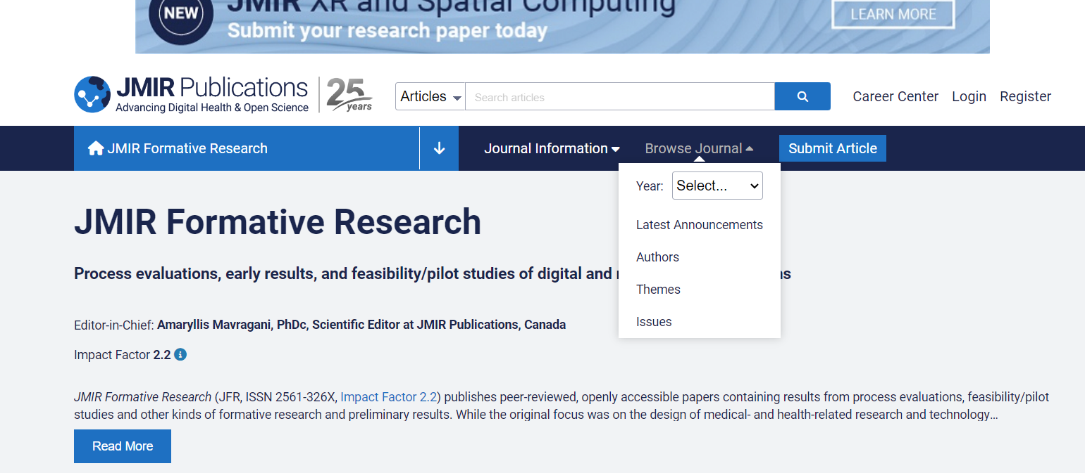

Select the latest volume or the issue available in here.

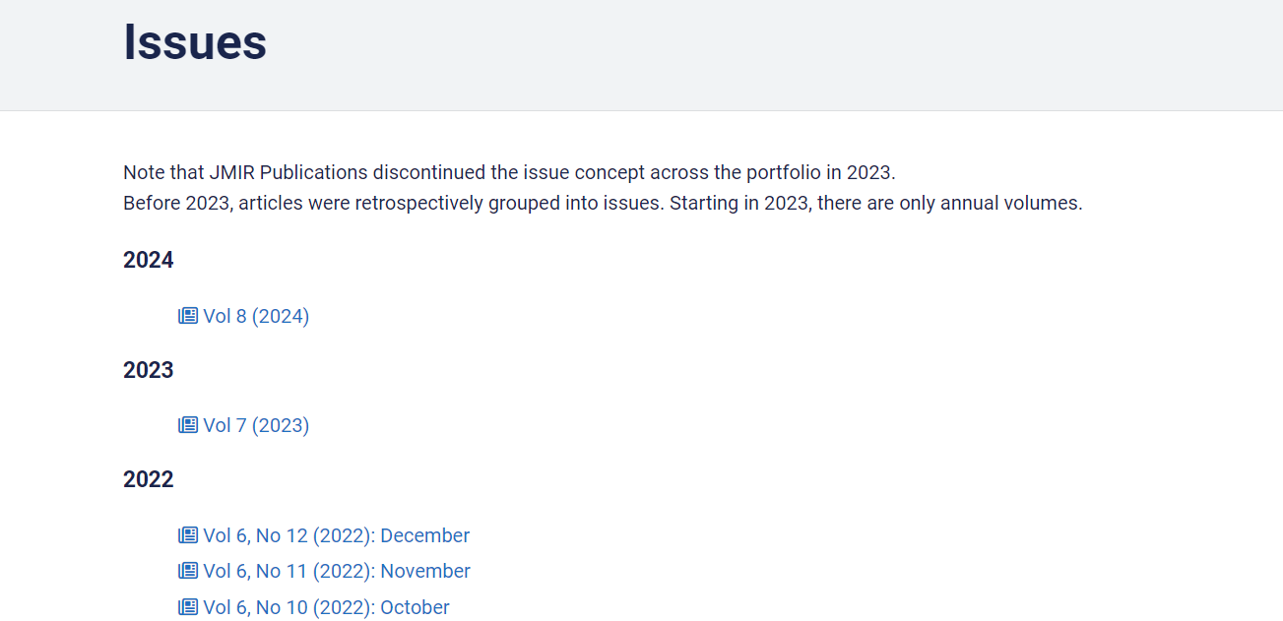

All required articles will be listed here.

Below are some of the meta-data that can be extracted from the website.

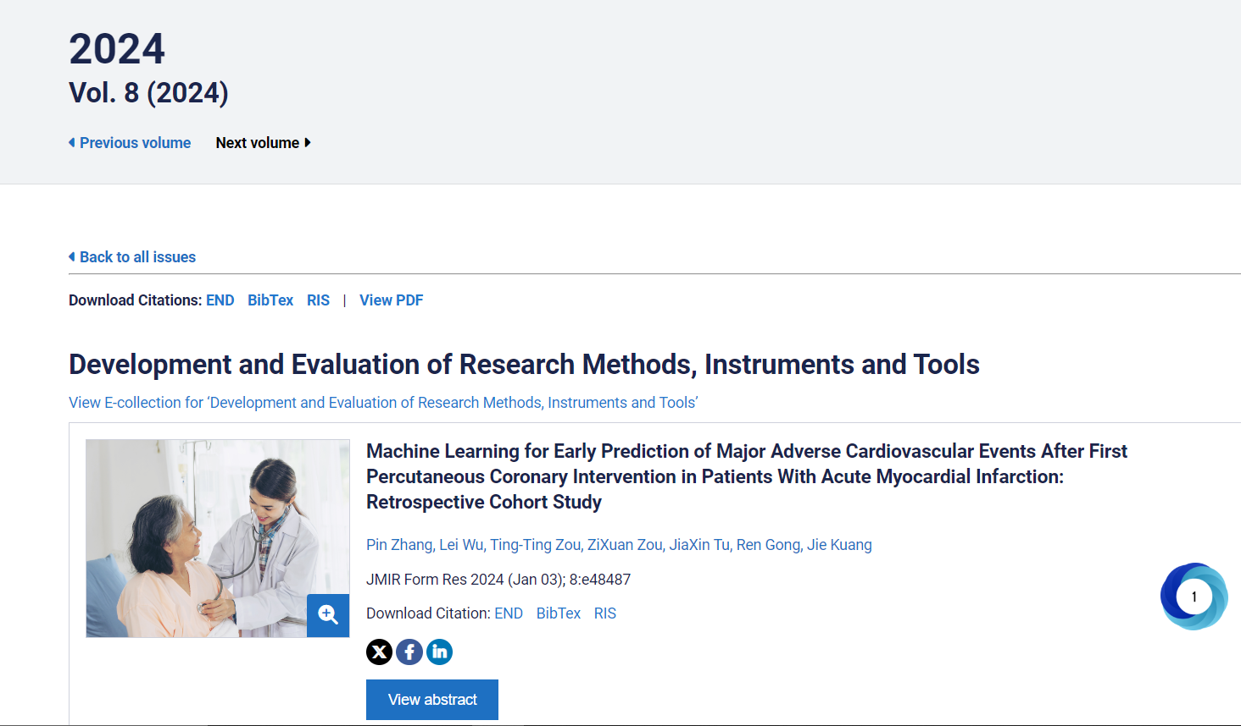

Identifier/ Article No

Title

Volume

Year

Some times and Issue no could be available next to the volume if so it should be captured as well.

Page Range should be “D” in this, and article no should be captured.

After capturing the data click the title.

URL

DOI

URL and DOI should be captured from here.

Scroll down, click the marked buttons to launch and Download the PDF

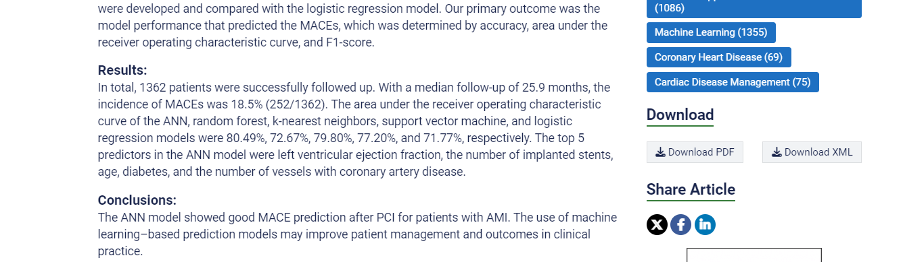

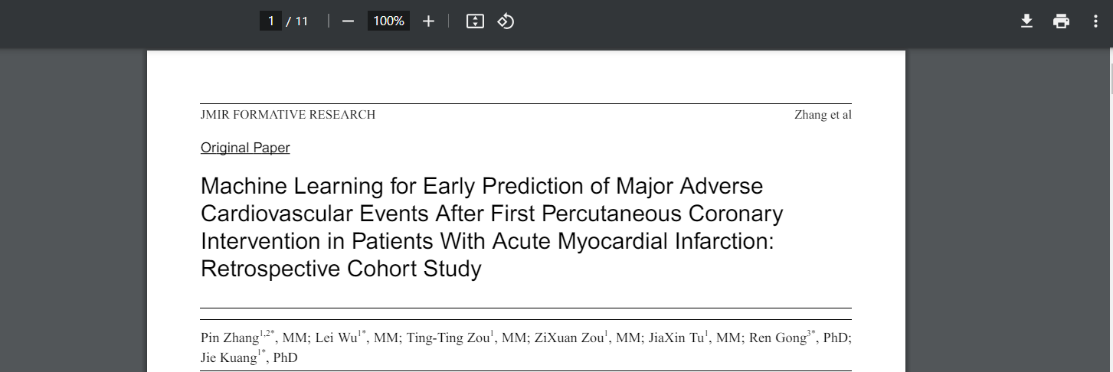

Downloaded