77845699

Base URL:

**Agreement URL:**

|  |
| --- |
| http://www.zpwz.net/zgptwkzzen/home |

* Select the issue from the issue list.

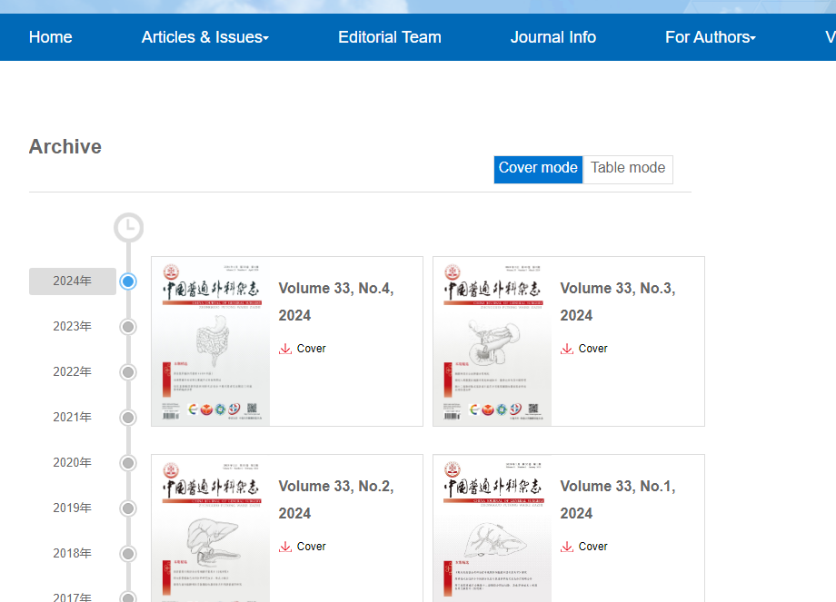

**Select the Current issue from here.**

* After selecting the issue content will appear here.

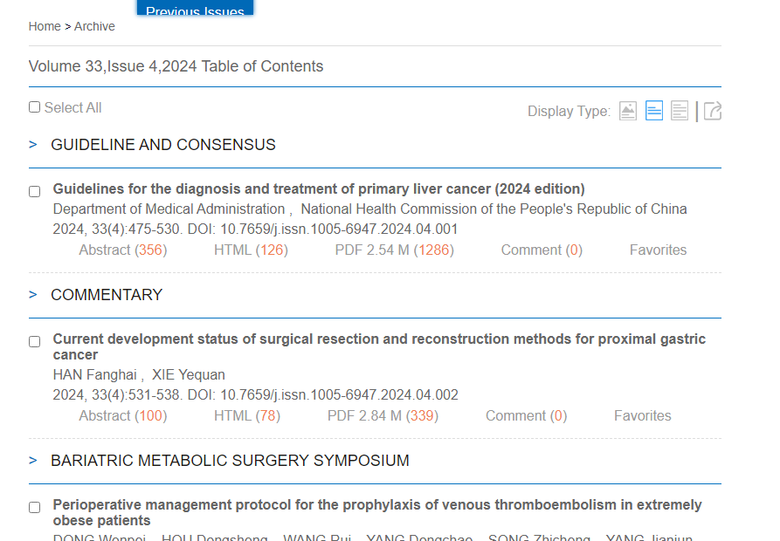

Title

Page range

* All required articles will be listed here

**Year**

**DOI**

**Then click here to download the pdf**

**Volume, issue**