76229199

Base URL:

**Agreement URL:**

|  |
| --- |
| http://ar.iiarjournals.org |

.

* Select the issue from the issue list.

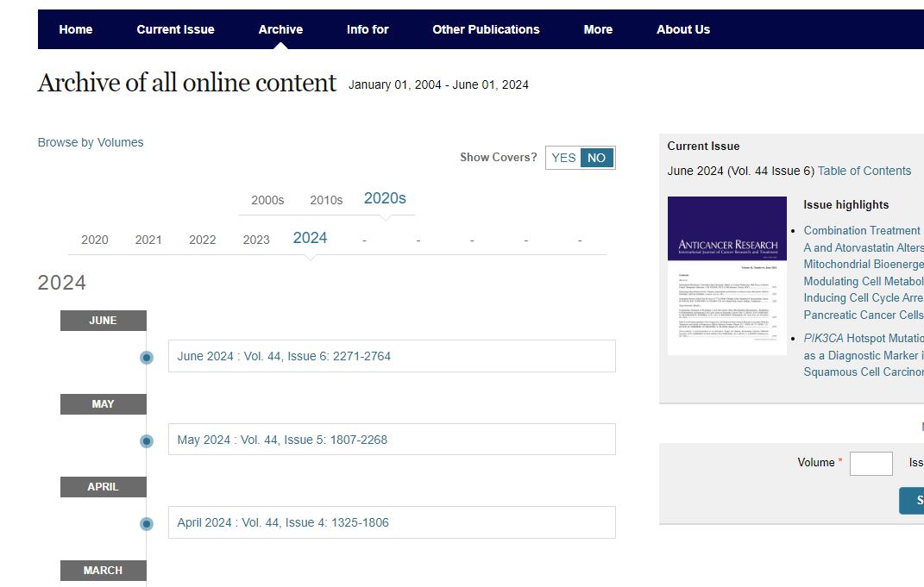

**Select the Current issue from here.**

* After selecting the issue content will appear here.

Title

Page range

**Year**

* All required articles will be listed here

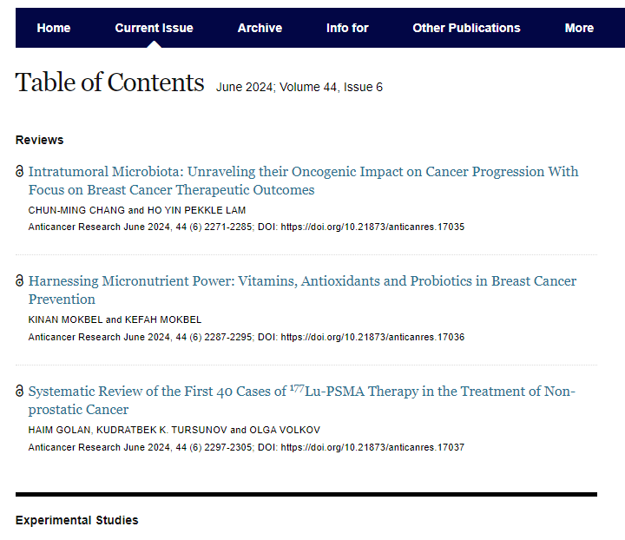

**DOI**

**Volume, issue**



**Then click here to download the pdf**