**79036999**

AreementRL: https://jestec.taylors.edu.my/Archives.htm

Select the Normal current issue

Select the special issue

In here normal issue will publish in once in a two month. And there is a special issue category also. So needs to capture both issues in once.

1)Normal current issue downloading. Just go to the website using based url then you will get normal current issue

Volume

Title

Page range

Year

Month

issue number

Click the title and go to the pdf

Click on the title and open the page to get the URL.

Download the pdf

2)Special Issue capturing

Select the special issue

Click here to get article lict

Special issue

month

Part number

Pub year

Please make sure to add “Special issue “ Text in special issue column. .And when capture the part number kindly put number only.

After clicking the text you will get article list like below. Make sure to scroll down little bit.

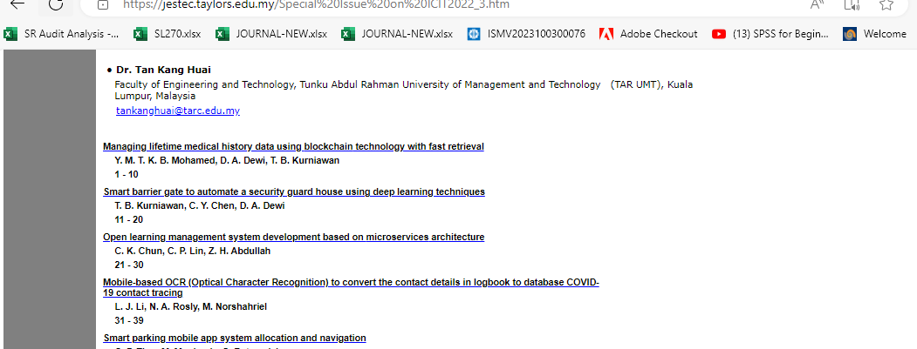

Page range

Article title

Click the title and go to the pdf

Click on the title and open the page to get the URL.

