Source ID - 78711099

Agreement URL - <http://www.cjmit.com/cjmit/ch/index.aspx>

* There is no English version of this website.
* The agreement URL directly takes to the Current issue of the Website.

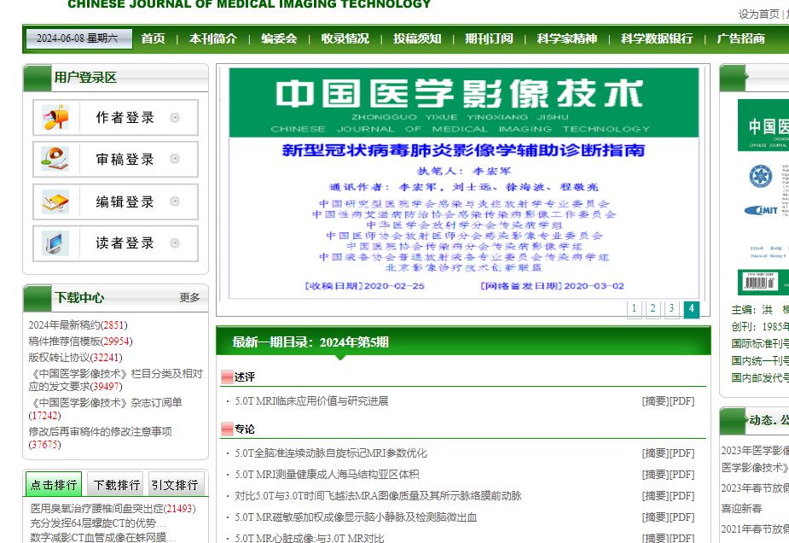

Click on the articles to capture data

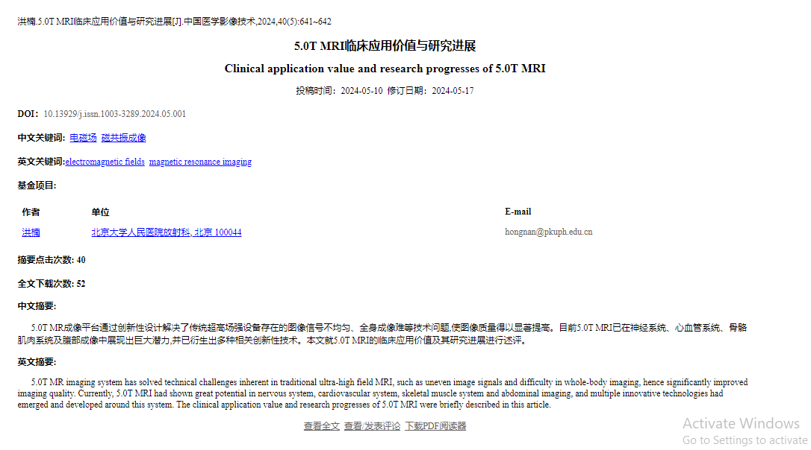

DOI

Click here to download PDF

Article title

Page range

Year, Volume and issue