Source ID - 946294808

Agreement URL - <http://kstom.ru/ks/issue/archive>

Click on ENG to view the English version of the website.

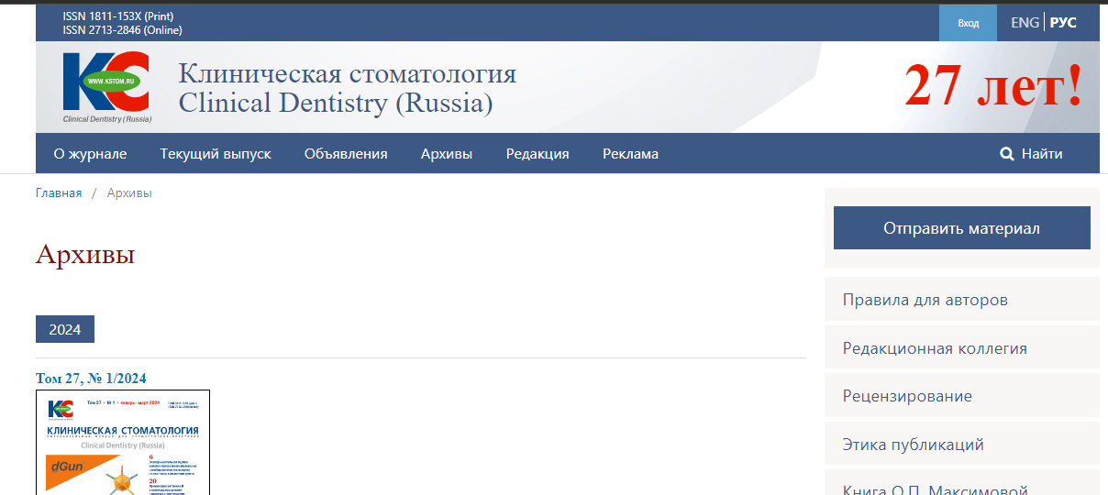

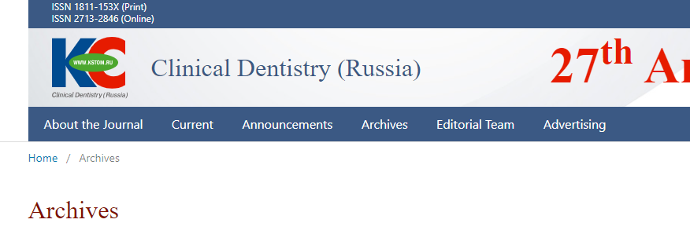

Click on current to view the current issue

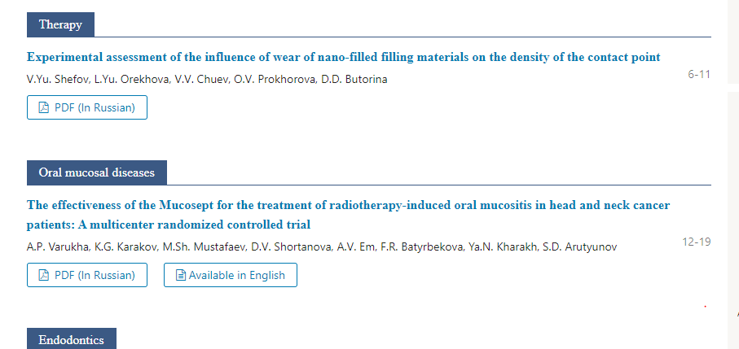

Page range should be captured from the TOC

Click on the article to capture data

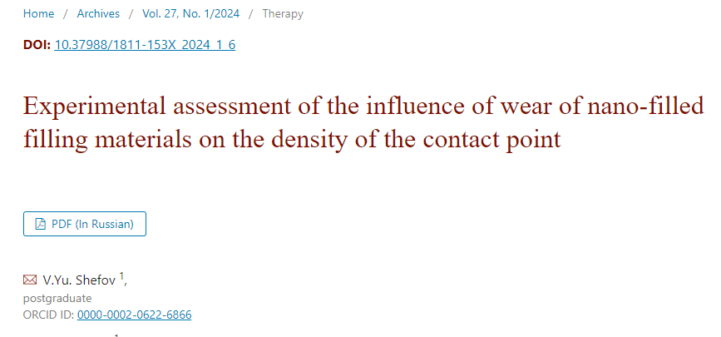

DOI

Article title

Click here to download PDF

Volume, Issue and year