943736813

https://www.riash.ru/jour/issue/current

Go to the website using based URL

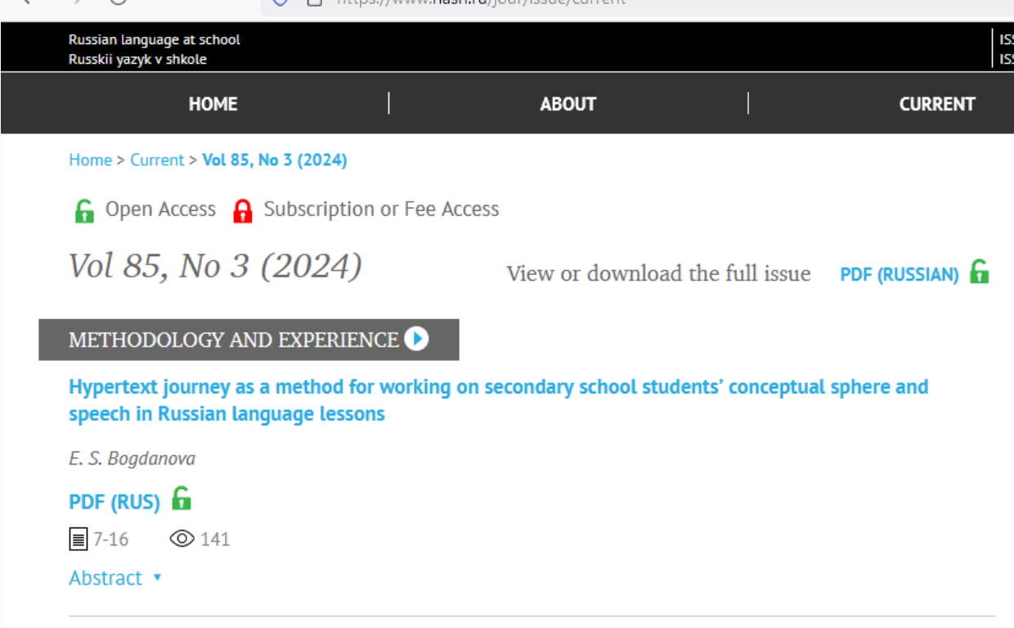

Capture page range

Capture article title and click

After clicking article title you will get article page like below

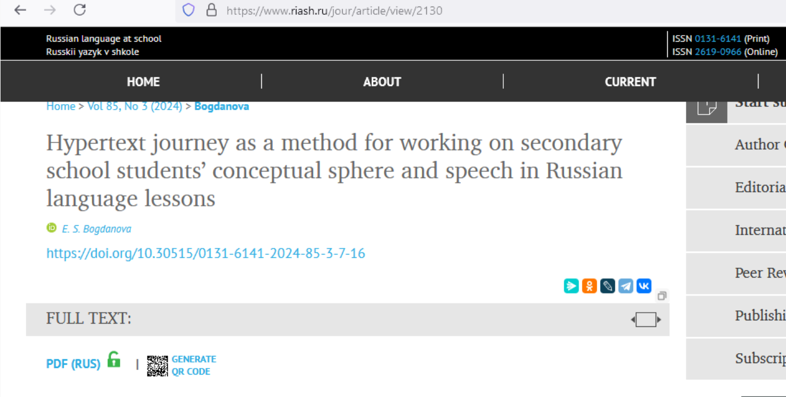

Click here to download pdf

Capture DOI

* In here both English and Russian toc needs to be captured so choose language option from website language conversion . then go to the Table of content page right click and save as pdf and merge in to one.