**SID - 937390316**

Base URL-<https://www.lcgdbzz.org/indexen.htm>

1)Go to the website using base URL. You will direct to the below page

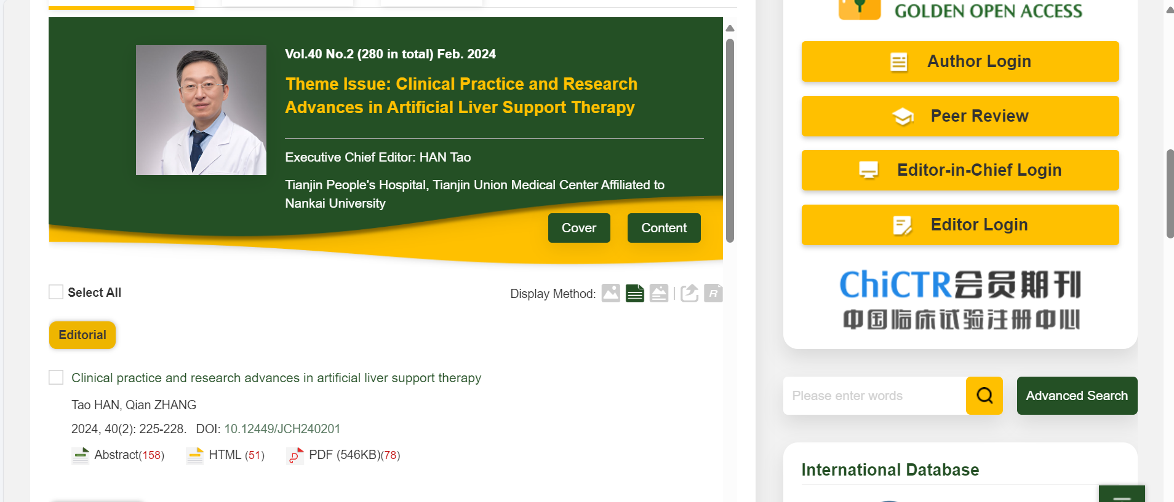

8)Click pdf to download pdf

6)Capture page range

5)Capture article title

7)Capture doi number

3)Capture issue

4)Capture month

5)Capture year

2)Capture volume

9)To download toc click right in mouse an save as html version.