|  |  |
| --- | --- |
| SOURCE ID | BASED URL |
| 77443799 | https://opg.optica.org/jot/issue.cfm |
| 77453999 | https://opg.optica.org/josaa/issue.cfm |
| 77454099 | https://opg.optica.org/josab/issue.cfm |
| 77486799 | http://www.osapublishing.org/opn/browse.cfm |
| 78265599 | https://opg.optica.org/col/issue.cfm |
| 294964999 | https://opg.optica.org/ome/issue.cfm |
| 301971399 | https://opg.optica.org/boe/issue.cfm |
| 301975899 | https://opg.optica.org/aop/issue.cfm |
| 638868208 | https://opg.optica.org/optica/issue.cfm |
| 638868209 | https://opg.optica.org/prj/issue.cfm |

These source ids having same structure for download pdfs…

Go to the based url and landing page will appear

Select the current issue from the issue list as below.

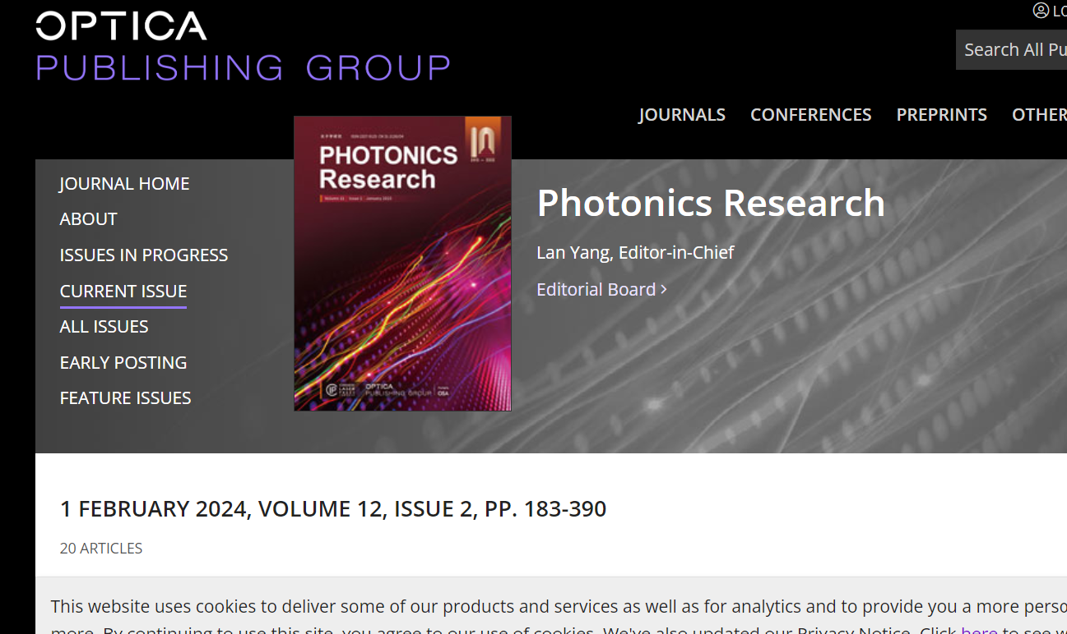

Always got to the current issue. Click the **current issue.**

Then article details will appear like below

Volume

Publication date,Month,year

Article Title

Page range

Issue

To download the pdfs click the **pdf button**

Will direct to the pdf download page .Then click download button and download the pdf

