**935890031**

**Base URL:**

**SourceURL:** http://www.ykxjz.com/oa/scriptlsit.aspxkind=Issue&Issue_No=2024%C4%EA4%C6%DA

Go to the base url

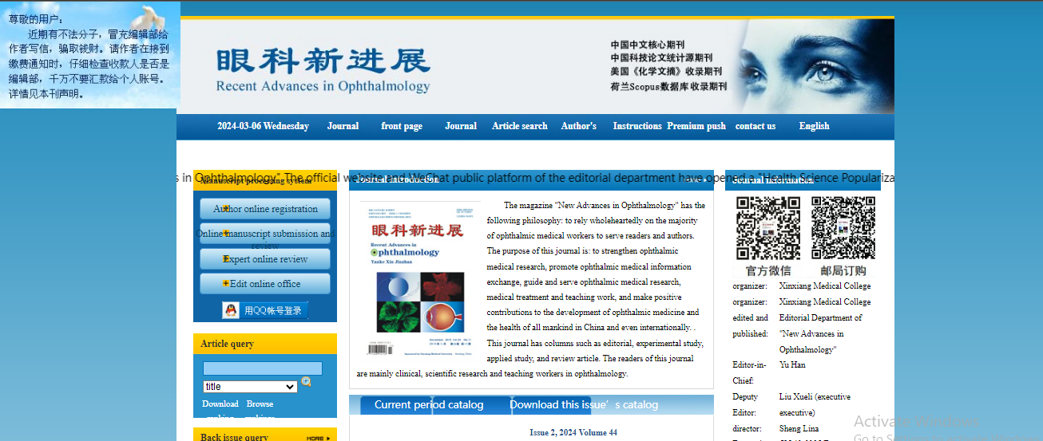

**Click the article search drop down and select issues.**

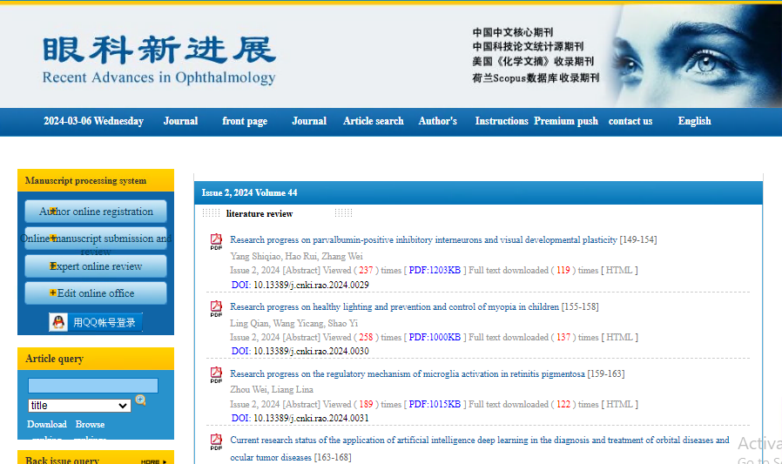

**Select the issues**



**After selecting volume issue all required articles will be listed here.**

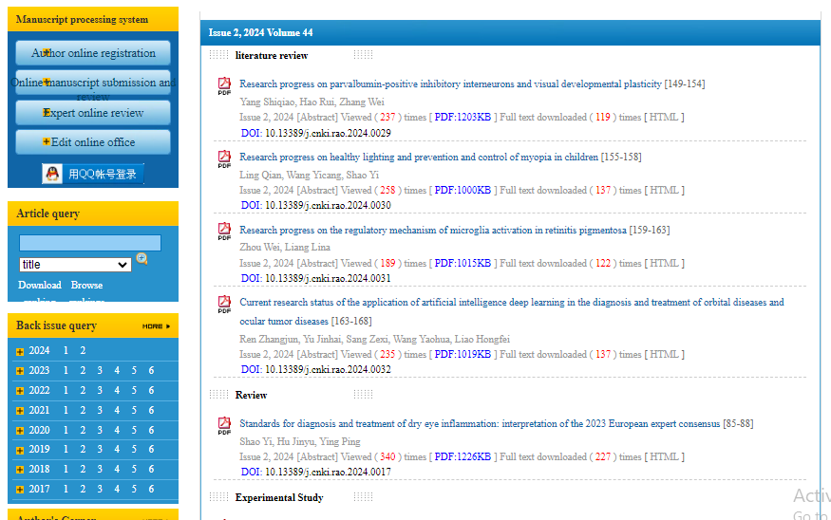

**Article names**

**Click the article name to open the article info page to download the PDF.**



**Apply following step to download the PDF.**

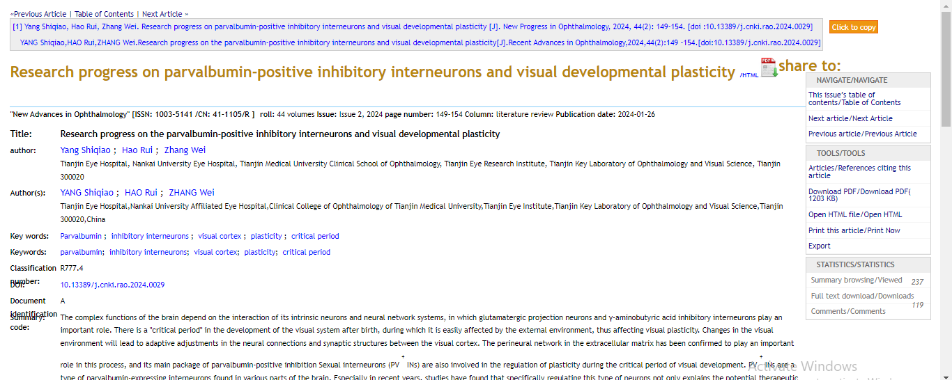

**Download the PDF file.**

**Select the PDF file.**

**Meta data can be captured as below.**

* **Month, Date, Year**
* **Volume and issue**

**Volume issue**

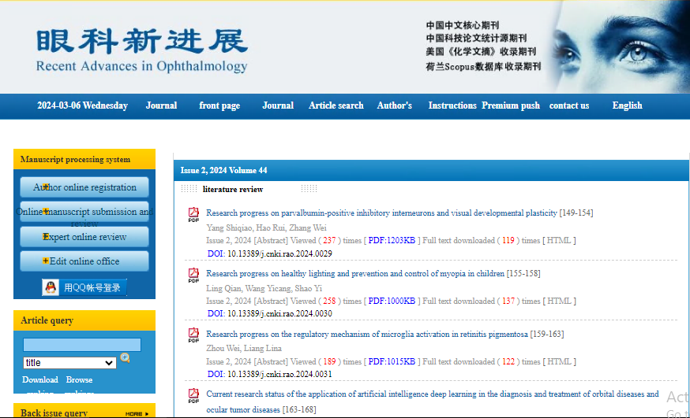

**Date Month Year**

* DOI
* Page Range

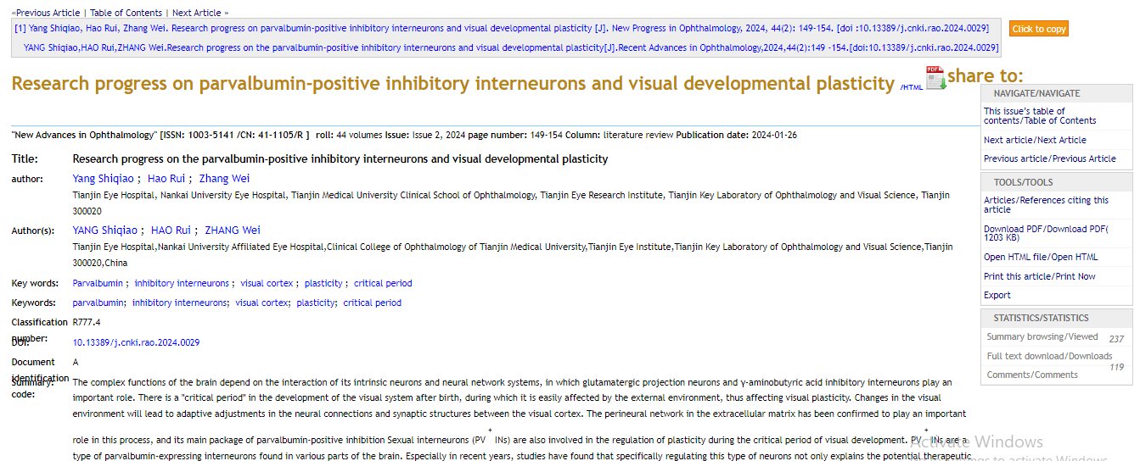

**DOI**

**Page Range**