

**Final Project**

|  |  |
| --- | --- |
| **Final Project – Assessment Sheet** | |
| **Programme** | Diploma in Information Technology |
| **Assessor/Lecturer** |  |
| **Unit** | Final Project |
| **Project Title** |  |
| **Student’s Name** |  |
| **Student’s Registration No** |  |
| **Submission Date** |  |
| **Marks Achieved (%)** |  |
| **Assessor/Lecturer Feedback** |  |
|  |  |
|  |  |

**Important Points.**

* Carefully check the hand in date and the instructions given with the project. **Late submissions will not be accepted.**
* Ensure that sufficient time is spent to complete the assignment by the due date.
* Do not wait till the last minute to get feedback on the project. Such excuses will not be accepted for late submissions.
* You must be responsible for efficient management of your time.
* If you are unable to hand in your project on time and have valid reasons such as illness, you may apply (in writing) for an extension.
* Failure to achieve at least 40.00% marks will result in a Repeat grade.
* Non-submission of work without valid reasons will lead to an automatic Repeat. You will then be asked to complete an alternative project.
* If you use other people’s work or ideas in your assignment, it must be properly referenced, using the HARVARD referencing system, in your text or any bibliography. Otherwise, you’ll be found guilty of committing plagiarism.
* If you are caught plagiarising, your grade will be reduced to a Repeat or at worst, you could be excluded from the course.

**Project Guidelines**

* You need to **create a software** solution for Skills International School using **visual studio** as your final project.
* Use **C# Programming language** for your project
* Follow the structure given in this document. Design given forms and apply value additions for it according to your requirement.
* Software **should** contain **minimum** **two forms**. Additional forms and features will get additional marks. (Login form and one Registration form is compulsory)
* Please follow the given instructions before you start the project.

**Instructions**

* Design the software system according to the given instructions.
* Use appropriate fonts, colors, and images for Frontend (GUI design) of your software.
* Proposed Software system **must have a database and properly connected** to the system. (Database should be designed using SQL Server Management Studio)
* Database must contain minimum **one Table** (Table column structure provided in Figure X).
* **Test the software** and submit the project on or before the given deadline.
* Create a **Microsoft Word Document** including all the screenshots of forms in your system and code snippets of each form.
* The entire project brief (These nine pages) should be attached as the first section of your project documentation.

**Word Processing Rules**

* The font size should be 12 point and should be in the style of Time New Roman.
* Set line spacing to 1.15. Justify all paragraphs.
* Ensure that all headings are consistent in terms of size and font style.
* Use the spell check and grammar check function of the word processing application to review the use of language on your assignment.

**Proposed Project**

Figure I – Login Form

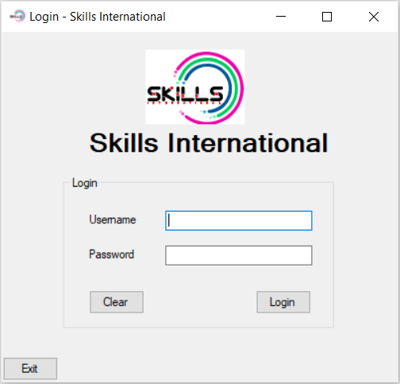

* Above form consist of;
  + One Picture Box
  + One Group Box
  + Three Labels
    - Skills International
    - Username
    - Password
  + Two Text Boxes
    - Username
    - Password
  + Three Buttons
    - Clear
    - Login
    - Exit

Design the above form using these tools and change respective properties using suitable values.

Figure II – Registration Form

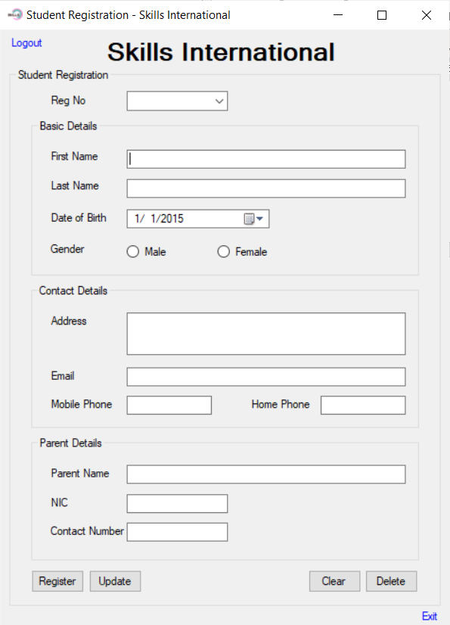

* Above form consist of;
  + Four Group Boxes
    - Student Registration
    - Basic Details
    - Contact Details
    - Parent Details
  + Thirteen Labels
    - Skills International
    - Reg No
    - First Name
    - Last Name
    - Date of Birth
    - Gender
    - Address
    - Email
    - Mobile Phone
    - Home Phone
    - Parent Name
    - NIC
    - Contact No
  + Nine Text Boxes
    - First Name
    - Last Name
    - Address (Multiline)
    - Email
    - Mobile Phone
    - Home Phone
    - Parent Name
    - NIC
    - Contact No
  + Four Buttons
    - Register
    - Update
    - Clear
    - Delete
  + Two LinkLabels
    - Logout
    - Exit
  + Two Radio Buttons
    - Male
    - Female
  + One DateTimePicker
    - Date of Birth
  + One ComboBox
    - Reg No

Design the above form using these tools and change respective properties using suitable values.

**Project Instructions**

**Designing**

* Design the project using Microsoft Visual Studio. **Designing above two forms is a must**, you can add more forms based on your imagination and those will be considered when marking.
* **Change the properties** of each object with suitable values.

**Functional Operations**

* When user runs the project, Login form needs to be appeared.

**Form I – Login Form (Figure I)**

* There is **one user** in the system. User name is **“Admin”** & Password is **“Skills@123”**. When user click on Login ( ) button after applying “Admin” as the username and “Skills@123” as the Password, the system needs to **hide the login form** and **open the second form** which is Registration form (Figure II). If the login credentials are wrong (Either Username, either Password or both), system needs to generate an error message (Figure III).

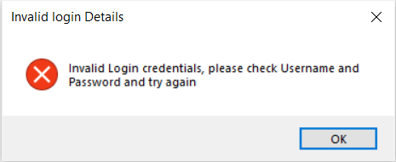

Figure III – Error Message

* You can **increase number of users** for the system. If so, there needs to be a table in the database to track those usernames and passwords as shown in figure IX.
* When user clicks on Clear ( ) button, texts in both username textbox and password textbox needs to be cleared and the username textbox needs to be **focused**.
* When you click on the Exit Button ( ) it needs to appear the following message box.

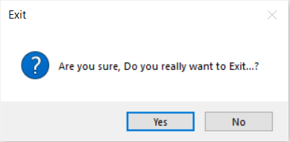

Figure IV – Exit Message

* If you click on Yes button, the entire system needs to be closed and if you click on No, the system stays without a change, but the dialogue box needs to be closed.

**Form II – Registration Form (Figure II)**

* The Form II (Figure II) is designated form for Student Registrations.
* Create the Database using Microsoft SQL Server Management Studio. Name the database as **Student**.
* Create the **Registration Table**.
* Connect the created Student Database with your C# project.
* In student Registration form, a registration can be done by clicking on Register Button ( ). Once the user clicks on **Register Button** after providing all the details in related fields in the registration form, the details need to be added in the “**Registration**” Table (Figure X) of “**Student**” Database and needs to appear following message box as well.

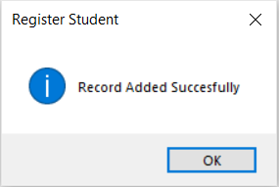

Figure V – Register Message Box



* Give the facility to the user to update records using **Update Butto**n ( ).
* Once the update executed, show the following message box.

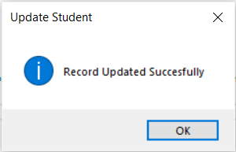

Figure VI – Update Message Box

* Give the facility for the user to Delete a selected record from the Database Table using the **Delete Button** ( ). Before Execution of Delete function, need to get users confirmation to delete. For that, use following message box or similar one.

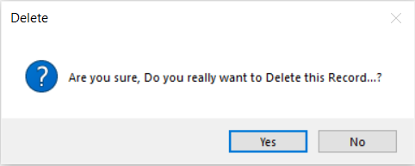

Figure VII – Delete Message Box

* Once the user clicks on Yes from the appearing message box, the details needs to be deleted from the system database based on the Registration Number of the record. After the execution of the Delete, following message box needs to be appeared.

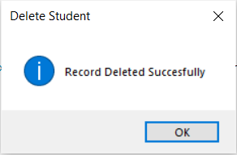

Figure VIII – Delete Confirmation Message Box



* When the user clicks on the **Reg No dropdown list** ( ), the user can see the registration numbers (Previously registered) appearing in the drop down list. When the user selects a registration number, it needs to work as a **Search** function when user changes the text of this and need to fill all other fields in the form by focusing the Reg No from the Database Table.
* When you click on the Exit Link Label ( ) it needs to appear the Exit message box (Figure IV).
* When user clicks on Logout Link Label ( ), it needs to logout from the system, disappear the Registration form and appear the login form (Figure I).

**Database Information**

Set Database name as “**Student**” and Registration Table (Figure X) needs to be there inside.

When designing the **Registration** Table in the Database, apply **regNo** column as the **primary key** for the table.



Figure IX – Database Table - **Logins**



Figure X – Database Table - **Registration**

**Table Structure**

Use the following table to identify data types for each column when you create the “**Registration”** table.

|  |  |
| --- | --- |
| **Field Name** | **Datatype** |
| regNo | Integer |
| firstName | varchar(50) |
| lastName | varchar(50) |
| dateOfBirth | dateTime |
| gender | varchar(50) |
| address | varchar(50) |
| email | varchar(50) |
| mobilePhone | Integer |
| homePhone | Integer |
| parentName | varchar(50) |
| nic | varchar(50) |
| contactNo | Integer |