**Summary**

This python command-line tool is completed to read in tagging data and split it into training, development, and test dataset. Arguments are passed with argparse module; data are read through read_tags and written through write_tags. Randomization is achieved using random.shuffle and a random seed is given.

The result for step 3 is as below.

The error hint will be presented if --seed is missing. The results of shasum for the same random seed is the same.

**Challenges**

I was unfamiliar with running python script in terminal so I forgot to use python3 to run the .py file. So, it leads to the error as below.

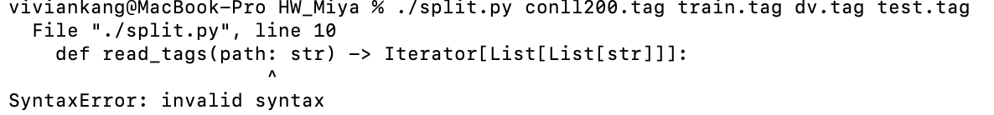

I tried to locate the error. I changed the main function in the file to make it run in IDE without using argparse. It worked so next I confirmed that my usage of argparse is correct. I also googled for the solution and there is similar problem whose solution is changed the python version to python3 by running with python3 xx.py. It suddenly occurred to me that I need to add python3 when I intend to use python3 to run .py file.

After that, everything is fine.