Week 1: Data Collection, Exploration and Cleaning in Agribusiness
1. Objective
The objective of this project is to collect, explore, clean, and analyze agricultural datasets to understand data quality and identify useful patterns in agribusiness data.
Three datasets were selected for this project:
- Indian crop production data
- Agricultural import and export data from FAOSTAT
- Cereal yield data from the World Bank
The datasets were explored for their structure, missing values, duplicate records, data types, and basic statistical characteristics. Exploratory data analysis was also performed using visualizations.

2. Dataset Description
2.1 Crop Production Dataset
File name: crop.csv
The crop production dataset contains information about agricultural production in India.
Number of records: 246,091
Number of columns: 7
The main variables include:
- State
- District
- Year
- Season
- Crop
- Area
- Production
This dataset can be used to study crop production patterns across different states, districts, years, seasons, and crops.

2.2 FAOSTAT Agricultural Trade Dataset
File name: faostat.csv
The FAOSTAT dataset contains agricultural trade information.
Number of records: 4,122
Number of columns: 15
The dataset contains information related to agricultural imports and exports, including quantities and values.
This dataset can be used to understand agricultural trade patterns and compare import and export activities.

2.3 Cereal Yield Dataset
File name: cereal_yield.csv
The cereal yield dataset contains cereal yield information across countries and years.
Number of records: 269
Number of columns: 70
Cereal yield is measured in kilograms per hectare.
This dataset can be used to study changes in cereal productivity across countries and over time.

3. Data Loading
The datasets were loaded into Google Colab using the Pandas library.
The following Python libraries were used:
- Pandas for data loading, cleaning, and analysis
- Matplotlib for data visualization
The datasets were loaded using the following approach:
import pandas as pd
import matplotlib.pyplot as plt

crop = pd.read_csv("crop.csv")
faostat = pd.read_csv("faostat.csv")
cereal_yield = pd.read_csv("cereal_yield.csv")
The final dataset dimensions were verified after loading:
Dataset | Rows | Columns
Crop Production | 246,091 | 7
FAOSTAT | 4,122 | 15
Cereal Yield | 269 | 70

4. Data Exploration
The first few records of each dataset were inspected using the head() function.
The structure of the datasets was examined using the info() function. This helped identify:
- Column names
- Number of records
- Data types
- Non-null values
- Potential missing values
Descriptive statistics were also examined to understand numerical variables such as area, production, trade quantities, and trade values.
The crop dataset was further explored by checking the number of unique:
- States
- Districts
- Crops
- Seasons
- Years
This helped provide an initial understanding of the coverage and diversity of the agricultural data.

5. Missing Value Analysis
Missing values were checked in all three datasets using Pandas.
The following method was used:
crop.isnull().sum()
faostat.isnull().sum()
cereal_yield.isnull().sum()
Missing-value percentages were also calculated to understand the proportion of missing observations in each column.
Crop Production Dataset
The crop production dataset contained missing values in the Production column.
These records were examined before deciding on the cleaning method.
FAOSTAT Dataset
The FAOSTAT dataset was checked for missing values across all 15 columns. The Note column was found to contain no useful values and was considered for removal during data preparation.
Cereal Yield Dataset
The cereal yield dataset was also checked for missing values because some country-year observations may not contain yield information.
Missing values should be handled based on the meaning of each variable rather than automatically replacing every missing value with zero.

6. Duplicate Analysis
Duplicate records were checked using Pandas:
crop.duplicated().sum()
faostat.duplicated().sum()
cereal_yield.duplicated().sum()
The datasets were examined for completely duplicated rows.
No completely duplicated rows were identified in the previously examined Crop Production and FAOSTAT datasets.
Duplicate records, if present, should be removed only after confirming that they do not represent legitimate repeated observations.

7. Data Type Analysis
The data types of all columns were examined using:
crop.dtypes
faostat.dtypes
cereal_yield.dtypes
Checking data types is important because incorrect data types can cause problems during analysis.
For example:
- Year should be treated as a numerical or time-related variable.
- Area and Production should be numerical.
- Crop, State, District, and Season should be categorical/text variables.
- Trade quantities and values should be numerical.
Data types were reviewed as part of the data-cleaning process.

8. Exploratory Data Analysis
Exploratory Data Analysis (EDA) was performed to identify patterns and relationships in the agricultural data.
8.1 Total Crop Production by Year
Total production was grouped by year and visualized using a line chart.
year_production = crop.groupby("Year")["Production"].sum()

year_production.plot(marker="o")
plt.title("Total Crop Production by Year")
plt.xlabel("Year")
plt.ylabel("Total Production")
plt.show()
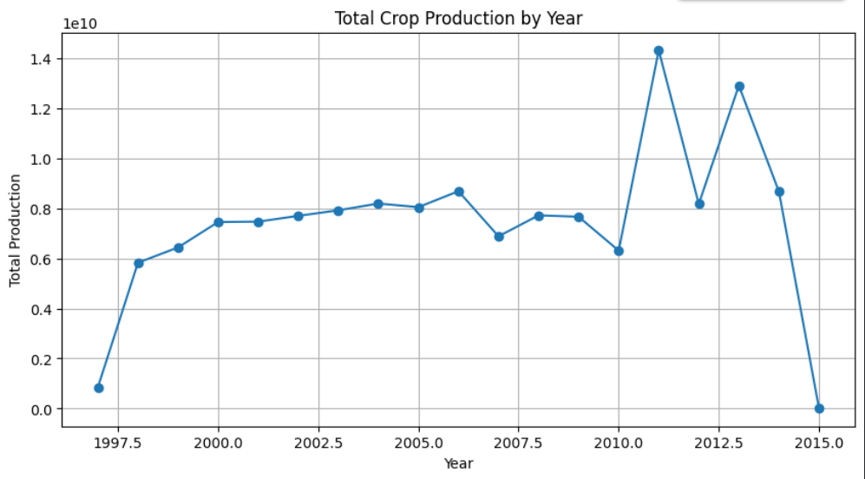
The visualization helps identify changes and trends in total crop production over the available years.

8.2 Top 10 Crops by Total Production
Crop production was grouped by crop and sorted to identify the ten crops with the highest total production.
top_crops = (
crop.groupby("Crop")["Production"]
.sum()
.sort_values(ascending=False)
.head(10)
)
A bar chart was used to compare the production levels of the top crops.
This analysis helps identify which crops contribute most to total recorded production.
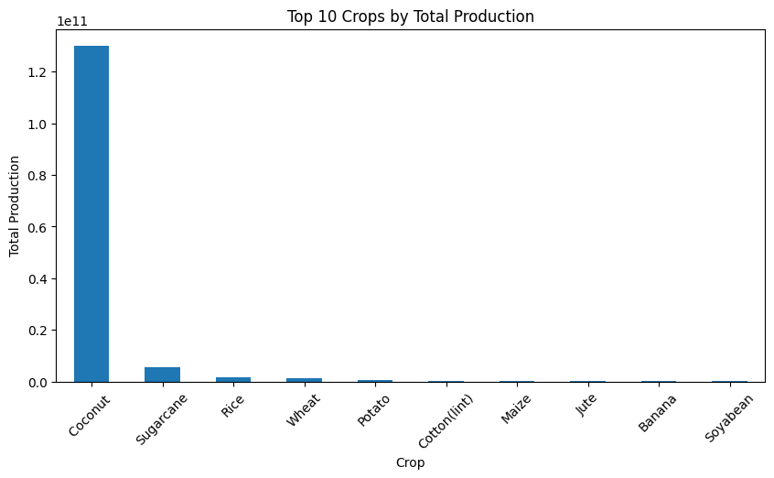

8.3 Crop Production by Season
Production was grouped by agricultural season.
season_production = crop.groupby("Season")["Production"].sum()
A bar chart was created to compare total production across seasons.
This helps understand how agricultural production varies between different growing seasons.
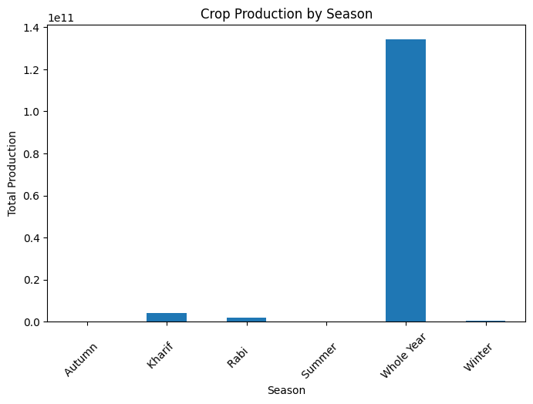

8.4 Crop Production by State
Total production was grouped by state to identify the states with the highest recorded crop production.
top_states = (
crop.groupby("State")["Production"]
.sum()
.sort_values(ascending=False)
.head(10)
)
A bar chart was created to visualize the top ten states.
This analysis helps identify major agricultural production regions.
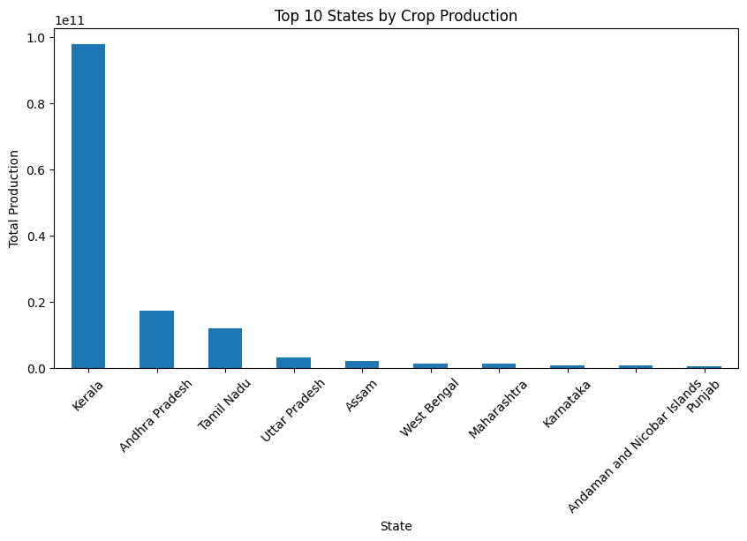

8.5 Relationship Between Area and Production
A scatter plot was created to examine the relationship between cultivated area and production.
plt.scatter(crop["Area"], crop["Production"], alpha=0.3)
plt.title("Area vs Crop Production")
plt.xlabel("Area")
plt.ylabel("Production")
plt.show()
The scatter plot provides an initial view of whether larger cultivated areas are associated with higher production.
The relationship may also be affected by crop type, productivity, location, weather, irrigation, and other agricultural factors.
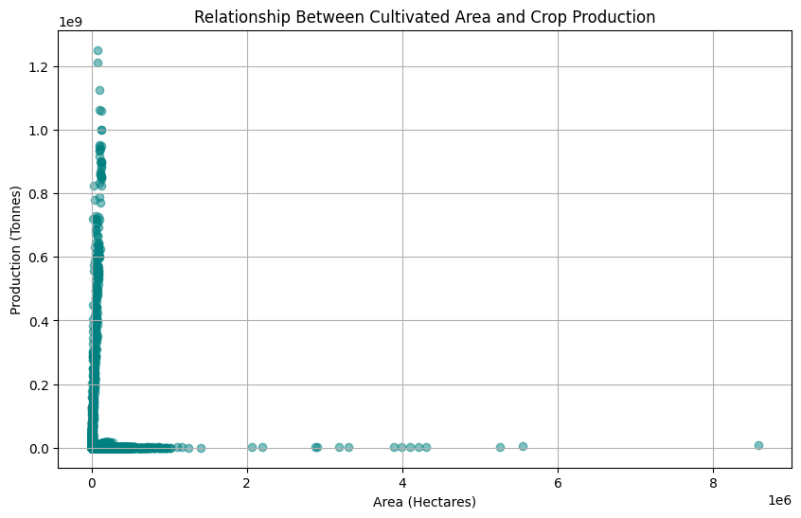

9. Data Cleaning
9.1 Handling Missing Production Values
Rows with missing values in the Production column were removed from the crop dataset because production is a key variable required for the production analysis.
The cleaned dataset was created using:
crop_clean = crop.dropna(subset=["Production"]).copy()
The number of records before and after cleaning was compared to measure the effect of this operation.

9.2 Handling Duplicate Records
Duplicate records were checked in the cleaned dataset.
crop_clean = crop_clean.drop_duplicates()
The number of duplicate rows was checked before and after the operation.
This ensured that completely duplicated records did not unnecessarily affect the analysis.

9.3 Final Data Quality Check
After cleaning, the final dataset shape, missing values, and duplicate records were checked.
print(crop_clean.shape)
print(crop_clean.isnull().sum())
print(crop_clean.duplicated().sum())
The final cleaned dataset was then saved as:
crop_cleaned.csv
using:
crop_clean.to_csv("crop_cleaned.csv", index=False)

10. Key Findings
The exploratory analysis provided several useful observations about the agricultural datasets.
Crop Production
The Crop Production dataset provides detailed information across states, districts, crops, seasons, and years. This makes it useful for studying agricultural production patterns in India.
Crop and State Comparison
Grouping production by crop and state makes it possible to identify the major contributors to total production.
The exact top crops and states were identified from the analysis performed in Google Colab.
Add the actual Top 10 Crops and Top 10 States results from the Colab output here.
Seasonal Production
Production was compared across different agricultural seasons. The results show that production levels vary between seasons, indicating the importance of seasonal agricultural cycles.
Area and Production
The area-versus-production analysis provides an initial understanding of the relationship between the amount of land cultivated and total production.
Data Quality
Missing-value analysis showed that data-quality issues need to be addressed before using the datasets for advanced analytics or machine learning.

11. Conclusion
In Week 1, three agricultural datasets were successfully collected and loaded into Google Colab.
The datasets were explored to understand their structure, variables, missing values, duplicates, and data types. Exploratory visualizations were created to examine crop production by year, crop, season, and state, as well as the relationship between cultivated area and production.
The Crop Production dataset was cleaned by handling missing production values and checking duplicate records. The cleaned dataset was saved for future analysis.
This Week 1 work provides a foundation for more advanced agribusiness analytics. In future stages, the cleaned data can be used for deeper statistical analysis, dashboards, predictive modeling, and agricultural decision-support applications.

12. Tools and Technologies Used
- Python
- Google Colab
- Pandas
- Matplotlib
- GitHub
- Microsoft Word

13. Project Files
The project contains:
- crop.csv – Indian crop production dataset
- faostat.csv – Agricultural trade dataset
- cereal_yield.csv – Cereal yield dataset
- crop_cleaned.csv – Cleaned crop production dataset
- week1_data_exploration.ipynb – Google Colab/Jupyter Notebook containing the analysis
- README.md – Project documentation

14. GitHub Repository
GitHub Repository:
https://github.com/methrepooja/agribusiness-data-analysis

