Project 2 - DS-600

## Introduction

Every year, there are many forest fires occur worldwide. To protect the natural wildlife, numerous attempts has been made to prevent forests from getting fire. In this project, we will be outlining a summary in about a forest fire that occurred in a region at Portugal. The data is collected by using metheorological and other data. For more information about the dataset, this [link](http://www3.dsi.uminho.pt/pcortez/forestfires/forestfires-names.txt) can be followed.

The following is the dataset information.

# reading   
forestfires = read.csv('forestfires.csv')

## Data Cleaning

With the dataset, we will first be investigating the variables’ data type and general shape of occurance. We will be examining data in terms of the following objectives:

1. Variable data types
2. Empty or NA values

Below, we are presenting the general outline of the dataset to understand the structure of our dataset. To use the some functions, we have to install the library “dplyr” first.

head(forestfires)

## X Y month day FFMC DMC DC ISI temp RH wind rain area  
## 1 7 5 mar fri 86.2 26.2 94.3 5.1 8.2 51 6.7 0.0 0  
## 2 7 4 oct tue NA 35.4 669.1 6.7 18.0 33 0.9 0.0 0  
## 3 7 4 oct sat NA 43.7 686.9 6.7 14.6 33 1.3 0.0 0  
## 4 8 6 mar fri 91.7 33.3 77.5 9.0 8.3 97 4.0 0.2 0  
## 5 8 6 mar sun 89.3 51.3 102.2 9.6 11.4 99 1.8 0.0 0  
## 6 8 6 aug sun 92.3 85.3 488.0 14.7 22.2 29 5.4 0.0 0

class(forestfires)

## [1] "data.frame"

dim(forestfires)

## [1] 517 13

names(forestfires)

## [1] "X" "Y" "month" "day" "FFMC" "DMC" "DC" "ISI"   
## [9] "temp" "RH" "wind" "rain" "area"

glimpse(forestfires)

## Observations: 517  
## Variables: 13  
## $ X <int> 7, 7, 7, 8, 8, 8, 8, 8, 8, 7, 7, 7, 6, 6, 6, 6, 5, 8, 6,...  
## $ Y <int> 5, 4, 4, 6, 6, 6, 6, 6, 6, 5, 5, 5, 5, 5, 5, 5, 5, 5, 4,...  
## $ month <fct> mar, oct, oct, mar, mar, aug, aug, aug, sep, sep, sep, s...  
## $ day <fct> fri, tue, sat, fri, sun, sun, mon, mon, tue, sat, sat, s...  
## $ FFMC <dbl> 86.2, NA, NA, 91.7, 89.3, 92.3, 92.3, 91.5, 91.0, 92.5, ...  
## $ DMC <dbl> 26.2, 35.4, 43.7, 33.3, 51.3, 85.3, 88.9, 145.4, 129.5, ...  
## $ DC <dbl> 94.3, 669.1, 686.9, 77.5, 102.2, 488.0, 495.6, 608.2, 69...  
## $ ISI <dbl> 5.1, 6.7, 6.7, 9.0, 9.6, 14.7, 8.5, 10.7, 7.0, 7.1, 7.1,...  
## $ temp <dbl> 8.2, 18.0, 14.6, 8.3, 11.4, 22.2, 24.1, 8.0, 13.1, 22.8,...  
## $ RH <int> 51, 33, 33, 97, 99, 29, 27, 86, 63, 40, 51, 38, 72, 42, ...  
## $ wind <dbl> 6.7, 0.9, 1.3, 4.0, 1.8, 5.4, 3.1, 2.2, 5.4, 4.0, 7.2, 4...  
## $ rain <dbl> 0.0, 0.0, 0.0, 0.2, 0.0, 0.0, 0.0, 0.0, 0.0, 0.0, 0.0, 0...  
## $ area <dbl> 0, 0, 0, 0, 0, 0, 0, 0, 0, 0, 0, 0, 0, 0, 0, 0, 0, 0, 0,...

summary(forestfires)

## X Y month day FFMC   
## Min. :1.000 Min. :2.0 aug :184 fri:85 Min. :18.70   
## 1st Qu.:3.000 1st Qu.:4.0 sep :172 mon:74 1st Qu.:90.20   
## Median :4.000 Median :4.0 mar : 54 sat:84 Median :91.65   
## Mean :4.669 Mean :4.3 jul : 32 sun:95 Mean :90.65   
## 3rd Qu.:7.000 3rd Qu.:5.0 feb : 20 thu:61 3rd Qu.:92.90   
## Max. :9.000 Max. :9.0 jun : 17 tue:64 Max. :96.20   
## (Other): 38 wed:54 NA's :7   
## DMC DC ISI temp   
## Min. : 1.1 Min. : 7.9 Min. : 0.000 Min. : 2.20   
## 1st Qu.: 68.6 1st Qu.:437.7 1st Qu.: 6.500 1st Qu.:15.50   
## Median :108.3 Median :664.2 Median : 8.400 Median :19.30   
## Mean :110.9 Mean :547.9 Mean : 9.022 Mean :18.89   
## 3rd Qu.:142.4 3rd Qu.:713.9 3rd Qu.:10.800 3rd Qu.:22.80   
## Max. :291.3 Max. :860.6 Max. :56.100 Max. :33.30   
##   
## RH wind rain area   
## Min. : 15.00 Min. :0.400 Min. :0.00000 Min. : 0.00   
## 1st Qu.: 33.00 1st Qu.:2.700 1st Qu.:0.00000 1st Qu.: 0.00   
## Median : 42.00 Median :4.000 Median :0.00000 Median : 0.52   
## Mean : 44.29 Mean :4.018 Mean :0.02166 Mean : 12.85   
## 3rd Qu.: 53.00 3rd Qu.:4.900 3rd Qu.:0.00000 3rd Qu.: 6.57   
## Max. :100.00 Max. :9.400 Max. :6.40000 Max. :1090.84   
##

We observed that FFMC variable has some missing values. Therefore, we decided to update values with replacing NAs with mean of it.

# finding indices of na  
ind = which(is.na(forestfires$FFMC))  
  
#replacing empty data with 0  
forestfires$FFMC[ind]=0  
  
#replacing empty data with 0  
forestfires$FFMC[ind]=mean(forestfires$FFMC)  
  
# removing outliers  
forestfires <- filter(forestfires, area < 150)

Now, we want to see how is the behavior of the weather through the time. Let’s take a look what are the values of some variables, as temperature, humidity, wind and rain in the months of this year. Doing this, we can know more about the weather of this zone of Portugal.

# making plots of temperature in Celsius, wind in km/h, rain in mm/m2, and humidty (RH) in %   
plot(forestfires$temp, forestfires$month)

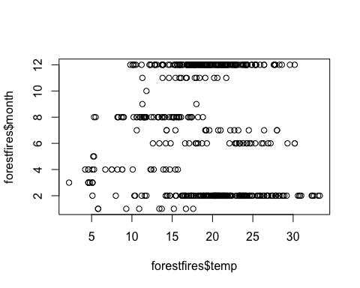

plot(forestfires$wind, forestfires$month)

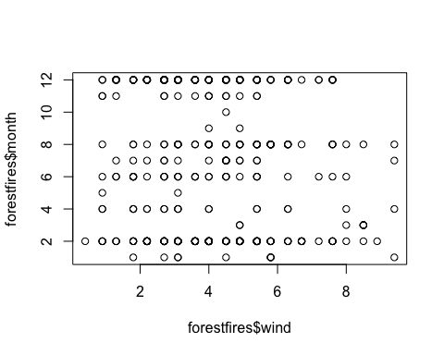

plot(forestfires$rain, forestfires$month)

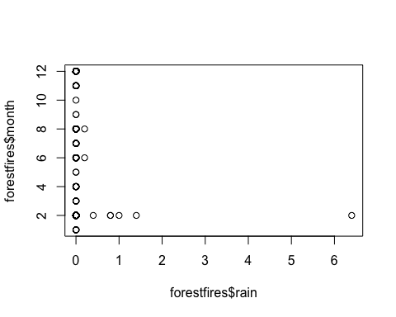

plot(forestfires$RH, forestfires$month)

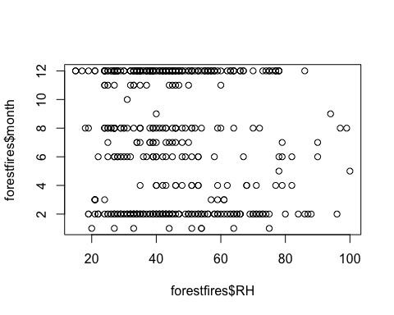

Another way to see the variables is through the histograms. Let’s see how is the behavior of some variables, as burned area of the forest.

# making histogram of burned area of the forest  
hist(forestfires$area)

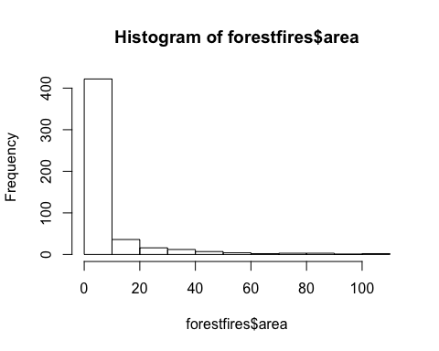

### Gathering the Information

The data presents the events of fires in x, y spatial coordinates within the Montesinho map. Other columns represents the features of each observed variable. For the sake of analysis, we may need to do some operations within the data. The following will present some manipulation examples that may occur during data analysis.

# unite coordinates  
forestfires_t1 <- unite(forestfires, "coordinates", c(X, Y))  
  
# changing data  
forestfires_t2 <- mutate(forestfires_t1, coordinates = paste("coor", coordinates, sep = "_"))  
  
# filtering the data with some parameters  
forestfires_t3 <- filter(forestfires_t2, month == "mar", day == "fri")  
  
# summarize all the columns with mean  
summarise_if(forestfires_t3, is.numeric, funs(round(mean(., na.rm = T), 2)))

## FFMC DMC DC ISI temp RH wind rain area  
## 1 90.01 34.46 81.19 8.36 14 38.36 5.86 0.02 0.99

# doing multiple things at once  
forestfires %>%   
 mutate(ISIandTemp = ISI * temp, rain = exp(rain), area = log(2)) %>%   
 select(X:day,ISIandTemp, ISI, temp, area) %>%  
 arrange(desc(ISIandTemp)) %>%  
 filter(temp > 32)

## X Y month day ISIandTemp ISI temp area  
## 1 4 5 aug mon 547.68 16.8 32.6 0.6931472  
## 2 6 5 aug tue 476.19 14.3 33.3 0.6931472  
## 3 2 5 aug sun 466.71 14.1 33.1 0.6931472  
## 4 3 4 aug tue 461.89 14.3 32.3 0.6931472  
## 5 4 4 aug thu 447.12 13.8 32.4 0.6931472  
## 6 1 3 aug fri 366.12 11.3 32.4 0.6931472

# grouping the data  
forestfires %>%  
 group_by(month) %>%  
 summarise(  
 n = n(),  
 RainTotal = sum(rain),  
 WindAverage = mean(wind),  
 areaTotal = sum(area)  
 )

## # A tibble: 12 x 5  
## month n RainTotal WindAverage areaTotal  
## <fct> <int> <dbl> <dbl> <dbl>  
## 1 apr 9 0 4.67 80.0  
## 2 aug 180 10.8 4.08 995   
## 3 dec 9 0 7.64 120   
## 4 feb 20 0 3.76 126   
## 5 jan 2 0 2.00 0   
## 6 jul 31 0.200 3.70 181   
## 7 jun 17 0 4.14 99.3  
## 8 mar 54 0.200 4.97 235   
## 9 may 2 0 4.45 38.5  
## 10 nov 1 0 4.50 0   
## 11 oct 15 0 3.46 99.6  
## 12 sep 168 0 3.58 1427

### Using GGPlot

ggplot(forestfires, aes(x=DMC)) +   
 geom_histogram(aes(y = ..density..)) +   
 geom_density(color = "red") +   
 geom_rug()

## `stat_bin()` using `bins = 30`. Pick better value with `binwidth`.

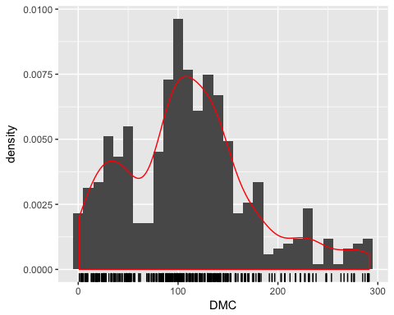

qqPlot(forestfires$DMC, main = "QQ plot", ylab = "")

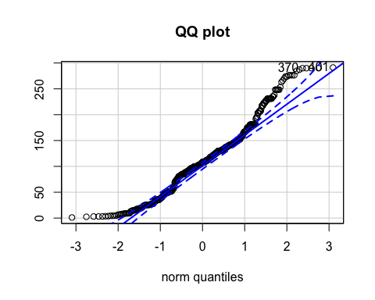

## [1] 401 370

ggplot(forestfires, aes(x=ISI, y=sqrt(area))) +  
 geom_boxplot() +   
 geom_rug() +   
 geom_hline(aes(yintercept=mean(forestfires$ISI, na.rm = T)), linetype = 2, color = "red") +  
 scale_x_discrete(breaks = NULL)

## Warning: Continuous x aesthetic -- did you forget aes(group=...)?

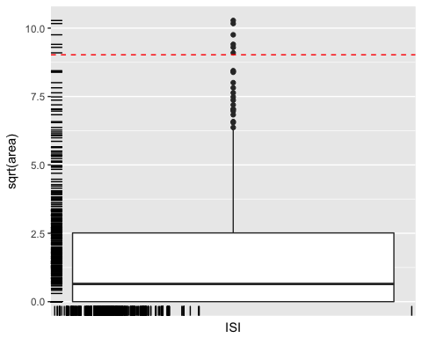

## Model Assesment

Up to this point, we analyzed our dataset of forestfires in terms of NA values and data structures. Everything we made to this point was data cleaning and tidying the dataset so as to do analysis on the data.

Here, we are presenting our analysis on the dataset. We made linear analysis and examine feature’s relationships within the features and the with the predictor variable.

### Correlation between features

symnum(cor(forestfires[5:12], use = "complete.obs"))

## F DM DC I t R w r  
## FFMC 1   
## DMC . 1   
## DC . , 1   
## ISI . . 1   
## temp . . . . 1   
## RH . 1   
## wind 1   
## rain 1  
## attr(,"legend")  
## [1] 0 ' ' 0.3 '.' 0.6 ',' 0.8 '+' 0.9 '*' 0.95 'B' 1

### Correlation Plot

cm <- cor(forestfires[,5:12], use="complete.obs")  
corrplot(cm, type="upper", tl.pose="d")

## Warning in text.default(pos.xlabel[, 1], pos.xlabel[, 2], newcolnames, srt  
## = tl.srt, : "tl.pose" is not a graphical parameter

## Warning in text.default(pos.ylabel[, 1], pos.ylabel[, 2], newrownames, col  
## = tl.col, : "tl.pose" is not a graphical parameter

## Warning in title(title, ...): "tl.pose" is not a graphical parameter

corrplot(cm,add=TRUE, type="lower", method="number",diag=FALSE, tl.pos="n", cl.pos="n")

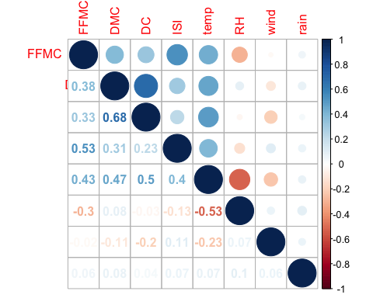 ### Dividing the dataset

Here, we are preparing our dataset for out-of-sample analysis. We are dividing the dataset into two parts, training and testing datasets for future analysis.

# removing outliers  
forestfires_test <- forestfires[c(401:508), ]  
forestfires <- forestfires[c(1:400), ]

### Linear Model

Implementations of models are represented in below.

fit.m0 <- lm(area ~ ., forestfires)  
fit.m1 <- lm(area ~ day + DMC + temp + RH, forestfires)  
fit.m2 <- lm(area ~ month + day + DC + temp, forestfires)  
summary(fit.m2)

##   
## Call:  
## lm(formula = area ~ month + day + DC + temp, data = forestfires)  
##   
## Residuals:  
## Min 1Q Median 3Q Max   
## -12.593 -7.053 -3.926 0.145 92.077   
##   
## Coefficients:  
## Estimate Std. Error t value Pr(>|t|)   
## (Intercept) -1.35445 6.77950 -0.200 0.8418   
## monthaug 4.42181 10.82910 0.408 0.6833   
## monthdec 15.40462 9.19492 1.675 0.0947 .  
## monthfeb 4.85361 7.38139 0.658 0.5112   
## monthjan -2.01206 12.40329 -0.162 0.8712   
## monthjul 5.46573 9.25313 0.591 0.5551   
## monthjun -2.08078 8.54205 -0.244 0.8077   
## monthmar 0.93991 6.58904 0.143 0.8866   
## monthmay -2.80110 16.37175 -0.171 0.8642   
## monthoct 8.10454 12.03876 0.673 0.5012   
## monthsep 10.58704 12.16251 0.870 0.3846   
## daymon 1.68135 2.67983 0.627 0.5308   
## daysat 2.03481 2.69789 0.754 0.4512   
## daysun 3.56401 2.56463 1.390 0.1654   
## daythu 0.31122 2.94353 0.106 0.9159   
## daytue 4.55673 2.86511 1.590 0.1126   
## daywed 1.42290 3.03022 0.470 0.6389   
## DC -0.01116 0.01512 -0.738 0.4611   
## temp 0.30005 0.19768 1.518 0.1299   
## ---  
## Signif. codes: 0 '***' 0.001 '**' 0.01 '*' 0.05 '.' 0.1 ' ' 1  
##   
## Residual standard error: 15.03 on 381 degrees of freedom  
## Multiple R-squared: 0.0466, Adjusted R-squared: 0.001559   
## F-statistic: 1.035 on 18 and 381 DF, p-value: 0.4193

### Distribution of the Values of Columns

plot1 = function(x) {plot(x,xlab="")  
 abline(h=mean(x,na.rm=T),lty=1)  
 abline(h=mean(x,na.rm=T)+sd(x,na.rm=T),lty=2)  
 abline(h=median(x,na.rm=T),lty=3)}  
  
plot1(forestfires$rain)

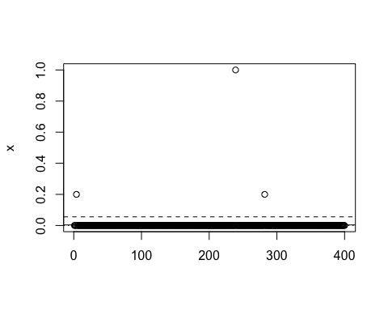

### Anova Analysis

After fitting a linear model, to understand model’s success, we do anova analysis to the model’s variance.

anova(fit.m2)

## Analysis of Variance Table  
##   
## Response: area  
## Df Sum Sq Mean Sq F value Pr(>F)  
## month 10 2624 262.40 1.1609 0.3160  
## day 6 920 153.41 0.6787 0.6670  
## DC 1 144 144.29 0.6384 0.4248  
## temp 1 521 520.74 2.3038 0.1299  
## Residuals 381 86120 226.04

To find the best model within two models, we are planing to do anova analysis to both models. The result of analysis on variances will indicate which model will better in terms of variance.

anova(fit.m1, fit.m2)

## Analysis of Variance Table  
##   
## Model 1: area ~ day + DMC + temp + RH  
## Model 2: area ~ month + day + DC + temp  
## Res.Df RSS Df Sum of Sq F Pr(>F)  
## 1 390 88177   
## 2 381 86120 9 2057.6 1.0114 0.4301

Here, we see that applying each model an anova analysis will take more computational time. Therefore, we will be using STEP function in order to find the best model. Below, we are presenting that we are improving the model with an AIC score of 2776.82 to 2759.06. our final model in below function indicates that the following is the best model that we should use, in order to predict area.

* formula = area ~ ISI + temp + wind

step(fit.m0, trace = F)

##   
## Call:  
## lm(formula = area ~ X + month + DMC + DC, data = forestfires)  
##   
## Coefficients:  
## (Intercept) X monthaug monthdec monthfeb   
## -0.21571 0.67922 16.63969 24.19850 6.15527   
## monthjan monthjul monthjun monthmar monthmay   
## 2.15854 13.73631 1.43427 1.51780 -1.41558   
## monthoct monthsep DMC DC   
## 30.50263 28.48066 0.10288 -0.04679

### Predicting with Test Dataset using Model

The best model we acquired from step function is used to create the final linear model. We are using the final model to assess the success of our model with the testing dataset that we created above.

# final model  
fit.m99 <- lm(formula = area ~ ISI + temp + wind, data = forestfires)  
  
# prediction with final model in test dataset  
preds <- predict(fit.m99, forestfires_test[-1], probability = T)  
  
# summary  
summary(fit.m99)

##   
## Call:  
## lm(formula = area ~ ISI + temp + wind, data = forestfires)  
##   
## Residuals:  
## Min 1Q Median 3Q Max   
## -10.147 -6.826 -4.976 0.027 96.775   
##   
## Coefficients:  
## Estimate Std. Error t value Pr(>|t|)   
## (Intercept) 1.7829 3.5598 0.501 0.6168   
## ISI -0.3041 0.1821 -1.670 0.0957 .  
## temp 0.2947 0.1577 1.869 0.0623 .  
## wind 0.5371 0.4436 1.211 0.2267   
## ---  
## Signif. codes: 0 '***' 0.001 '**' 0.01 '*' 0.05 '.' 0.1 ' ' 1  
##   
## Residual standard error: 15.01 on 396 degrees of freedom  
## Multiple R-squared: 0.01208, Adjusted R-squared: 0.004599   
## F-statistic: 1.615 on 3 and 396 DF, p-value: 0.1854

According to the linear model, we expect the model’s residual distribution to be normally distributed. Below, we are presenting the models’ predicted values with testing dataset’s ‘area’.

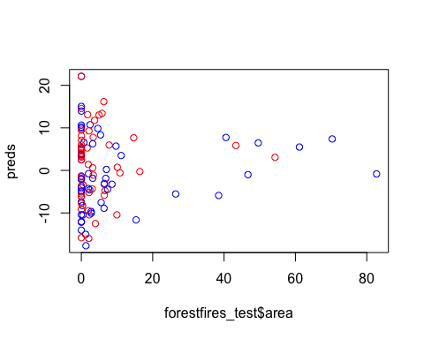

The color red is representing the real data and the color blue, predicted data. Because the majority of the data is around zero, meaning that there are small fires in terms of area, that indicates our model represents a good model indicator.

## Conclusion

The data after cleaning operations is ready for statistical analysis. After operations of tidying, restructing and removing outliers, we will have the data that is ready for further analysis.

After analysis on the report, we evaluate the model in terms of correlation between features. After, we run a linear model to see the results. Above, we represent our findings and plot features according to predictors.