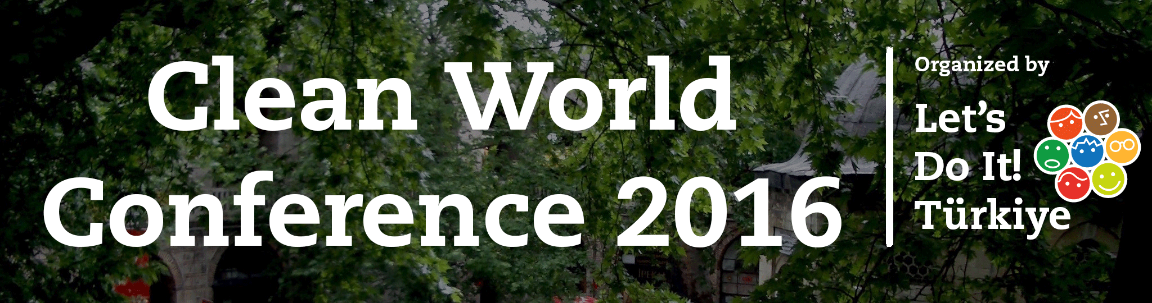

**28th – 31st January 2016**

**Bursa, Turkey**

Dear Participant,

We are glad to welcome you among the participants of the annual **Clean World Conference 2016** that is organized by **Civil Life Association**, **Association of the Research And Development of the Societal Issues**, **Let’s Do It! Foundation** and will take place in Bursa, Turkey from the 28th to 31st January 2016!

The conference will bring together over 150 passionate civic leaders from various countries across the World. Moreover with the objective of bring close together on the subject of dealing with the trash.

The objectives of CWC are:

* To raise interest among young people and youth organizations about prevention of  alcohol related harm and alcohol policy,

To empower the participants with the necessary skills and capacities in order to  effectively work on the field of alcohol,

To empower the participants with the necessary tools to engage in advocating for  more comprehensive alcohol policy on regional, national and international level,

To provide the necessary tools and training for participants to be able to conduct  projects to reduce the alcohol related harm on youth, and

To give participants the opportunity to exchange their expertise and good  practices with their peers.  The aim of the conference is to offer an international learning experience to practitioners active in the alcohol work field to young people from across Europe who are interested in the topic of alcohol and people who are already working in the field. Some places are also reserved for participants from outside of Europe.  Given that the date of the Conference is approaching, please find below the 2nd information pack with relevant practical information in it.

Clean World Conference 2016 Team

# Practical Information

### Money

Turkey uses own currency called as **Turkish Lira**. 1 Turkish Lira equals 100 Kuruş. In many of the ATM’s in Turkey you may have chance to withdraw in Turkish Lira with additional transaction fees. Banknotes and coins as follows on below picture:

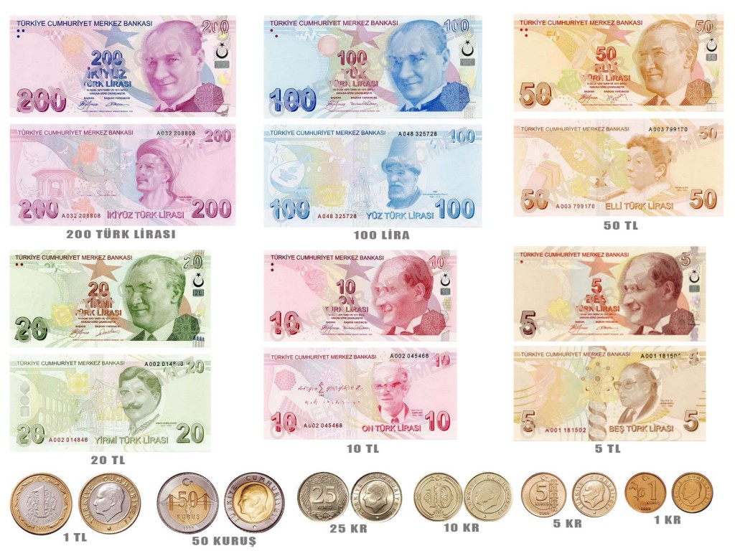

If you wonder to exchange your own currency to the Turkish Lira the rate is approximately as follows:

|  |  |
| --- | --- |
| **1 EUR(€) : 3,20 TL** | **1 USD($) : 2,90 TL** |

## Wheather

Since Turkey is in the Northern side of the globe, January considered as winter. Please be aware that will be cold. So you will need garments that keeps you warm. Also the warmest coat you have, of course. You may check the actual temperature from the following link: <http://www.accuweather.com/en/tr/bursa/317350/weather-forecast/317350>

The average temperature for Bursa in January

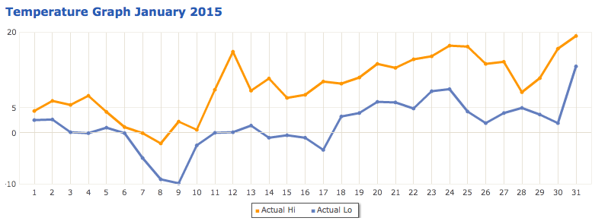

## Language

Official programme language is English and communication during the conference will always be maintained only in English.

## Certification and Official Invitations:

Successful applicants will be provided with an official invitation letter by our secretariat upon request, to be used in case of applications for financial supports, work- school allowances or visa applications.

## Frequently Asked Questions

**Q: Where should I exchange money in order to get the best buying price?**A: If you need to change money urgently when you land, you can use any of the offices on the arrival section of the airport. In order to get best rate, our Organization Committee will help you in Bursa, as soon as you reach to hotel.

**Q: How will the weather be like in Bursa?**  
A: Weather is estimated to be partly rainy and partly cloudy on conference dates. Expected temperature is generally between 5°C and 18 °C. You can check updated day by day weather forecast anytime here: <http://www.accuweather.com/en/tr/bursa/317350/weather-forecast/317350>

**Q: In case something goes wrong, what number can I call?**A: Emergency Contact: +90 507 056 2028

**Q: Is there a dress code for the event? Do I need to wear formal clothes?**    
A: Dress code applies only for Opening Ceremony. At the other parts of the program you can dress as youthly as you want!☺

**Q: Which workshop am I attending?**A: When you registered, you chose the workshop that suits you best. When you arrive at the Conference there will be a list with the allocations of the participants to the workshops. However, on basis of your motivation and experience, we have allocated you to the workshop we believe suits you most (but keeping in mind your first with). There will still be an opportunity to switch the workshop if you will find a suitable person to exchange it with you.

## How to get there?

**From Istanbul Atatürk Airport to Bursa Bus Terminal**

When you reach Atatürk Airport, take the metro directly to the Esenler Terminal. The Airport is the last stop of the metro; therefore, there is only one possible direction to go. From Esenler Terminal, there are some options to go Bursa. We advice you take a direct bus to Bursa International Bus Terminal with one of the firms listed below.

* Kamil Koç: http://www.kamilkoc.com.tr
* Nilüfer: http://www.niluferturizm.com.tr
* Pamukkale: http://www.pamukkale.com.tr

Generally there is one bus of each company to Bursa in every half an hour, including night time. From Istanbul Esenler Bus Station to Bursa International Bus Terminal journey takes around 4 hours.

**From Istanbul Sabiha Gökcen Airport to Bursa Bus Terminal**

When you reach up Sabiha Gokcen Airport follow the signs to the major exit. Directly opposite to the major exit of international arrivals there are buses waiting. There is only one company running scheduled trips directly from Sabiha Gokcen Airport to Bursa Bus Terminal which is called Akmis Seyahat. Please check and book your trip before your arrival on: http://www.akmisseyahat.com.tr/hareket/bursa !  From Sabiha Gökcen Airport to Bursa Bus Terminal journey takes around 2.5 hours.

**From Bursa Bus Terminal to the Hotel Venue**

…

## Venue

…

## Contact Information

…