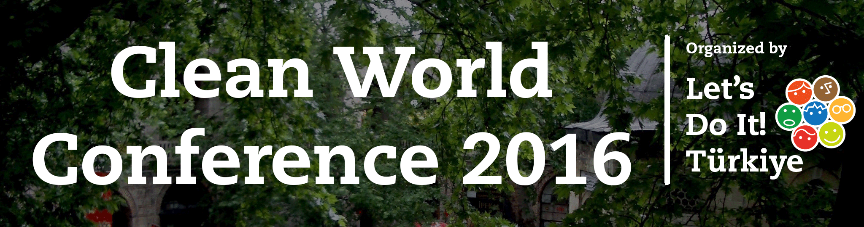

**28th – 31st January 2016**

**Bursa, Turkey**

|  |  |  |  |  |
| --- | --- | --- | --- | --- |
| **Hours**  **Days** | **28th of January** | **29th of January** | **30th of January** | **31st of January** |
| **8:00** |  | Breakfast | Breakfast | Breakfast |
| **8:45** | Program Announcement | Program Announcement | Guided City Tour |
| **9:00** | Openning Ceremony | Introduction of Working Groups |
| **9:30** | VIP Guest Gathering | Airport Transfer |
| **9:45** | Working Groups (Parallel Session) |
| **10:00** | Keynote Speaker |
| **11:00** | Keynote Speaker |  |
| **11:45** | Refreshment Break |
| **12:00** | Registiration | Rainer’s Best Speech Ever! | Summaries of Workshops |
| **12:30** | Networking |
| **13:00** | Lunch | Lunch |
| **14:00** | After Lunch Voo-Doo | Networking |
| **14:30** | Introduction of World Cleanup 2018 Plan | Working Groups (Parallel Sessions) |
| **15:15** | World Cleanup 2018 Discussions |
| **16:00** | Refreshment Break |
| **16:15** | World Cleanup 2018 Discussions –Continues |
| **16:30** | Refreshment Break |
| **16:45** | Summaries of Workshops |
| **17:00** | Wrap up and Decisions |
| **17:30** | Wrap up and Decisions |
| **18:30** | Voo-Doo |
| **19:00** | Dinner | Dinner | Dinner |
| **20:00** | Socializing Event |  | Evening Program |
| *Disclaimer: Conference program is not definite. It might have subject to change. | | | | |