Metering Installation Error Report

Accuracy
The accuracy of the metering installation (combined meter and transformers) has been calculated for 3 annual load profiles.
Load Profile Error Uncertainty Error-Uncert Error+Uncert
1 2.76 % 0.74 % 2.01 % 3.50 %
2 1.41 % 0.40 % 1.00 % 1.81 %
3 0.58 % 0.21 % 0.36 % 0.79 %
The uncertainty is the expanded uncertainty calculated at a 95 % level of confidence. For each load profile the same variation in temperature and network conditions was assumed. Sensitivity coefficients published for an IEC class 0.2 meter were incorporated in the uncertainty calculation.
The uncertainty includes a contribution due to the temperature of the metering installation differing from the temperature at which the components were calibrated. An average value of 15.0 °C with an expanded uncertainty of 1.0 °C is assumed for a twelve-month period.

Annual Load Profiles
Annual load profiles used for this error calculation. The graph is normalised to give the relative amount of energy at each combination of current and phase angle.
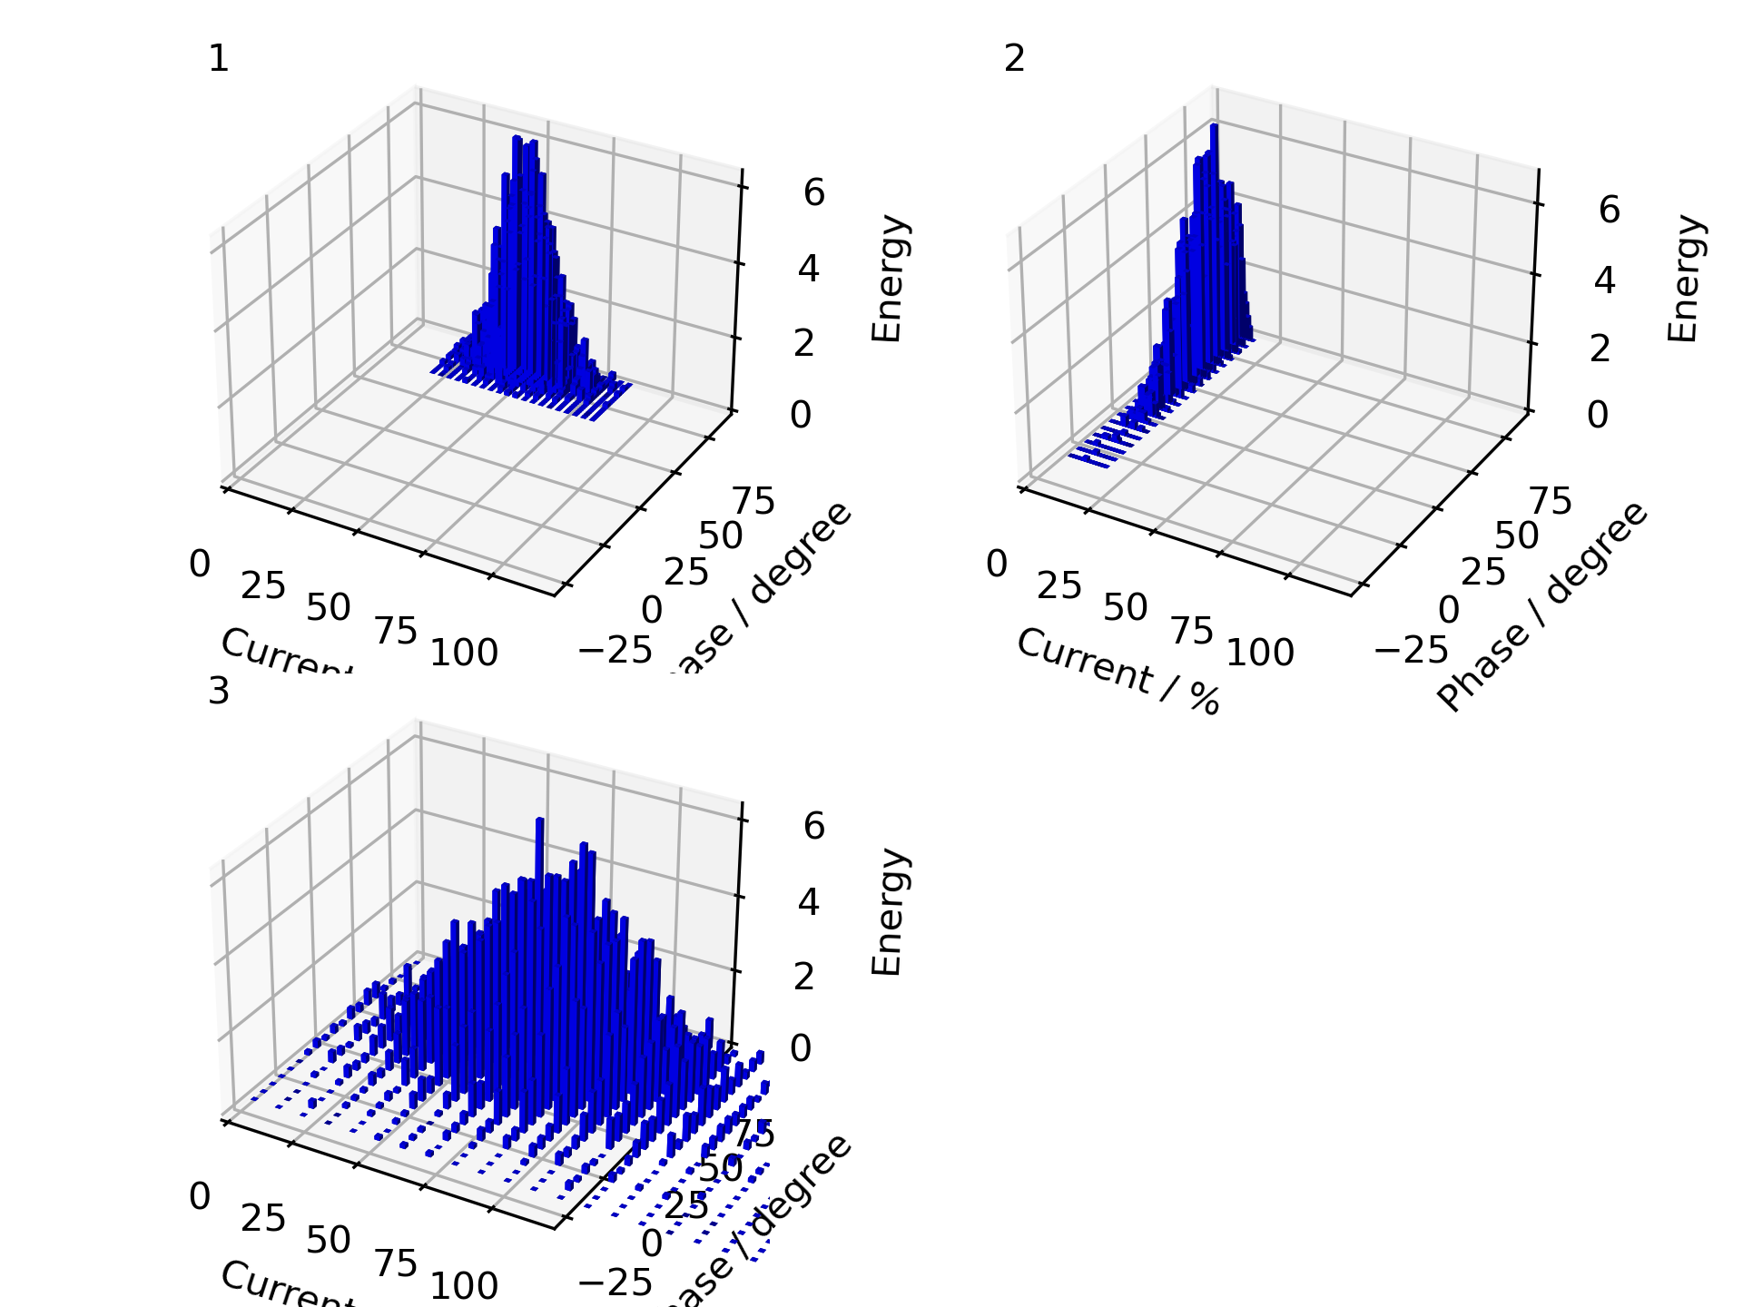

Error Plots
Installation error over the phase and current values for the load profiles
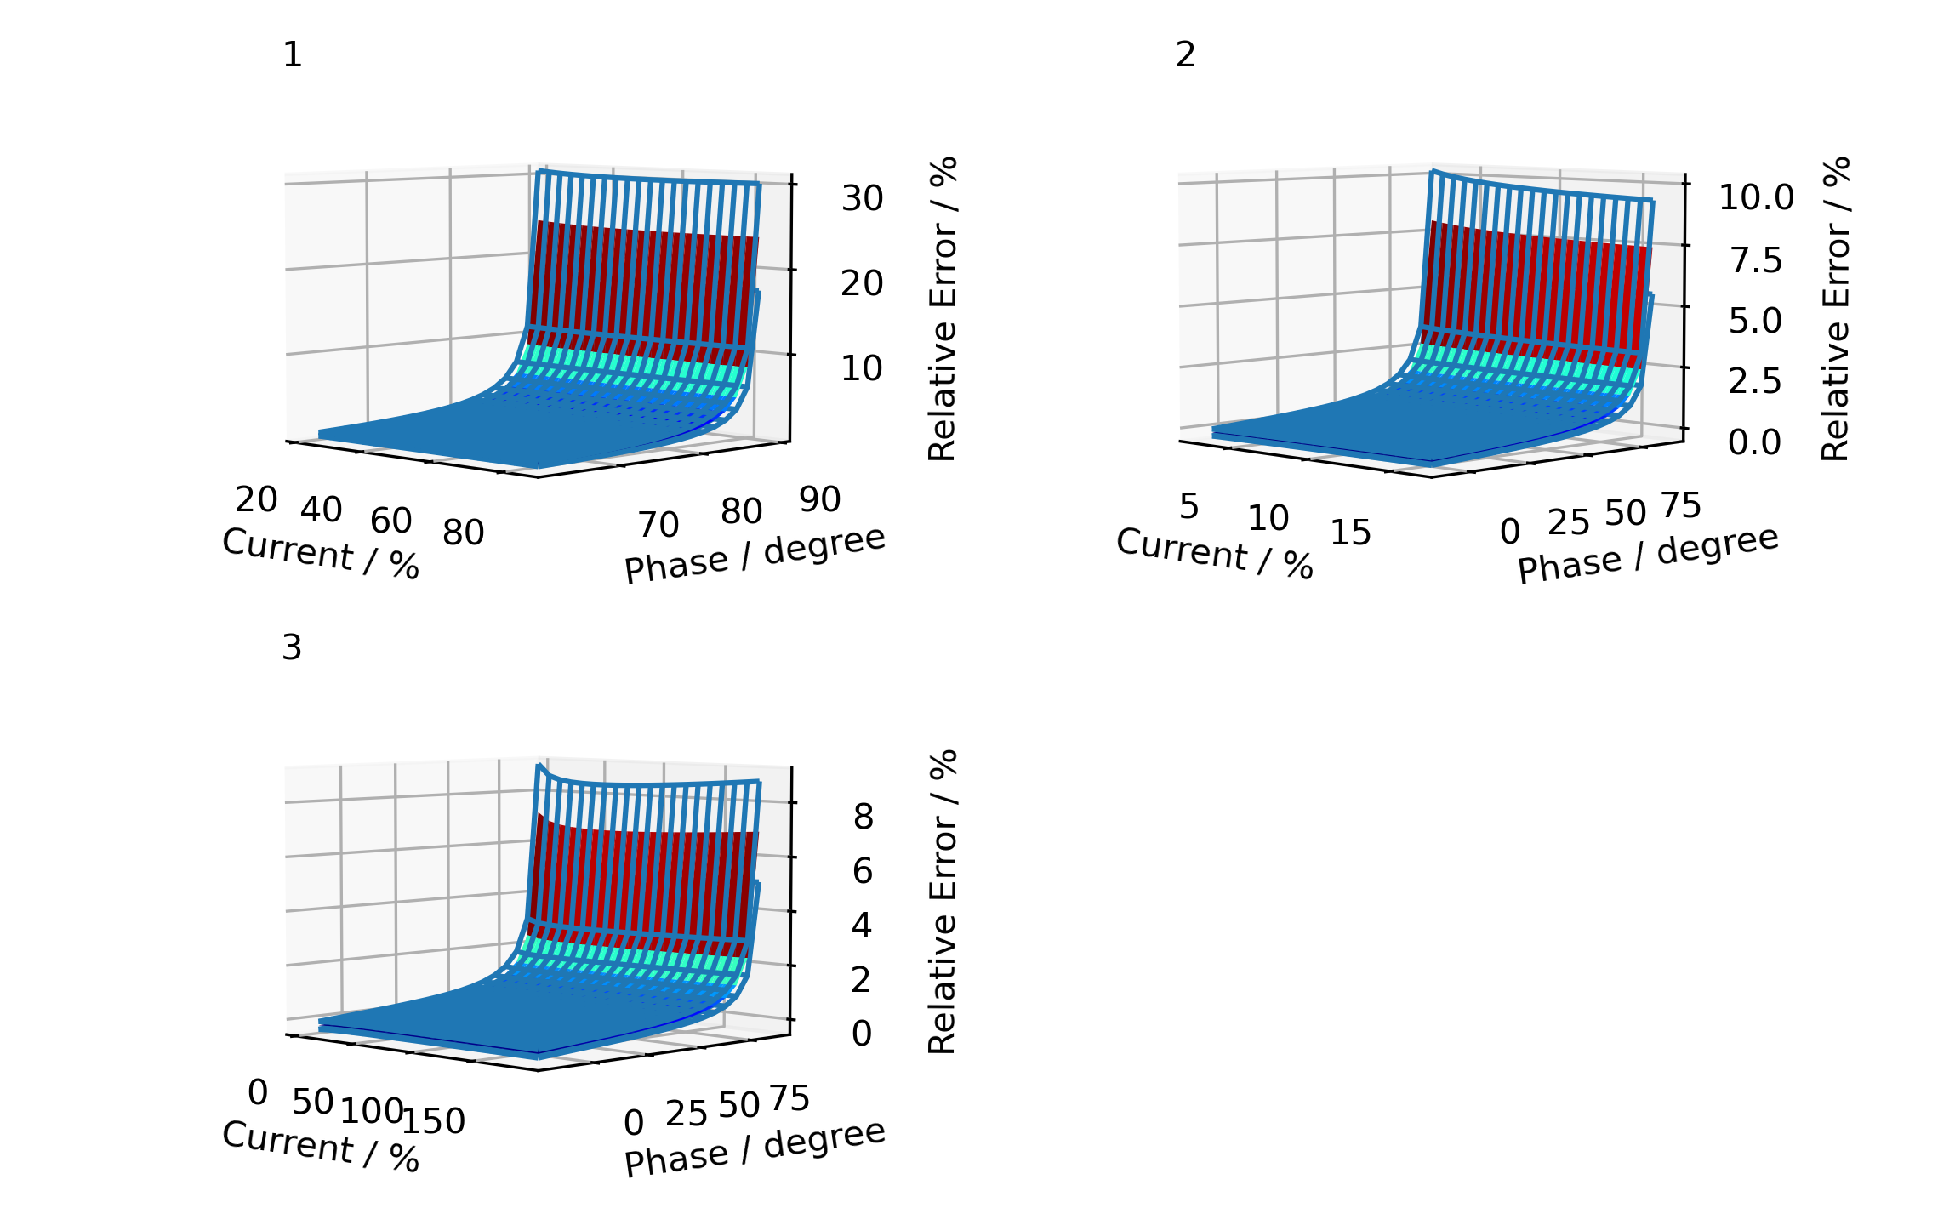

Uncertainty by Component
Uncertainty contribution given by component as a percentage of total variance. This is calculated for each load profile. This may help with any decisions about which components might be considered for an upgrade
Load Profile Meter CT VT
1 54 % 15 % 31 %
2 50 % 10 % 40 %
3 60 % 15 % 25 %

Component Calibration
For each component the calibration points are plotted on a graph with uncertainty bars. Fitted curves are shown with an upper and lower curve indicating the uncertainty of the fit. The coefficients of these curves are used to calculate the metering installation error.

Current Transformer
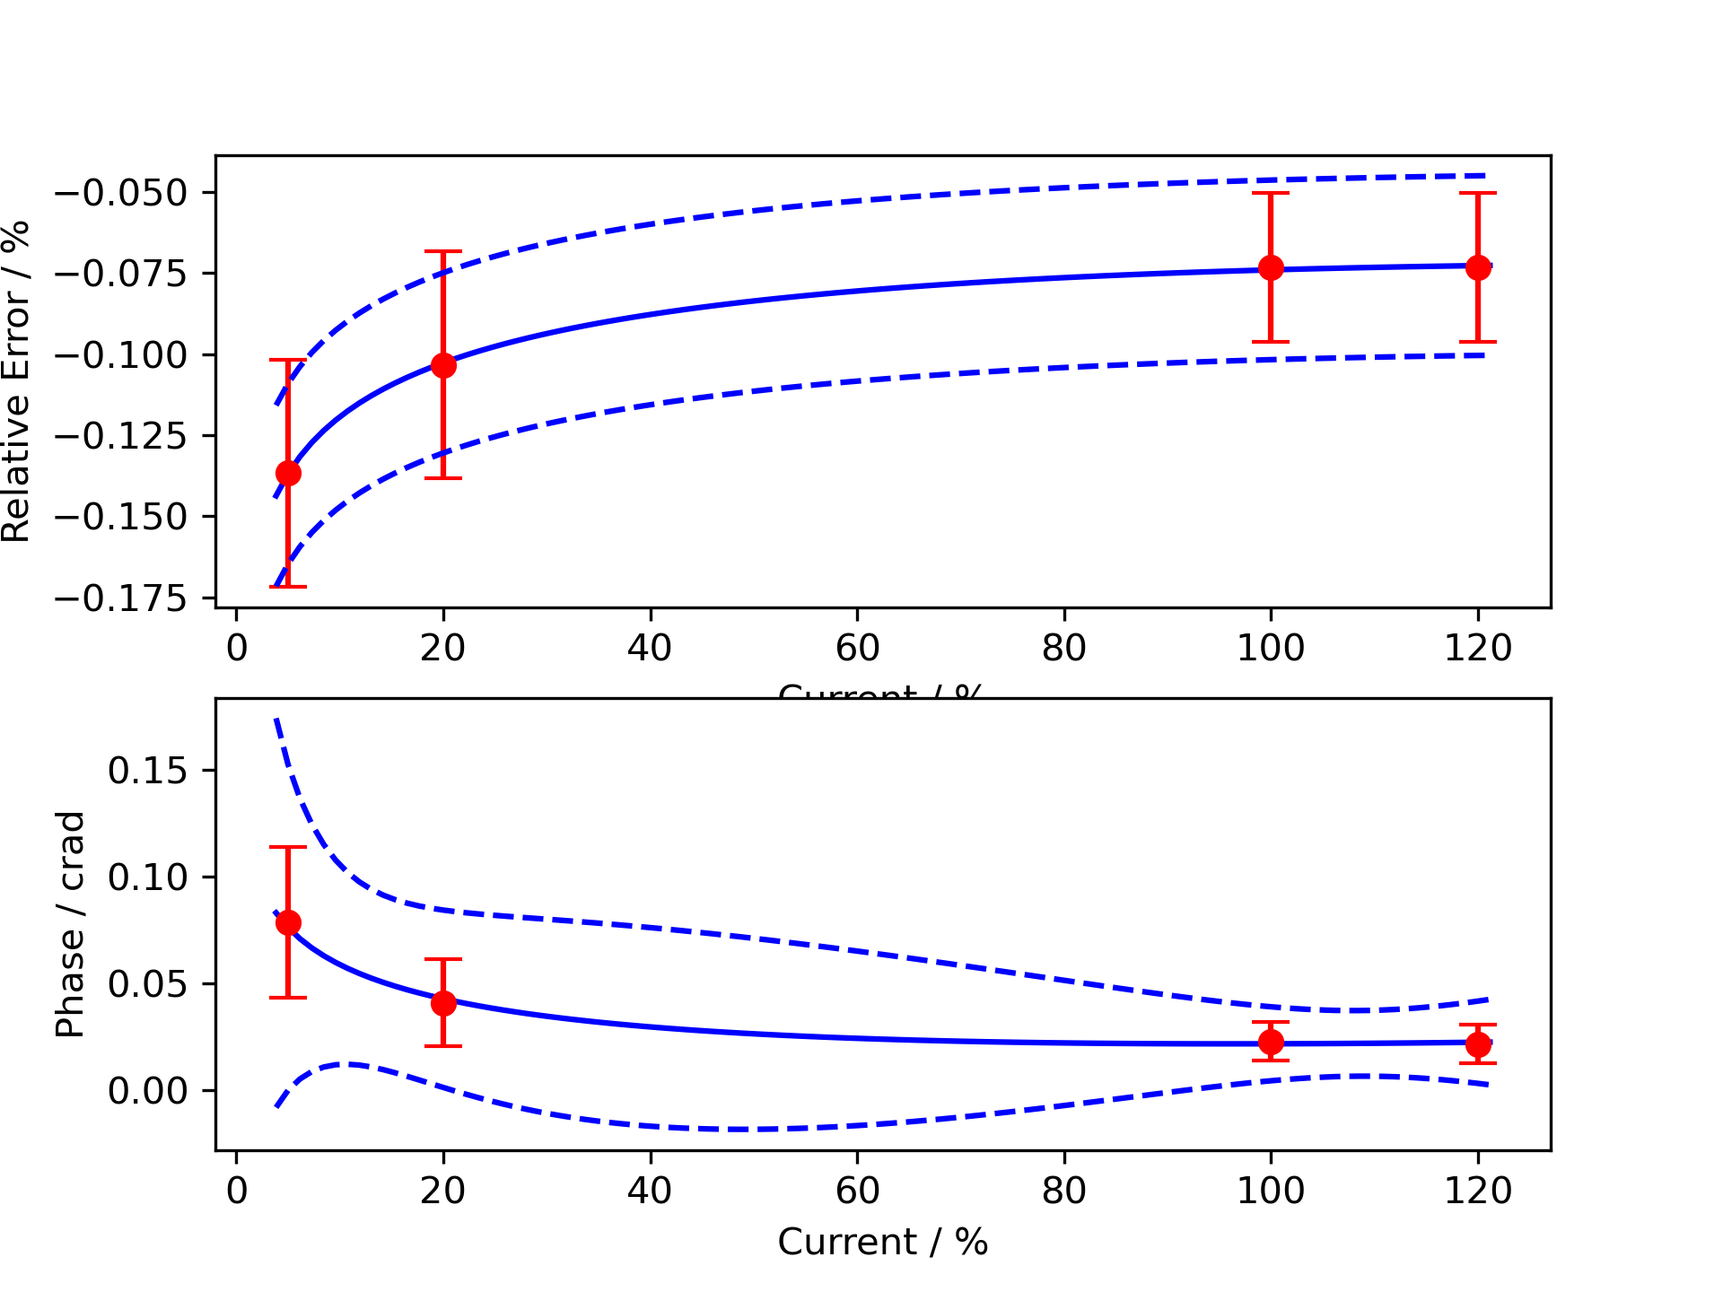

Voltage Transformer
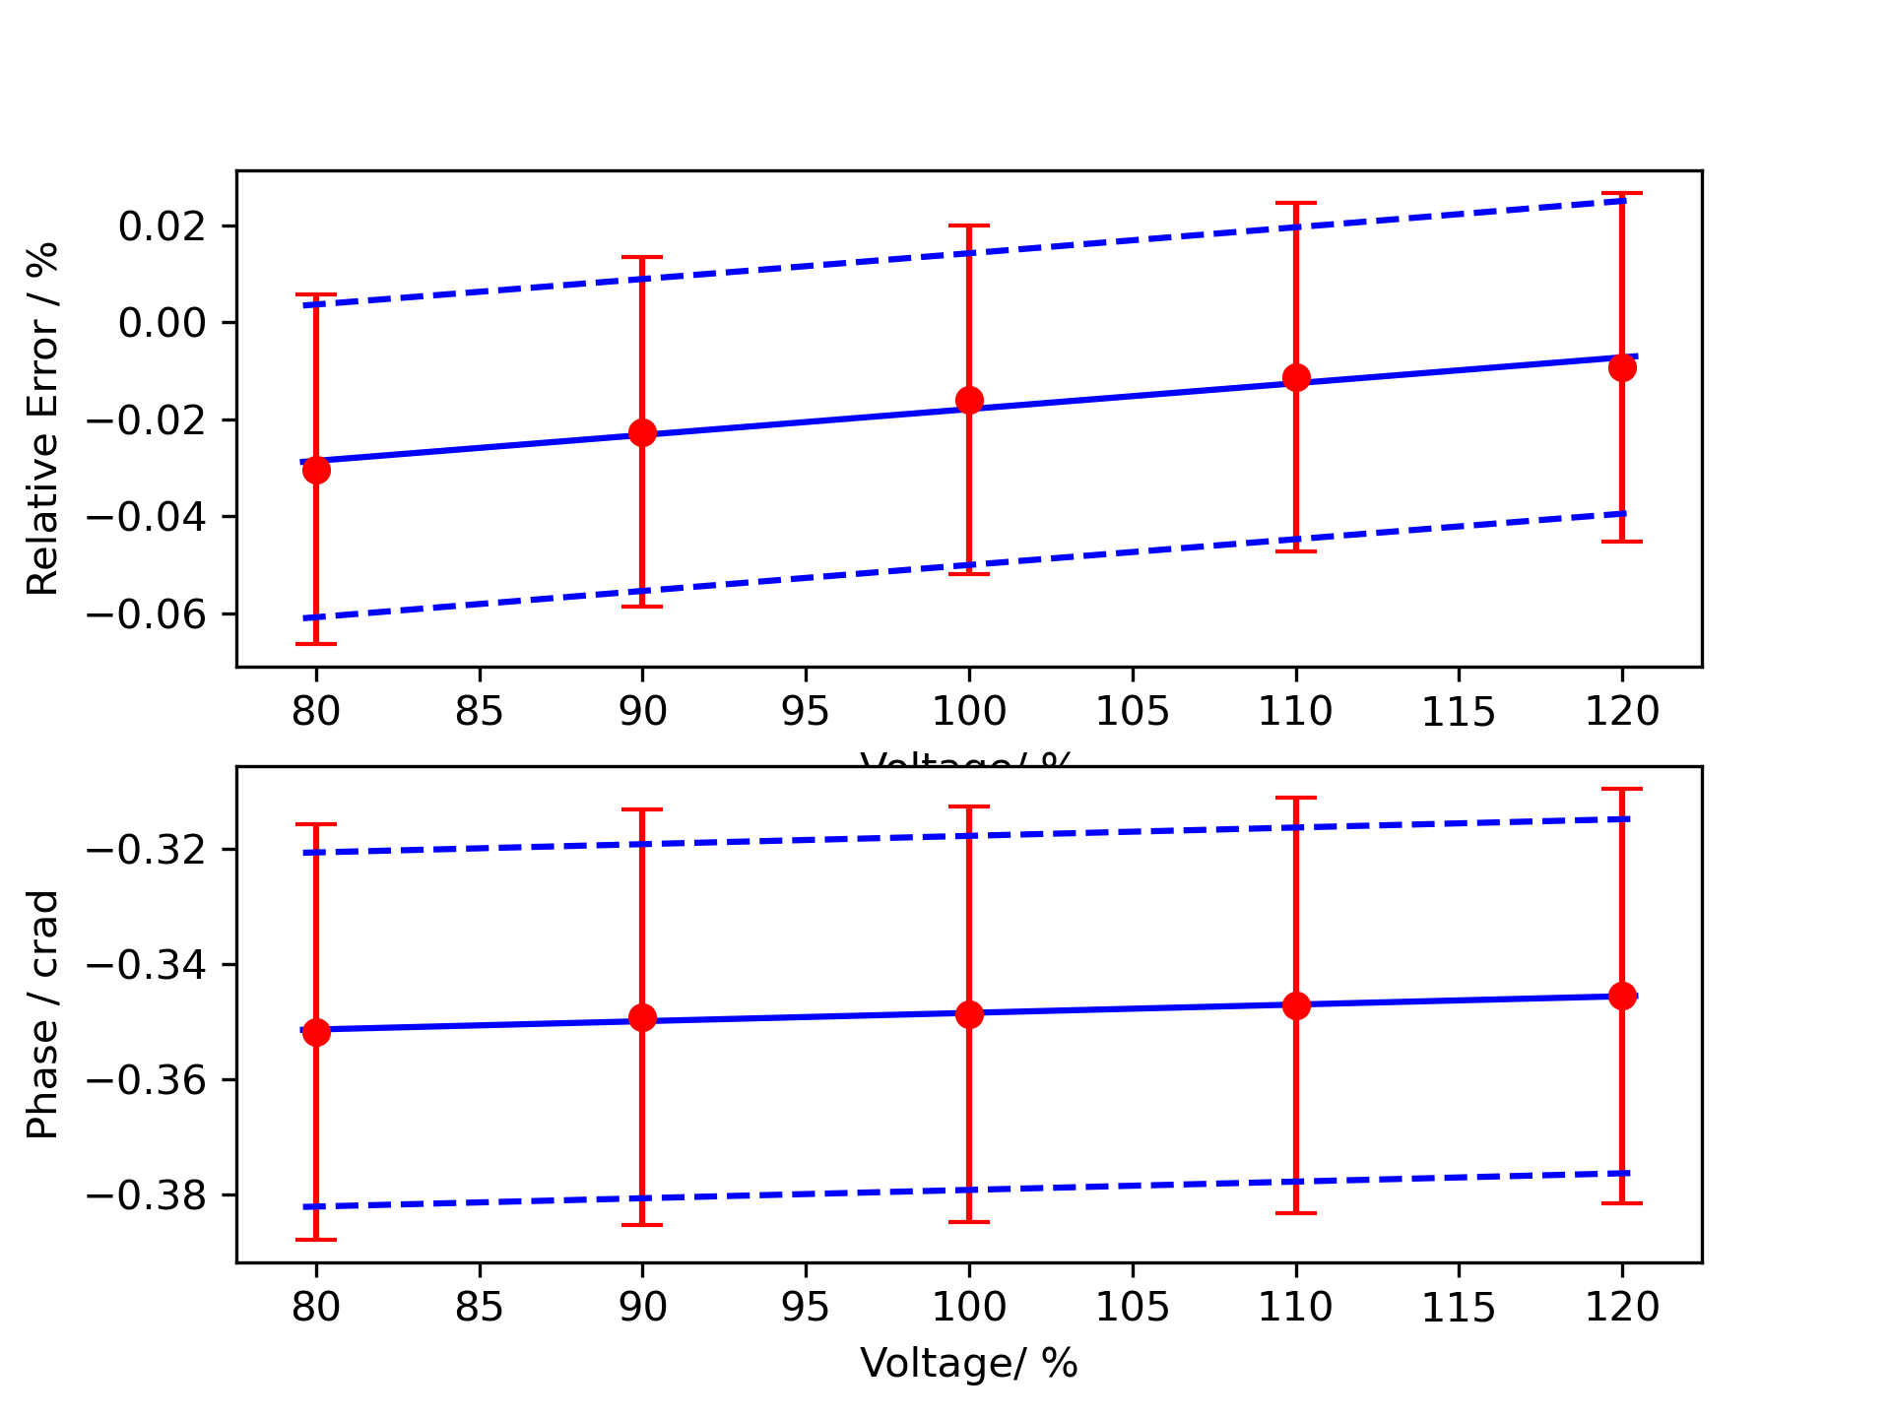

Meter
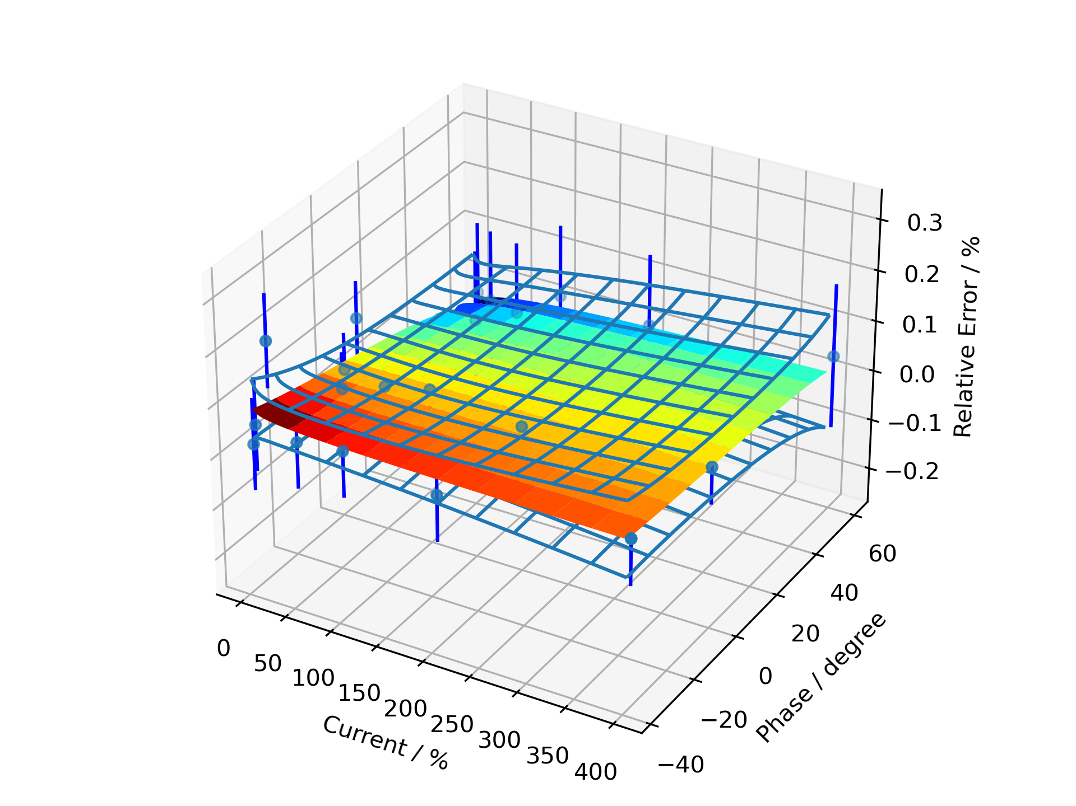

Installation Maximum Error Contour
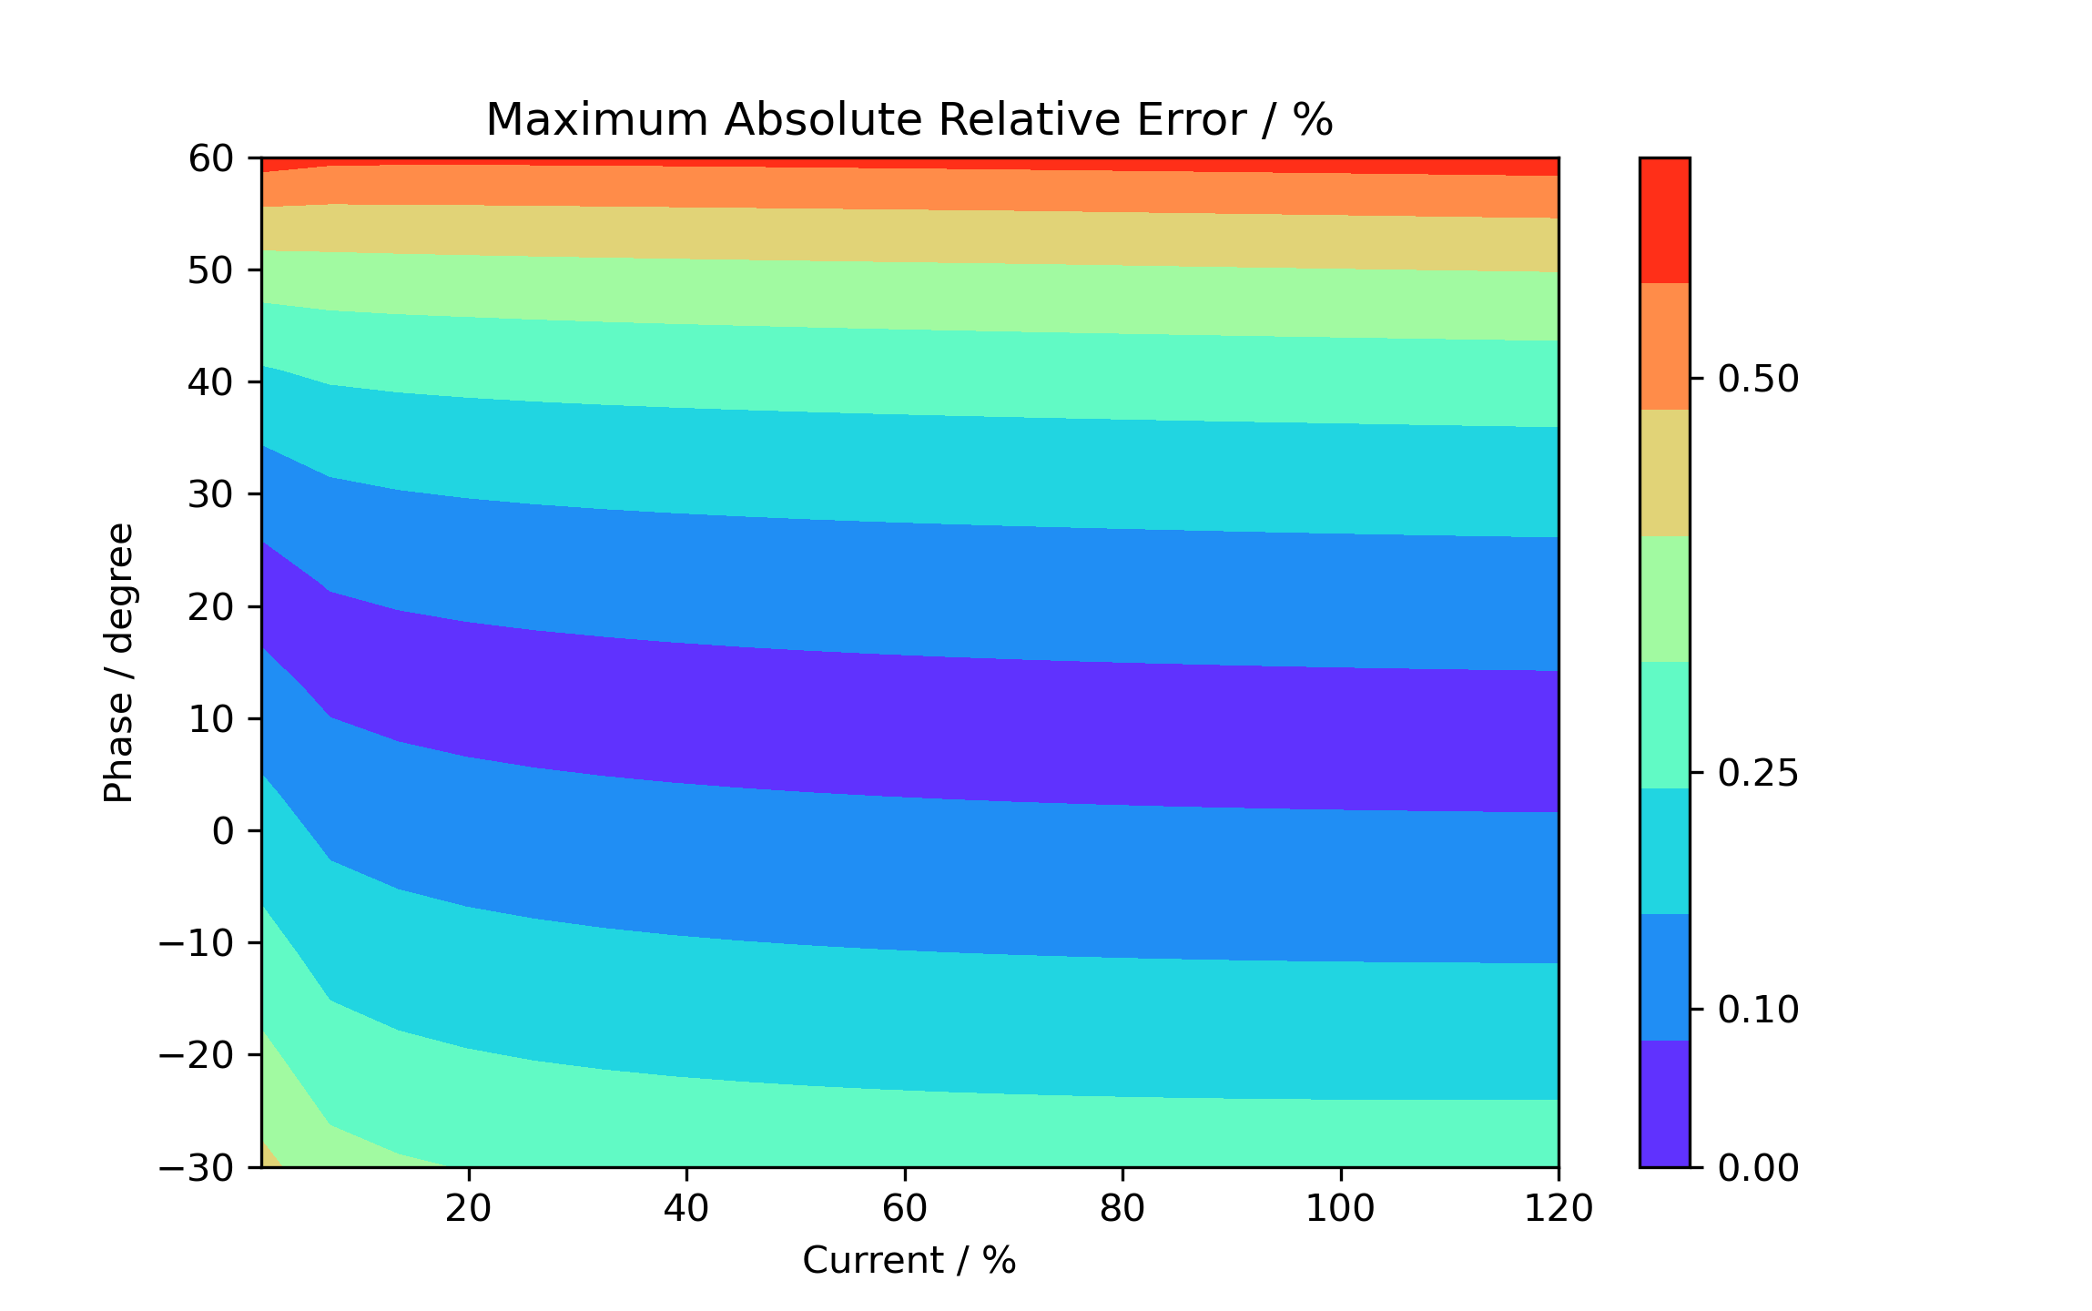

Additional Information

Text Output From the Calculation Process
Meter data
Data scatter greater than expected, a poor fit.
CT ratio data
Fit has lower uncertainty than expected from calibration data, so type B component added.
CT phase data
Good fit.
VT ratio data
Fit has lower uncertainty than expected from calibration data, so type B component added.
VT phase data
Fit has lower uncertainty than expected from calibration data, so type B component added.

Load phase limited to 89.9 degrees maximum.
For profile in C:\Users\k.jones\OneDrive - Callaghan Innovation\KJ\PycharmProjects\MIEcalc3\Projects
\mie_temp\load.txt
Max current = 86.65 %, Min current = 20.35 %, Max phase = 89.90 degrees, Min phase = 61.93 degrees

Load phase limited to 89.9 degrees maximum.
For profile in C:\Users\k.jones\OneDrive - Callaghan Innovation\KJ\PycharmProjects\MIEcalc3\Projects
\mie_temp\load1.txt
Max current = 16.78 %, Min current = 2.41 %, Max phase = 89.90 degrees, Min phase = -11.13 degrees

Load error, low or negative current.
Load phase limited to 89.9 degrees maximum.
For profile in C:\Users\k.jones\OneDrive - Callaghan Innovation\KJ\PycharmProjects\MIEcalc3\Projects
\mie_temp\load2.txt
Max current = 193.16 %, Min current = 0.10 %, Max phase = 89.90 degrees, Min phase = -19.92 degrees

start site error

Load Profile # 1
Budget for overall error by coefficients
error = 2.757, standard uncertainty = 0.361, degrees of freedom = 25.8
a2 meter: 0.302478
VT calibration burden: 0.29453
a3 meter: 0.293324
a2 CT_p: 0.181719
b0 VT_p: 0.132538
a0 CT_p: 0.114243
a1 CT_p: 0.0513759
Meter temperature coefficient: 0.040078
Site VT burden: 0.029453
Meter harmonic dependence: 0.0282843
Site harmonics: 0.0282843
Meter field dependence: 0.0176777
Site EM field: 0.0176777
CT calibration burden: 0.0174925
b0 VT_e: 0.0163636
a0 meter: 0.015926
b0 CT_e: 0.0140929
a0 VT_p: 0.0126774
a1 VT_p: 0.0125524
Meter voltage dependence: 0.0106066
Meter annual drift: 0.01
Site voltage: 0.00860223
a2 CT_e: 0.00756254
a0 VT_e: 0.00664262
a1 VT_e: 0.00657718
Site frequency: 0.00647566
Meter frequency dependence: 0.0053033
Site temperature: 0.00510347
VT temperature coefficient of phase: 0.00471247
a1 meter: 0.00455804
a0 CT_e: 0.00405622
VT calibration temperature: 0.0029453
a1 CT_e: 0.00247547
Meter calibration temperature: 0.00176777
Site CT burden: 0.00174925
CT temperature coefficient of phase: 0.00071668
zero burden factor: 0.000394415
CT temperature coefficient of error: 9.20302E-05
CT calibration temperature: 7.80812E-05
start site error

Load Profile # 2
Budget for overall error by coefficients
error = 1.405, standard uncertainty = 0.199, degrees of freedom = 34.8
a2 meter: 0.152815
VT calibration burden: 0.1488
a3 meter: 0.0871667
b0 VT_p: 0.0669601
a0 CT_p: 0.0577172
a2 CT_p: 0.0540012
Meter temperature coefficient: 0.040078
Meter harmonic dependence: 0.0282843
Site harmonics: 0.0282843
Meter field dependence: 0.0176777
Site EM field: 0.0176777
CT calibration burden: 0.0175606
b0 VT_e: 0.0163636
a0 meter: 0.015926
Site VT burden: 0.01488
b0 CT_e: 0.0140929
Meter voltage dependence: 0.0106066
Site voltage: 0.0103856
Meter annual drift: 0.01
a0 VT_e: 0.00664262
a1 VT_e: 0.00657718
a0 VT_p: 0.00640476
a1 VT_p: 0.00634166
Site frequency: 0.0059272
Meter frequency dependence: 0.0053033
a1 CT_p: 0.00524587
a2 CT_e: 0.00442777
a0 CT_e: 0.00405622
Site temperature: 0.00366844
VT temperature coefficient of phase: 0.0023808
Meter calibration temperature: 0.00176777
Site CT burden: 0.00175606
VT calibration temperature: 0.001488
a1 meter: 0.000910132
CT temperature coefficient of phase: 0.000791389
zero burden factor: 0.00056192
a1 CT_e: 0.000494293
CT temperature coefficient of error: 0.000131115
CT calibration temperature: 8.25343E-05
start site error

Load Profile # 3
Budget for overall error by coefficients
error = 0.575, standard uncertainty = 0.106, degrees of freedom = 62.7
a3 meter: 0.072325
a2 meter: 0.0673792
VT calibration burden: 0.0656087
a2 CT_p: 0.0448066
Meter temperature coefficient: 0.040078
b0 VT_p: 0.029524
Meter harmonic dependence: 0.0282843
Site harmonics: 0.0282843
a0 CT_p: 0.0254486
a1 CT_p: 0.0184513
Meter field dependence: 0.0176777
Site EM field: 0.0176777
b0 VT_e: 0.0163636
a0 meter: 0.015926
b0 CT_e: 0.0140929
Site voltage: 0.0114037
Meter voltage dependence: 0.0106066
Meter annual drift: 0.01
a2 CT_e: 0.00836194
a1 meter: 0.00734566
a0 VT_e: 0.00664262
a1 VT_e: 0.00657718
Site VT burden: 0.00656087
Meter frequency dependence: 0.0053033
Site frequency: 0.0050725
a0 CT_e: 0.00405622
a1 CT_e: 0.00398943
a0 VT_p: 0.00282398
a1 VT_p: 0.00279616
Site temperature: 0.00246011
Meter calibration temperature: 0.00176777
VT temperature coefficient of phase: 0.00104974
VT calibration temperature: 0.000656087
CT calibration burden: 0.000502787
zero burden factor: 0.000368504
CT temperature coefficient of phase: 0.000143998
CT temperature coefficient of error: 8.59842E-05
Site CT burden: 5.02787E-05
CT calibration temperature: 7.25173E-06
start error by point

