Amgen GUI TFL Output
Produced on 2017-01-09 using the Pharmacometrics TFL Generator (R::GUI 1.2.0, R::TFL 1.2.0)
Preliminary Population Pharmacokinetic Analysis of <<matrix>>
in <<subjects>> from Amgen Phase <<#>> Studies
Authors:
Contributing Scientists:
Tables
Parameter Estimates from <model>

The estimates and their corresponding precisions (%RSE) are those found from the population analysis.

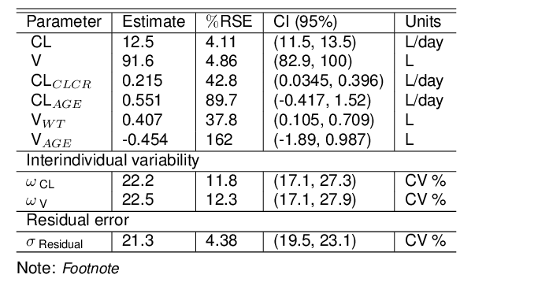
Summary statistics of <continuous columns> by <stratification>

Caption

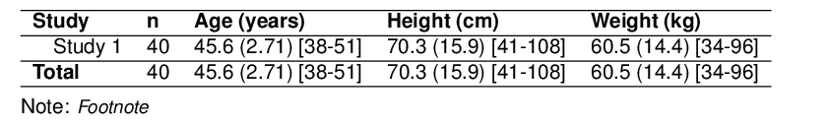
Summary statistics of <categorical columns> by <stratification>

Caption

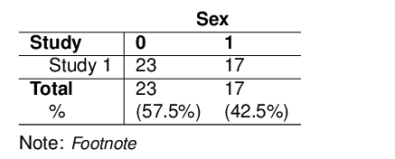
Figures
Concentration time profiles

Caption

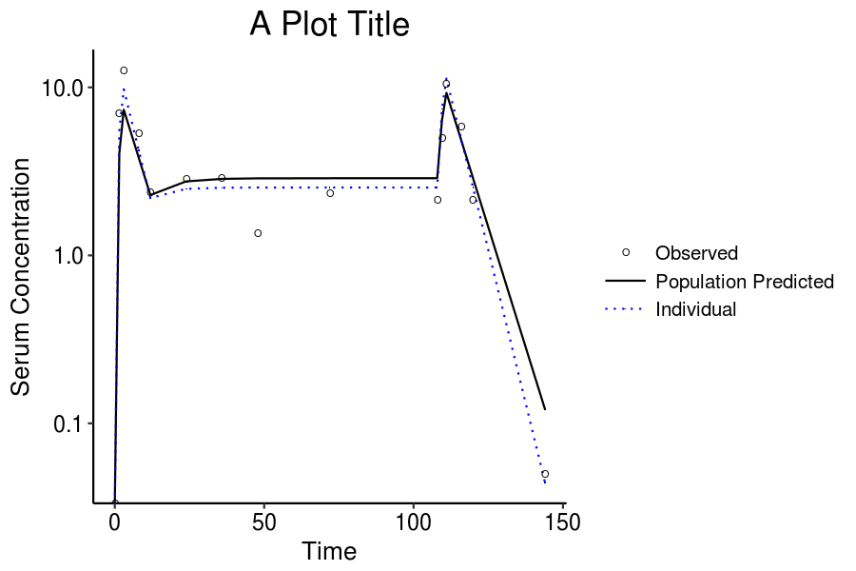
Note: Footnote
Concentration time summary

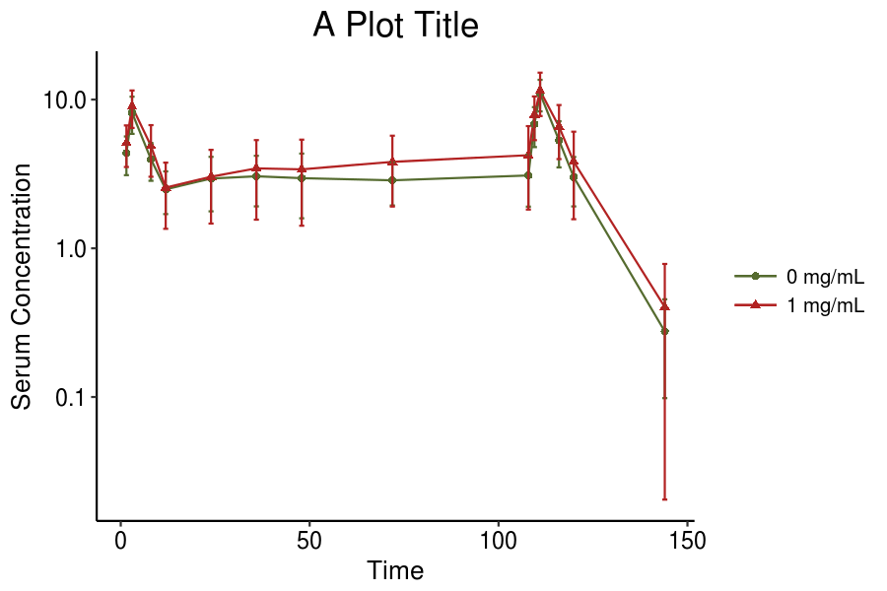
Note: Footnote
Observed vs Population Predicted Serum Concentrations from <model>

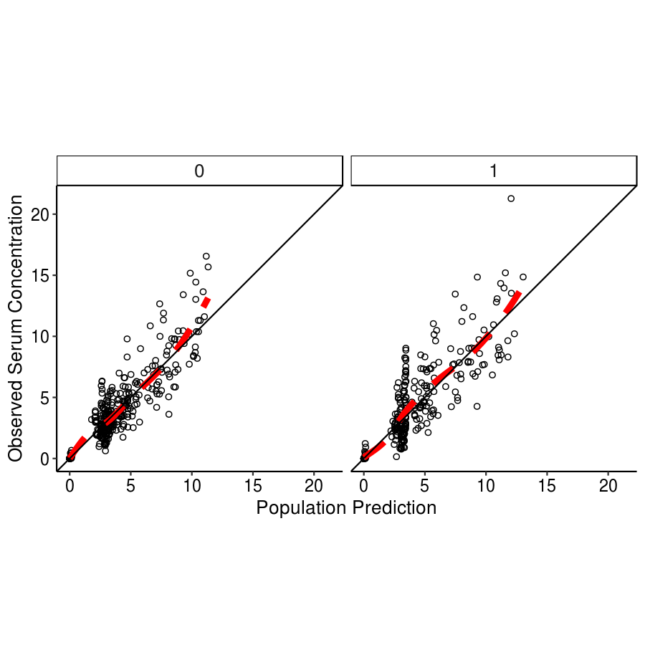
Note: Footnote
Parameter distribution

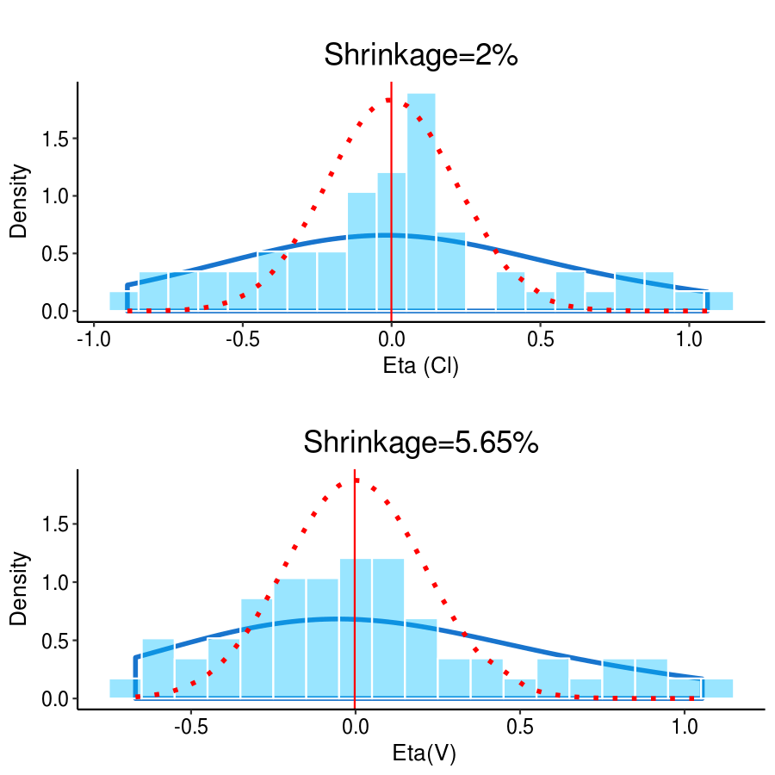
Note: The y-axis shows the percent of observations that fall into respective bins. The solid blue lines illustrate the density of the random effect distributions. The red vertical lines show medians of these distributions. The dashed red lines show the density of the random effect distributions as estimated by the model. Shrinkage calculations are described in the Methods section.
Distribution of <y variable(s)> Stratified by <x variable(s)>

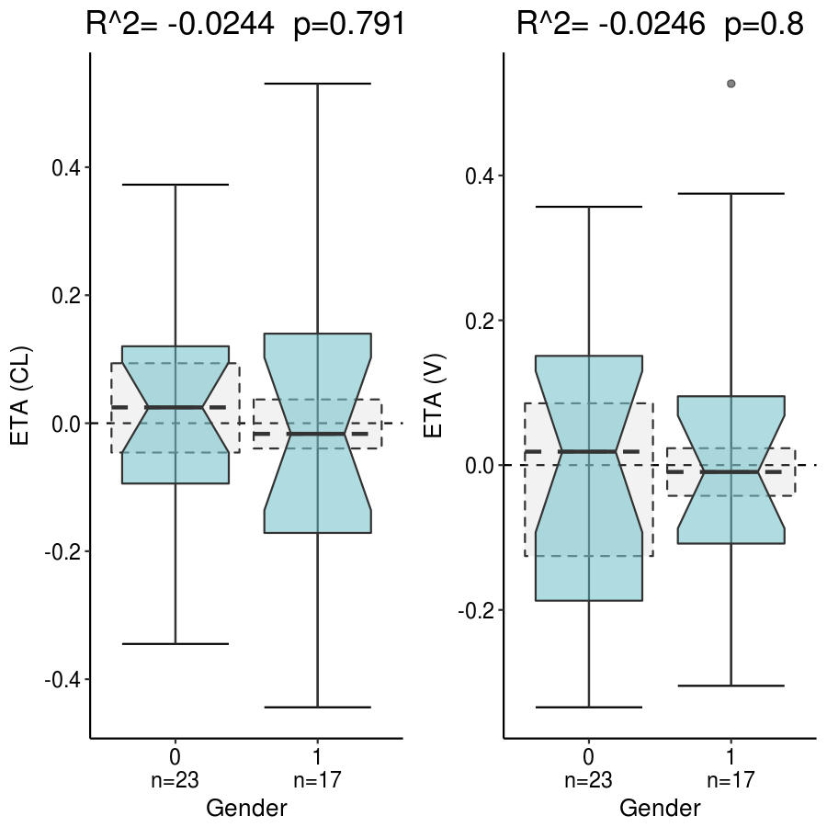
Note: Footnote
Relationship between <y variable(s)> and Covariates <x variable(s)>

Caption

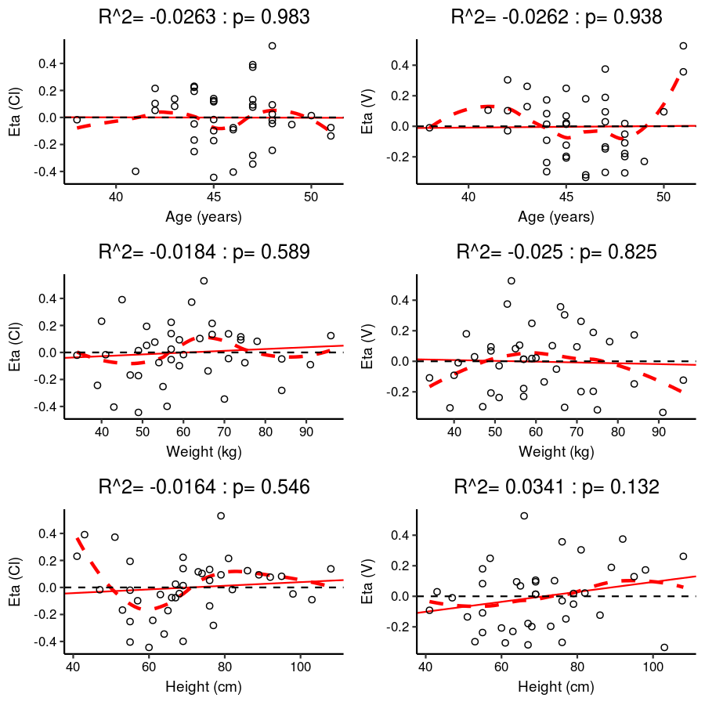
Note: Footnote
Correlations of Interindividual Random Effects

Caption

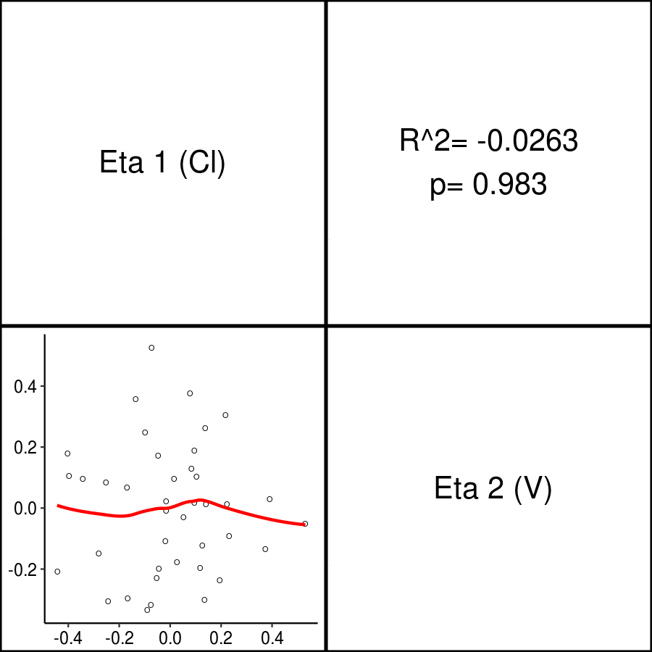
Note: The continuous covariates (points) and the red lowess (local regression smoother) trend lines are plotted. The coefficient of determination between the covariates are also presented.
QQ plot

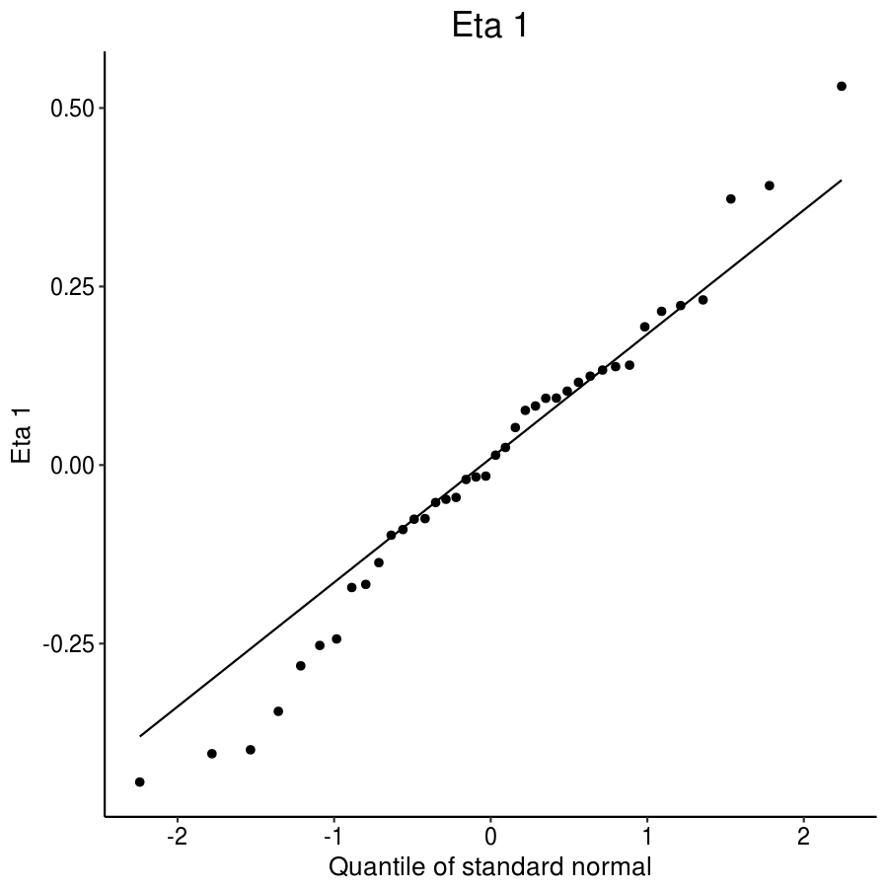
Note: Distribution of <random effect> is compared to the standard normal distibution.
Goodness of Fit Plots

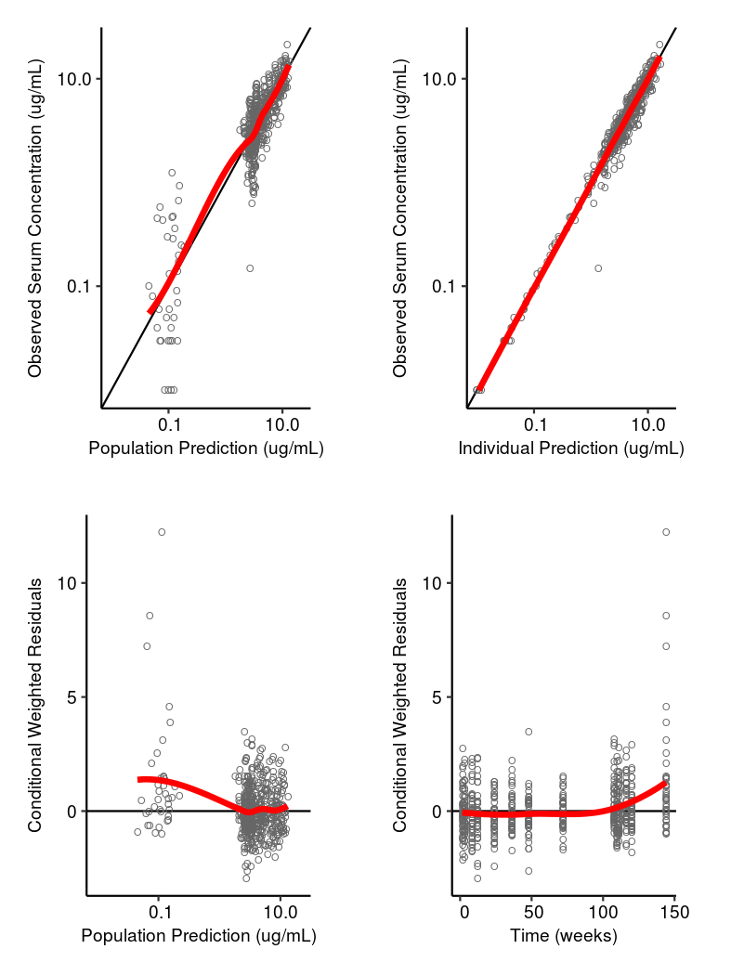
Note: The red line is the lowess (local regression smoother) trend line
Density Plots

Caption

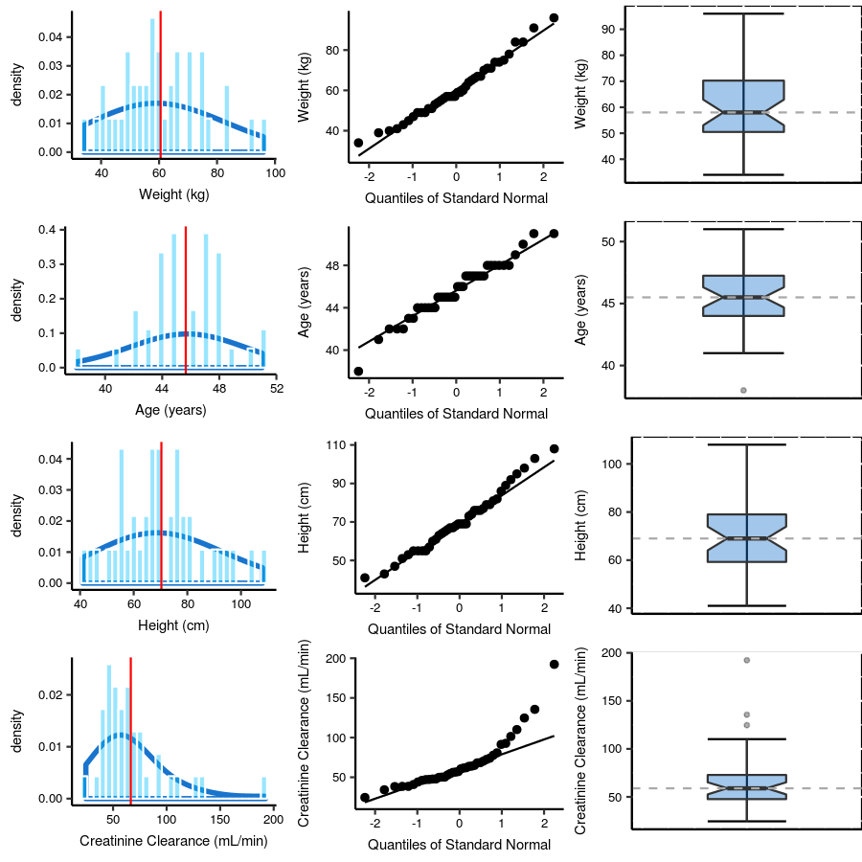
Note: Left panel: Frequency histograms of the covariate distributions, where the y-axis shows the probability density of the covariate distribution. The sum of the bar heights times bar widths equal 1. The solid red line is the mean of the covariate distribution. Middle panel: Quantile-quantile plots of the random effect distributions against the standard normal distributions. Solid lines are the reference lines that correspond to perfectly normal distributions.Right panel: Box plot of the covariate distribution, with the grey dash line showing the median of the covariate distribution.
Distribution of Subject's Sex, Race, and Disease status

Caption

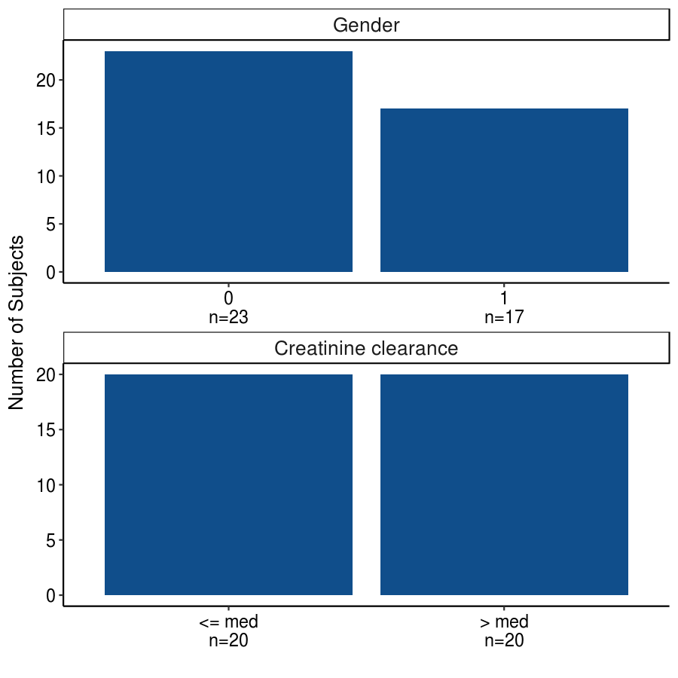
A VPC Plot

Observed data (open circles) and median (solid line). 5th and 95th percentiles of the predictions for the 5th, median, and 95th percentiles are shown as shaded regions.

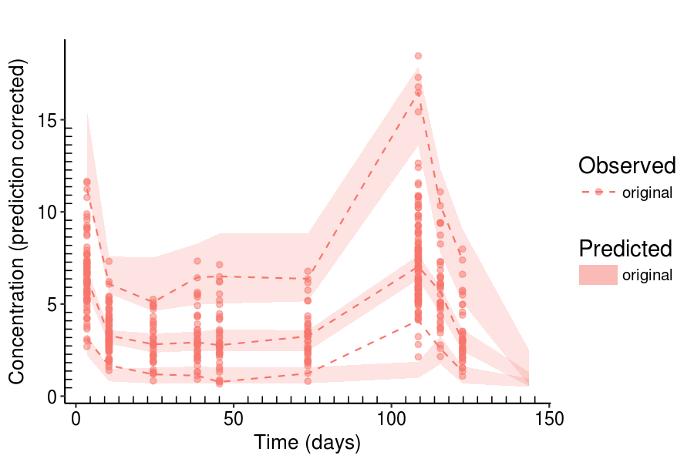
Note: Footnote
Listings
Population (Solid Lines), Individual Model Fit (Dashed Lines), and Observations (Open Circles) for Subjects in Clinical Studies Using <Model>

