Text Numbering Count: Staff

Goal
To check the accuracy of text numbers, whether or lines or paragraphs

Items you need
These should all be in the relevant edition folder, but not any of the subfolders.
- Texts (in Microsoft Word)
- Patience and endurance – counting is tedious!

Instructions
- In the Text(s), count line/paragraph numbers to check for accuracy and sequential ordering. Be aware of unnumbered lines.
  - If it’s a Facing-Page Translation, check that line/paragraph numbers match up between the original language and the modern English translation
  - If it’s a Prose text, make sure the paragraph numbers restart at every chapter and book.
    - Check also that book and chapter numbers appear in sequential order.
  - If it’s a Drama text, please note that stage directions and scene locations, generally italicized, are usually not numbered. For details, refer VEs to https://metseditions.org/submissions#formatting-texts > Drama.
    - Check that no single line contains both a line number and a speaker name. We don’t have room for both in InDesign. If you find lines that contain both, insert comments where these occur: tell the VE that speaker names take precedence, so the next line of text should be numbered. This may mean deviation from every 5th line being numbered. So if a speaker name appears on line 140, only the speaker name should appear here and then line 141 will get a line number.
    - Check that no single line contains both a speaker name and a folio number. Again, we don’t have room for both in InDesign. If you find lines that contain both, insert comments where these occur: tell the VE that the folio number should be placed above the speaker name on an unnumbered line.

Tips
- Counting every five lines is mind-numbing, so start slow and careful. After you’ve built up a rhythm, you can go faster (or put in some headphones). The Managing Editor at this point recommends eyeballing the number of lines between the line numbers: if there are four, it’s probably right – as long you’re keeping track that the line numbers are going up by 5.
- If it’s a long text (say, more than 1000 lines), you can start to tire. So take breaks! As you get up in thousands of lines, it’s easy to miss zeroes at the end of line numbers that get past 3 digits. Be careful!

- If there are numbering errors, make sure Track Changes is on, and correct it. If it’s just a typo, this is sufficient. But if it’s an actual counting number that means the remainder of the text will need renumbering, insert a comment saying so. Indicate to the VE they must also re-collate to the E- and T-Notes (and any additional back matter), and check/revise cross-references. NB: The Managing Editor will double check cross-references in Second Read.
  - Record any errors as a subtask in Asana, just so we have a record of it. Since we (staff) won’t be correcting errors, you don’t need to list each one individually. I’d add a subtask for each kind of error and list each instance within the subtask (typos vs. counting errors):

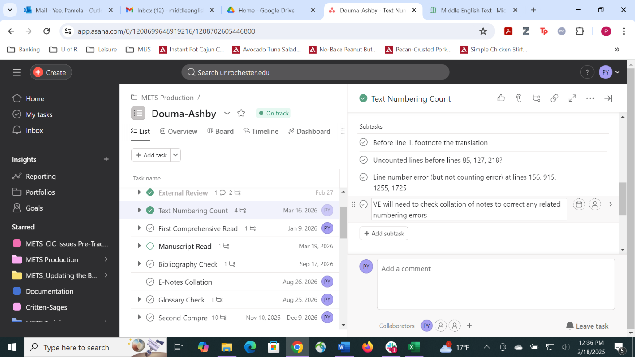

This way, you can check each subtask off when corrections are returned.

- Repeat for all texts within the edition! If your edition has multiple texts, it may be helpful for you to create a list of subtasks in Asana to check off as you complete the count for each text. If you’d like to do this, add each text in Text Numbering Count as a subtask.

