External Review: Select Advisory Board Members
This review is assigned by the Editorial Board to either an Advisory Board member or a scholar external to METS. This review focuses on field-specific content and context, ensuring that the critical apparatus adequately and appropriately situates the text within the field and supports the needs of both novice and experienced readers. Once the reader is selected, the member of the Editorial Board who knows them best will reach out to them. Once a reader accepts, the Managing Editor will start the workflow.

Create and Populate New Folders
- Go to External Review. Change this folder name to include the reviewer’s last name in parentheses. For example, if the reviewer is David Lawton, the folder name should become External Review (Lawton). This helps the Managing Editor see quickly who the reviewer is.
- Since the review is double-blind, it is imperative that the edition is anonymized before it is sent to the external reader. But we only want to anonymize the files for this step, not for the remainder of production. So first, in the newly renamed External Review folder, create a new subfolder and title it “Anonymized Word files.”
- Return to the main edition folder. Select all the edition files, including any Excel spreadsheets labelled “Table #”, but exclude the short titles spreadsheet. Copy all these files, and paste them into the “Anonymized Word files” subfolder.

Anonymize the Edition Files
- To anonymize the edition’s Word files, open the first Word file, usually labelled 00-Front. Select the File tab and, on the lefthand blue sidebar, choose Info. Note that in the righthand column, under Related People, the Volume Editor’s name, is listed by Author. We want to get rid of this name, so the reviewer will not know the Volume Editor’s name.
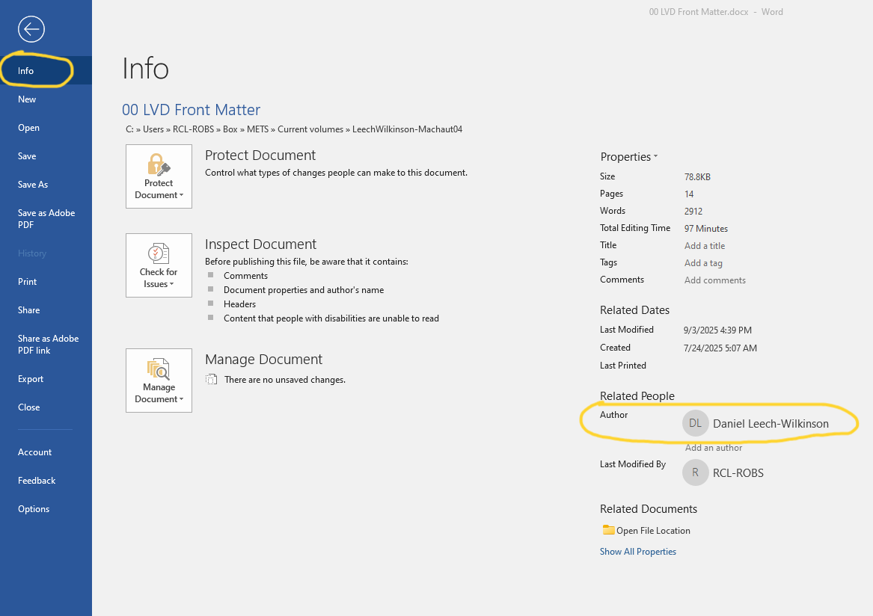

- In the Inspect Document, click the Check for Issues icon, which will open a dropdown menu. Choose “Inspect Document.” This will open a new Document Inspector window. In its list, make sure “Document Properties and Personal Information” is checked; it’s okay if other fields are also checked. Then, click Inspect. It will take a few seconds for this inspection to finish.

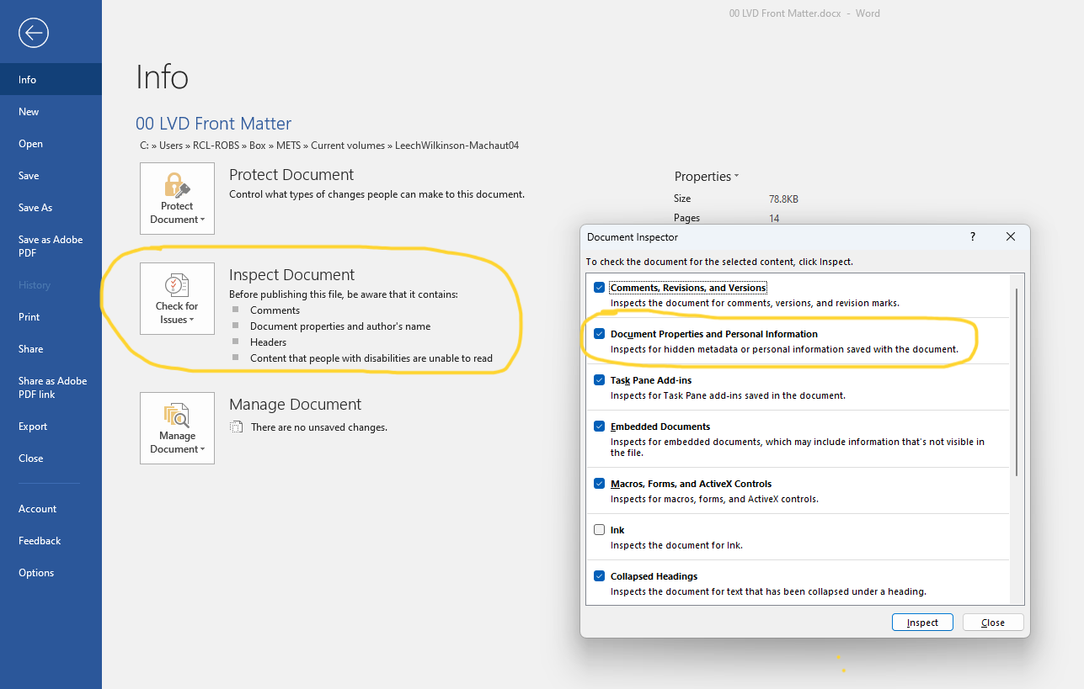

- When the inspection is done, in the Document Properties and Personal Information section, click “Remove All” to remove the document and author properties associated with this file. Then click “Close.”

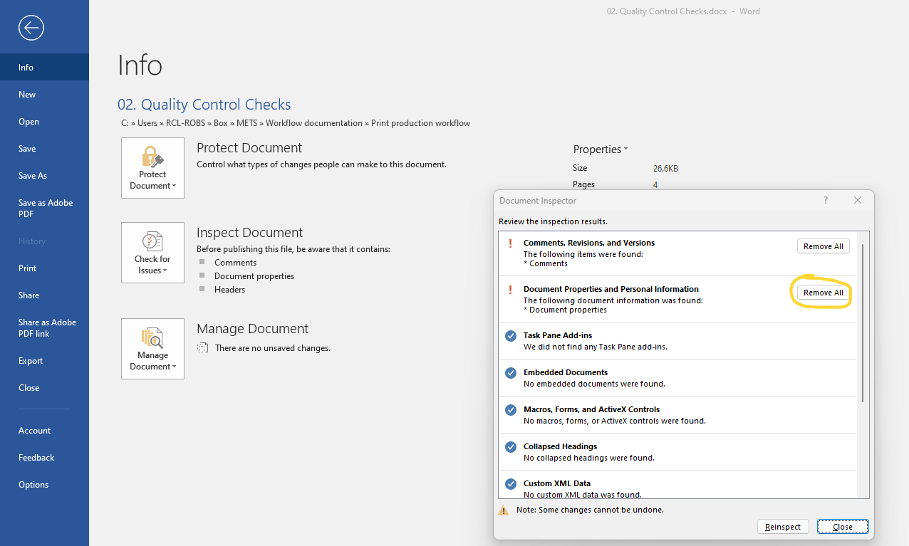
- Note that under “Related People,” the Volume Editor’s name is gone. It has been replaced by prompting text to “Add an author.”

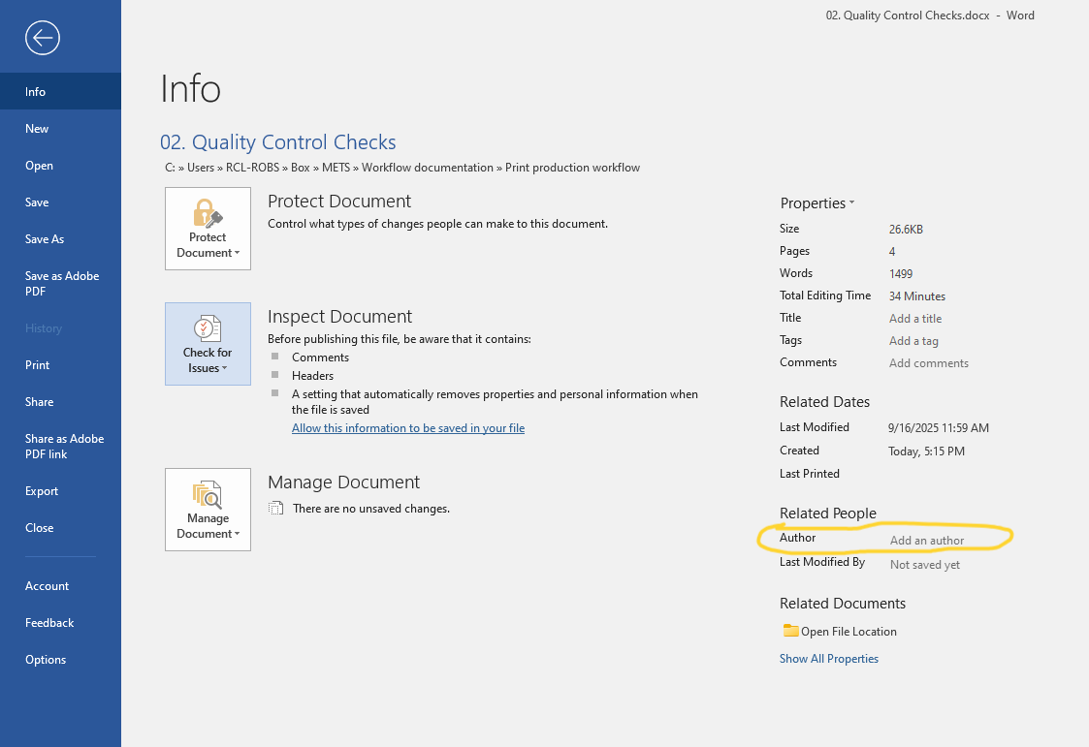
- At this point, make sure to Save. When the file is re-opened, the Author information will remain gone.
- If there are Excel spreadsheets, use the same steps to remove their Author information.
- Check if this edition has additional images by going to Images. Check if these images have Author information by right-clicking the image file, choosing Properties, and selecting the Details tab. If there are no names under “Origin > Authors,” the image should be anonymized. If it does have a named author, click Remove Properties and Personal Information” link at the bottom of this Properties window and follow the prompts.
- Repeat steps 4-10, above, for all remaining Word and Excel docs in the edition.

Compile into a single document
- Now that all edition documents are anonymized, export each one into a PDF. Open the first Word file, select the File tab, and click Save as Adobe PDF in the lefthand blue sidebar. This will open a File window. In the file path, choose “External Review (Lawton)” folder, and click Save.
- If there are Excel spreadsheets, use the same steps to convert them to PDFs. If there are multiple sheets in a single Excel file, you will need to export each sheet separately, so there are multiple PDF files.
- Repeat steps 12-13 for all remaining Word and Excel docs in the editions.
- Now that all edition files are PDFs, we will compile them into a single manuscript. On your desktop, open Adobe Acrobat. In the top horizontal toolbar, select “See all tools” and on the resulting page, under “Create,” click the “Combine Files” icon.

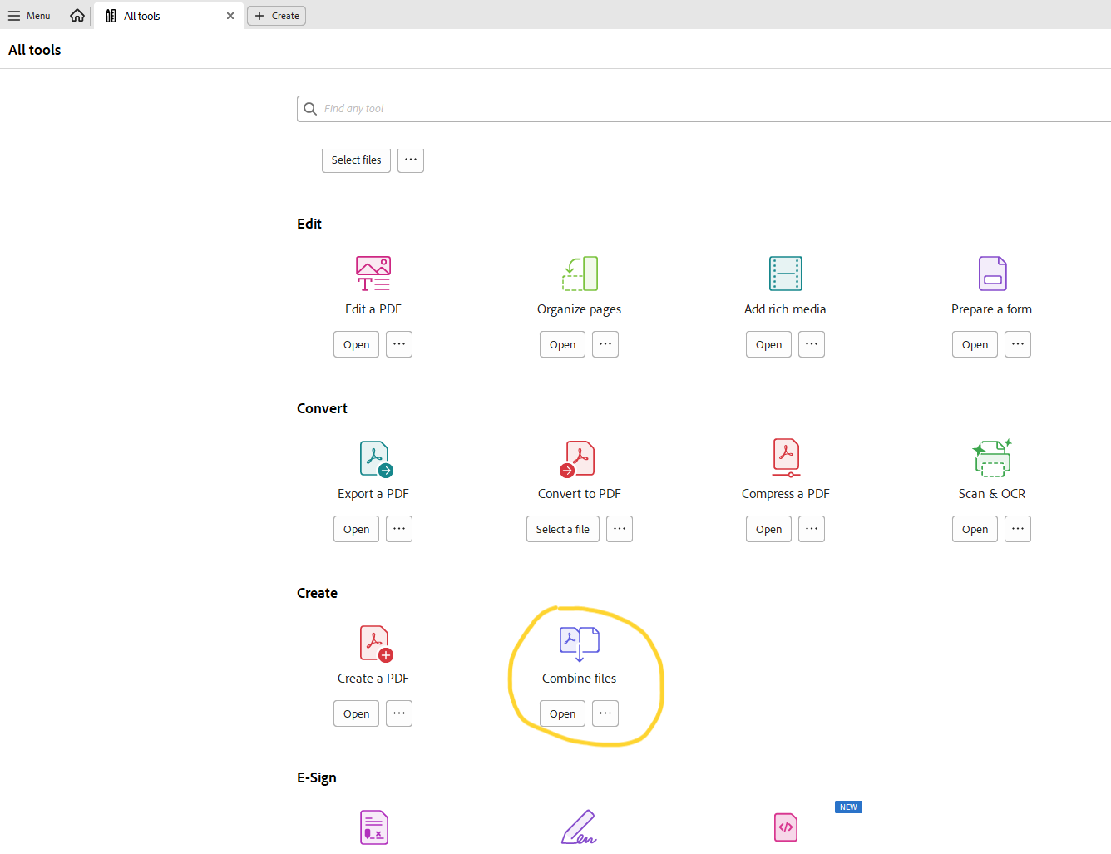

- On the new page, drag and drop all the edition’s PDFs from your “External Review” folder. Adobe Acrobat will list them in order of the filename numbering. In the top righthand corner, click “Combine.” You’ll see the status updating to “successful” in the righthand column. Be patient; if there are a lot of files, it may take a few moments to incorporate them all.

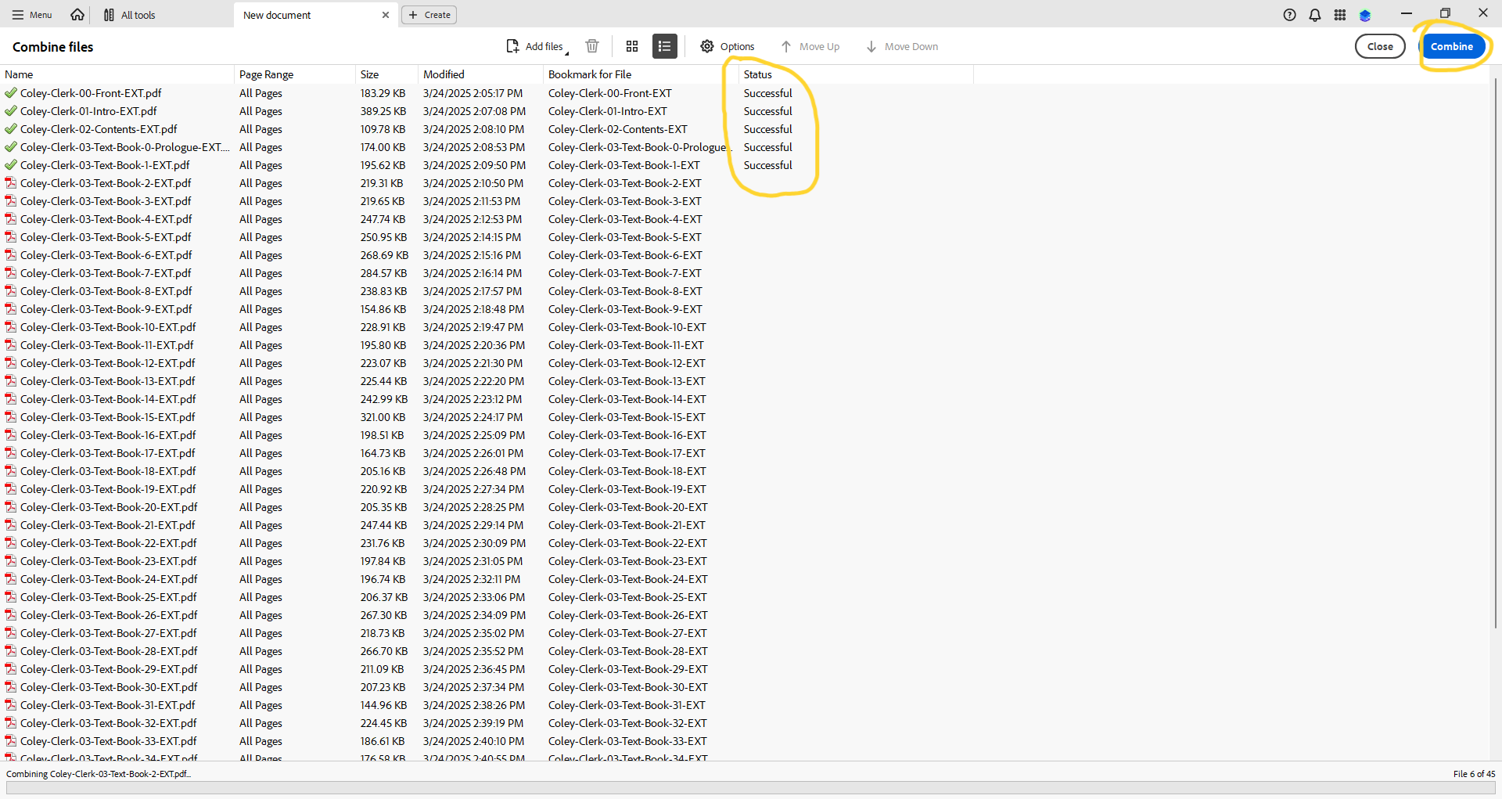

- Once it’s done, it will open on the first page of the combined PDF. Notice that it’s filename defaults to Binder1.pdf. Click Shift + Ctrl + S to Save As. Choose your “External Review (Lawton)” folder. In the Save As window, rename the file from Binder1 to Editor-Title-EXT, using the usual project name. The -EXT indicates the production step, external review. Click Save.
  - Note that when you open this combined PDF’s Document Properties, the Author field is blank.
  - In the bottom righthand corner, note how many pages this PDF is. Is it above or below 500? Keep this in mind for the next steps.

Prepare the External Review Guidelines
- Go to 04a. METS External Review Guidelines. Copy and paste it into the “External Review (Lawton)” folder.
- Rename it with the correct project name, for example, Coley-Clerk-Review-Guidelines.
- Open it. Under #4 Responsiveness, there is a Turnaround deadline. You will need to add in a bespoke deadline at which time the external reader should return the reader’s report. METS typically allows 3 months for an external read. Calculate 3 months from today (or whenever you plan to contact the external reader) and round off to the nearest Monday or Friday. Add this date in boldface after Turnaround deadline. Ex: Friday, December 19, 2025.
  - For longer editions (500+ pages), we allow more time – typically another month of two. Consult the Editorial Board for an exact period.

Send Material to the External Reader
- Luckily, we have correspondence templates for sending this email to the external reader. Go to Correspondence Emails Templates. Open External review email and copy and paste it into your new email.
  - Fill in the bracketed phrases with the relevant information.
  - Attach the indicated files, including images from the Images subfolder, if necessary.
    - If all the attachments make the files too big to send by email, zip them. If they’re still too big to send, upload all attachments into METS’ dropbox.

