For each section, read the entire instructions before you try to follow them. Knowing where you are going will help.

Overview: InDesign Interventions
Once all the necessary Export files have been added to the appropriate Editor-Volume-Export folder in Box, we go through each InDesign document and make specific changes to prepare these files for their TEI conversion. There are three major steps to this process:
- Delete certain print-specific formatting details.
- Add in Indicators for Explanatory Notes, Textual Notes, and Glosses, according to our Best Practices
Make sure the Highlight Override feature in the Paragraph Styles menu is turned on. Check and clear any remaining overrides that exist in the text.
- Leave any overrides present in paragraph numbers for prose texts.
- If there is an override on purpose in the body of the text, make a note of it in the oXygen Interventions worksheet so we can check on it later in the process.
- Reminder: overrides are the blue highlighting that indicate a style may not be correctly rendered. In the Paragraph Style menu, click the paraph marker at the bottom right. For more, refer to the Formatting Reference documentation, section Overrides.
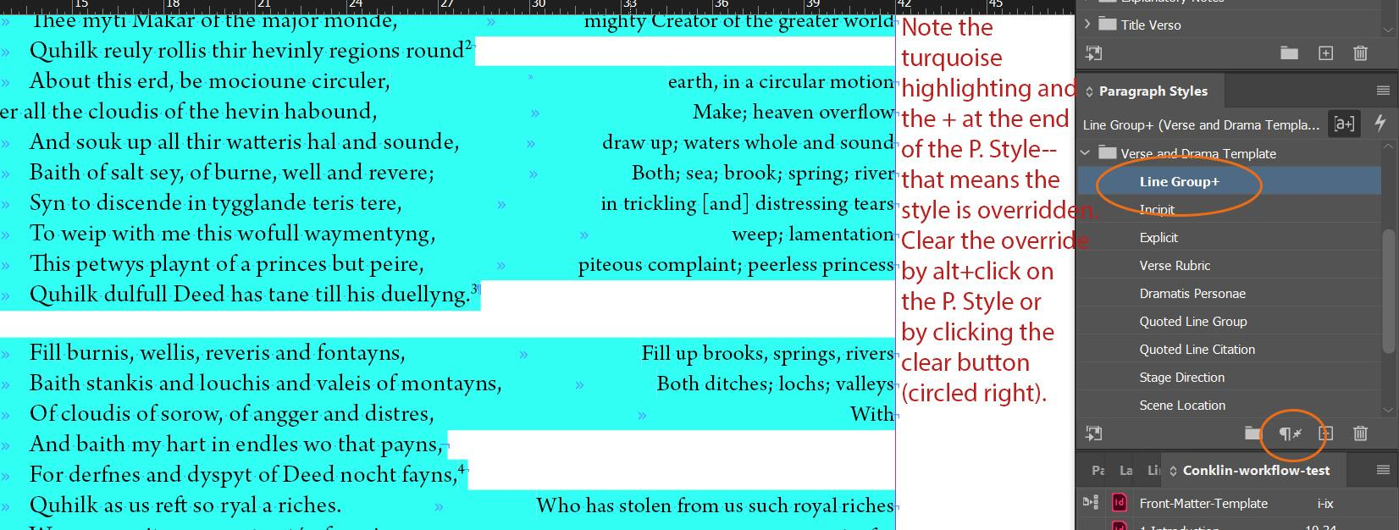

Delete Print-Specific Formatting

When formatting for Print Production, we make some decisions in InDesign to prioritize the look of the print book. However, we need to undo some of this work to prepare the files for conversion into TEI.
- This conversion to TEI is done by a transformation script, which recognizes the various Paragraph and Character styles we use in InDesign and transforms them into TEI-XML elements that we have designated.
- Most of our Styles have formatting loaded in them to look correct for the printed page as well as be correct for their conversion into TEI.
- Work done to prioritize the look of the print book is often bespoke to a particular edition, and not necessarily a standard that we apply widely across editions, which means that our script won’t be able to transform it correctly.
Below is a list of print-specific formatting that will need to be changed before we can convert these files to TEI. We try very hard to keep this list of common exceptions very small, as this list represents duplicated labor on our parts.

Introduction or Headnote files
- If the paragraph style Annotated Bibliography Paragraph has been used, replace it with List No Bullet Level 2.

All Text files
This includes any main text files, as well as any Appendix files that contain texts.
- Delete any (see note) or (see t-note) phrases, if present
  - These are typically found in marginal glosses
    - If it is next to other glosses and not part of a gloss, remove the semi-colon before the phrase.
    - If it is the only phrase in the marginal gloss area, delete any extra tabs used to make it right justify. We always want the forced line break to hug the end of the last word on the line.
  - Sometimes they can be found in footnote glosses
    - If it is next to other gloss information, remove any punctuation before the phrase.
    - If it is the only phrase in the footnote, delete the entire footnote.
      - This happens most often in Prose texts.

- Delete any added page breaks that were inserted to prevent orphans/widows.
  - Ex:
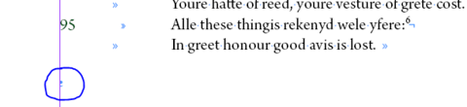

Verse texts
- If the paragraph style Verse Rubric has been applied, verify whether the Verse Rubric should be in verse or in prose. If it should be in prose but has marginal glosses, it will also have forced line breaks.
  - Set any marginal glosses as footnote glosses.
  - Then, remove any forced line breaks that have been applied
- If the Verse text has speakers:
  - Check for any long speaker names that have had more than one tab added between the name and the line of text to make the print more legible.
    - If these occur, then delete the extra tabs so there’s only one tab between the name and the line of text.
  - Quickly double check the styles that have been applied to speakers. These speaker names should not have the Speaker Character Style applied. Instead, they should have some combination of Small Caps or Person Name Small Caps.
    - Any language information should be recorded in the oXygen Interventions spreadsheet.

Drama texts
- If the Drama text has speaker names:
  - Check for any long speaker names that have had more than one tab added between the name and the line of text to make the print more legible.
    - If these occur, then delete the extra tabs so there’s only one tab between the name and the line of text.
  - Quickly double check the styles that have been applied to speakers. These speaker names should all have Speaker Character Style applied.
    - Any language information or Person Name information should be recorded in the oXygen Interventions spreadsheet.

Explanatory Notes and Textual Notes
Any verse block quotes with columns in Explanatory Notes and Textual Notes files will need to have their formatting adjusted so that the script / reader view will know what to put in the left column vs the right column.
- First, make sure the original language and the translation are in one stanza, with forced line breaks at the end of each line. If there are stanzas contained in the block quote, use an end of paragraph symbol to separate the stanzas. You will need to do this work by hand, as we have made columns using tabs for print. Have the original language first, followed by the translation. Alternately, have the text from the first witness first, followed by the second witness.
- If any column lines needed to be wrapped to the next line, remove any extra forced line breaks / tabs so that all the text for that line is together on one line.
  - If you are unsure whether this is happening, look back at the formatting in the original Word document or ask the Managing Editor.
- It should look like this:
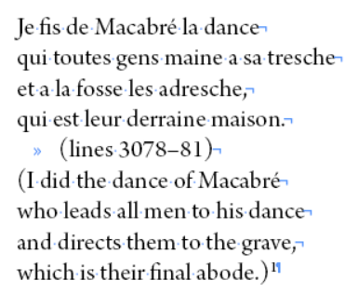
- Apply Notes Line Group Columns-Digital Paragraph Style to the entirety of the quote.
- Add a column break at the end of the original language / first witness:
  - Right Click > Insert Break Character > Column Break.
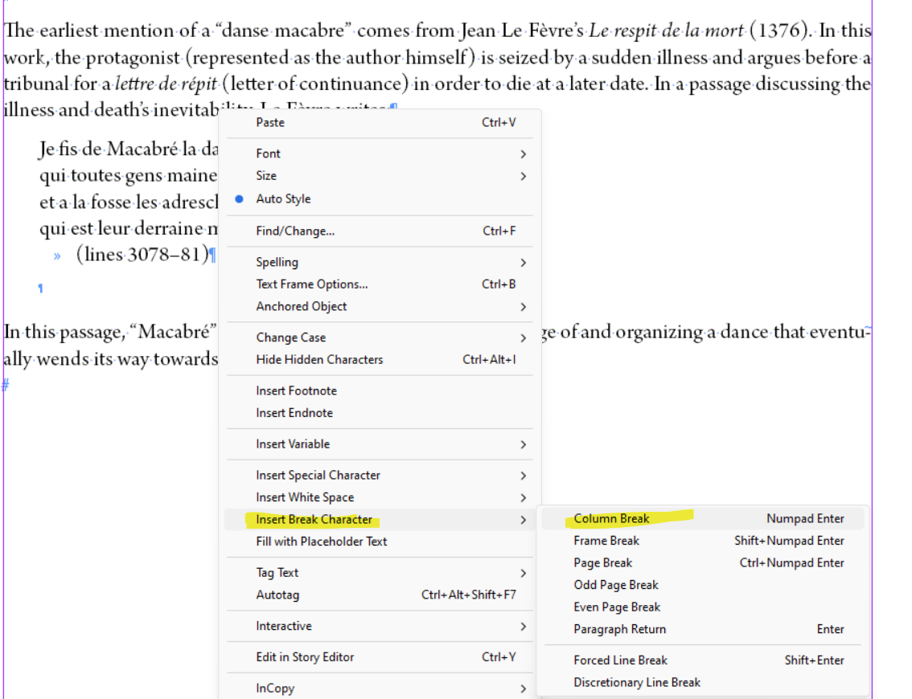
- Check the column alignment; you may need to delete an extra forced line break to ensure the lines align correctly.
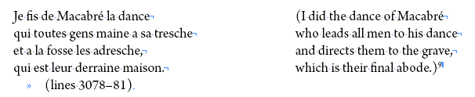
Finally, fix the Paragraph Style overrides
- Clear any overrides. Refer to Formatting Reference (section Overrides) as needed.
- Check all formatting against the original document.

Index of Proper Names
- Remove any ornamental divisions between entries. We won’t need these online.

Index of First Lines
- Delete the text “Page” that is styled with Heading 3 Paragraph Style at the top of the document.
- If there are any page numbers right justified on the page, delete them along with any tabs used to right justify them. The end of paragraph symbol should immediately follow the last character of the entry.

Insert Indicators

We need to add indicators for Explanatory Notes, Textual Notes, and marginal Glosses into all text files, including any Appendix files that contain a text that has marginal glosses, Explanatory Notes, and/or Textual Notes associated with it. These indicators allow our users to access any additional explanations while reading through the text in our digital editions.

Best Practices for Inserting Indicators:

Take your time when doing this work.
- This process is extremely detail-oriented and easily subject to mistakes caused by eye-skip. We want it done as correctly as possible the first time around.

Indicators should follow a particular order.
- Indicators should always be listed in the text in the following order:
  - Any punctuation associated with the last word of the catchphrase, if present
  - Footnotes
  - Explanatory Notes Indicators
  - Textual Notes Indicators
  - Gloss Indicators
- Typically, it is best to work through inserting indicators in rounds. Start with adding all the indicators for Explanatory Notes, then move on to the indicators for Textual Notes, then end with the indicators for Glosses.

Placing Indicators in already tagged phrases
- As much as possible, we don’t want an indicator to interrupt a phrase that has already been tagged with Person Name Character Style, Place Character Style, Animal Name Character Style, Date Character Style, or Title Character Style. If possible, move the indicator to the end of the tagged phrase. The catchphrase in the notes document should remain the same.
  - Ex. “Jesus Christ” would be marked with one application of Person Name Character Style. If there was a note catchphrase of “Jesus”:
    - Correct: Jesus Christ^{N}
    - Not Correct: Jesus^{N} Christ
- We recommend giving these five Character Styles a Character Color, so that any applications of them immediately stand out to you as you are adding in any indicators.
  - Find the Character Style listed in the Character Styles Panel
  - Right click > Edit “Style Name.” This will open the Edit Style window.
  - Select the Character Color option in the left menu and choose a color.
    - Typically, Person Name and Animal Name are set to pink, Place is set to Green, and Date is set to Blue, but these are guidelines. Choose any color you like, as long as you can keep which is which straight.
    - N.B.: Please don’t choose yellow. It makes the text really hard to read.
  - Click OK
- We can interrupt phrases that are already tagged with Character Styles for a language or pure formatting, like Latin Character Style, Italic Character Style, Bold Character Style, etc. It’s less important to keep together specific phrases with these styles applied
Examples:
- Marie Maudeleyne^{N} : indicator goes at end of full name
- Castell of [fol. 41v] Emaus^{N}: indicator goes at end of full place, foliation interrupts place
- a constitutione^{T} mundi^{N} : indicators go on the words they are meant to be applied to; entire phrase is tagged Latin
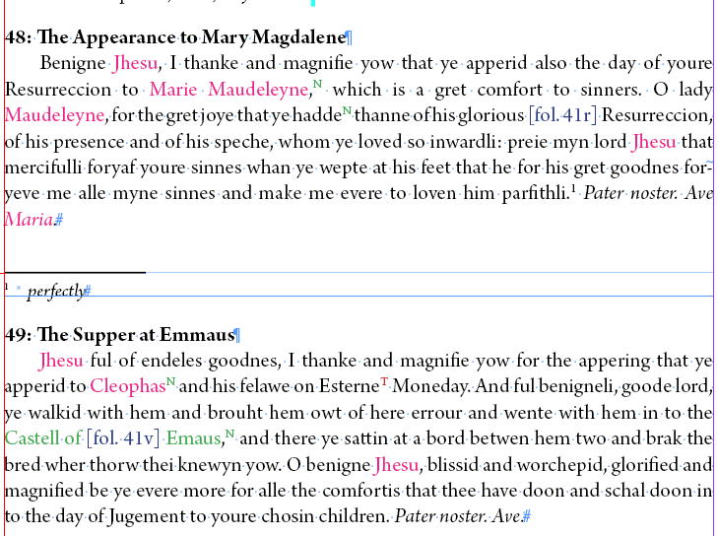
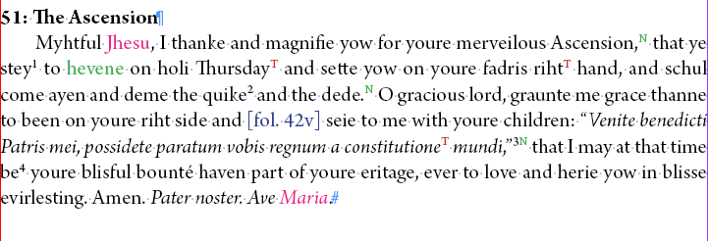

Adjusting for Overset Text
- Sometimes adding Indicators will make the text overset the text frame, especially in Prose texts that have chapters.
  - This essentially means that there is more text than can be displayed within the bounds of the text frame. All the text is still there, but the end of it is hidden from view. You can tell this happens if, at the very end of your text frame, there is a little red box with a + mark in the bottom right corner.
  - If this happens to you as you insert indicators, you will need to make the text frame larger in order to see all the text.
  - To adjust the size of the text frame, make sure you are using the Selection Tool and click on the final text frame of a chapter.
    - You can right click > Fitting > Fit Frame to Content. This will automatically adjust the size of the text frame to include all text (including footnotes) without any excess white space. However, if there is a lot of text that has become overset, the text frame might end up expanding past the size of the page, which we don’t want.
    - You can also click the middle of the bottom side of the text frame and drag the text frame edge down to make it larger.
    - You may need to add a new threaded text frame to the next page. To do this, add a new page using the Pages panel. Then, use the Selection Tool to click on the red + mark. Hover your mouse over the new page. Notice that it seems to be holding the faint outline of text on it. Click into the box near the top left corner of this outline on the new page.
  - If you are working in a Prose Text with Chapters and you need to make the final text frame of one chapter larger, you will need to readjust the size of the first text frame of the following chapter so the text isn’t overlapping on the page.
    - Click the middle of the top side of the first text frame of the following chapter, then drag it down so that is flush with the bottom edge of the previous text frame.
    - In some cases, you’ll need to move the text frame to the next page, either by cutting (ctrl+X) and pasting (ctrl+V) onto the next page, or by deleting the initial text frame.
      - N.B.: Only delete the initial text frame if it is threaded to following frames.
  - Do this as needed.

Inserting Explanatory Note Indicators

- Make sure you have both the Text file and the Explanatory Note file open for this process. You’ll want to compare between the two documents.
- You will be inserting an Explanatory Note Indicator (a superscript N) in the text for every single Explanatory Note.
  - Look at the first Explanatory Note. Typically, Explanatory Notes will include a line number that is followed by a catchword or phrase in italics.
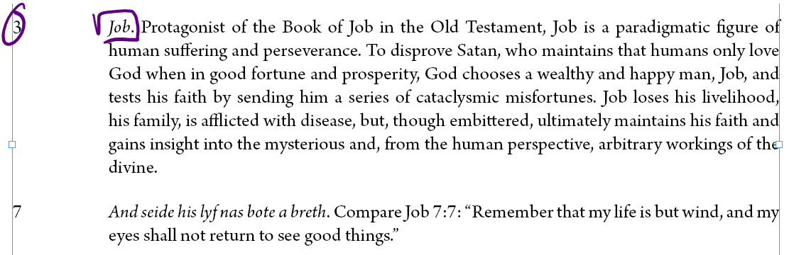
  - If your text is prose and the catchword/catchphrase appears multiple times in the same paragraph, there is documentation to help you figure out which instance is correct. Go to METS > Current volumes > Editor-Volume > Editor-Volume -Word. Open the relevant file and you’ll see two colors of highlighting, yellow and blue. Yellow indicates Explanatory Notes indicators, so compare it to this InDesign file. This will indicate which instance of the catchword / catchphrase is the one linked to your note.
  - Go back to the text. You will insert an indicator after the last word of the catchword/catchphrase.
    - Type an N after the final word.
    - Style the N with the Character Style Explanatory Note Indicator, found in the XML Export Folder in the Character Style menu. This will turn it into a superscript.
      - Optional: you can add colors to indicators to make them more visually distinct. To do this, right click the character style and select a color.
    - Going forward, you can copy and paste this wherever you need a new Explanatory Note Indicator.
      - If you do copy and paste, make sure you are not adding additional spaces along with the indicator. This can sometimes happen.

- As you go through the Explanatory Notes document, you will want to make sure that the order of the explanatory notes matches the order of the indicators you are inserting into the text.
  - For print production, we order explanatory notes in numerical order according to the first number in the line range associated with the notes.
    - 19
    - 24
    - 35-70
    - 42
  - But, since we are inserting indicators at the end of the last word of a catchphrase, we need to order these notes in numerical order according to the last number in the line range associated with the notes. That way, they match up appropriately with the order of indicators
    - 19
    - 24
    - 42
    - 35-70
  - To reorder notes, you will want to copy the entire note and paste it in its new location. Make sure you delete the old instance of the note.
- If there are multiple notes within a line range, make sure that the notes are in the same order that their indicators appear in the text.
- If there are multiple notes attached to different words in the same line, make sure that the notes are in the order that their indicators appear in the text.
- If there are multiple notes attached to the same word on one line, make sure the notes are all grouped together. As long as the notes are grouped together, it doesn’t matter which order the notes are put in.

Inserting Textual Note Indicators

The process for inserting Textual Note Indicators is the same as inserting Explanatory Note Indicators.
- Make sure you have both the text file and the Textual Note file open at the same time. You’ll want to compare between the two documents.
- In the text, locate the end of the catchphrase for a note and add an indicator.
  - If your text is prose and the catchword/catchphrase appears multiple times in the same paragraph, there is documentation to help you figure out which instance is correct. Open the relevant Word file and you’ll see two colors of highlighting, yellow and blue. Blue indicates Textual Notes indicators, so compare it to this InDesign file. This will indicate which instance of the catchword / catchphrase is the one linked to your note.
  - Type a T after the final word of the catchphrase.
  - Style the T with the Character Style Textual Note Indicator, found in the XML Export Folder in the Character Style menu. This will turn it into a superscript.
    - Optional: you can add colors to indicators to make them more visually distinct. To do this, right click the character style and select a color.
  - Going forward, you can copy and paste this wherever you need a new Textual Note Indicator.
    - If you do copy and paste, make sure you are not adding additional spaces along with the indicator. This can sometimes happen.
- As you go through the Textual Notes document, you will want to make sure that the order of the textual notes matches the order of the indicators you are inserting into the text.
  - For print production, we order textual notes in numerical order according to the first number in the line range associated with the notes.
    - 19
    - 24
    - 35-70
    - 42
  - But, since we are inserting indicators at the end of the last word of a catchphrase, we need to order these notes in numerical order according to the last number in the line range associated with the notes. That way, they match up appropriately with the order of indicators
    - 19
    - 24
    - 42
    - 35-70
  - To reorder notes, you will want to copy the entire note and paste it in its new location. Make sure you delete the old instance of the note.
- If there are multiple notes within a line range, make sure that the notes are in the same order that their indicators appear in the text.

Things to look out for:

- Extra spaces when inserting indicators
  - Sometimes, if you insert indicators using the copy-and-paste method, extra spaces are added in between the word and the indicator. We always want the indicator to be right next to the word it is linked to, and right next to any other indicators that are present on the same word. Finally, make sure there is no space after the indicator if it is at the very end of a line or paragraph.
- Notes with line numbers but no catchphrase
  - Some notes do not have catchphrases, which happens occasionally (and with more frequency in our backlog). For these instances, we default to putting the indicator at the end of the text of the line.
    - Note: This means after the final word of Middle English on that line, and not after any glosses that may be on the same line.
- Notes that refer to multiple lines will require multiple indicators (and multiple notes)
  - Ex: 373, 377 catchphrase.
    - For these, you will need to insert an indicator in the relevant place for both line 373 and line 377.
    - Since there are now two indicators, we need two notes to match up with them. Copy and paste the note into an appropriate place in the Explanatory/Textual Notes document.
- Placing Indicators around previous applications of Character Styles
  - Pause if the indicator comes in the middle of a phrase that has already been tagged with one of the following Character Styles: Person Name, Animal Name, Place, Date, or Title.
  - Refer above to Best Practices, p. 6, for instructions on how to proceed.
- Notes for titles
  - If a note is attached to a title that is in the Parent Page, put the indicator at the end of the first folio number so that the title note is the first note encountered.
    - In this example, the Textual Note Indicator on fol. 71va is supposed to go on the title, but since we cannot apply indicators in the script on Parent Page headings, we need to put it in the first item that is encountered in the body of the document.
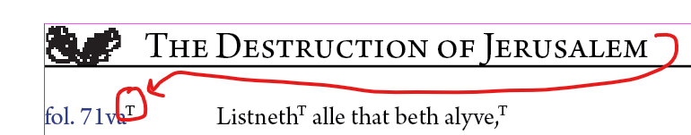
  - If there is no beginning folio number, then place the indicator at the end of the first word.
- Make sure the hashtag hidden character at the end of the document is flush with the last word/punctuation on the page.

Inserting Gloss Indicators

We add indicators for the glosses found in-line along the right margin of a text.
- Only Verse and Drama texts in Middle English or in Scots will need these indicators since they are the only text types that have marginal glosses.
  - We do not add indicators for any footnote glosses. These remain footnotes.
- As you go through this process, look for any instances of (see note) or (see t-note) phrases. These phrases should have been deleted in the first step of this process, but check for any overlooked instances.
The process of inserting gloss indicators is quite similar to Explanatory and Textual Note Indicators. The main difference is that you will need to match the gloss with the Middle English or Scots word that it refers to.
- Going through the text line by line, locate the Middle English word or phrase that matches up with the gloss that appears in the right margin. For help, use the Middle English Dictionary (MED; for more, see below). If you are working with Scots, use the Dictionaries of the Scots Language.
- Add an indicator.
  - Type a G after the final word of the catchphrase.
  - Style the G with the Character Style Gloss Indicator, found in the XML Export Folder in the Character Style menu. This will turn the letter into a superscript.
- As a reminder: glosses are separated by semicolons only. Make sure that you identify each gloss listed in the margin.
  - If there are multiple glosses included in the right margin, there should be an equal number of Gloss Indicators in the line of text
  - Beware! Commas often appear within glosses. Commas do not indicate separate glosses; only semicolons do.
    - If there are two words separated by a comma, these are still part of one gloss and therefore would only have one indicator. The comma punctuation will most likely be reflected in the text.

Using the Middle English Dictionary
The Middle English Dictionary (MED) will become your new best friend as you work through adding gloss indicators. However, the MED is not the most intuitive search engine.
Begin by searching with the “Headword (with alternate spellings)” option since spelling is so variable in Middle English.
- Make note of some specific Middle English grammatical conventions
  - Verbs: infinitives. Many ME infinitives end in -en, but you will typically encounter a conjugated form in the text. Try looking up an infinitive form of the verb by adding -en to the stem. This might get you closer to finding your query.
  - Common spelling shifts. METS best practices ask editors to standardize many common manuscript spelling conventions, such as the/thee, of/off, and u/v. However, other variations to look out for include:
    - Letters used interchangeably:
      - i / y / e
      - y / g / gh
    - Final endings:
      - n / nn / ne
- Typical boolean style searching methods (quotation marks around an exact phrase, etc.) can help in some cases, but may narrow your search results too much and show you no search results.
- If these don’t return anything, try searching for the Modern English gloss using the “Definition and notes” filter. This may return many search results to scroll through, but can prove helpful.
- If you are truly stumped and not getting any search results, use the Middle English in the “Entire entry” search. This will give you many search results that you will have to read carefully, but may give you a better starting point.
- Sometimes the “Modern English word equivalent” search option can help, but it usually only shows the Middle English option that is closest to Modern English.
- For more detailed information on how to search the MED, consult the MED’s Using the Middle English Dictionary Guide, where it walks you through general search information, dictionary searches, what to do with special characters, and so on.
If you are looking at a text in Scots, you will want to consult the Dictionaries of the Scots Language, and specifically A Dictionary of the Older Scottish Tongue (DOST). Remember: Scots uses different grammatical and spelling conventions than Middle English. If you need help navigating the search engine, consult the Managing Editor.

Things to look out for:

- Placing Indicators around previous applications of Character Styles
  - Pause if the indicator comes in the middle of a phrase that has already been tagged with one of the following Character Styles: Person Name, Animal Name, Place, Date, or Title.
  - Refer above to Best Practices for instructions on how to proceed.
- Due to the nature of Middle English, glosses are not always straightforward. If you have questions about which word in the line matches up with the modern English gloss, put it in a queries list in Asana.
  - For guidelines on how to record queries in Asana, refer to the Queries in Asana documentation.
  - This list will be reviewed by the staff member who audits the InDesign Export files.
  - If queries remain post-audit review, these queries will be reviewed by the Managing Editor and, in some cases, sent back to the editors for clarification.
- If the grammar is weird, make a query looping in the Managing Editor:
  - Grammar with Middle English is weird and can make placing Gloss Indicators difficult. If the phrase is not straightforward, or references convoluted grammar, make a note in your queries list and tag the Managing Editor. With new editions going forward, we will ask editors to make it a footnote and not a gloss.

Final Pagination Adjustment Check

As you finish any InDesign Interventions in an Export file, you will need to make sure that the hashtag that indicates the end of the text appears after the final punctuation on the page. Pagination should be more or less set before you move onto a new document. See the Completing a Text Frame section and the Document Pagination section of the Formatting Reference for more details.

