Read the entire instructions before you try to follow them. Knowing where you are going will help.
It helps to have some record documentation open as you move through this workflow.
- Templates for making TEI Header Contributor Metadata spreadsheets
- METS Student Roster
- METS Production Tasks Mapped to TEI Header Roles reference spreadsheet
- METS-Editions-Categories-Metadata spreadsheet

An Overview: TEI Header Contributor Metadata Spreadsheets

Purpose
Transparency was a key goal for our new digital editions. The TEI header present in all our TEI-XML files offers us a unique opportunity to include responsibility statements about which staff member completed which production task, as well as the approximate time period in which the work was completed for a particular file. This practice allows us to give credit to those who have participated in the production process, as well as to shed light on the extent and length of the production process itself.
To avoid duplicated labor when creating our TEI files, we collect metadata at an individual file level into spreadsheets that can be referenced by the html-to-xml transformation script to populate the TEI header with information about that particular file. There will be significant overlap in information for files from the same edition, but ultimately, each TEI header needs to be specific to the document it is a part of. That is why we make one spreadsheet for every single InDesign file that needs to become its own XML document.

Contents
These spreadsheets contain three sheets.

Sheet 1: Contributors
We enter record information about who did what when to a particular file on this sheet. We use a controlled vocabulary to describe the work we do as different roles. We track the time period in which work is completed in month/year format. We fill in all columns in this spreadsheet using dropdown menus.
It is important to note that the in-house production terms that we use at METS differs from the language we officially use in the TEI headers to describe the roles that people perform. Often, one production step for METS can equal several individual roles as we record them in the TEI header.
- Ex. We use the term ‘Bib Check’ to refer to a particular step of our Print Production process, but this step includes three separate roles:
  - Checked and corrected bibliographic references
  - Ensured adherence to METS Style Guide
  - Entered corrections for print edition
It can be dizzying to keep track of exactly how all our in-house terms align to our controlled vocabulary, let alone which ones apply to which files. We have made a spreadsheet that collates our internal language with the controlled vocabulary we use in TEI headers.
- Refer to METS Production Tasks Mapped to TEI Header Roles reference spreadsheet

Sheet 2: Dropdowns
This sheet stores all the controlled vocabulary that populates the dropdown menus on the Contributors sheet. The controlled vocabulary for production roles, time periods, and languages should remain stable; the Managing Editor is responsible for updating these columns on this sheet as is needed. As part of this workflow, Staff Editors will update the Contributor Names column with any Staff Editors who have participated in the production process for an edition.

Sheet 3: File Metadata
This sheet records basic file metadata including Author, Editor, Translator, and language information.

Templates
Making and filling out these spreadsheets is difficult. There is a lot of data to reference and compile, and you will need to have a lot of knowledge of our production process in order to understand what data to look at. To try to make this process easier to complete, we have made templates for each file type that will need this metadata.
There is one template for approximately each file type that will need this metadata. We have multiple templates because not all spreadsheets will need the same information recorded. These templates come already filled in with the relevant production tasks and the roles that align with them, so in most cases, all you will need to do is fill in the name of who completed a task and the time period in which it was completed.
See below a screen shot from the TEI-Metadata-Spreadsheet-Introduction template:
- 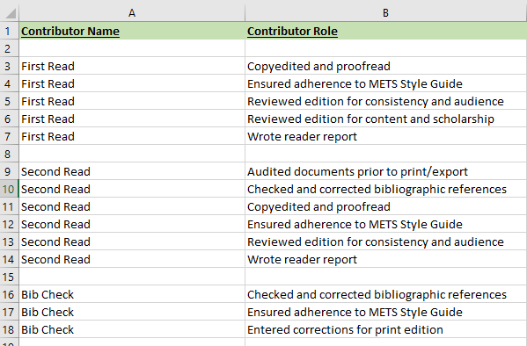
- In the template, the Contributor Name column is filled with an in-house production term as a placeholder, and the Contributor Role column has multiple roles associated with each production term.

Please note the following:
- Most templates are named according to the file type they correspond with.
  - N.B.: Each edition is unique. These templates are meant to be a starting point to make the process easier, but you may have to further customize the spreadsheets to reflect the production process for that particular edition.
- There is one template for Basic Files; we use this template for any files that don’t get the production steps Bibliography Check or Manuscript Read. Including, but not limited to:
  - Dedication
  - Acknowledgments
  - Index of Proper Names
  - Index of First Lines
  - Some Appendices
- Appendices are tricky. Some of them require more production steps than others. Check with the Managing Editor about which template is best for the appendix at hand.
- In general, if you aren’t sure which template will work best for a particular file, check with the Managing Editor for a recommendation.

Creating New TEI Header Contributor Metadata Spreadsheets

Check in with the Managing Editor
Before you dive into all the spreadsheets, check in with the Managing Editor to gain some insight into the production process of this edition, in particular:
- What work was done to any Appendices files in the edition
  - This will help you decide what kind of spreadsheet to start with.
- If there are any pieces of apparatus that were written by only one editor or by some, but not all, of the editors
- If there was anything out of the box that happened for this edition
- What time period to set for and which staff member is assigned to the following roles:
  - Collected Metadata (specifically for collecting TEI Header Metadata, this the task you are performing)
  - oXygen Interventions
  - TEI Audit
  - Uploaded / Published digital edition

Select the Appropriate Template
As a reminder: We will need one spreadsheet for every InDesign Export file that needs to be converted into TEI-XML. Keep the Editor-Volume-Export folder open as you work so you know approximately how many spreadsheets will need to be made.
- It can help to work your way through the edition, starting with the file with the section number 01.
- However, depending on the size and complexity of the edition, it can make more sense to make all the spreadsheets for a particular file type at once.
  - i.e., in an edition that has ten texts, each with a corresponding Explanatory Notes and Textual Notes file, it may make more sense to make all the Text file spreadsheets, then all the Explanatory Notes spreadsheets, then all the Textual Notes spreadsheets.
- Do what makes the most sense to you.
For the purposes of this workflow, we will be working with the Livingston-Knyghthode-Export files, so we will start with the first InDesign Export file: Livingston-Knyghthode-Export-01-Acknowledgments.
- Navigate to the templates folder where all the TEI Header spreadsheets templates live. Find the one that will work best for the file you are collecting metadata for.
  - In our example, we would choose the TEI-Header-Metadata-Spreadsheet-Basic-File template to hold the metadata for the Acknowledgments file we are working on.
- Then, copy and paste the template into the relevant metadata folder.
- Rename the spreadsheet to exactly match the title of the InDesign file you are collecting metadata for. This is how the script knows which spreadsheets full of metadata should be loaded into which TEI files’ headers.
  - In this case, our spreadsheet should be called Livingston-Knyghthode-Export-01-Acknowledgments.xlsx
- N.B.: Please don’t enter information into the Templates files that live in the Production Templates folders. Make sure you have saved the file in your Metadata folder first.

Open the Appropriate Reference Documents
You will be cross-referencing multiple documents in order to fill in these spreadsheets. It helps to have them all open at once. Be sure you have the following open:
- METS student roster, for all our records of who has done what when.
  - Our records are separated into two sheets on this spreadsheet: one for Print Production and one for Digital Production. You’ll be compiling information from both these sheets into your singular file’s TEI Header Contributor Metadata spreadsheet.
    - Unless otherwise noted in the Notes column, tasks have been completed across all relevant files in that edition.
- The relevant Asana project, in case you would like more context.
- METS Production Tasks Mapped to TEI Header Roles reference spreadsheet, for further clarity on production task names or if your spreadsheet needs to be customized more.

Fill in Sheet 2: Dropdowns

First, you will need to add all the names of everyone who worked on an edition into the Contributor Names column of the Dropdowns sheet.
These names are recorded in the METS student roster spreadsheet.
- Open the METS student roster spreadsheet.
- Start with the Print Production sheet.
  - Column A will have the title of the edition and the editors’ last names in it; use this to locate the edition you are working on.
  - Column C contains all the names of anyone who worked during Print Production.
- Record these names in the Contributor Names column of the Dropdowns sheet.
  - Replace any cells that have the filler text “Name” with the staff member’s name.
  - Names should be entered in the following order: LastName, FirstName MiddleInitial
  - Double check the spelling of these names.
  - Do not include any names related to External Review; we anonymize this information for public-facing records.
- Repeat this process for the Digital Production sheet.
  - If a name has already been added to the Contributor Names column, you don’t need to add it again.
  - It is also okay if you have cells with the filler ‘Name’ text left over.
  - If you have more names than cells with the filler ‘Name’ text, pause and check in with the Managing Editor. They will help you adjust the settings of the spreadsheets to accommodate the extra names.
- N.B.: Whatever order these names are listed in will be the order presented in the dropdown menus in Sheet 1: Contributors. It can help to list these names in alphabetical order, but it isn’t necessary for this column if you don’t mind sorting through the names.
Before:
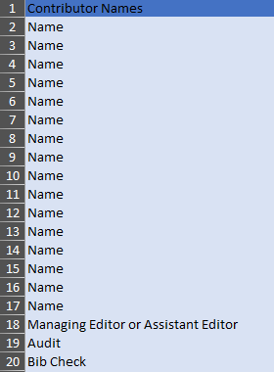

After:
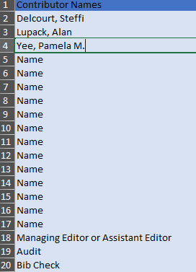

Collate across spreadsheets
Once you have entered all the Contributor Names into the Dropdowns sheet, you can save time when making new spreadsheets by copying and pasting this list into any new spreadsheet that you make from a template.
- When using the Copy / Paste function in these Excel spreadsheets, it is very important that you do not use the keyboard shortcut Ctrl+V to paste. Instead, you will want to use Right Click > Paste Values. This will preserve the functionality of the spreadsheet while still copying and pasting the information.

Fill in Sheet 1: Contributors

Add Names and Dates
Assign the relevant names and dates to the various production tasks filled in the template. Remember, the information entered into this sheet should only reflect the work done to create the specific file that this spreadsheet goes to, not the entire edition.
- First, check the METS student roster to see if there are production tasks that multiple people contributed to.
  - Many of our production tasks can have two to three people contributing to them during the production process.
- Then, check the METS student roster to see if there is any information in the Notes column. We use that column to note whether people did parts of specific production tasks, or if they did tasks only in specific files as opposed to in every relevant file of the edition. This information will help you decide what information needs to go on which TEI Header Contributors Metadata spreadsheets.
  - If the Notes column is blank, then that person did the full production task on all relevant files of an edition.
  - If there are specific files listed, then that person did the full production task on only some files of an edition.
  - If there are parts of specific production tasks listed, you’ll need to reference the METS Production Tasks Mapped to TEI Header Roles spreadsheet to see how parts of production tasks align with the roles we use on these spreadsheets.
- If there are multiple people who worked on one task for the specific file you are currently filling in a spreadsheet for, then on the TEI Header Contributors Metadata spreadsheet you may need to copy the list of roles associated with that task and paste it at the bottom of the spreadsheet.
  - Ex.: If three people performed a Bibliography Check on one edition, then you will want to copy and paste the whole list of roles associated with bibliography checks one more time at the bottom of the spreadsheet.
    - N.B.: If you have to copy and paste, it is very important that you do not use the keyboard shortcut Ctrl+V to paste. Instead, you will want to use Right Click > Paste Values. This will preserve the functionality of the spreadsheet while still copying and pasting the information.
- In the TEI Header Contributors Metadata spreadsheet, replace the placeholder information in the Contributor Name column for a particular task with the name of the person who performed that task, using the dropdown menu.
- You’ll also want to fill in the dates associated with that task.
  - If there is only one date listed on the METS student roster, that date will serve as both the beginning and end date on the Contributors sheet of the TEI Header Contributors Metadata spreadsheet.
  - If there are no dates associated with a particular task, leave the fields blank. Sometimes all we have is partial data, and that is okay.
- N.B.: We do not include any information about External Review in these spreadsheets, since we anonymize that information on public-facing records.

Anticipating Future Tasks
Some production tasks have metadata for work that still needs to happen or be completed as you are currently collecting the metadata about who is completing them. Including:
- Collecting TEI Header Metadata
- oXygen Interventions
- TEI Audit
- Uploaded / Published digital edition
Information about who will complete these tasks and the time frame we will complete them in will have been given to you by the Managing Editor in your initial meeting. If you don’t have that information at this point, check back in with the Managing Editor.
At this point, you will not have any information for the Revisions / Corrections task, as this task is for anyone who enters corrections and updates into InDesign files during our Annual Updates. Leave these here for right now.

An example: Filling in an Acknowledgments spreadsheet for Livingston-Knyghthode
- Alan Lupack and Russell A. Peck both performed a First Read for the Livingston-Knyghthode edition. This work is done across all files for an edition, so would need to be entered into the Acknowledgments spreadsheet.
  - First, we would copy all the roles associated with First Read and paste it at the bottom of the spreadsheet.
- Alan Lupack’s name replaces all the instances of First Read in the Contributor Name column. The METS student roster spreadsheet only lists one date for Alan, so it will be both his Begin and End dates.
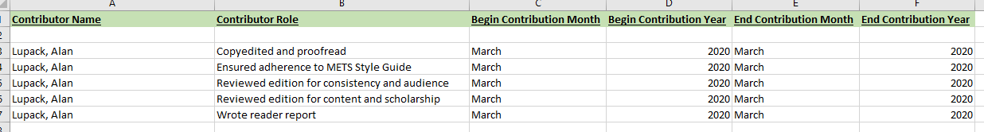
- Russell A. Peck’s name replaces all the instances of First Read in the Contributor Name column for the list that we pasted at the bottom of the spreadsheet. He has different start and end dates for this step than Alan does, so his Begin and End dates have been entered accordingly.
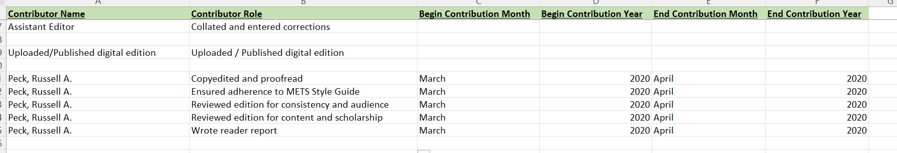
- For Livingston-Knyghtode, Mead Bowen is listed as having contributed to the task InDesign formatting. His entry has a note in the Notes column that specifies he only did semantic tagging work.
  - Since he only did part of the InDesign formatting work, Mead would only need one of the roles traditionally associated with InDesign formatting.
  - Cross-referencing the METS Production Tasks Mapped to TEI Header Roles spreadsheet shows us that semantic tagging work should be assigned the role ‘Formatted for XML export,’ and only on spreadsheets associated with Text files, since those are the only files where semantic tagging takes place.
  - Therefore, we do not need to include Mead Bowen’s work in the Acknowledgments spreadsheet, but we will need to add his work on any future spreadsheets that are for Text files.

Remember: Our Templates help, but may need tweaking for each edition.
The templates are here to make the process of collecting this metadata easier. The templates have been designed to anticipate most of the roles that have been done for each file type. However, our records are complicated to wade through. Depending on what you find in our records for a particular edition, you may need to customize the spreadsheets to accommodate what metadata needs to be recorded. This includes adding more instances of a particular production step, like is described above. But this may also include adding other production steps or adding certain roles from other production steps.
- You will know if this is necessary from your chat with the Managing Editor and/or from the Notes column of the METS student roster spreadsheet.
- In some cases, you’ll need to cross-check the METS Production Tasks Mapped to TEI Header Roles spreadsheet to see what is relevant.
- If you run into something in the METS student roster spreadsheet that is confusing, or you are having trouble figuring out the METS Production Tasks spreadsheet, make a query in Asana attached to the ‘Collect TEI Header Contributor Metadata’ task. Then, schedule a follow-up with the Managing Editor to troubleshoot.
  - For details on how to enter queries in Asana, see Queries in Asana documentation

Fill in Sheet 3: File Metadata

This metadata is particular to the XML file being created. The Author, Editor, and Translator fields are the only three fields in this entire spreadsheet where you will need to type names into the relevant fields.

Author
For a Text file, refer to the METS-Editions-Categories-Metadata spreadsheet for author information. Text title information is in Column F, and author information is in Column B. If there are multiple names, enter them in one cell and use semicolons to separate them out.
- Enter the author information in the following order: Lastname, Firstname MiddleInitial.
- If there is no author information listed, or the author is listed as Unknown, then enter Unknown.
- If the author has partial information or only a first name and a location, then enter the what information is there exactly as it is displayed in the spreadsheet.
For an Apparatus file, the author information will be the editor(s) of the edition. Refer back to any notes from your check in with the Managing Editor to see if there are any special cases where an Apparatus file was authored by some, but not all, of the editors of a particular volume.

Editor
For a Text file, the editor(s) will be the editors of the edition. If there are multiple names, enter them in one cell and use semicolons to separate them out.
- In some cases, the apparatus information specifies which editor is responsible for a particular text. Check the METS-Editions-Categories-Metadata spreadsheet, Column C, for more information.
- Enter the editor information in the following order: Lastname, Firstname MiddleInitial.
For an Apparatus file that the editors wrote, leave this field blank.

Translator
Translator is only applicable for Text files. Refer to the METS-Editions-Categories-Metadata spreadsheet, Column D, for names. If there are multiple names, enter them in one cell and use semicolons to separate them out.
- Enter the translator information in the following order: Lastname, Firstname MiddleInitial
- If the translator has partial information or only a first name and a location, enter in the following order: FirstName of Location.
- If there is no translator information, leave this field blank.

Languages
All language options will be selected from a dropdown menu that includes single languages, as well as entries that pair languages with Modern English in a semicolon-delineated list.
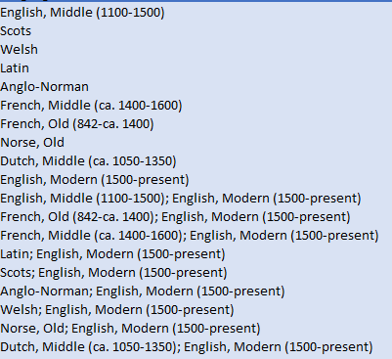
For a Text file or an Appendix File containing Texts, refer to the METS-Editions-Categories-Metadata, Column J, to see what language has been assigned to a particular text.
- Check the file name to see if the file contains a standard Text or a Facing Page Text.
  - Facing Page texts will include the phrase “FP” before the text type.
- For a standard Text or Appendix file containing a Text: select the assigned language from the dropdown menu.
- For a Facing Page Text file or Appendix File containing a Facing Page Text: select the option that pairs the assigned language with Modern English in a semicolon delineated list from the dropdown menu.
For an Apparatus file that the editors wrote, select the option for Modern English.
Save once more, and then you are freed from that spreadsheet.

Pause and Save Here

Once all the metadata has been entered, save the spreadsheet before moving any further in the workflow. If the metadata needs to be revised later on in the process, it will be much easier to restore this saved version in Box and update the data than it would be to sort out what roles need updating after everything has been alphabetized and condensed together. See below for specific guidelines on revising metadata entered into Sheet 1.
If you are not entering any revisions to the metadata, go back at this point and delete any tasks that have not had any people assigned to them. Most often, this will be the Revisions/Corrections task, with its three associated Contributor Roles.

Check and Collate Information for Multiple Files of the Same File Type

Multiple Files of the Same File Type
If there are multiple files in an edition that are the same file types (Basic-File as defined above, Introductions, Texts, Explanatory Notes, etc.), you can save time by saving copies of a file, renaming, and adjusting the content at this point. Tread carefully with this; if there are too many differences in the metadata for files that are the same file type, it may take more time to verify and update the metadata than it would to make a new spreadsheet from scratch.
- File > Save As
  - Rename the file appropriately.
  - Repeat as many times as needed.
- Check both Print Production and Digital Production sheets in the METS student roster spreadsheet to see whether any of these files had individualized work done to them.
- If there is individualized work, take the time now to update the new copy you have just saved. This includes:
  - Adding new copies of task information to record a second person’s work.
    - Copy and paste the relevant task information from a template into the spreadsheet.
    - Then, fill in the Names and Dates.
  - Removing task information of someone who worked on a previous file but not the current one your spreadsheet refers to.
    - Delete carefully if this is the case.
- When you finish collating information, pause and save here. If the metadata needs to be revised later on in the process, it will be much easier to restore this saved version in Box and update the data than it would be to sort out what roles need updating after everything has been alphabetized and condensed together. See below for specific guidelines on revising metadata entered into Sheet 1.

An example:
- The files Livingston-Knyghtode-Export-08-Bataile-Part1-Enotes and Livingston-Knyghthode-Export-11-Bataile-Part2-Enotes have the same metadata because the same people did the same steps across both files.
- Once you have completed making the spreadsheet for Livingston-Knyghthode-Export-08-Bataile-Part1-Enotes, File > Save As > rename the file to match Livingston-Knyghthode-Export-11-Bataile-Part2-Enotes and save it within the Editor-Volume-Export spreadsheet folder.
- Then, double check the METS student roster spreadsheet to see whether 11-Bataile-Part2-Enotes had an extra person who helped with the Bibliography Check only on that file. Since it didn’t, save the file and then continue on to the next step.

Organizing Sheet 1: Contributors
Once a spreadsheet has all the Names and Dates added to Sheet 1, we need to organize them so all the information will display correctly in our TEI headers.

Alphabetizing Entries
We need to alphabetize the Contributor Names in our spreadsheet so that these names will be alphabetized in our TEI headers.
- First, select all the text you’ve entered into all the columns of Sheet 1 so far.
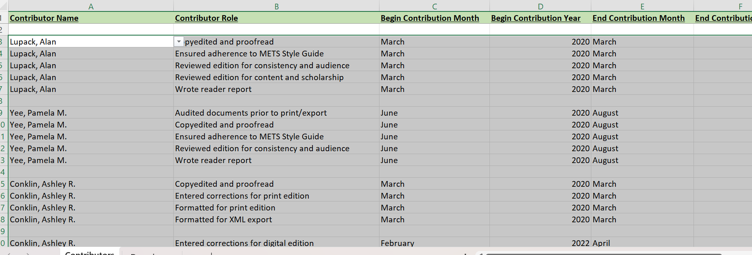
- Click the Data menu tab, then click Sort.
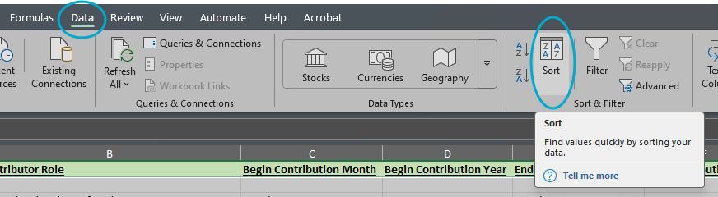
- This will open the Sort Menu. Fill in the following, then click OK:
  - Sort by: Column A
  - Sort On: Cell Values
  - Order: A to Z
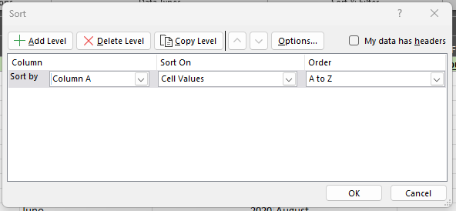
- The result should reorder everything in alphabetical order according to Contributor Name:
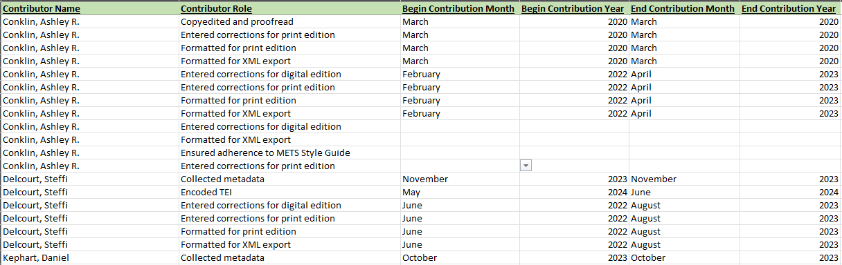

Sort Roles Alphabetically
Once the Contributor Names are sorted alphabetically, we want to do the same for the Contributor Roles.
- Select all the columns associated with one person’s name, so all the metadata stays together.
- We want to sort alphabetically by Column B.
  - Click the Data menu tab, then click Sort.
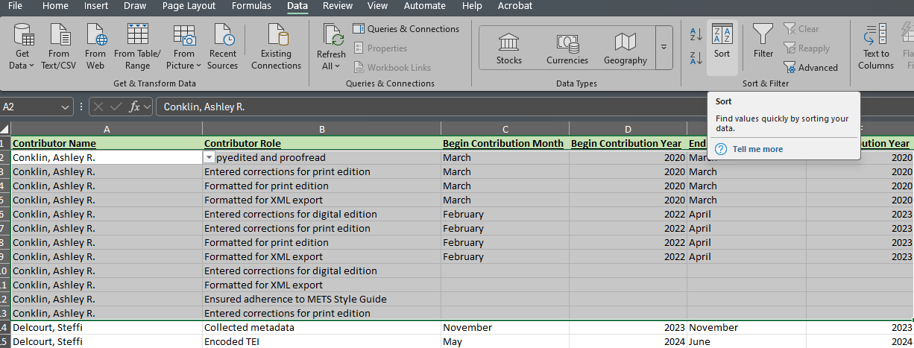
  - This will open the Sort Menu. Fill in the following, then click OK:
    - Sort by: Column B
    - Sort On: Cell Values
    - Order: A to Z
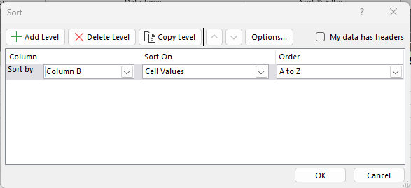
- This will alphabetize all roles. This makes it easier to see any multiples of roles.
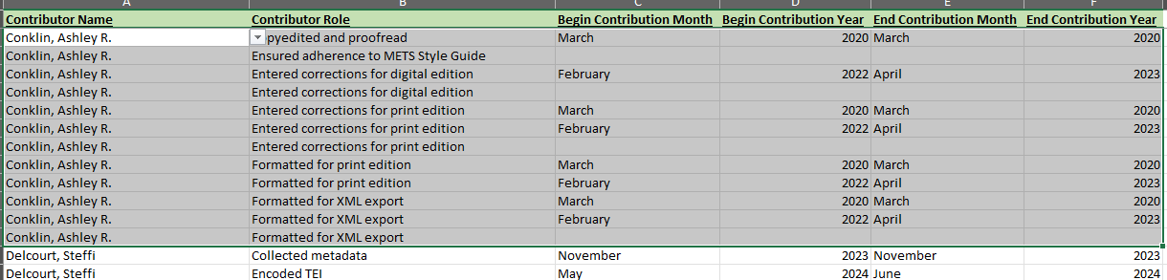

Combine Multiples of Roles
Some production tasks include work on the same type of roles. Depending on who has done which production tasks, there may be some multiples of roles with varying time frames attached to them. If the same role shows up multiple times for one staff editor, we want to combine these multiples into just one entry for the role.
- Look at the multiple entries and review the dates associated with them.
- Pick one instance of the role to keep.
- Change that instance’s beginning and ending dates to match the earliest begin date and latest end date associated with that role.
- Then, delete the extra entries.
Example: Ashley Conklin has three entries listed for ‘Entered corrections for print edition’ that we want to condense into one entry.
- One entry has no associated date information, and the other two have different begin and end dates from each other.
  - The earliest begin date associated with that role is March 2020, and the latest end date is April 2023.
  - So, you would change the first entry of that role to have those dates.
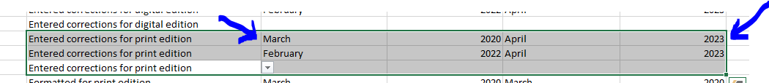
  - Then, delete the entire rows containing the extra two entries.
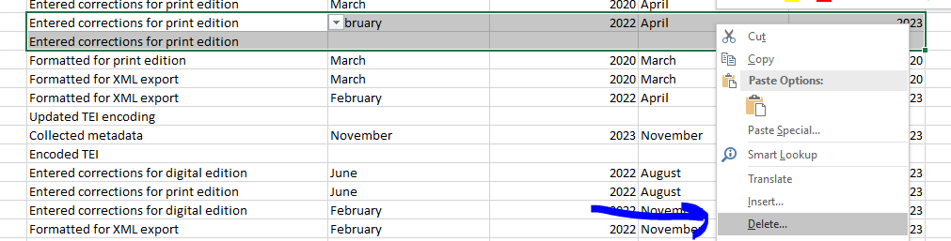
- Make sure to check for multiples of roles for each contributor name as you move through the document.

Revising Metadata

It is easiest to adjust or update metadata on these spreadsheets by restoring a previous version of the spreadsheet from the save made before moving onto Organizing Sheet 1.
- Go to Box Online and log in.
- Select the spreadsheet that needs updating, then open the Version History.
- Locate the version that was saved after filling in Sheet 1: Contributors, but before the entries were alphabetized. To do this, you will need to download copies of previous version to find the one last saved before the sheet is organized. You may need to download multiple versions, depending on how frequently they were saved.
- Once you have found the version you are looking for, click the menu next to its name in the Version History, then select “Make Current” to restore that version of the file.
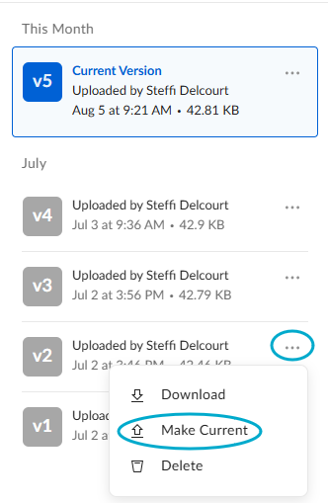
- Once you have restored the older version, open the spreadsheet in Microsoft Excel using Box Drive.
- Update any metadata needed and save, then work through the rest of this workflow starting with the step Organizing Sheet 1: Contributors.

Next Steps

As of July 2025, these spreadsheets need to be manually integrated into the script that creates our XML files before we can run our files through the webform. When the spreadsheets have been completed, let either the Managing Editor or the Digital Publishing Specialist know, so they can let our programmer know that there are more spreadsheets to integrate into the script’s repository.
If there were revisions made to these spreadsheets after our programmer had integrated them previously, then he will need to update the spreadsheets he has on file. Once all revisions have been made to the spreadsheets, let either the Managing Editor or the Digital Publishing Specialist know, so they can notify our programmer.

Expanding the Range of Dropdown Menus

If there are more names than the Dropdown fields have room for in the template, the Managing Editor or the Digital Publishing Specialist will go in and expand the range of the Dropdown fields in the Data Validation menu. If this is necessary for one spreadsheet in an edition, it will need to be done to all spreadsheets for the edition.
Go to the Contributors sheet.
- Click into one of the Contributor Name entries
- Along the top, click the Data menu, then click Data Validation. This will pull up a menu that looks like this:
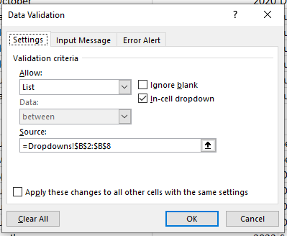
- Click into the Source field. It should automatically swap views of the sheets from the Contributors sheet to the Dropdowns sheet, as well as show you which cells are currently included in the range.
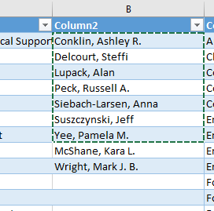
- Change the final number to the number of the cell that holds the final name.
- While you are on this screen, check the box next to “Apply these changes to all other cells with the same settings.” This will apply the settings we have just updated to all other similar cells in the spreadsheet.
- Then click Ok. This should update the dropdown menu to include all the names.

