Converting InDesign files to HTML

First, we need to convert our InDesign files into HTML. The resulting HTML files will be run through our transformation script to produce our (mostly final) TEI-XML files.
- Open each InDesign Export file.
- File > Export, or Ctrl+E
- Check that you have selected HTML (Legacy) as the Save as type.
  - Sometimes the window will default to exporting to Adobe PDF Print. If it does, you’ll need to click the dropdown menu and select HTML (Legacy).
  - N.B.: The latest version of InDesign offers two options for HTML export: HTML (Legacy) and HTML5. We want HTML (Legacy) for now.
- Select the correct folder to save these files in.
- Make sure the “Use InDesign Document Name” box is checked. We need the file names of the HTML files to match the file names we used for the InDesign files and for the TEI Header Contributor Metadata spreadsheets so that the conversion script knows which documents are related to each other.
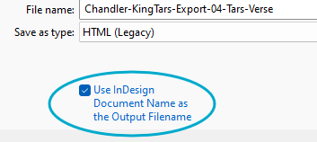

- Then click Save. This will bring up another Options window.
- Uncheck “View HTML after Exporting”, then click Export.
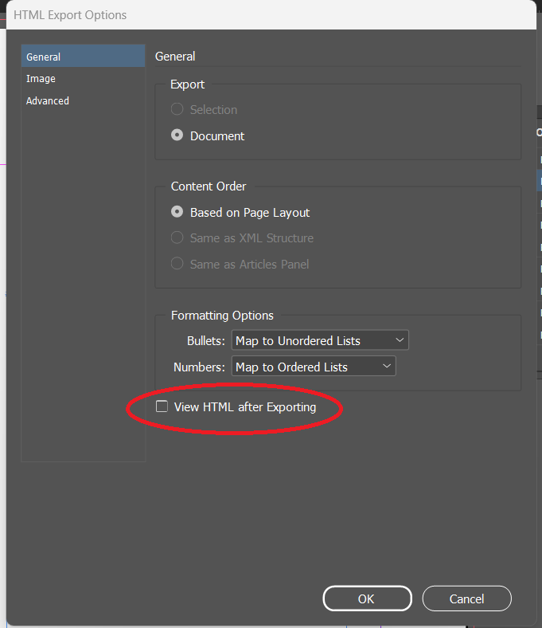
It is important to note that, if you have unchecked the “View HTML after Exporting” option, nothing will open once you have clicked the button that says Export. If you want to make sure that the files have exported properly, you will need to go to the HTML folder you saved the files in.
- If everything worked properly, you will find an HTML file along with a folder labeled web-resources. This is normal. We don’t use the web-resources folder for our export process, so you can delete those.

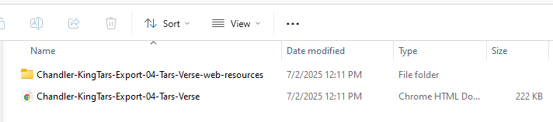

Transforming HTML to TEI-XML: The Webform

Once all the HTML files have been transformed, we need to run them through our transformation script to create workable TEI-XML files.
We access our script through a webform that has been created for us. The webform has been streamlined as much as possible to prevent duplicated data entry if we have to rerun files multiple times. This means that the webform only includes two fields: one where you enter the Document Title, and one to load in the HTML file:
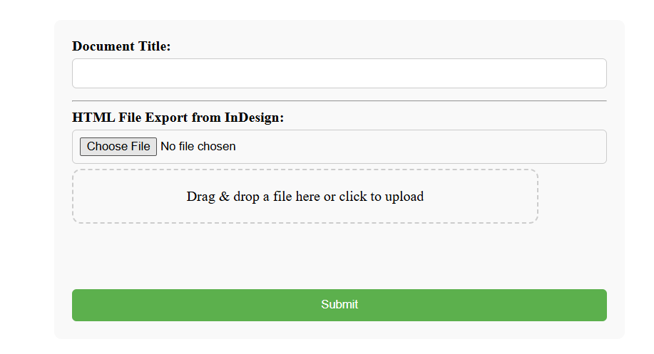

Adding the document title
Type the full, official title associated with the file into the Document Title field. This will go in the <title> element of the <fileDesc> section in the TEI header.
- If you are working with the Introduction to an edition, the title should be either Introduction or, if there are individual introductions and/or headnotes associated with texts, General Introduction.
- If you are working with an apparatus file specifically linked to a text, you should include one of the following phrases before the title of the text:
- Introduction to
- Explanatory Notes to
- Textual Notes to
- Any other files’ titles should exactly match the title listed on the Table of Contents
  - Look at the Front Matter file for the correct Table of Contents information.

Adding HTML files
Either drag and drop a file into the field, or click “Choose File” and select the correct file through the File Explorer.

Webform Results

As of October 2024: When you click Submit, the webform page will refresh. First on the page will be debugging information, and below should be a link to download the XML file:
================BEGIN DEBUGGING INFO===================
[debugging information]
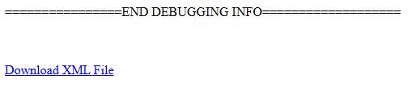
Beneath the Download link, the webform should reappear empty, ready to be filled out again.
Download the file. You will want to save the XML file to the appropriate folder.

