Accessible PDF for Digital Editions

We make PDFs available for download on our website and on our Github. We create these PDFs ourselves based on our Updates InDesign files, to ensure they include any and all corrections that have been made to the edition, either from MIP during the Print Production process or from Volume Editors / METS staff post-publication. As a result, we make these PDFs as one of the last steps of the Digital Production workflow.
We make a few changes to our PDFs so we respect our copyright agreement with MIP.
- We remove all page numbers from the edition.
  - This we will need to do temporarily in InDesign before we make the PDF.
- We will only include the Interior Title Page and the Abbreviations List pages of our Front Matter.
  - This we can do after making the PDF.

Export to PDF

Make InDesign book for Updates files
InDesign > File > New > Book
- Save the book in the Editor-Volume-Updates folder and name the book according to our File Naming Conventions
  - Ex. McShane-Jerusalem-Updates.indb
- The Book will list all documents that are added in the order you have added them. The first document you add will automatically become the source document, where the book will pull any Styles or Pages when you sync the book together. You can click and drag documents to reorder them, which will automatically update pagination.
  - The first document / source document should always be the Front Matter InDesign file. It will always be numbered Editor-Volume-Updates-00-Front-Matter.
- Then add all the Updates InDesign files in the Updates folder, in the order they are numbered.
- Do a quick check here that all InDesign files start on the recto side (unless they are facing page, in which case they should start on the verso side) of the spread. If there are any blank pages, they should have the [None] Parent Page applied.

Double check File Info of Front Matter file
This should carry over from when the Front Matter file was created in the Updates folder, but now is a good time to double check.
- File > File Info
- 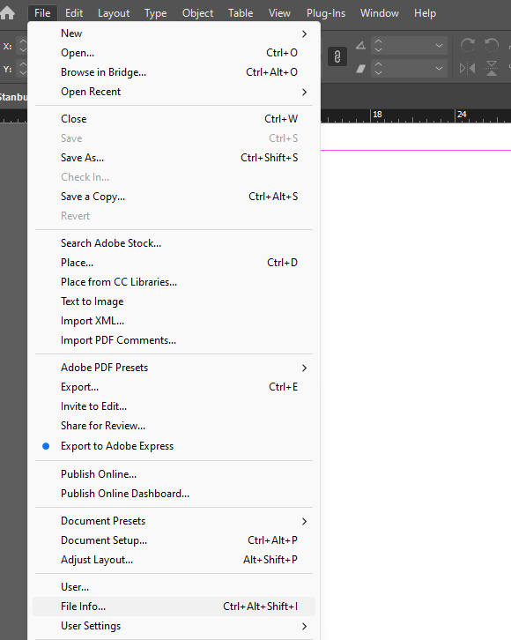
- This will open a menu where you can add in metadata information about the InDesign file. It will look like this:
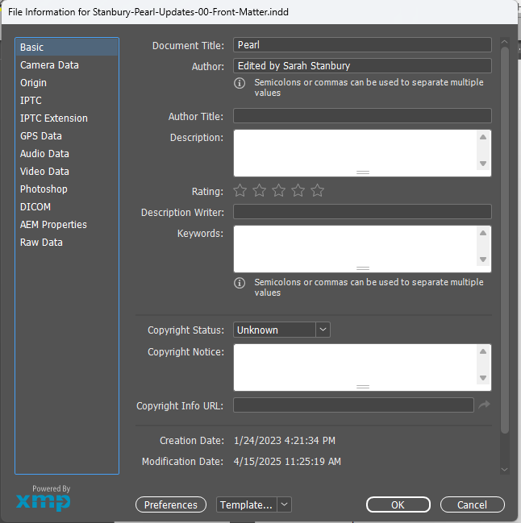
- If it’s not already there, Document Title: add the title of the edition here
- If it’s not already there, Author: Add “Edited by [the name(s) of the Volume Editor(s, in the order presented in the title page)]”
- Click OK.
- Save.

Remove Page Numbers Temporarily
Have the Book open while you do this work. Open files from within the book. It is very important that you do not save at any point during this process; we want to remove these page numbers in order to make the PDF, but the files themselves need to keep their page numbers.
- Front Matter: Delete the page number from the Abbreviations List Parent Page. Do not save.
  - Click into the AB-Abbreviations List Parent Page in the Pages Panel
  - Select the text frame with the page number. This will be centered at the bottom of the page. Instead of a number, it will read AB. (See circled section of image below.)
    - If you are having trouble selecting a text frame on a Parent Page, Ctrl+Shift+Click the frame. This will bring the text frame out of the background and make it more easily editable.
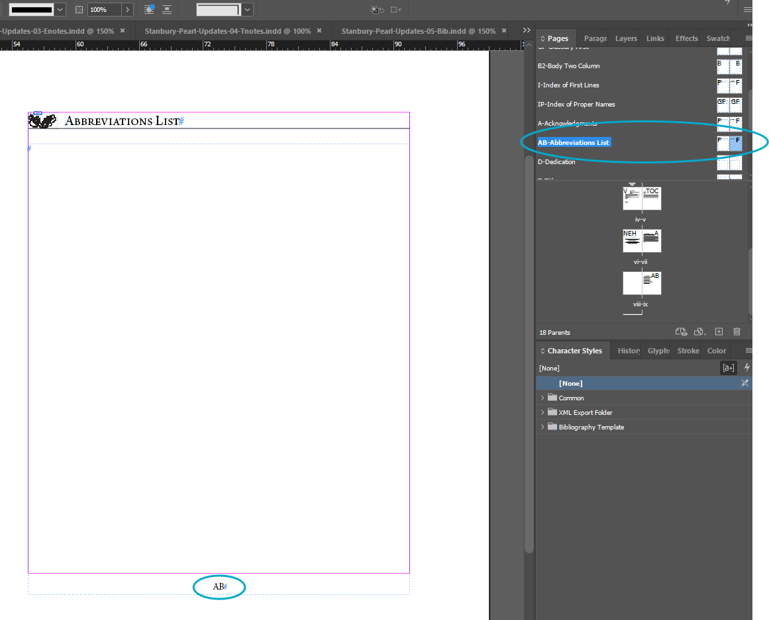
  - Then, delete.
  - Click back into the current page and double check that the page number is gone.

- Open each InDesign file, find which Parent Pages are used in the file. Then, click into these Parent Pages in the Pages Panel, and delete the page numbers present. Do not save. Typically, these Parent Pages will be:
  - F-First
  - B-Body
  - PF-Prose First
  - PB-Prose Body
  - GF-Glossary First
  - B2-Body Two Column
  - I-Index of First Lines
  - IP-Index of Proper Names
- For Parent Pages that are the first page of a file, the page numbers will be centered at the bottom of the page. Instead of a number, it will read the abbreviation of the Parent Page.
  - Ex. F-First Parent Page has F instead of a number
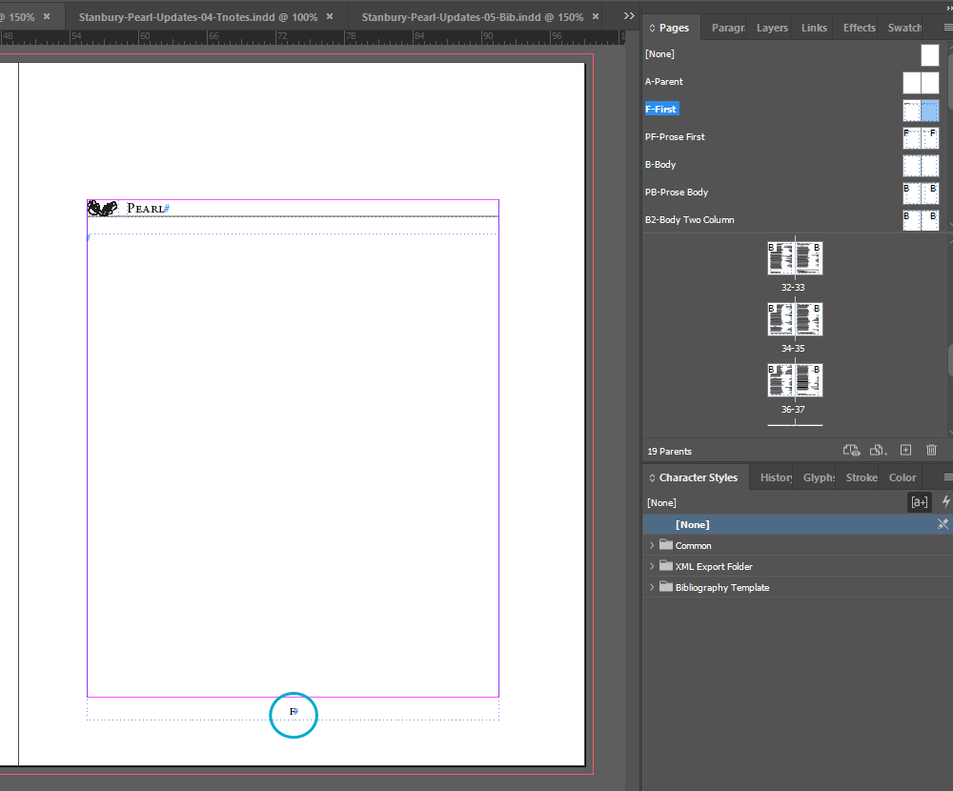
- For Parent Pages for pages that are after the first page, the page numbers will be at the upper left corner of the verso page and at the upper right corner of the recto page. Instead of a number, it will read the abbreviation of the Parent Page.
  - Ex. B-Body Parent Page has B instead of a number
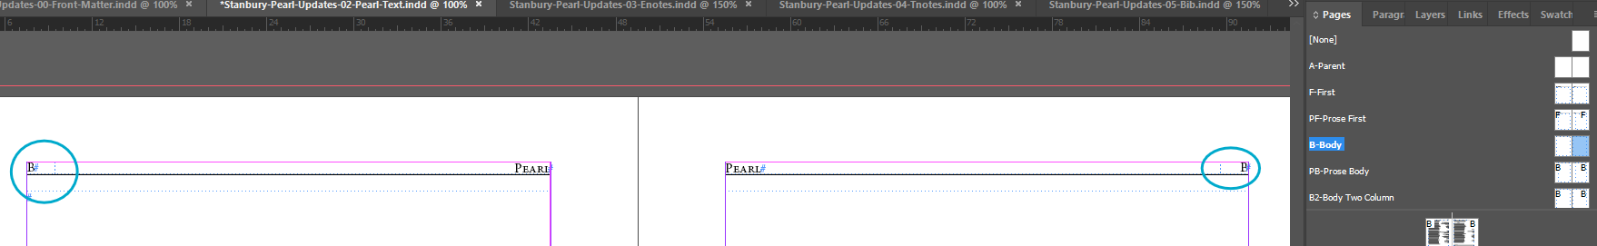

Export InDesign Book to PDF
In the edition’s Book panel > Hamburger menu > Export Book to PDF
- This first opens a File Explorer window where you select where to save the PDF. Select the Editor-Volume-Updates folder and click Save.
- This will open an Export Adobe PDF window.
  - General > Export As: Pages
  - General > Include: Hyperlinks
  - Advanced > Accessibility Options > Display Title: Document Title
- Then click Export.

Close the InDesign Files and Book without saving.
Once the PDF has been made, close each InDesign file and the InDesign book without saving any document or the book. This will set the documents back to when they had page numbers.

Edit PDF in Adobe Acrobat

Open the PDF in Adobe Acrobat. It is important to open using Acrobat, not Acrobat Reader. We will be editing the document in ways that are not possible in Acrobat Reader.

Delete Front Matter Pages
We want to delete some of the front matter.
- All Tools > Organize Pages.
  - 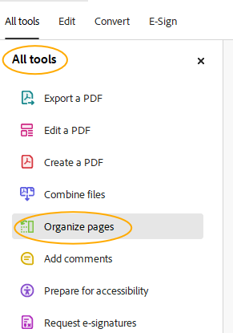
- This will open a menu called Organize pages along the lefthand side of your screen, as well as a high-level view of the entire document with thumbnails for each page.
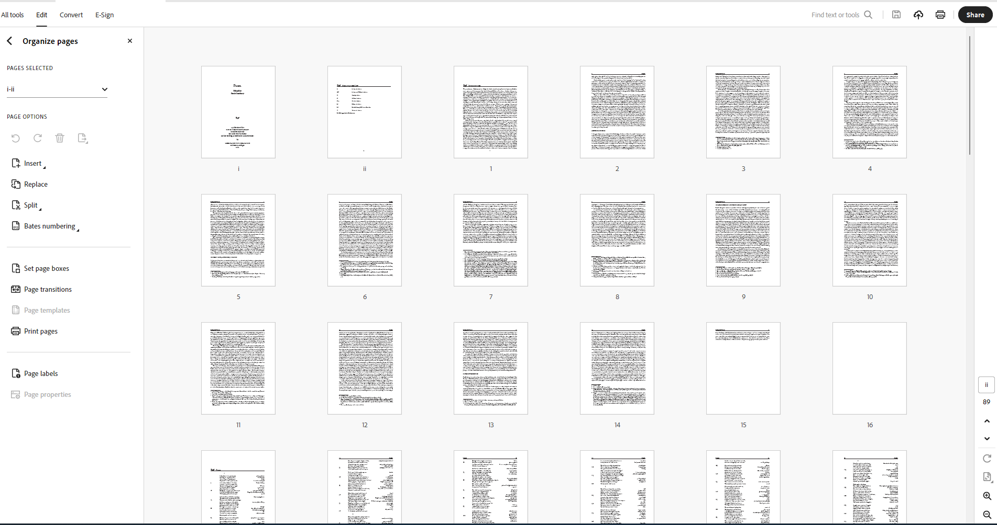
- Select and delete the first Title Page, the Editorial Board page, the Copyright Page, the entire Table of Contents, the NEH page, the entire Acknowledgments, and any blank pages around the Abbreviations List.
  - You can do this one at a time: Selecting one page will show a small trashcan icon; clicking the trashcan will delete that page.
  - 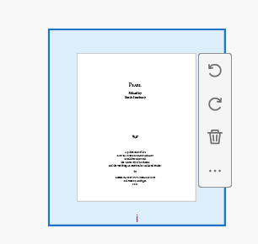
  - Or, you can select multiple pages at a time by holding Ctrl+clicking on multiple pages. If you do this, you will need to click the small trashcan that appears in the lefthand menu.
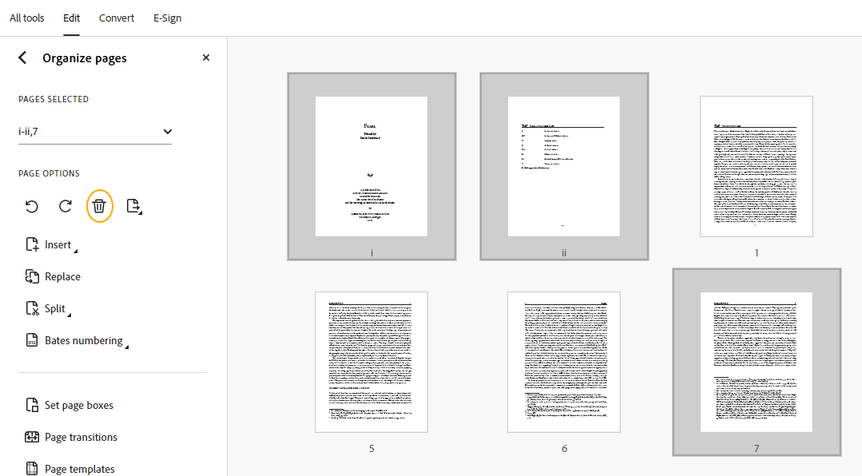
- The only Front Matter Pages that should be left are the main title page that includes all publication information and the complete Abbreviations List.
- Then, exit out of the Organize Pages tool by clicking the x at the top of the lefthand menu.

Accessibility Tags
Along the righthand side of your screen, there should be an abbreviated menu of shortcut tools. From top to bottom, you will find icons that represent:
- Edit, delete, or reply to comments
- Add, delete, or go to a specific bookmark
- Add, delete, or go to a specific page using thumbnail images
- View the reading order of content and reorder or fix tags
- Add, delete, or edit accessibility tags
- The current page number of the page viewed onscreen
- Arrows to navigate the PDF document
- Rotate page
- Fit one page within the window
- Zoom in
- Zoom out
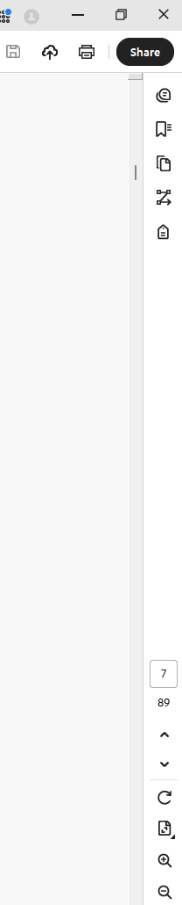
- Click the fifth icon from the top shaped like a tag, for Accessibility tags. The panel should open along the righthand side of your screen.
- This should have tags already populated within the menu, based on what we have entered into our InDesign paragraph styles. It should look something like this:
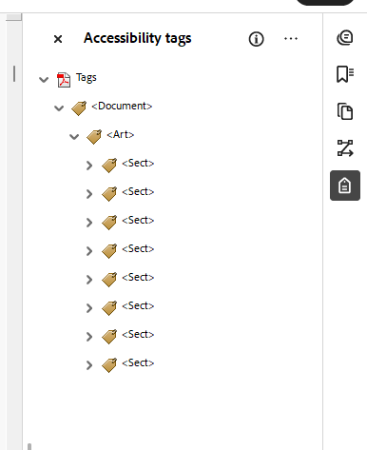
- Expanding the dropdown arrows should show you more and more of the content. At this point, these are typically nested like so:
  - <Art>: Article. There will only be one <Art> tag
    - <Sect>: Section. Sections will roughly line up to each story (aka, a series of threaded text frames) in InDesign. These are always nested under <Art>
      - <H2>: Heading Level 2. These line up with the Paragraph Styles Heading, Heading 4, Fitt Number, Stanza Number, Prose Rubric. These are always nested under <Sect>.
      - <H3>: Heading Level 3. These line up with the Paragraph Style Heading 2. These are always nested under <Sect>.
      - <P>: Paragraphs. This is basically everything else.
        - <Reference>: Footnote numbers. These are always nested under <P>.
        - <Note>: Footnotes. These are always nested under <P>.
- Do a very quick check and make sure that Sections, P tags (paragraph), and <H2> (Heading Level 2) and <H3> (Heading Level 3) tags are all in the correct order.
  - Verify that you can find some of these tags where you expect them to be. Don’t feel the need to check every section if you are able to find 2-3 instances of them where you expect them to be.
  - Double check that footnotes are linked correctly. It should look like the following in the tag tree:
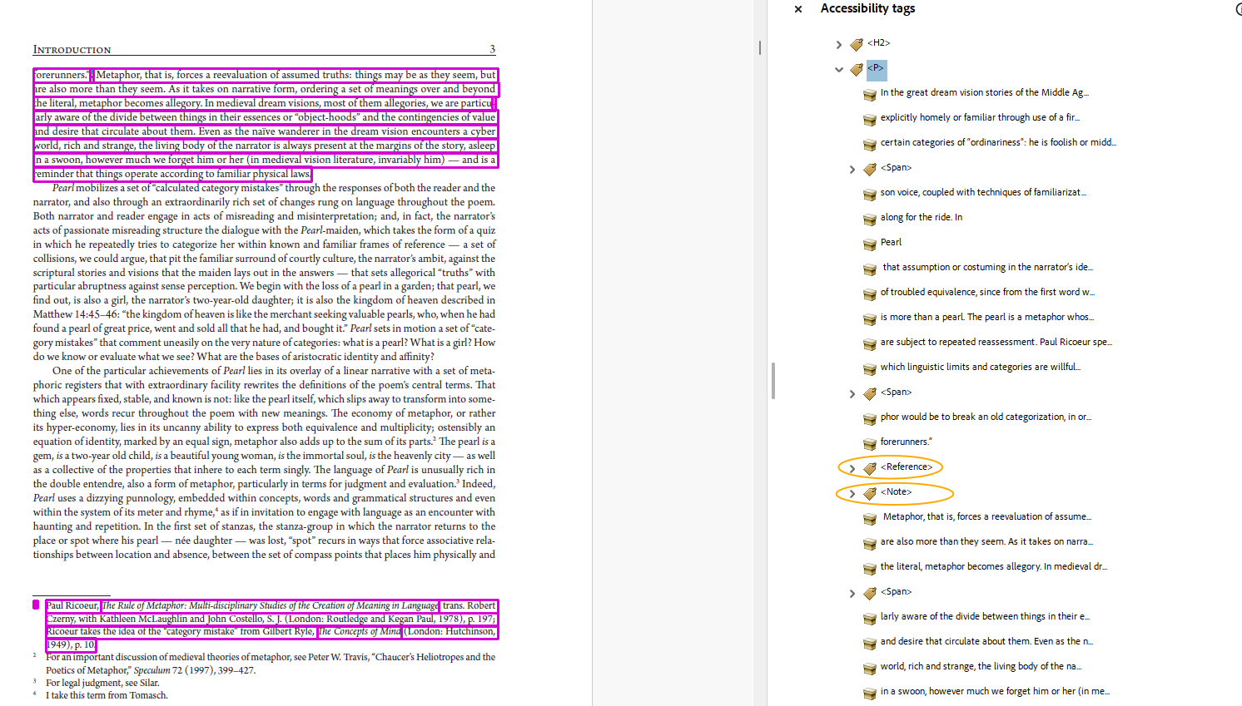

OCR the PDF
In the All tools menu, click Scan and OCR.
- Click Recognize Text > In this file > Settings (gear)
- Set Output to Searchable Image (Exact), then click Ok. Then click Recognize Text.
- Depending on the size of the PDF, this can take awhile. Be patient. Go get a coffee.
This will change the look of the Accessibility Tags. Instead of having one <Art> tag containing multiple <Sect> tags, there will be one <Art> tag for each page of the edition.

Create Heading Tags for Each Section Title
Titles that we enter on our Parent Pages don’t show up in the tagged content of a document, since it lives in the background of the InDesign page. We need to add these headings into the PDF manually and tag them appropriately.
- In the Accessibility tags menu, click the … hamburger menu > New Tag
  - Select: Heading Level 1.
  - This will create a <H1> tag in the tag tree.
- Nest the <H1> tag as the first tag under the corresponding Section tag. This can be tricky, so it may take multiple attempts.
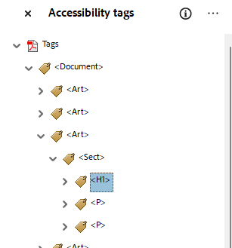
- When it is nested, select the <H1> tag.
- Then, select the text that is in the heading in the PDF page.
- Click the … hamburger menu in the Accessibility tags menu > Create tag from selection.
  - This will create a tag with the text content nested under the <H1> tag in the file structure’s tag tree.
- Complete this process for all of the following:
  - The Title on the Title Page
  - Abbreviations List
  - Introduction
    - If there is more than one introduction in a print edition, each introduction gets its own <H1> tag, and the <H1> name should be specific enough to reflect which introduction it is (i.e., General Introduction, Holkham Prayers and Meditations Introduction, etc.)
  - All Texts
  - Explanatory Notes
    - If there is more than one Explanatory Notes file in a print edition, each explanatory notes file gets its own <H1> tag, and the <H1> name should be specific enough to reflect which text these notes go back to (i.e., Holkham Prayers and Meditations Explanatory Notes)
  - Textual Notes
    - If there is more than one Textual Notes file in a print edition, each explanatory notes file gets its own <H1> tag, and the <H1> name should be specific enough to reflect which text these notes go back to (i.e., Holkham Prayers and Meditations Textual Notes)
  - Any Appendices
  - Bibliography
  - Glossary
  - Any Indices
- N.B.: In order to locate many of these sections, you will need to click through multiple <Art> tags to find the first page of each section.
  - As a reminder: each <Art> tag contains essentially one page of text.
  - If you happen to be familiar with the edition, you will have a sense of how long Texts / other sections are and so may have an educated guess of how many <Art> tags to click through.
  - If you aren’t familiar with the edition, there will probably be a lot of clicking involved here as you randomly click through the <Art>s until you find what you are looking for.

Add Bookmarks
- Select the Bookmarks icon from righthand menu. This will open up the Bookmarks menu alongside the righthand part of your screen.
- Click the … hamburger menu > New Bookmarks from Structure
  - Structure: H1
  - Click Ok.
- This will create an untitled folder of Bookmarks, with bookmarks made for all the <H1> tags we just put in. The text for each new bookmark will be the content for each <H1> tag.
  - Rename the folder Edition Sections.
  - If the title of the Edition exactly matches the title of the Text, add “- Title Page” to the end of the first Bookmark
  - See example image below.
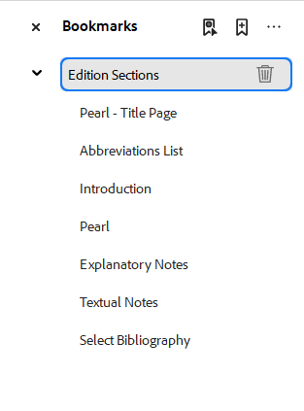

Reading Order: Title Page
Make sure that the reading order is in the correct order for the title page. We want the title to be read first, any editor / translator information read second, and the publication information at the bottom of the page read third.
Open Order panel. This will display everything by pages. Click into Page 1.
Any content on the page will be laid out in content blocks, which correspond to numbered tags. The numbers indicate the order in which the content on a particular page is read. These numbered tags will restart at 1 with every new page. You can see exactly what content is contained in each numbered content block on the page view itself; there will be a small number in the upper lefthand corner of selected text, shown to be selected by a grey box surrounding it.
To reorder: Click and drag the title to the top of the nested tags under Page 1. This should change the number associated with the tag.
If you know there are tables or images with captions within your PDF, navigate to where those are within your edition and check that the reading order is correct.
We will not adjust any other reading order at this time.
Congratulations, the PDF has been made accessible! Next steps are to upload the PDF to the website and to Github.

