This document contains general InDesign formatting rules for common and complicated formatting situations across all documents.

Notes for the Formatter

Before you begin work on an edition, check for any notes the Managing Editor has left about this particular edition for the formatter. These will either be in descriptions of tasks in the edition’s Asana project, or in a Word document in Box. The Managing Editor will review these notes with you before InDesign formatting begins.

File Naming Conventions

We follow strict file naming conventions in order to keep track of what document we are working on, which edition it is part of, and who is working on the document. These naming conventions also tell our transformation script how to process our InDesign files when transforming them into TEI-XML. Please review the METS File Naming Conventions and the METS File Naming Dictionary before creating any files.

General Formatting Rules

Our online formatting is being controlled by a CSS, which means that all formatting commands / guidelines will be universal across editions. This means that all editions must be formatted identically, with no exceptions to formatting guidelines, as we will be unable to replicate these exceptions online. Formatting is assigned via Paragraph and Character Styles in InDesign. These Styles determine the appearance of the edition within a print volume and online; in order to maintain consistency between print and online, you should not add formatting outside of these Styles (ex: italics, extra spacing between paragraphs) to print editions, as it is not possible to replicate that formatting online.
There is no semantic tagging for the apparatus (Front Matter, Introduction, Notes, Glossary, Bibliography, Indices, Appendices) of a volume, only for the text. You must use styles that apply formatting in the apparatus but will not use any tags that apply semantic meaning outside of this formatting. In Facing Page, only semantically tag the original language, not the modern English translation.
By the time the edition is formatted in InDesign, it has gone through a series of reads and corrections in a Word Doc, so the formatting there should more or less conform to our Style Guidelines. There may be some slight deviations with spacing and alignment, but most formatting, such as italics, will be corrected in the Word Doc. While formatting, you should replicate the format of the source text, unless it clearly violates one of our Style Guidelines. In these instances, default to the standards outlined in the InDesign instructions and bring any questions to the Managing Editor.
Always begin formatting with the first document in an edition (Front Matter: Dedications, Acknowledgements, and Abbreviations List), and then work through the edition in document order. This will prevent undue formatting and pagination issues. Follow the Table of Contents provided by the edition editor.

Record Queries in Asana

During the overall formatting process, you will have questions. The workflow that follows sets out the formatting guidelines you should follow, but inevitably you will run into files that contain strange or specific formatting that the guidelines don’t anticipate, or words in Middle English that have ambiguous meanings and make semantic tagging difficult.
When you have questions, please record them in the Print Production section of your Editor-Volume’s Asana Project; each query should be its own subtask attached to the relevant formatting task within the “InDesign Formatting” Milestone Task. The InDesign auditor will review and respond to queries via comments here when the audit happens. This documentation is crucial because it helps us keep track of what decisions have been made on an edition. Using Asana allows us to centralize all questions and conversations about a particular edition in one place that is easily accessible by all METS Staff.
For full guidelines on how to record queries in Asana, see the Queries in Asana documentation.

Common Rules

Whenever you work in InDesign make sure you have the hidden characters and the override highlighting turned on. This will identify any formatting errors, including ones that are invisible, like overrides between Paragraph Styles. These types of overrides will affect spacing in the print edition and will cause errors in the export, so make sure to remove ALL of them.

Hidden Characters
Delete the following hidden characters and either replace them with a typical space (punctus) or eliminate them entirely if an extra space isn’t needed.

Hidden Colon (also known as the cursed colon)
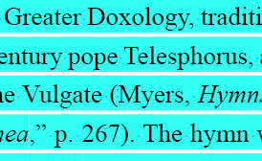
No idea what this one does, but it’s the most prevalent kind of hidden space character and sometimes it interferes with the transformation script to generate TEI-XML.

Hidden caret
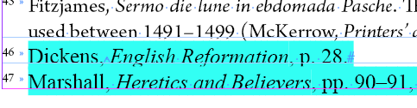
These indicate non-breaking spaces. Any non-breaking spaces needed for the look of the print edition will be added by MIP when the press does its final typesetting and proofreading after we have sent them our final files.

Hidden tiny dash in the middle of words
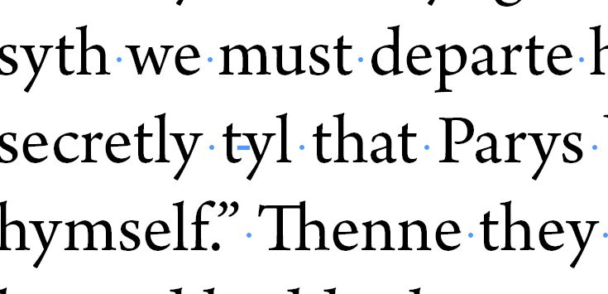
Also no idea what this one does, but we figure it’s safer to delete it rather than leave it and chance that it messes with the transformation script to generate TEI-XML.

Extra tabs within texts
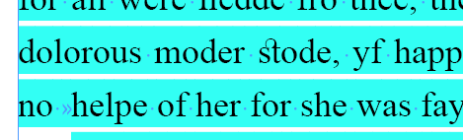
These should be caught before InDesign formatting begins, but they are hard to spot in Word and so some may slip through.

Use the Paragraph Styles and Character Styles to Apply Styling
Use the embedded formatting in Paragraph and Character Styles. These Styles are designed to apply extra spacing above and below lines of text, some amount of indentation, set standardized tabs, and any styling like Italic, etc. Unless specifically outlined in the formatting instructions, you should never alter the formatting of these Styles.
For a full list of all our current Paragraph Styles and Character Styles, please refer to the Style Reference.

Common errors include:
- Adding additional paragraph ends (i.e. hard returns) between paragraphs in order to create larger white space between paragraphs
- Adding tabs to the beginning of a Body First Paragraph Style
- Applying Italic through the Character Panel instead of using the Italic Character Style
If you find yourself adding formatting, review the file’s workflow and the list of InDesign Styles in the Style Reference to ensure that you’re using the correct one.
- For example: Body First does not have an indent, whereas Body does; so if your paragraph requires an indent of the first line, make sure you use Body.
If there are no options that will correct this formatting, make a note of this in the edition’s Editor-Volume Asana project. You’ll want to leave a comment on the InDesign Formatting task under the Print Production section. In your comment, please note the location and describe the formatting that needs to be added. Make sure to tag the managing editor here, as we may have to make a new InDesign style and update our transformation script that generates our TEI-XML files in order to accommodate the request.

Tagging Character Styles on multiple lines
This can introduce errors when we convert our InDesign files into TEI. If you select multiple lines at once and apply a Character Style to all of them, you will most likely catch extra text or hidden characters that are supposed to be tagged differently, which results in our transformation script spitting out error codes instead of pretty TEI-XML files. For example, in verse, glosses will often interrupt the tag.
kalens first day
Of Marche
For styles like Latin or French, do tag on both lines, as you want to style the entire foreign language phrase, but only select the text / phrase on each line that needs to be tagged Latin or French. For Person Name, Place, or Date, try to tag the most meaningful piece of information – in the above example, you would tag “Marche” but not “kalens.”

Caesura
If there are caesuras in the verse, they need to be tagged so we can replicate the spacing in our digital editions. There should be 6 spaces to each caesura. Highlight the 6 spaces and tag with Character Style “Caesura.”

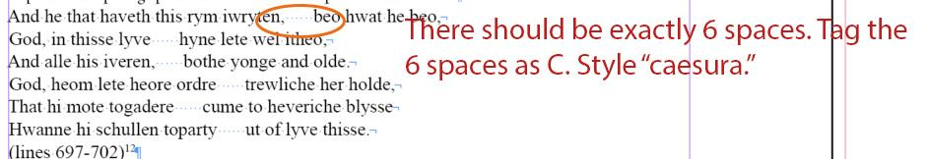

Ellipses
There is no Character Style for ellipses; this is purely formatting. We do not use the auto-formatted ellipses that Word will generate. For all ellipses in the edition, including for catchphrases, use three periods with spaces before, between, and after.
- Ex.: We’ve had one, yes, but what about second breakfast . . . elevenses, luncheon, afternoon tea

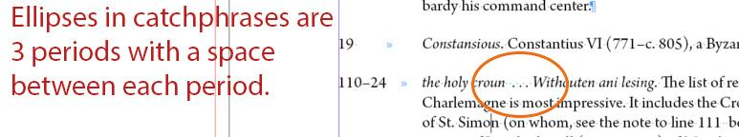
- Rare edge case: If a catchphrase begins with an ellipsis, you’ll start with a period instead of a space (so period-space-period-space-period-space). This typically happens if indicating damage to a manuscript resulting in incomplete text.

Em-dash
There should be a space before an em-dash and after an em-dash to offset it from the surrounding words. Use shortcut alt+shift+- to insert an em-dash. You can also insert an em-dash by Right Click > Insert Special Character > Hyphens and Dashes > Em Dash
- Ex.: Nonsense – it’s ridiculous!

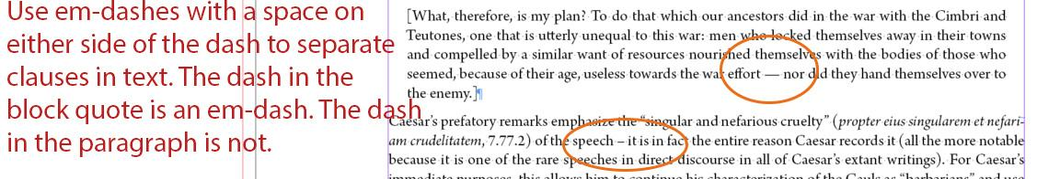

En-dash
Use an en-dash between ranges of numbers. Use shortcut alt+- to insert an en-dash. You can also insert an en-dash by Right Click > Insert Special Character > Hyphens and Dashes > En Dash

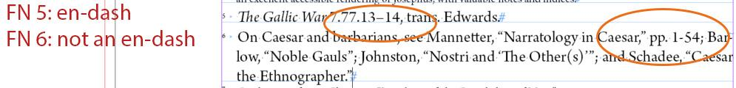

Footnotes spacing
Delete any extra spaces at the beginning of the footnote; there should not be any spaces in between the tab and the start of the footnote.
- You can get rid of extra spaces at the beginning of the gloss using the Find / Change function in InDesign if you set specific settings to search.
  - Ctrl+F
  - Set the Find what: field to a tab and a space
    - Enter click the @ symbol to the right of the field and select tab. This will enter ^t (indicating a tab) in the Find bar. Then, enter a space following this.
    - 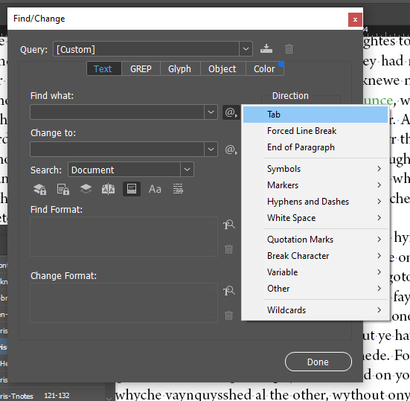
  - Set the Change to: field to a tab, using the same @ symbol selection menu
  - Set the Find Format: field to the Footnote Paragraph Style
    - Click into the empty field to bring up a menu labeled Find Format Settings.
      - Here you can set specific Character and Paragraph Styles to search within. For the purposes of this search, you only need to specify the Paragraph Style as Footnote
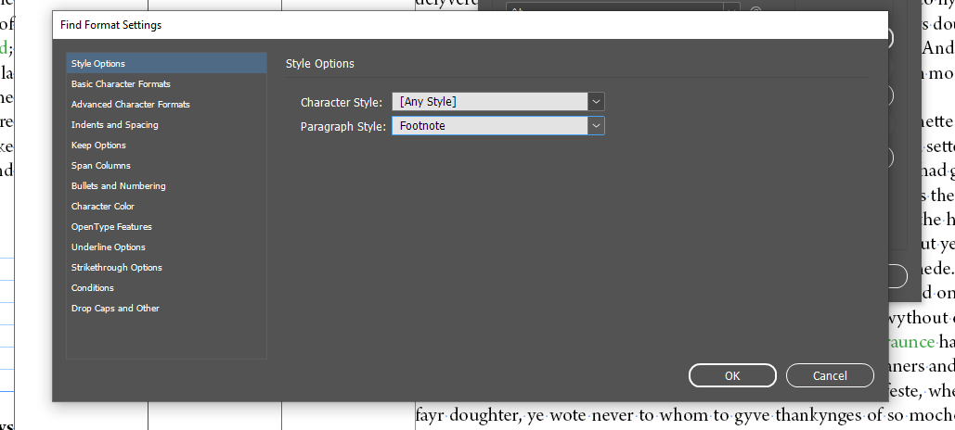
Your Find/Change menu should look like this:
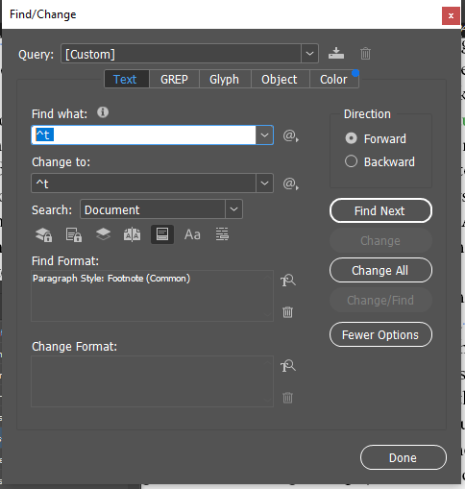
  - Once all these settings are filled out exactly like this, click Change All. This will replace any and all Tab-Space combinations in Footnote Paragraph Styles with just Tabs.

Forced Line Breaks
These are used in verse at the end of lines that are grouped within the same stanza. The keyboard shortcut is shift+enter.

Fractions
These are rare but can occur in manuscript descriptions. For these, it is important to have the highlight override turned on. For “typical” fractions (ex: ½, ⅓, ¾, etc.) InDesign will format these automatically as fractions. For unusual fractions (ex: ⅝) InDesign will not format these, and they will either look weird or be overridden. For these unusual fractions, you will have to highlight the entire thing and select the “Fraction” Character Style. For “typical” fractions, do not tag them with a Character Style.

Indentations
Verse and Drama texts may contain different indentation at the beginning of lines. In this instance, you should best try to replicate the indentations in the original Word Document. We have up to 8 indentation depths and these are set in the tab settings of Line Group Paragraph Styles.
Every verse text should have at least 1 indentation at the start of each line, which offsets the line from the left margin and the line number. Use additional tabs for each new level of indentation. Be sure to be consistent and make sure you are applying the same level of indentation to lines that the editor has indented.

Drama Speech Lines
In drama, lines are occasionally broken between speakers. When this occurs, try to indent so that the new line of speech is indented roughly in line with the end of the previous line of speech. This will indicate to readers that these lines are continuous.

Nested Tagging
InDesign can only nest one Character Style inside one Paragraph Style, so you cannot apply more than one Character Style or Paragraph Style to the same word. Sometimes this will be an issue in regard to semantic tagging. When this occurs, make note of where in the text it occurs in an oXygen Interventions spreadsheet, following our best practices. Since the tagging will occur in oXygen, page numbers, line numbers, or paragraph numbers are not useful references all by themselves. You should include a phrase that you can ctrl+F, and be specific about the tag and the exact words that should be tagged.
- For our oXygen Interventions Best Practices, see the relevant documentation.

Overrides
There are overrides in your text when there is a + sign next to a Paragraph Style name or when the text in your document is highlighted turquoise, when the “highlight override” is turned on. Styles are overridden when text holds formatting from imported documents rather than the formatting embedded in our Paragraph Styles. This can be a useful tool while you’re formatting a text, but it needs to be resolved so that all of our published texts are consistent.

Highlight Override
This is the button that is in the Paragraph Style menu and should be turned on anytime you are working in an InDesign Document. Refer to image below.

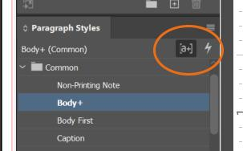

Clearing Overrides
Use the clear override button or alt-click on the Paragraph Style+ in order to remove all overrides in a given Paragraph Style. Refer to image below.
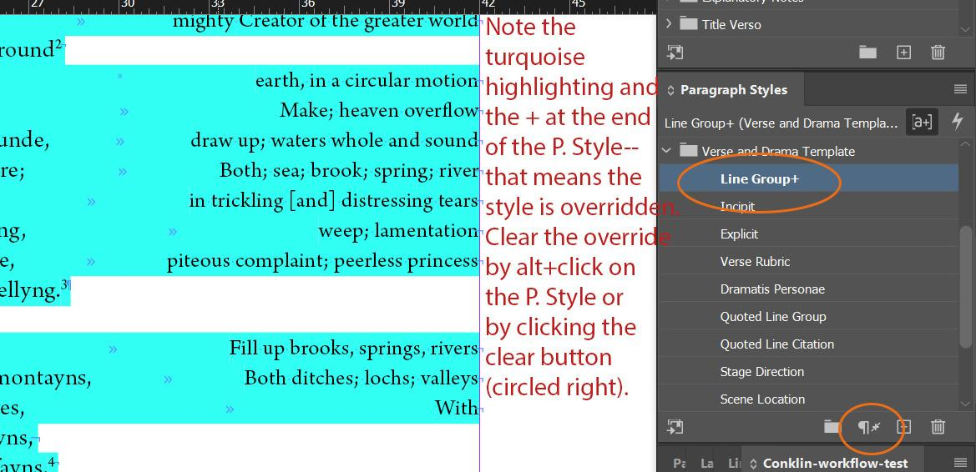

Person Name:
Used to tag all proper noun names for people or people-like beings. Certain names may not be capitalized, depending on the editor’s preference, so you need to read carefully in order to determine whether or not to apply the Character Style. Keep the Style Reference open as you apply tags in order to ensure that you are properly tagging people.

Place
Used to tag all named places, real or imaginary. Certain places may not be capitalized, depending on the editor’s preference, so you need to read carefully in order to determine whether or not to apply the Character Style. Keep the Style Reference open as you apply tags in order to ensure that you are properly tagging places.

Don’t use Ctrl+F to tag repeated names or places!
Although InDesign does have the ability to tag multiple names at once using the Find/Change function, please don’t. You really need to work your way through the text, line by line, in order to ensure that you’re capturing all Middle English variations of names and that you are not erroneously tagging names or places or accidentally tagging the middle of an unrelated word.

Common font styles to look for in each section of text
Semantic tagging in texts – such as “gloss,” or a language tag, which apply italics – supersedes the use of these tags. Use the following font styles when you need to apply specific formatting to a word or phrase but there’s no semantic component to the tag or for most formatting in the apparatus. Replicate the formatting present in the original Word document, using the follow tags:
- Bold
- Bold Italic
- Bold Small Caps
- Italic
- Italic Strikethrough
- Small Caps
- Underline

Instructions for List Bullet / hierarchies
When creating a bulleted list in InDesign – which often occurs when listing MS variants in introductions – make sure that you use the List Bullet Paragraph Style. If you need an additional level within the list, you would use List Bullet 2 for the second level.
As you are formatting, make sure that you clear any paragraph overrides between Paragraph Styles as well as the paragraphs themselves. These types of overrides interfere with the code and also alter the spacing of the print edition.

Verse: Long Stanzas vs. Short Stanzas
We have two workflows for how to format Verse depending on how long or short the stanzas included in the text. Both workflows include the same formatting work, but follow different orders since stanza length can change the difficulty level of adding styling-specific formatting and will determine whether you do that work before or after clearing the overrides.
Please note that here we are not referring to stanzas using the standard definition of the literary form (i.e., a stanza includes a certain number of lines or a particular type of rhyme scheme). Rather, we are using the term ‘stanza’ to refer to a line group that has white space separating it from other line groups. A short ‘stanza’ can be anywhere from four lines to a couple hundred lines long, whereas a long ‘stanza’ is usually at least 300+ lines long.
When deciding which workflow to use, look at the Text’s Word document and get a feel for how long the stanzas seem to be relative to how long the overall text is. If there do not seem to be any distinct line groups in your text (i.e., there is no added white space between lines), then follow the workflow for long stanzas.

Drama-Specific Common Rules

Drama: Line Numbers and Speaker overlaps
Occasionally line numbers will appear on the same line as a speaker. In this instance, you will use the next line for the line number so that the speaker remains in the left column.
- Ex: Instead of 105 Abraham use Abraham
106

Drama: Foliation and Speaker overlaps
Occasionally folio numbers will appear on the same line as a speaker. In this instance, you will place the folio number directly above the speaker’s name on an unnumbered line. Foliation should also be placed above Stage Directions, but they can coincide on the same line with a Scene Location. Print Only Exceptions: stanzas that are preserved as a unit with speaker changes. In Print, we keep the Foliation with the Glosses. In Export, we will insert the Foliation on a blank unnumbered line. In Print, Foliation should NOT receive a paragraph break - for spacing, make sure a forced line break is applied. In Export, re-insert the paragraph break.
Ex: fol. 105r [Rome]
Abraham Hello

Scene Location
Receives the Paragraph Style Scene Location. There should be one tab inserted before any text so the scene location in question is in line with the rest of the text. Semantic Tags will apply if the scene location is original to the text.

Stage Direction
Receives the Paragraph Style Stage Direction. This Paragraph Style will italicize the text and set it flush with the left margin. Stage Directions are frequently in Latin; keep an eye out for this and apply the Latin Character Style as needed. For any associated glosses, add a footnote and tag as Footnote Gloss, as we do in Prose. Semantic Tags will apply if the stage direction is original to the text.

Standard Formatting for Glossaries
All glossary entries are single-spaced, with no spaces between entries and double-spacing after the headword.
- The headword should be bold [use Character Style “Bold”]
- the definition should be italic [use Character Style “Italic”]
- any punctuation and word forms should be roman [no Character Style applied]

Standard Formatting for Proper Noun Indexes
All index entries are single-spaced, with no spaces between entries.
- The index entry in the original language should be bold [use Character Style “Bold”]
- Translated forms of the entry should be bold italic [use Character Style “Bold Italic”]
- The textual references (which could be article, line, or paragraph numbers) should be roman [no Character Style applied]

Standard Formatting for First Line Indexes
Italicize titles, incipits, Latin. Everything else in roman.

Middle English Characters

For Middle English characters like yogh and edth (and occasionally thorn), you will likely need to manually insert these into the text using the Glyphs Panel in InDesign.

Inserting Middle English Characters with Glyphs Panel
Click into the text where you need to insert the character.
- In the upper menu, select Type→ Glyphs.
- The Glyphs pop-up menu will appear. Select the font “Arno Pro” in the bottom dropdown menu
- Type the name of the Glyph (ex: yogh) into the search bar.
- Choose the correct Glyph--either uppercase or lowercase, not small caps--and double-click on it.
- This will insert it into the text.
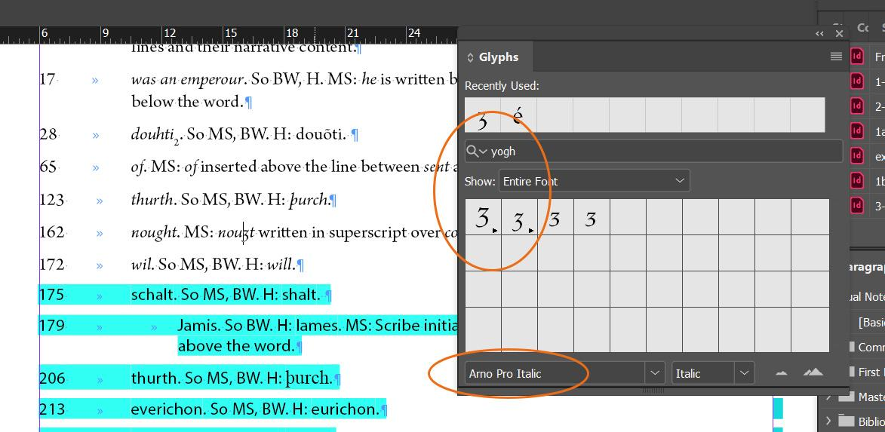

Macrons
Sometimes macrons over characters are replicated in our Textual Notes or other Apparatus files. Any macron over a vowel should format correctly using our Arno Pro font family.
- Very rarely – and primarily in the backlist – you may find yourself needing to insert a small letter n with macron character. This character does not exist in our Arno Pro font family; it will not appear at all in InDesign upon importing the source Word document.
- Instead, you’ll need to use the N with Macron Character style, which is set to the font Source Serif Variable, Italic, 9pt font size.
  - You’ll need to copy and paste this character into your file where the n with macron needs to appear: n̄
  - Then, apply the N with Macron Character Style to it.
  - Finally, clear any remaining overrides. The character should display properly now.

Wynn
Wynns are a particular Middle English character that does not exist in our Arno Pro font family. It should appear as a small blank box. You’ll need to apply the Wynn Character Style, which is set to the font Cambria, Italic.
- Apply the Wynn Character Style to the small blank box.
- Then, clear any remaining overrides. The character should display properly now.

Diacritics
Of course, there are other special characters that have various diacritic marks that also aren’t part of the Arno Pro font family we use. If you come across something that is displaying as a small white box, first try to apply the Diacritics Character Style, which is set to the font Times New Roman, 10pt font size. This should do it for most special characters that aren’t in Arno Pro; if it doesn’t work, consult the Managing Editor.

Completing a Text Frame

In Design marks the end of a text with a # character. After you format any individual text frame, you should make sure that this # appears directly after the final punctuation or letter in the frame.

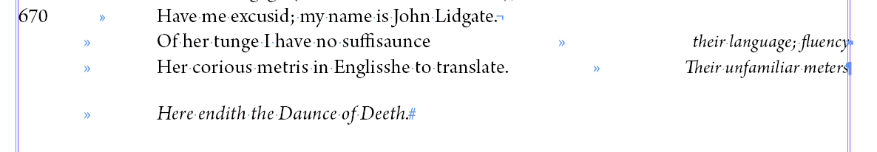

Document Pagination

Pagination should be more or less set before you move onto a new document. This is especially important for Prose, but changing pagination can be problematic in all InDesign documents.
- Scroll through and make sure no extra blank pages have been added throughout your document. Also check for extra pages at the end of the document. Delete as needed.
- If your text ends on a verso page, congratulations! You don’t have to do anything.
- If your text ends on a recto page, you need to add a blank page to the end of your document.
  - In the Pages menu, double-click on the final page of your text. You’ll know it is selected when it turns blue.
  - Select the plus sign at the bottom of the menu.
  - This should add a page.
  - Make sure that page has the [None] Parent Page applied to it.
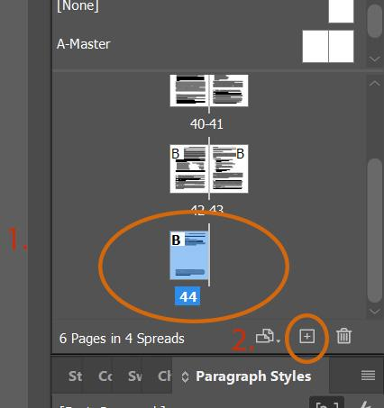
- ** The exception to this is if your next document is a Facing Page text. For that, the first page actually needs to be a verso page, so if your text ends on a recto page, you’re fine. If it ends on a verso page, you will need to add an extra page.
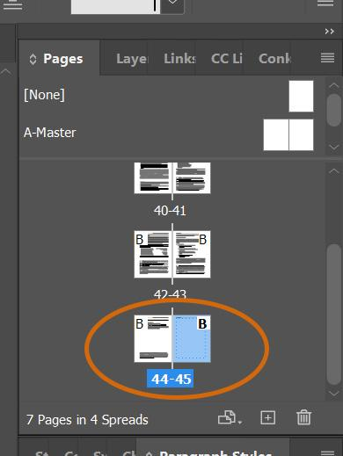
- If, for some reason, at the end of your document there are multiple blank pages, you can double-click into the extra page and select the trashcan at the bottom of the Pages menu to delete it.

