Read the entire instructions before you try to follow them. Knowing where you are going will help.
It helps to have the Formatting Reference and the Style Reference documentation as you move through this workflow.
First, Show Hidden Characters (ctrl+alt+i) and the Highlight Override feature ([a] at the top of the Paragraph Style menu). Don’t do anything before turning these on.

Preparing Word documents for Dedications, Acknowledgments, and Abbreviations Lists for Import

Editors prepare the front matter from a template we provide; it includes all aspects of the front matter collected together. For the Dedication (if present), the Acknowledgments, and the Abbreviations List, you will need to make separate Word documents so that we can place them correctly into InDesign.
- First, check to see if there is a folder specifically for Word documents for the edition. This is where you will be saving all new Word documents.
  - If there isn’t a folder named Editor-Volume-Word, check with the Managing Editor.
  - If there are a lot of production-related files already in the folder, you may find it helpful to create a subfolder (ex. “Import to InDesign”) to group all your Word files together.
- Open the final Production Word document that contains all of the information for the Front Matter.
  - Copy and Paste each individual section into its own Word document.
  - N.B.: You never want to Cut / Paste these sections into new files. We want to preserve the original Production file as one complete document.
- Make sure you name each Word document to identify which section it contains. This will help a lot when importing the files.
  - Ex. Campbell-Apocalypse-00a-Acknowledgments
  - Best practices are to follow our File Naming Conventions

How to Add a Front Matter File to an Editor-Volume-Print Folder

The first InDesign file we add to an InDesign Production folder is a copy of the Front Matter template.
The Front Matter is the document that contains the Middle English Text Series information page, the title page, publication pages, table of contents, acknowledgements, and abbreviations. The Template file of our Front Matter is also the document that contains all the most up-to-date Parent Pages, Paragraph Styles, and Character Styles we use throughout our editions.
- Copy (ctrl+c) the Example-00-Front-Matter file and paste it (ctrl+v) into the new Editor-Volume-Print folder
Immediately after you paste the Front Matter Template into the new Editor-Volume-Print folder, you will want to update the name to match METS File Naming Conventions:
- Editor-Volume-Print-00-Front-Matter

Filling in the Front Matter

First Title Page
This page contains the complete title of the volume. Below, see the Template, which has the placement of the Volume Title preset. If the volume has a medieval author, that author will be listed on the first line of the title, with the rest of the title on subsequent lines. If it is a multi-line title, consult with the Managing Editor about how best to format it.
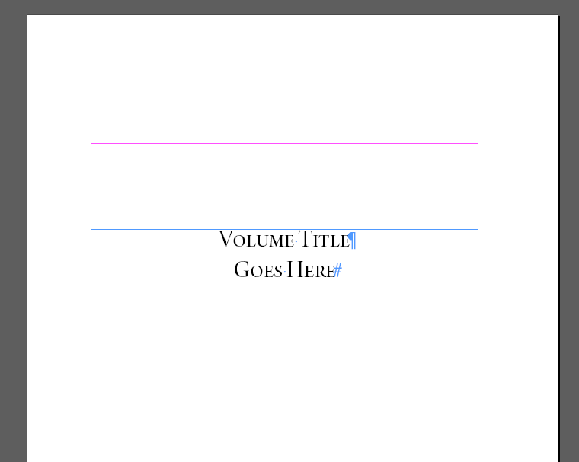
See the example below for a title page with an author. Note that the author’s name is on the first line. The rest of the title is split between two lines, as it is lengthy. Also note the paraph symbols at the end of the first two lines and the # after the last word on the final line. The paraphs mark hard returns at the end of each line. One is already built into the preset format, but you may add more as needed. The hashtag should always appear at the end of the final word on the page.
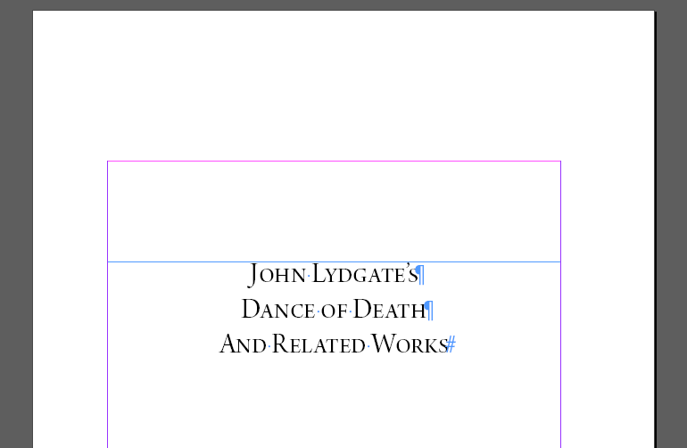
Note that this page uses a single Paragraph Style: Book Title, which is found in Paragraph Styles → Front Matter Template → Title Pages → Book Title. The text should be pre-styled but do check it.
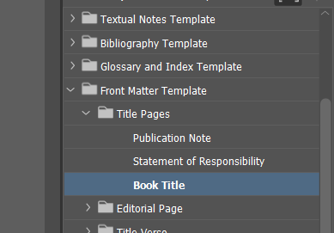

Middle English Texts Series Page
The entire page should be filled in and will require little intervention.
If you are working on a text that has not yet been published, the information about the Editorial and Advising Board should all be pre-filled in and correct. Check with the Managing Editor to make sure no changes have been made since it has last been updated.
See below for an example:
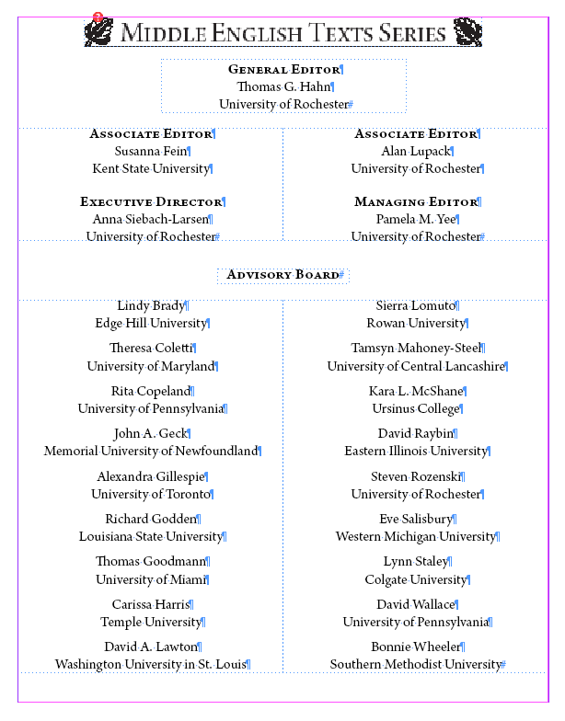
This information should be updated on an annual basis by the Managing Editor if any Board membership changes. You’ll need to go into the E-Editorial Parent Page if you need to change any of this information, since all of this text is embedded there.
- Pages Panel > double-click into the Parent Page marked E-Editorial. This will take you to the Parent Page of the METS Editorial Page.
- From here, you can click into text boxes and alter board members as needed.
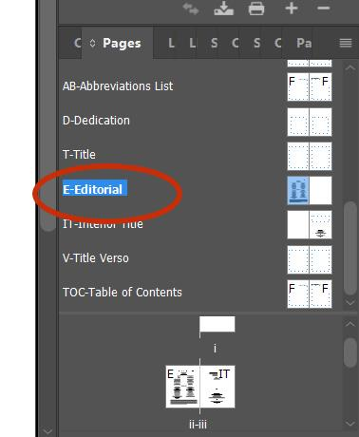
If you do alter this page, make sure that you apply the correct Paragraph Styles.
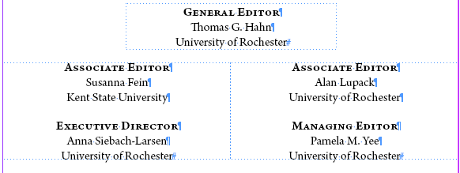
Role titles like “Associate Editor” use Paragraph Style: Editorial Page Staff Role.
For names of people or institutions of the editorial board use: Editorial Page Staff Name and Institution.
For names of people of the advisory board use: Editorial Page Staff Name and Institution
For institutions of the advisory board use: Editorial Page Advisory Board Institution

Title Page with Editors and Publication Information
In this page, you will need to fill out the title of the work and the editors, so you will only be working in the top section of the page. See below:
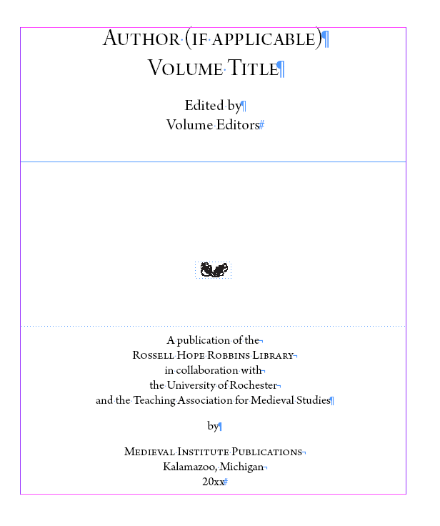
The format of the title on this page should match the one on the initial title page.
List the editor(s) on a single line beneath the “Edited by” phrase.

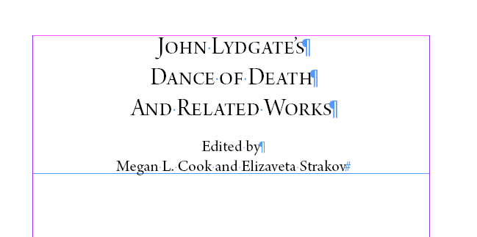
The Paragraph Styles are already added to the text you are replacing, so you should not have to change these. But if you do, the correct styles are found in Front Matter Template → Title Pages. Use Book Title for the title of the edition, and Statement of Responsibility for the editor’s names.
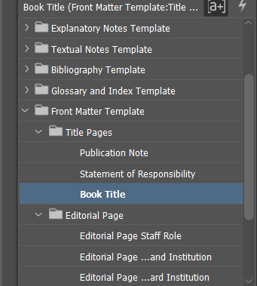
Do not alter the publisher information nor publication date at the bottom of this page. The publication date will be filled in later.

Publication and Library of Congress Information
This information is filled in by MIP, do not alter it.
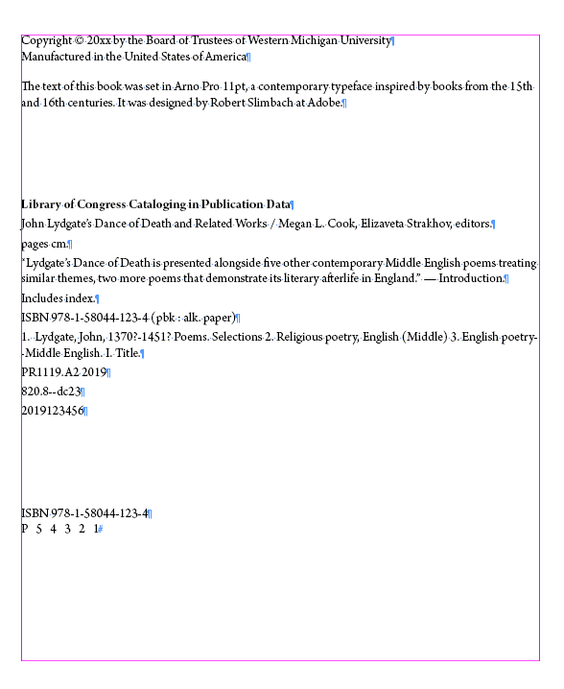

Dedication
- If the editor(s) has included a Dedication, you will import it from a Word doc directly into the text frame on the Dedications page. For instructions on importing text from Word into InDesign, refer to 03a. Making New InDesign Documents documentation.
- Apply the Paragraph Style Dedication Text so that it is formatted correctly. You may need to manipulate the formatting of the dedication by adding in line breaks where you would like to split longer dedications for aesthetic purposes.
Ex.:
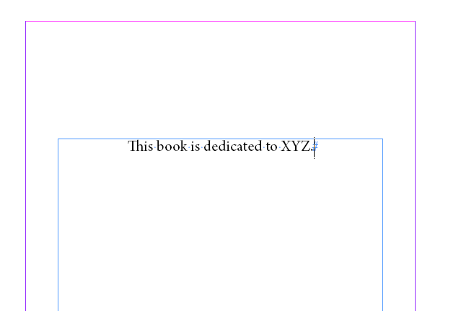
- If there is no dedication, delete the Dedication page and the blank page following it from the book so that the Table of Contents begins directly after the publication page. Refer to Document Pagination in the Formatting Reference to learn how to add and delete pages from books.

Table of Contents (TOC)
This begins on a recto page. The TOC can continue onto the following page. If it does, you will need to add a page directly after the original TOC page. Refer to Document Pagination in the Formatting Reference for how to do this. You will need to turn the Parent Page of the new document into B-Body to have the correct margins.
There is a standard Table of Contents template that imports with all Front Matter (see below). This template comes in with the proper Paragraph Styles assigned to different Table of Contents sections. Go in and adjust the section titles now, but the Managing Editor will not be able to finalize pagination until formatting is complete and page numbers are set. For more about setting pagination, see the Setting Pagination Instructions in our Final Steps documentation.
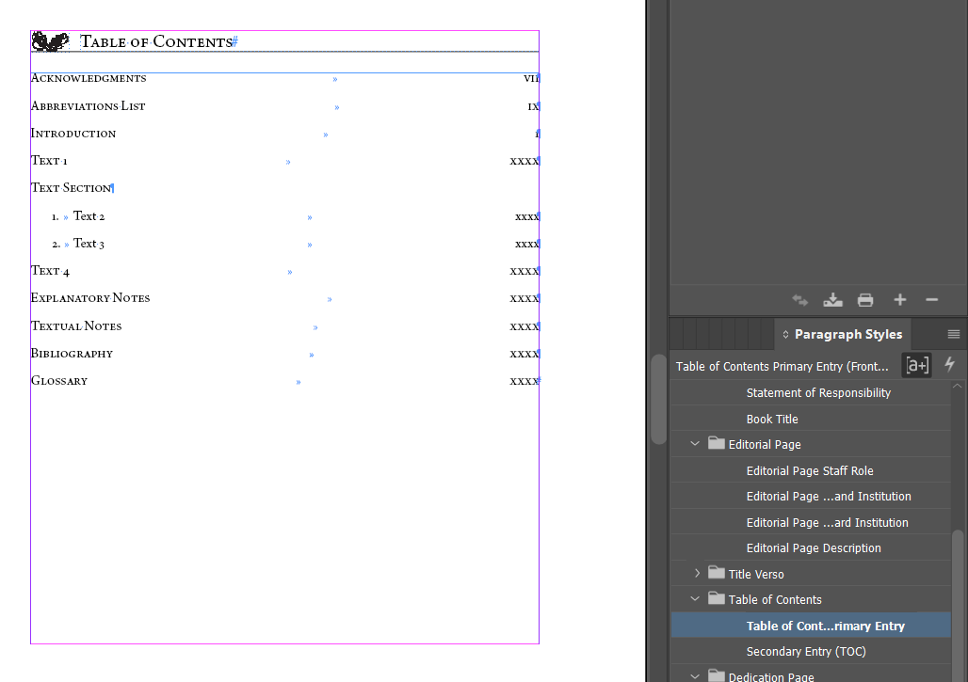
All major texts and sections of the edition should use the Paragraph Style: Table of Contents Primary Entry. If there are subsections beneath those main sections, you will use Secondary Entry (TOC). You will have a Table of Contents put together by the volume editor; use that to fill this section out. Unlike most InDesign documents, you need to type this in manually rather than importing a file.
A note about page numbers: the Front Matter uses roman numerals and the substance of the edition, which begins with the Introduction, are numbered with Arabic numbering. This is set up to work automatically, but you will need to adjust this in the TOC.

National Endowment for the Humanities Page
This begins on the first verso page after the Table of Contents. We have a standard page acknowledging the support that the National Endowment of the Humanities has given us through their grant. This uses the required language and logos provided by the NEH. The Managing Editor will update this page as the NEH continues to update its guidelines.

Acknowledgments
This begins on the first recto page after the National Endowment for the Humanities Page. If the Acknowledgments spill onto the following verso page, that’s fine. If it does, you will need to add a page directly after the original Acknowledgments page. Refer to Document Pagination in the Formatting Reference for how to do this. You will need to turn the Parent Page of the new document into B-Body in order to have the correct margins.
You will import Acknowledgments from a Word doc directly into the textbox on the Acknowledgments page. For instructions on importing text from Word into InDesign, refer to the 03a. Making New InDesign Documents documentation.
Style the first paragraph of Acknowledgments with Body First Paragraph Style, so it will have no indent. Any following paragraphs should be styled with Body Paragraph Style, so the indent will be built into the Paragraph Style. There should be little or no additional formatting but if there is, refer to Common Font Styles in the Formatting Reference as needed.
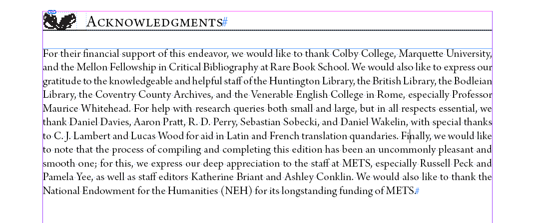

Abbreviations List
This begins on the first recto page after the Acknowledgments. Import Abbreviations Lists from a Word doc directly into the textbox on the Abbreviations page. For instructions on importing text from Word into InDesign, refer to the 03a. Making New InDesign Documents documentation.
If the Abbreviations List spills onto the following verso page, that’s fine. If it does, you will need to add a page directly after the original TOC page. Refer to Document Pagination in the Formatting Reference for how to do this. You will need to set the Parent Page of the new document to B-Body to have the correct margins.
Note that backlist texts do not have an abbreviations list in the same format as our current editions. Consult the backlist-specific workflow for creating these abbreviations lists.
See below for a standard Abbreviations List.
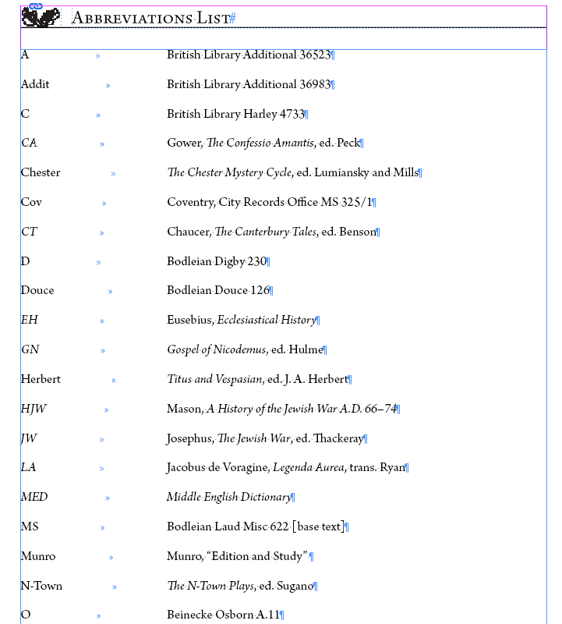

Every entry should use the Abbreviations List Paragraph Style. There should be an end of paragraph symbol at the end of every entry. Refer to the Common Font Styles in the Formatting Reference to make sure that the formatting of each entry is correct; you will primarily use Italic.
An entry consists of the abbreviation, which is aligned with the left margin and should be listed in alphabetical order. There should be one tab between the abbreviation and the short title of the entry.
Note that the Abbreviations List should be more or less correct when you import it. If you notice anything that seems to go against our typical short title guidelines (refer to the METS Style Guide for full details), bring it to the Managing Editor’s attention, but otherwise you should simply replicate the formatting found in the Word doc of the Abbreviations List.

Final Pagination Adjustment before Moving on to the next Document

First, make sure that the hashtag that indicates the end of the text appears after the final punctuation on the page. You’ll need to check this individually for the Dedications, Table of Contents, Acknowledgments, and Abbreviations Lists.
Pagination should be more or less set before you move onto a new document. Refer to the Formatting Reference for more information about setting pagination once your document is complete. See the Completing a Text Frame section and the Document Pagination section of the Formatting Reference for more details.

