Read the entire instructions before you try to follow them. Knowing where you are going will help.
When making new folders or files, always make sure you are following METS File Naming Conventions. Refer to the following documentation:
- METS File Naming Conventions
- METS File Naming Dictionary

How to Make a New Document in InDesign

All InDesign documents are created using the same initial steps:
- After opening InDesign, select File→ New → Document.
- This will open a new window where you can set options for the layout. Select the METS Book Preset option, which contains the proper page size and margins for all our documents.
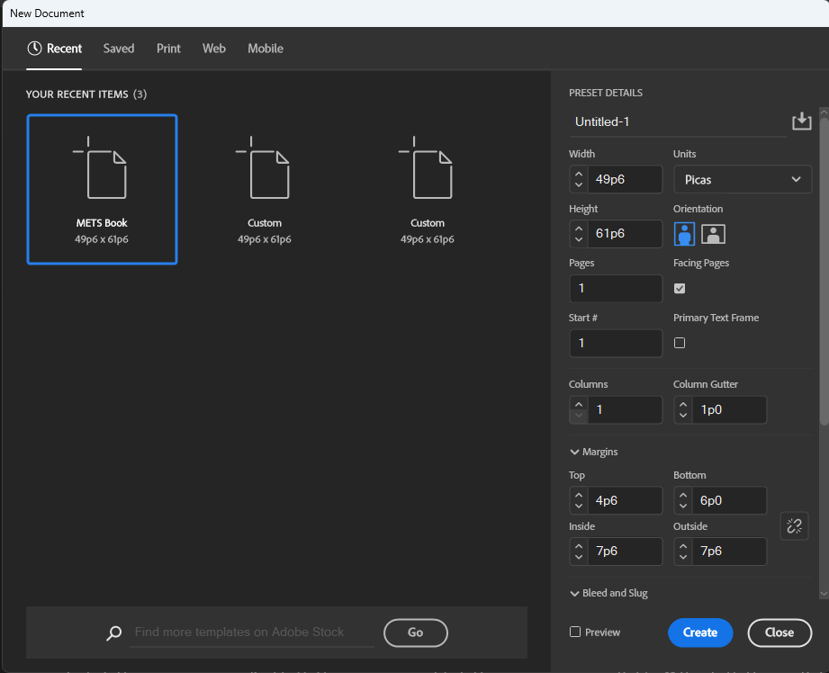
  - This Preset is a setting that lives independently on each workstation. Sometimes it disappears. If it disappears:
    - Don’t panic. We can make it again.

Recreating the METS Book Preset in InDesign
You’ll be changing some of the measurement information in the right column titled Preset Details to match the following information:
- Width: 49p6
- Height: 61p6
- Units: Picas
  - Picas (p) are a form of measurement that equal 1/6 of an inch. It’s what InDesign measurements tend to default to. We go with it.
- Pages: 1
- Facing Pages: Checked
- Start #: 1
- Columns: 1
- Column Gutter: 1p0
- Margins: First, click the link icon so it is broken. (We don’t want all our margins to be the same size, so we need this setting turned off.)
  - Top: 4p6
  - Bottom: 6p0
  - Inside: 7p6
  - Outside: 7p6
Incorrect:
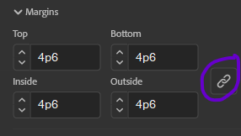
Correct:
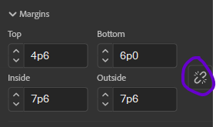
- Bleed: Here, leave the link icon whole.
  - Top: 0p9
  - Bottom: 0p9
  - Inside: 0p9
  - Outside: 0p9
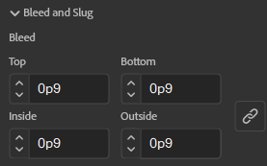
- Slug: We leave all these settings at 0p0.
- Scroll back up to the top of the Preset Details column and click the Save Document Preset button.
  - 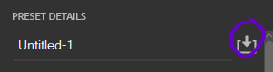
  - The top will change to look like this:
  - 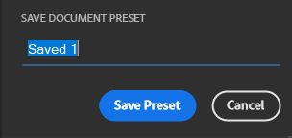
  - Replace “Saved 1” with “METS Book”. Then click Save Preset.
  - This will Create a Saved Blank Document Preset that will show up under “Saved”.
- N.B.: If you try and change the title first, then click the Save Document Preset button, the title you enter won’t actually carry over, and you’ll have to reenter it again.
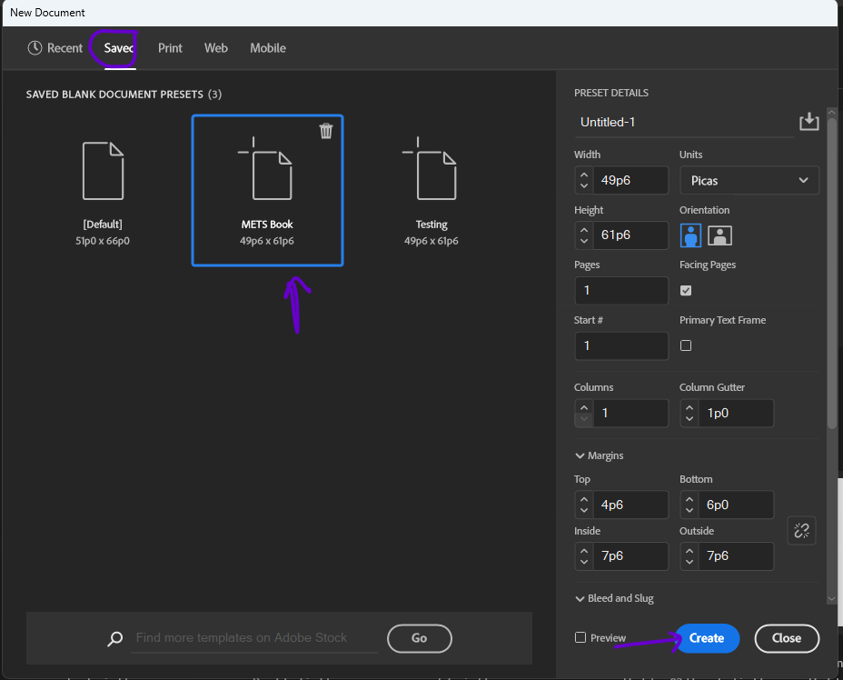

Make sure that the METS Book preset is selected, then click Create.
- When the document opens, File → Save As. Check that you are saving into the Editor-Volume-Print folder. Name the document, following the naming conventions outlined in METS File Naming Conventions Documentation.
  - Ex.: Fein-Owl-Print-01-Intro

Adjusting Initial Pagination

All of our texts (except for Facing Page) begin on a recto page.
- The METS Book saved preset should create an InDesign file that automatically begins on a recto page, so you should be good.
  - If for some reason your document is not starting on a recto page, we suggest closing the document and starting again from the top of this workflow. Make sure you are using the correct METS Book saved preset settings.
If you are working with a Facing Page text:
- See full instructions in the documentation 03c. Making New InDesign Documents – Facing Page.

Loading in Paragraph Styles, Character Styles, and Parent Pages

We use Paragraph Styles, Character Styles, and Parent Pages so that our editions will all be formatted consistently. In order to use these settings, we will need to load them into our shiny, brand-new InDesign file we have just created. You will need to complete the following two steps for every single InDesign document you create for an edition.

Loading Paragraph Styles and Character Styles
Find the Paragraph Styles Panel. Right now, it will only include the style [Basic Paragraph].
- Click the Hamburger menu > Load All Text Styles
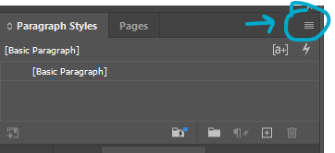
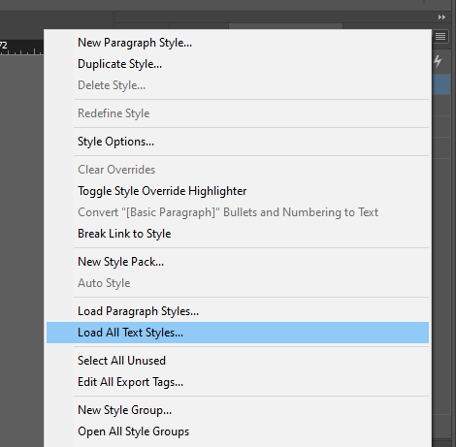
- This will open a File Explorer window where you can select a document to load in the Paragraph Styles and Character Styles from.
  - You always want to load in settings from the Front Matter InDesign Template because it will be the most up-to-date.
  - Select Example-00-Front-Matter.indd
  - Click Open.
- This will open the Load Styles menu. All paragraph and character styles should automatically be checked, with any conflicts with existing styles set to “Use incoming definition”
- Click Ok. This should load in all our current Paragraph Styles and Character Styles.
- Save.

Loading Parent Pages
Find the Parent Pages Panel. It will only have the Parent Pages [None] and A-Parent.
- Click the Hamburger menu > Parent Pages > Load Parent Pages
- 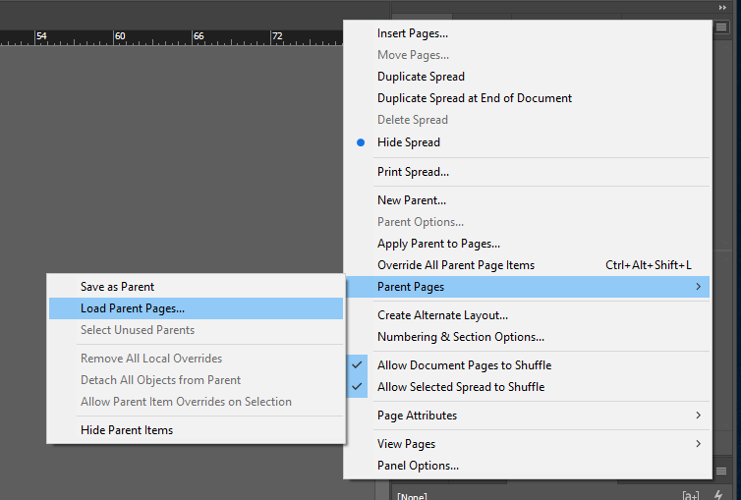
- This will open a File Explorer window where you can select a document to load in the Paragraph Styles and Character Styles from.
  - You always want to load in settings from the Front Matter InDesign Template because it will be the most up-to-date.
  - Select Example-00-Front-Matter.indd
  - Click Open.
- This should have loaded in all our Parent Pages; double check that they all seem present in the new file, just in case.
  - Refer to the section Parent Pages at the end of the Style Reference documentation for a full list.
- Save.

How to Apply Parent Pages

These steps are the same for most documents. For Prose, Facing Page texts, Glossary, Index of First Lines, or Index of Proper Names, skip to those workflows.
- For Prose: 03b. Making New InDesign Documents – Prose; 08. Prose Instructions
- For Facing Page: 03c. Making New InDesign Documents – Facing Page.
- For Glossaries and Indices: 03d. Making New InDesign Documents – Glossaries and Indices
First, in your new InDesign Document, set the Parent Page.
- Open the Pages tab in the vertical menu on the right side of your screen.
- You will see a list of Parent Pages next to icons that look like the pages of a book. Beneath the list you will see a separate section with one white page. This is your document. The Parent Pages are probably set to the default, which is A.
- Click on F-First Page and drag it down to the recto page icon.
  - You can click on the actual words, or the image to the right of it.
  - If you click the image, you will need to make sure you are clicking the side of the spread that matches up with the page you want to apply the Parent Page to (i.e., click the recto side to apply to a recto page)
- F will appear in the upper left corner.
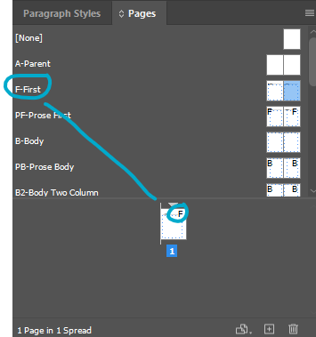

How to Import Text from Word into InDesign

N.B.: You need to have applied a Parent Page first before this step, otherwise there will not be a text box to click into on your page.
- In the InDesign Document, ctrl-shift-click inside the text box on the page. This will make a new text box appear. You can tell because little blue squares appear in the blue lines at the edge of the text box.
- In InDesign, ctrl+D [place]. A file menu will pop up. Select the relevant Word Document and check the box that is marked Show Import Options (it is above the File Name box). Click open.

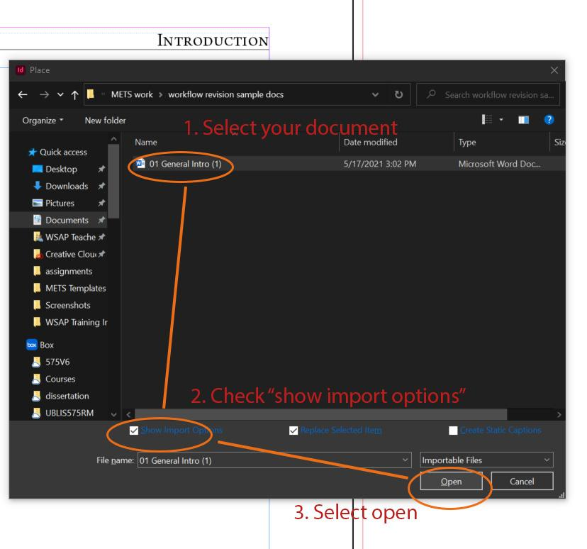
- The Microsoft Word Import Options box will pop up. About ⅔ down the box, look for Manual Page Breaks and make sure that No Breaks is selected in the dropdown menu next to it.
- At the bottom of the box, click Customize Style Import and then click the round button that appears next to it called Style Mapping.

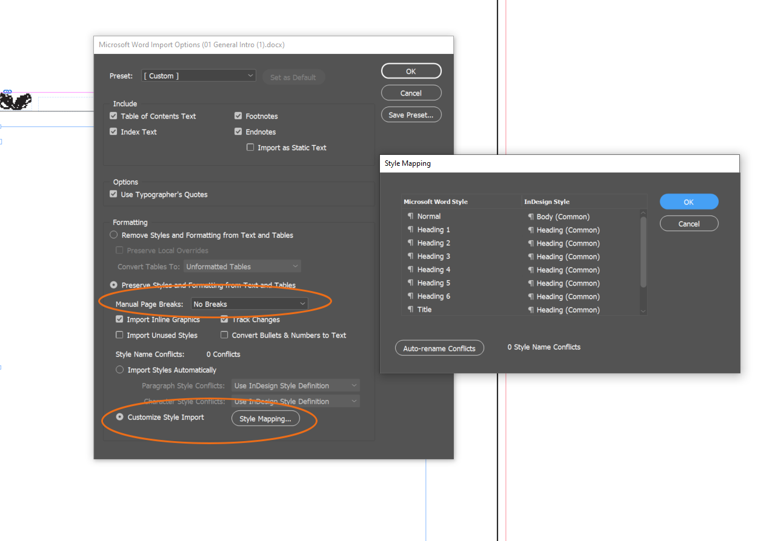
- The Style Mapping box will pop up with a list of styles that will import from the Word Document. Re-map the drop-down menu to conform to our styles.
- What styles are available to re-map, and what you re-map them to will depend on the Word document you start with and on the type of file you will be formatting.
  - Take a quick look at the file-specific workflow you will be using before fully filling in the Style Mapping; whatever Paragraph Style will be applied the most throughout the document should be mapped to Normal.
  - A Verse Text might give you:
    - Normal → Line Group (Verse and Drama Template)
    - Footnote Text → Footnote (Common)
    - Poem Title → Heading (Common; this really only matters if there are headings within the poem, as you will delete the poem title)
    - Footnote Reference → Footnote Number (Common)
  - An Introduction will be different:
    - Normal → Body
    - Heading 1 → Heading
    - Footnote Text → Footnote (Common)
    - Footnote Reference → Footnote Number (Common)
- If you encounter paragraph or character styles that are connected to revision – such as balloon text/balloon text char, revision, various annotations, or comments – make sure to map these on to [No Paragraph Style] or [None] in order to prevent strange formatting. See screenshot below.
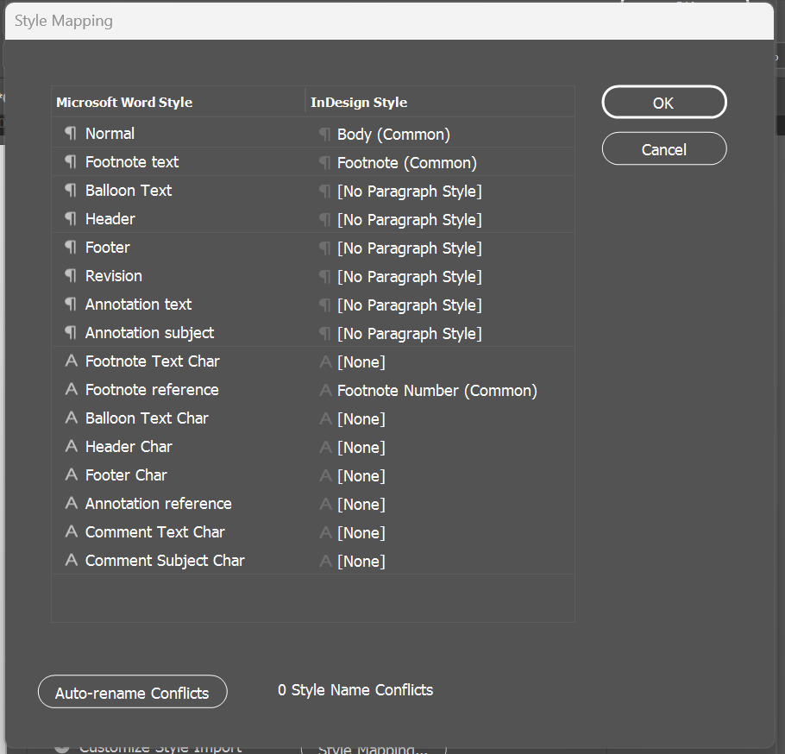
- There may be other choices, and you can use your best guess about how to remap these, but most of this will be fixed in your initial format anyway.
  - It can help to map any unknown / unnecessary styles to either [No Paragraph Style] or [None], but this can be a tedious process. You can skip this step, but you will need to double check whether any of those styles have imported into our styles menu. See below for more.
- Click OK.
- This brings you back to the Microsoft Word Import Options box. Click OK.
- This should make the text appear in the textbox on your InDesign document. It will also look horrible. Don’t panic.

Missing Fonts
- You may get a message saying that there are missing fonts in the document because InDesign doesn’t have New Baskerville. Our Styles will apply Arno Pro almost all of the time, but it does help to go ahead and update the fonts here.
  - In the Font Information, select the first font that isn’t Arno Pro.
  - Set the Font Family to be Arno Pro. Match the Font style to whatever is listed in the Font Information (Italic, Regular, etc.).
  - Click ‘Change All’
  - You’ll need to repeat this process for each font that isn’t Arno Pro in the Font Information.
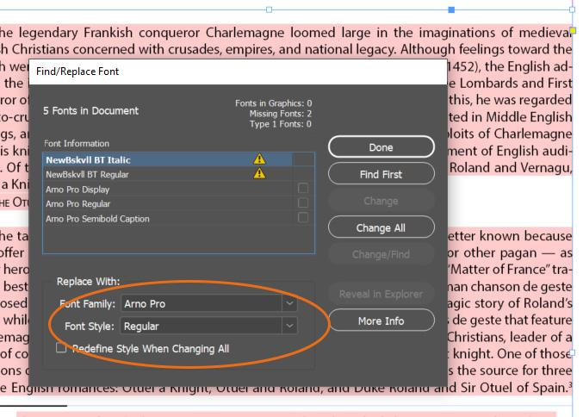

Insert the Second Page and Apply Parent Page
- You need to manually insert the next page (only one). Make sure you have the Selection Tool selected (the black arrow) and click into the textbox on your InDesign document.
- In the Pages menu on the right, there are a series of icons at the very bottom of the menu. Click on the one that says Create New Page when you hover over it. It looks like a page with a plus sign (+) inside.
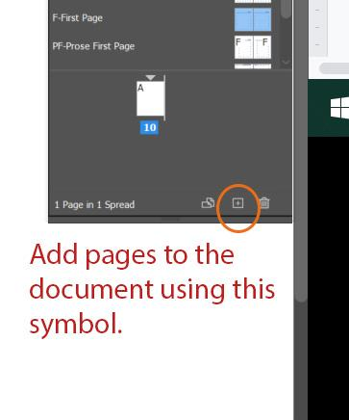

- This should insert a new page after your first one. This is a little finicky. If it doesn’t work, do Ctrl+Z to undo and try it again.
- For the new page, set the Parent Page as B-Body.
- Make sure you are using the selection tool (black arrow on left toolbar). Pick up the overset text by clicking on the red (+) on the bottom right of the first page. Hover your mouse over the new page. Notice that it seems to be holding the faint outline of text on it. Click into the box near the top left corner of this outline on the new page. This will insert the rest of the text into the new page and will cause the text to roll onto as many pages as your text requires.

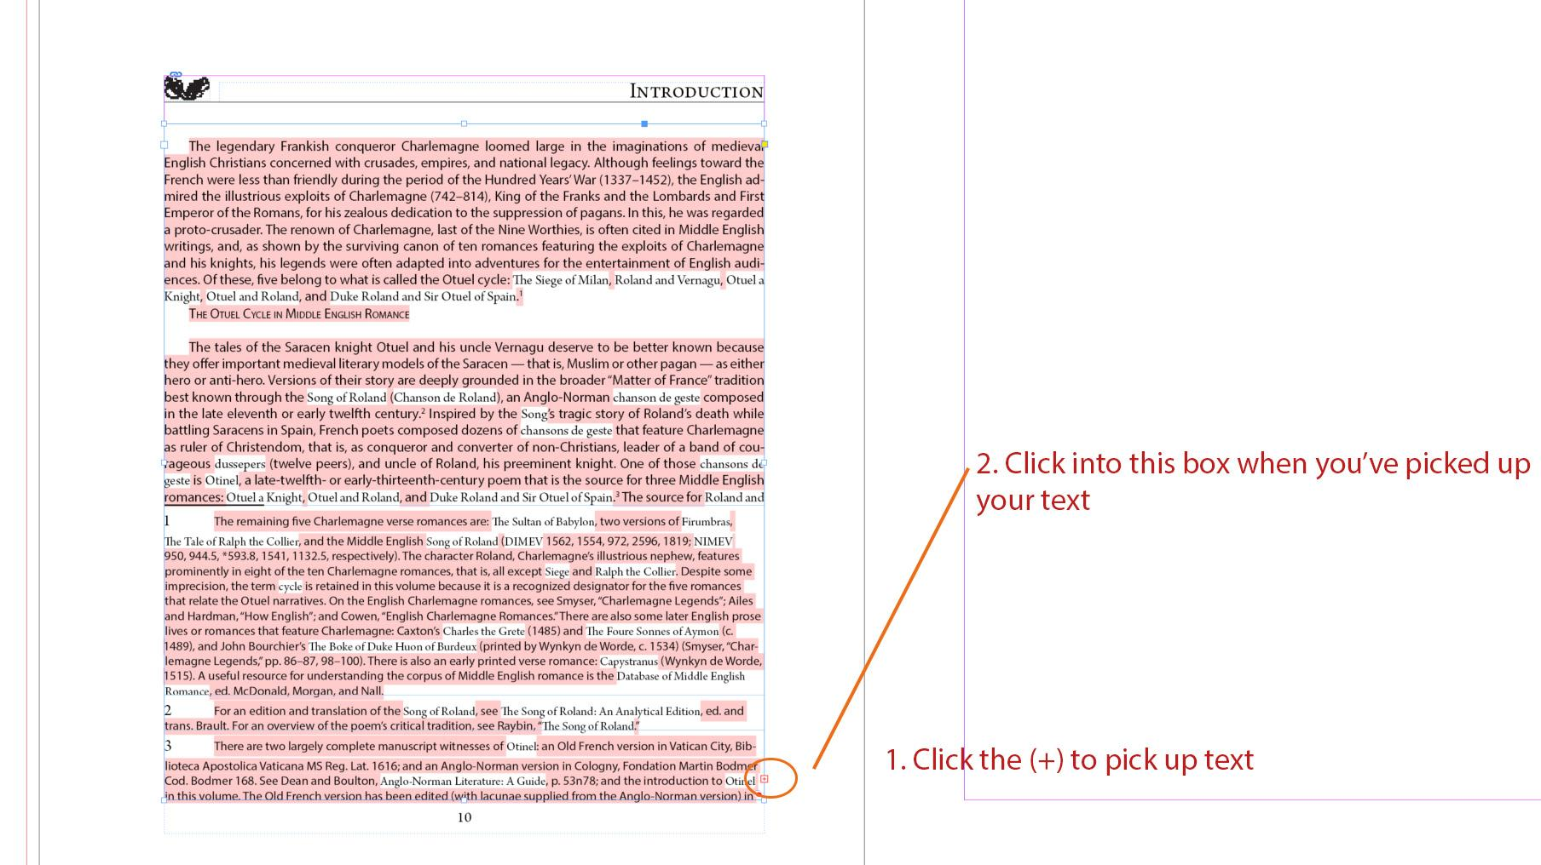

Deleting Extra Styles Imported from Word
- We want to delete any extra Styles from Word that have imported in through the Style Mapping process.
  - Styles from Word typically appear at the end of our list of pre-set styles and have a save icon on their right:
  - 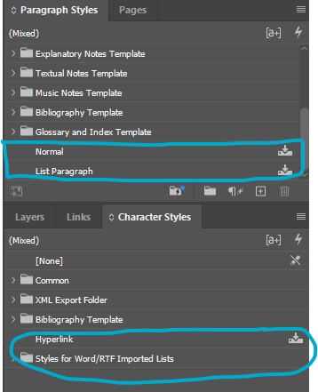
  - If these appear, you’ll need to delete them at the end of formatting.
    - Right click > Delete Style
  - If the style is still applied somewhere in the document, you’ll get a warning:
  - 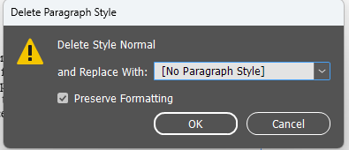
  - Set to replace with either [No Paragraph Style] or [None] if it’s a Character Style, with the Preserve Formatting function set, then click Ok.
  - You’ll need to take another look through your file to look for any blue highlighted overrides and correct/clear them as needed.

Next Steps

Before you move onto the file-specific workflow, review the Initial Steps for All InDesign Documents. Then, go to the file-specific workflow.
- If you are formatting a Verse Text, you will need to know whether your text has long stanzas or short stanzas and use the corresponding workflow. Consult to the section Verse: Long Stanzas vs. Short Stanzas in the Formatting Reference for more on how to tell the difference between long and short stanzas.

