Read the entire instructions before you try to follow them. Knowing where you are going will help.
When making new folders or files, always make sure you are following METS File Naming Conventions. Refer to the following documentation:
- METS File Naming Conventions
- METS File Naming Dictionary

Preparing Word documents for Prose Texts with Chapters for Import

If the Prose text has Chapters (or similar smaller divisions, such as Prayers), you will need to make separate Word documents for each smaller division so that we can place them correctly into InDesign.
- First, check to see if there is a folder specifically for Word documents for the edition. This is where you will be saving all new Word documents.
  - If there isn’t a folder named Editor-Volume-Word, check with the Managing Editor.
  - If there are a lot of production-related files already in the folder, you may find it helpful to create a subfolder (ex. “Import to InDesign”) to group all your Word files together.
- Open the final Production Word document that contains the text you will be formatting.
  - Copy and Paste each individual chapter into its own Word document.
  - N.B.: You never want to Cut / Paste these chapters into new files. We want to preserve the original Production file as one complete document.
- Make sure you name each Word document to identify which text and which chapter it contains. This will help a lot when importing text.
  - Ex. Campbell-Apocalypse-02-English-Text-Chapter-1
  - Best practices are to follow our File Naming Conventions

How to Make a New Document for a Prose Text in InDesign

All InDesign documents are created using the same initial steps:
- In the InDesign launch screen, select New→ Document. OR, if you are already in an InDesign document, select File→ New → Document.
- This will open a new window where you can set options for the layout. Select METS Book Preset option, which contains the proper layout for all our documents.
  - If you don’t see this preset as an option, go to 03a. Making New InDesign Documents to see instructions on how to recreate it.
- Then click Create.
- When the document opens, File → Save As. Check that you are saving into the Editor-Volume-Print folder. Name the document, following the naming conventions outlined in METS File Naming Conventions Documentation.
- The number of InDesign documents you make at this stage depends on how your Prose Text is structured.
  - If the prose text does not have books:
    - Make one InDesign document with the title of the text as its name, using our METS File Naming Conventions.
      - Ex. Hudson-Caxton-Print-02-Blanchardyn-Text
  - If the prose text does have books:
    - Make a separate InDesign document for each book, with the title indicating the text and book number
    - Ex. Ex. Hudson-Caxton-Print-03-Shewings-Book-One-Text

Adjusting Initial Pagination

All of our texts (except for Facing Page) begin on a recto page.
- The METS Book saved preset should create an InDesign file that automatically begins on a recto page, so you should be good.
  - If for some reason your document is not starting on a recto page, we suggest closing the document and starting again from the top of this workflow. Make sure you are using the correct METS Book saved preset settings.
If you are working with a Facing Page Prose text:
- Go to the workflow for Making New InDesign Documents – Facing Page instead.

Loading in Paragraph Styles, Character Styles, and Parent Pages

We use Paragraph Styles, Character Styles, and Parent Pages so that our editions will all be formatted consistently. In order to use these settings, we will need to load them into our shiny, brand-new InDesign file we have just created. You will need to complete the following two steps for every single InDesign document you create for an edition.

Loading Paragraph Styles and Character Styles
Find the Paragraph Styles Panel. Right now, it will only include the style [Basic Paragraph].
- Click the Hamburger menu > Load All Text Styles
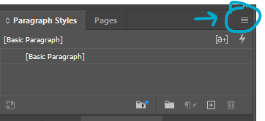
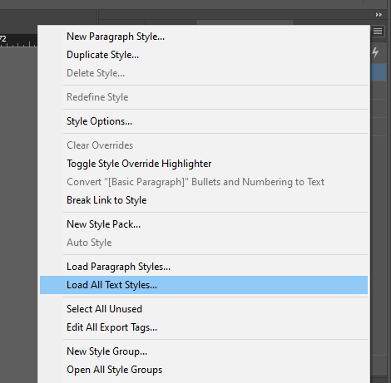
- This will open a File Explorer window where you can select a document to load in the Paragraph Styles and Character Styles from.
  - You always want to load in settings from the Front Matter InDesign Template because it will be the most up-to-date.
  - Select Example-00-Front-Matter
  - Click Open.
- This will open the Load Styles menu. All paragraph and character styles should automatically be checked, with any conflicts with existing styles set to “Use incoming definition”
- Click Ok. This should load in all our current Paragraph Styles and Character Styles.
- Save.

Loading Parent Pages
Find the Parent Pages Panel. It will only have the Parent Pages [None] and A-Parent.
- Click the Hamburger menu > Parent Pages > Load Parent Pages
- 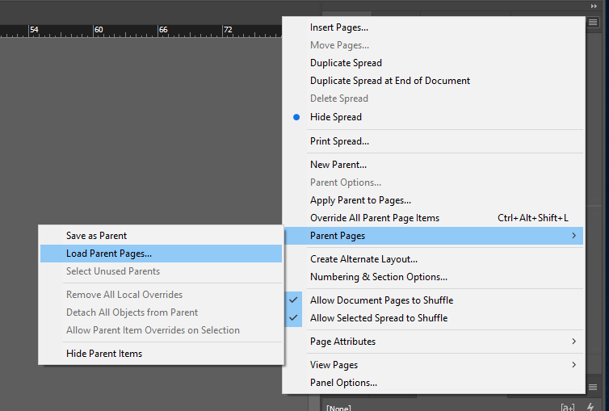
- This will open a File Explorer window where you can select a document to load in the Paragraph Styles and Character Styles from.
  - You always want to load in settings from the Front Matter InDesign Template because it will be the most up-to-date.
  - Select Example-00-Front-Matter
  - Click Open.
- This should have loaded in all our Parent Pages; double check that they all seem present in the new file, just in case.
  - Refer to the section Parent Pages at the end of the Style Reference documentation for a full list.
- Save.

How to Apply Parent Pages

First, in your new InDesign Document, set the Parent Page.
- Open the Pages tab in the vertical menu on the right side of your screen.
- You will see a list of Parent Pages next to icons that look like the pages of a book. Beneath the list you will see a separate section with one white page. This is your document. The Parent Pages are probably set to the default, which is A.
- Click on PF- Prose First Page and drag it down to the page icon.
  - You can click on the actual words, or the image to the right of it.
  - If you click the image, you will need to make sure you are clicking the side of the spread that matches up with the page you want to apply the Parent Page to (i.e., click the recto side to apply to a recto page)
- PF will appear in the upper left corner.
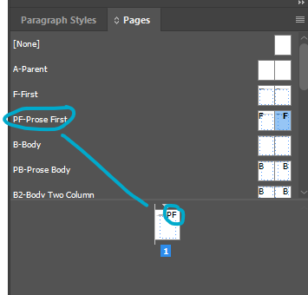

Pause here if you have a Prose Text with Chapters

You’ll follow the rest of the workflow progression for inserting and formatting Chapter 1 of your Prose Text. Any following chapters will not be inserted into an InDesign document until the preceding chapter is inserted and fully formatted.
- InDesign gets touchy the more you edit text frames, especially with prose. If you try and insert all the chapters first, then go back and format, you’ll end up duplicating a lot of work.
- Full instructions on what to do with Chapters 2-end of your Text will be in 08. Prose Instructions

How to Import Text from Word into InDesign

N.B.: You need to have applied a Parent Page first before this step, otherwise there will not be a text box to click into on your page.
- In the InDesign Document, ctrl-shift-click inside the text box on the page. This will make a new text box appear. You can tell because little squares appear in the lines at the edge of the text box.
- In InDesign, ctrl+D [place]. A file menu will pop up. Select the relevant Word Document and check the box that is marked Show Import Options (it is above the File Name box). Click ok.
  - If the prose text in question has smaller divisions like chapters within it, you will need to select the Word Document for the first smaller division here.
- The Microsoft Word Import Options box will pop up. About ⅔ down the box, look for Manual Page Breaks and make sure that No Breaks is selected in the dropdown menu next to it.
- At the bottom of the box, click Customize Style Import and then click the round button that appears next to it called Style Mapping.
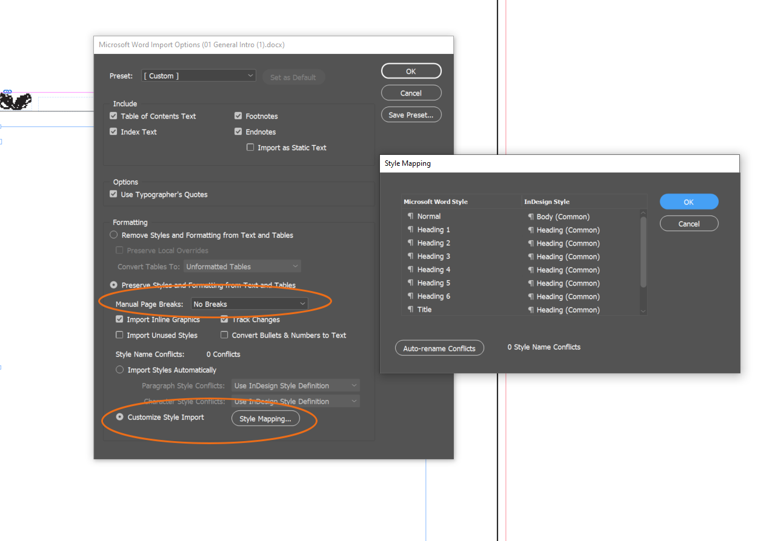
- The Style Mapping box will pop up with a list of styles that will import from the Word Document. Re-map the drop-down menu to conform to our styles:
  - Heading → Prose Rubric (Prose Template)
  - Normal → Prose Paragraph (Prose Template)
  - Footnote → Footnote (Common)
  - Footnote reference → Footnote Number (Common)
- If you encounter paragraph or character styles that are connected to revision – such as balloon text/balloon text char, revision, various annotations, or comments, make sure to map these on to [No Paragraph Style] or [None] in order to prevent strange formatting. See screenshot below.
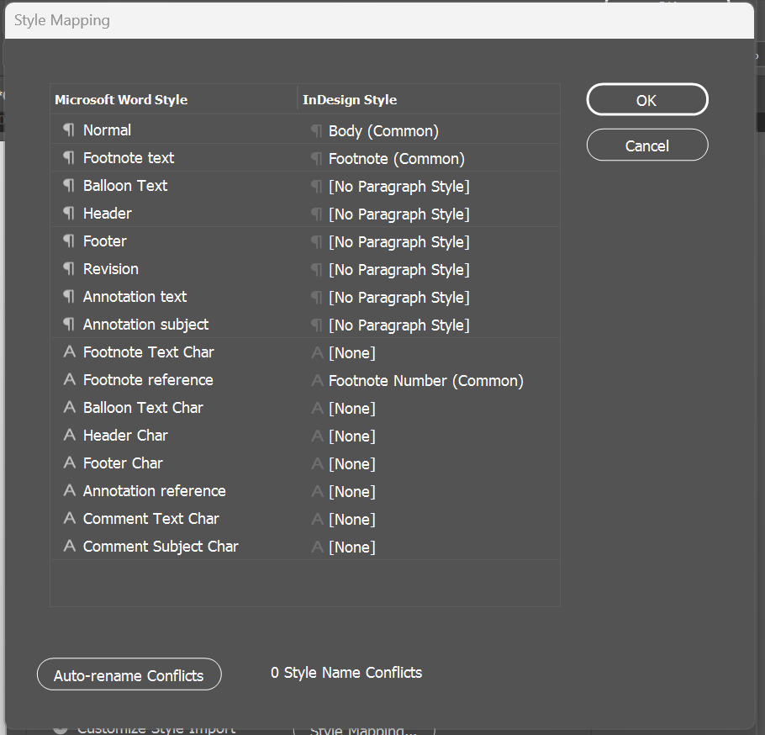
- There may be other choices, and you can use your best guess about how to remap these, but most of this will be fixed in your initial format anyway.
  - It can help to map any unknown / unnecessary styles to either [No Paragraph Style] or [None], but this can be a tedious process. You can skip this step, but you will need to double check whether any of those styles have imported into our styles menu. See below for more.
- Click OK.
- This brings you back to the Microsoft Word Import Options box. Click OK.
- This should make the text appear in the text box on your InDesign document. It will also look horrible. Don’t panic. We will fix it.

Missing Fonts
- You may get a message saying that there are missing fonts in the document because InDesign doesn’t have New Baskerville. Our Styles will apply Arno Pro almost all of the time, but it does help to go ahead and update the fonts here.
  - In the Font Information, select the first font that isn’t Arno Pro.
  - Set the Font Family to be Arno Pro. Match the Font style to whatever is listed in the Font Information (Italic, Regular, etc.).
  - Click ‘Change All’
  - You’ll need to repeat this process for each font that isn’t Arno Pro in the Font Information.
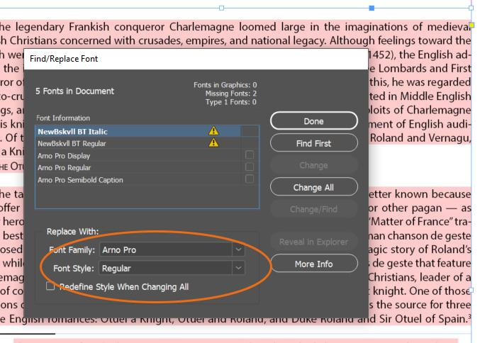

Insert the Second Page and Apply Parent Page
- At this point, you’ll need to manually insert the next page (only one). Make sure you have the Selection Tool selected (the black arrow) and click into the textbox on your InDesign document.
- In the Pages menu on the right, there are a series of icons at the very bottom of the menu. Click on the one that says Create New Page when you hover over it. It looks like a page with a plus sign (+) inside.
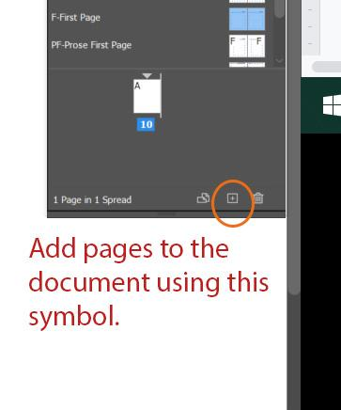

- This should insert a new page after your first one. This is a little finicky. If it doesn’t work, do Ctrl+Z to undo and try it again.
- For the new page, set the Parent Page as PB - Prose Body.
- Make sure you are using the selection tool (black arrow on left toolbar). Pick up the overset text by clicking on the red (+) on the bottom right of the first page. Hover your mouse over the new page. Notice that it seems to be holding the faint outline of text on it. Click into the box. This will insert the rest of the text into the new page and will cause the text to roll onto as many pages as your text requires.
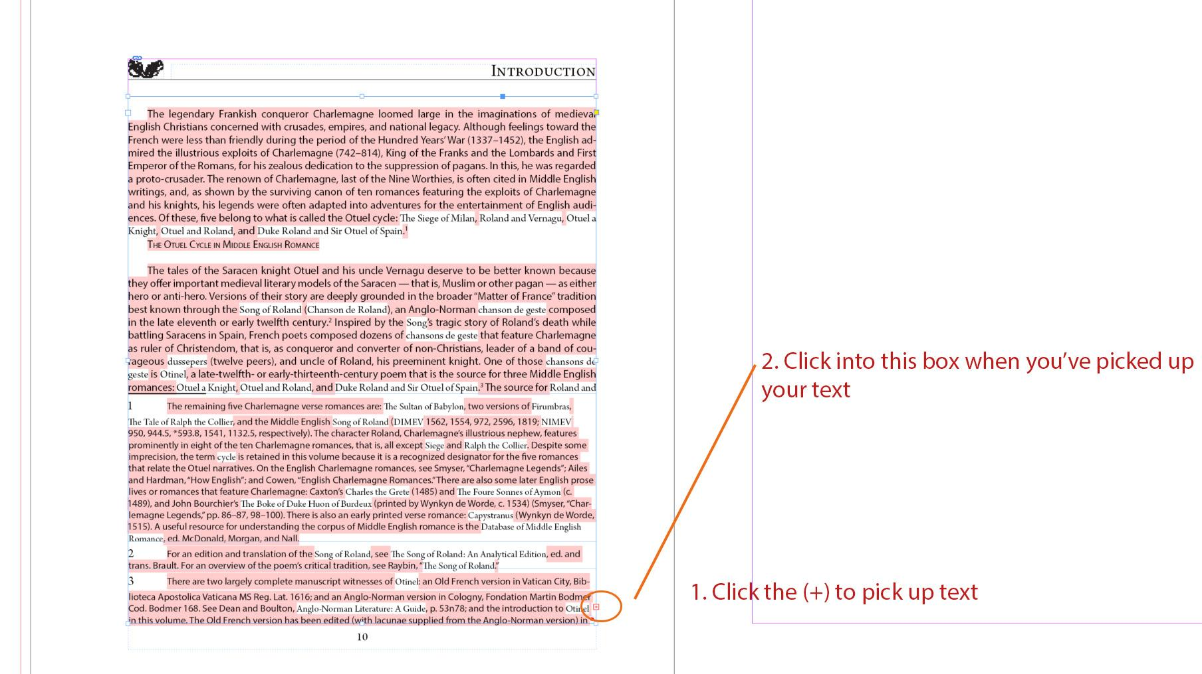

Deleting Extra Styles Imported from Word
- We want to delete any extra Styles from Word that have imported in through the Style Mapping process.
  - Styles from Word typically appear at the end of our list of pre-set styles and have a save icon on their right:
  - 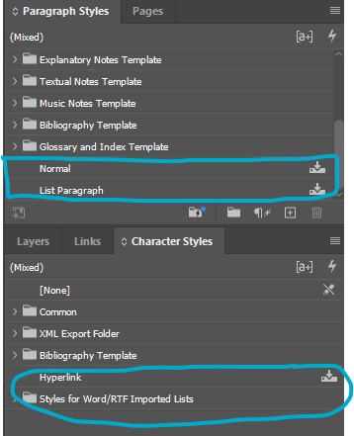
  - If these appear, you’ll need to delete them at the end of formatting.
    - Right click > Delete Style
  - If the style is still applied somewhere in the document, you’ll get a warning:
  - 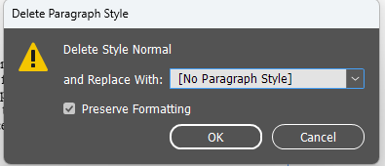
  - Set to replace with either [No Paragraph Style] or [None] if it’s a Character Style, with the Preserve Formatting function set, then click Ok.
  - You’ll need to take another look through your file to look for any blue highlighted overrides and correct/clear them as needed.

Next Steps

Before you move onto the file-specific workflow, review the Initial Steps for All InDesign Documents. Then, go to the file-specific workflow.
- 08. Prose Instructions

