Read the entire instructions before you try to follow them. Knowing where you are going will help.
When making new folders or files, always make sure you are following METS File Naming Conventions. Refer to the following documentation:
- METS File Naming Conventions
- METS File Naming Dictionary

How to Make a New Document for a Facing Page Text in InDesign

All InDesign documents are created using the same initial steps:
- In the InDesign launch screen, select New→ Document. OR, if you are already in an InDesign document, select File→ New → Document.
- This will open a new window where you can set options for the layout. Select METS Book Preset option, which contains the proper layout for all of our documents.
  - If you don’t see this preset as an option, go to 03a. Making New InDesign Documents to see instructions on how to recreate it.
- Then click Create.
- When the document opens, File → Save As. Check that you are saving into the Editor-Volume-Print folder. Name the document, following the naming conventions outlined in METS File Naming Conventions Documentation.

Adjusting Initial Pagination

All of our texts (except for Facing Page) begin on a recto page. The METS Book saved preset should create an InDesign file that automatically begins on a recto page. However, Facing Page is unique in that the first page of the document should begin on a verso page, not a recto page.
- At this stage, you’ll want to add more pages until you have a complete spread of pages.
  - In the Pages menu on the right, there are a series of icons at the very bottom of the menu. Click on the one that says Create New Page when you hover over it. It looks like a page with a plus sign (+) inside. You want to have two pages next to each other in a spread.
  - 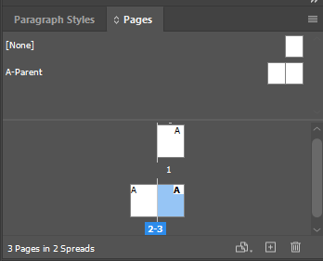
  - There will be a blank page before the full spread; this will be cleaned up later by the Managing Editor when they set pagination for the edition at the end of the Print Production workflow.

Loading in Paragraph Styles, Character Styles, and Parent Pages

We use Paragraph Styles, Character Styles, and Parent Pages so that our editions will all be formatted consistently. In order to use these settings, we will need to load them into our shiny, brand-new InDesign file we have just created. You will need to complete the following two steps for every single InDesign document you create for an edition.

Loading Paragraph Styles and Character Styles
Find the Paragraph Styles Panel. Right now, it will only include the style [Basic Paragraph].
- Click the Hamburger menu > Load All Text Styles
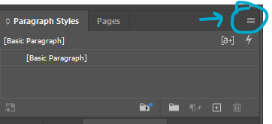
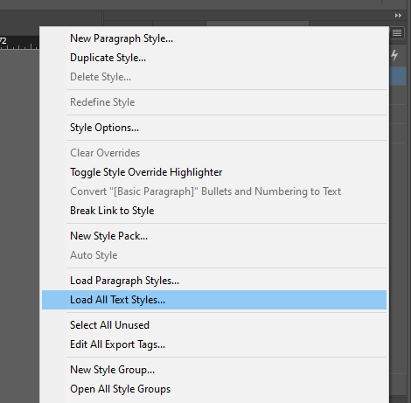
- This will open a File Explorer window where you can select a document to load in the Paragraph Styles and Character Styles from.
  - You always want to load in settings from the Front Matter InDesign Template because it will be the most up-to-date.
  - Select Box Example-00-Front-Matter
  - Click Open.
- This will open the Load Styles menu. All paragraph and character styles should automatically be checked, with any conflicts with existing styles set to “Use incoming definition”
- Click Ok. This should load in all our current Paragraph Styles and Character Styles.
- Save.

Loading Parent Pages
Find the Parent Pages Panel. It will only have the Parent Pages [None] and A-Parent.
- Click the Hamburger menu > Parent Pages > Load Parent Pages
- 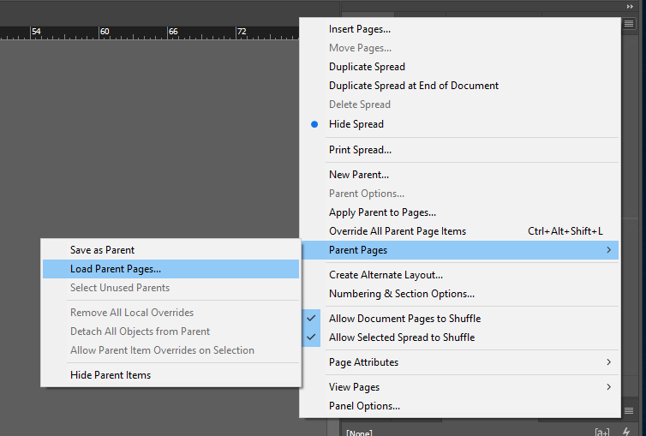
- This will open a File Explorer window where you can select a document to load in the Paragraph Styles and Character Styles from.
  - You always want to load in settings from the Front Matter InDesign Template because it will be the most up-to-date.
  - Select Example-00-Front-Matter
  - Click Open.
- This should have loaded in all our Parent Pages; double check that they all seem present in the new file, just in case.
  - Refer to the section Parent Pages at the end of the Style Reference documentation for a full list.
- Save.

How to Apply Parent Pages

- Set the Parent Page for both pages as F-First by dragging the words down onto the page. If you are working on Prose, choose the PF-Prose First Parent Page.
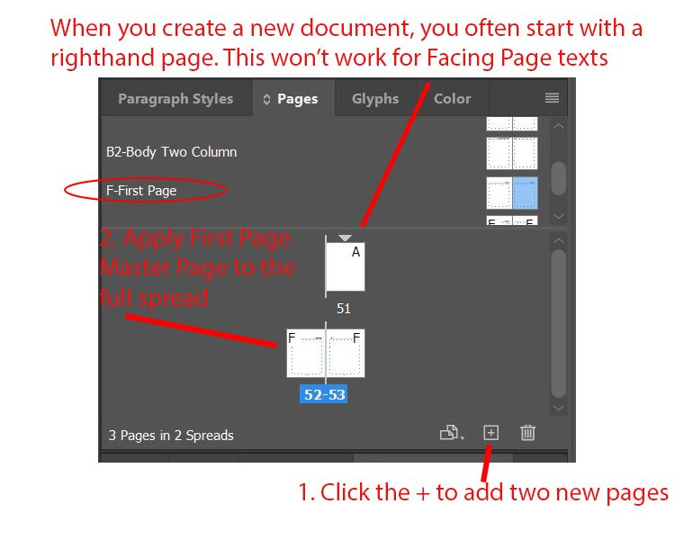
To create the facing page effect we want:
- The Text’s Original Language will always be set on verso (left) pages
- The Text’s Translation will always be set on recto (right) pages
Because we want to specify which page a particular type of content is set on, formatting Facing Page Texts requires much more manual work in the initial set up of a file than any other type of file.
We want to prevent one of these texts from flowing on both the left and right pages when initially importing the Word document, so we need to edit our settings for this document.
- Go to Edit → Preferences → Type → Uncheck Smart Text Reflow.
  - This will keep the document from autofilling pages with the Middle English or the translation when you import the two documents.
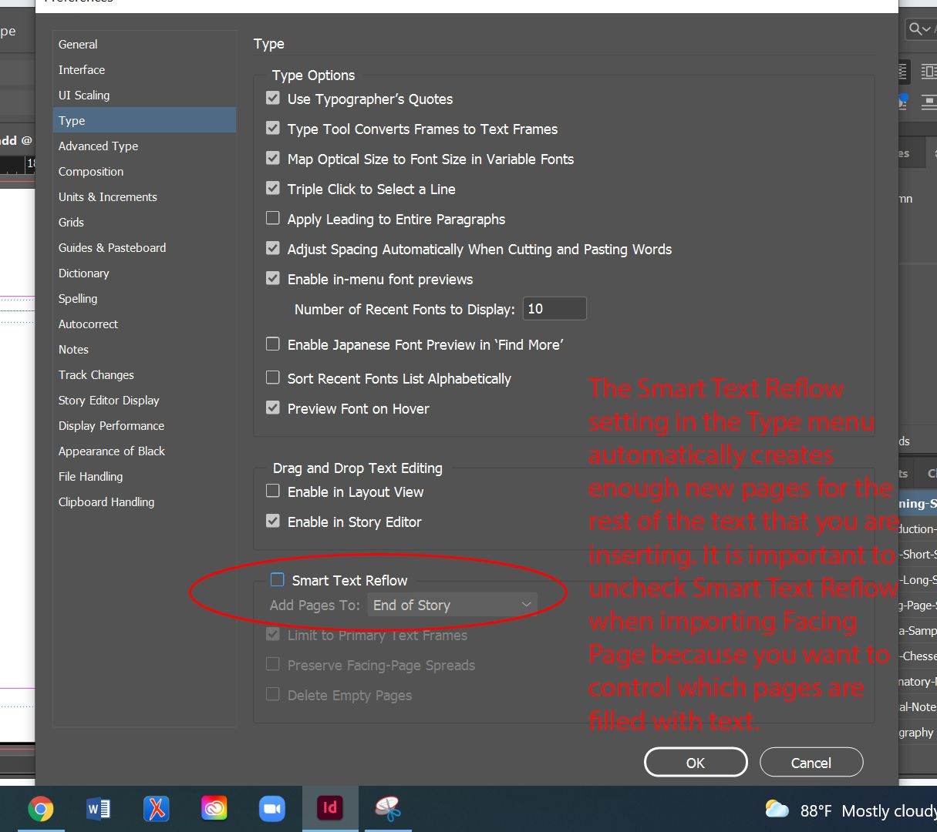

Inserting Original Language Text: First Page

- In the left page, Ctrl+shift+click inside the text box on the page. This will make a new text box appear. You can tell because little squares appear in the lines at the edge of the text box.
- Ctrl+D. A file menu will pop up with options for placing the text. Select the relevant Word Document and check the box that is marked Show Import Options (it is above the File Name box). Click ok.
- The Microsoft Word Import Options box will pop up. About ⅔ down the box, look for Manual Page Breaks and make sure that No Breaks is selected in the dropdown menu next to it.
- At the bottom of the box, click Customize Style Import and then click the round button that appears next to it called Style Mapping.
- The Style Mapping box will pop up with a list of styles that will import from the Word Document. Re-map the drop-down menu to conform to our styles:
  - If a Verse or Drama text:
    - Normal → Line Group (Verse and Drama Template)
  - If a Prose text:
    - Normal → Prose Paragraph (Prose Template)
- If you encounter paragraph or character styles that are connected to revision – such as balloon text/balloon text char, revision, various annotations, or comments, make sure to map these on to [No Paragraph Style] or [None] in order to prevent strange formatting. See screenshot below.
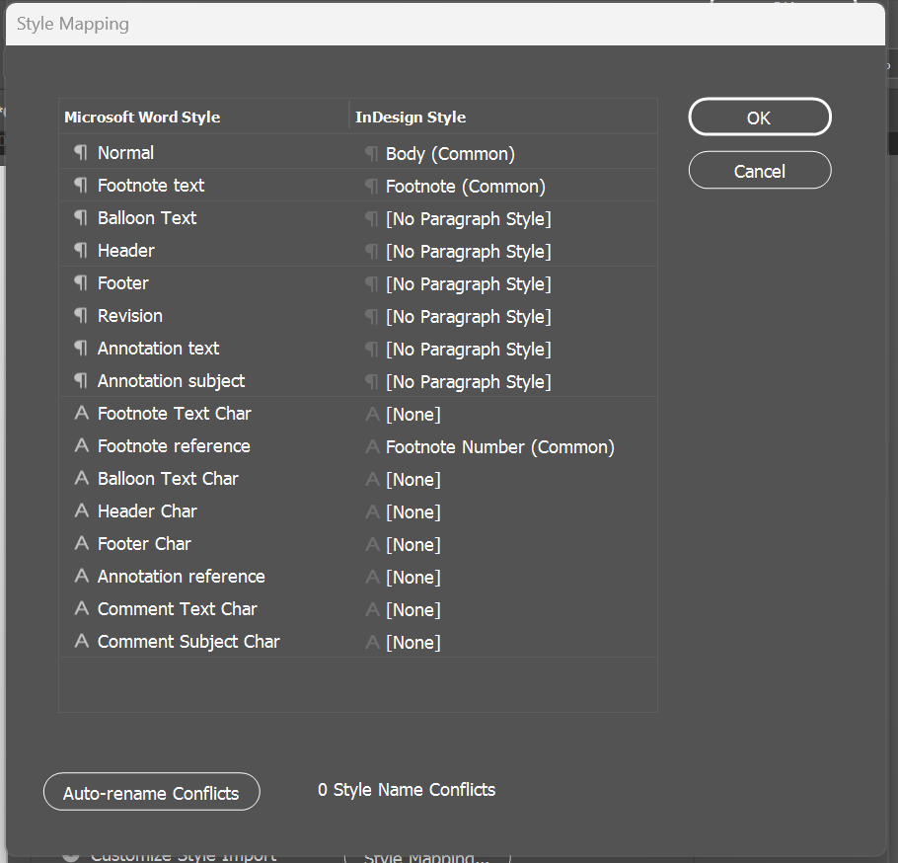
- There may be other choices, and you can use your best guess about how to remap these, but most of this will be fixed in your initial format anyway.
- Click OK.
- This brings you back to the Microsoft Word Import Options box. Click OK.

Missing Fonts
- You may get a message saying that there are missing fonts in the document because InDesign doesn’t have New Baskerville. Our Styles will apply Arno Pro almost all of the time, but it does help to go ahead and update the fonts here.
  - In the Font Information, select the first font that isn’t Arno Pro.
  - Set the Font Family to be Arno Pro. Match the Font style to whatever is listed in the Font Information (Italic, Regular, etc.).
  - Click ‘Change All’
  - You’ll need to repeat this process for each font that isn’t Arno Pro in the Font Information.
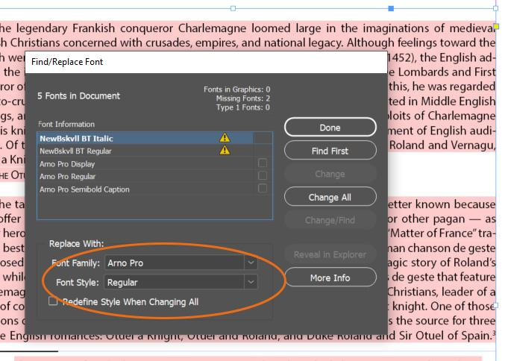
This will leave you with the text imported, but only appearing on the left side of the page spread.
Click on the selection tool option for your cursor on the left toolbar (the black arrow), then click off the left text box to deselect it. Then move on to insert the translation.

Inserting the Translation: First Page

- In the right hand page, Ctrl+shift+click inside the text box on the page. This will make a new text box appear. You can tell because little squares appear in the lines at the edge of the text box.
- Ctrl+D. A file menu will pop up with options for placing the text. Select the relevant Word Document and check the box that is marked Show Import Options (it is above the File Name box). Click ok.
- The Microsoft Word Import Options box will pop up. About ⅔ down the box, look for Manual Page Breaks and make sure that No Breaks is selected in the dropdown menu next to it.
- At the bottom of the box, click Customize Style Import and then click the round button that appears next to it called Style Mapping.
- The Style Mapping box will pop up with a list of styles that will import from the Word Document. Re-map the drop-down menu to conform to our styles:
  - If a Verse or Drama text:
    - Normal → Line Group (Verse and Drama Template)
  - If a Prose text:
    - Normal → Prose Paragraph (Prose Template)
- If you encounter paragraph or character styles that are connected to revision – such as balloon text/balloon text char, revision, various annotations, or comments, make sure to map these on to [No Paragraph Style] or [None] in order to prevent strange formatting. See screenshot below.
- There may be other choices, and you can use your best guess about how to remap these, but most of this will be fixed in your initial format anyway.
- Click OK.
- This brings you back to the Microsoft Word Import Options box. Click OK.

Missing Fonts
- You may get a message saying that there are missing fonts in the document because InDesign doesn’t have New Baskerville. Our Styles will apply Arno Pro almost all of the time, but it does help to go ahead and update the fonts here.
  - In the Font Information, select the first font that isn’t Arno Pro.
  - Set the Font Family to be Arno Pro. Match the Font style to whatever is listed in the Font Information (Italic, Regular, etc.).
  - Click ‘Change All’
  - You’ll need to repeat this process for each font that isn’t Arno Pro in the Font Information.
At this point, there will be two pages with text on them, but no more. At the bottom right-hand side of each text box, you will see a small red box with a + sign in the middle of it. This means that there is more text than that particular text box can display at one time. Because you have unchecked the smart text reflow option, importing a document will import all the text from the document, but it will not automatically generate and fill following pages for the rest of the text in InDesign. This lets us control which pages are linked together, but it also means that we have to create pages and fill them ourselves.
Sample Facing Page after importing text and translation:
The foreign language text (in this case, Anglo-Norman) is inserted on the left page, and the matching modern English translation is on the right page. The only change to the text that had been made was to remove the titles at the top of the documents. Note the two red (+) boxes at the lower right corner of each page’s text frames; these indicate there is more text than currently seen on the page.
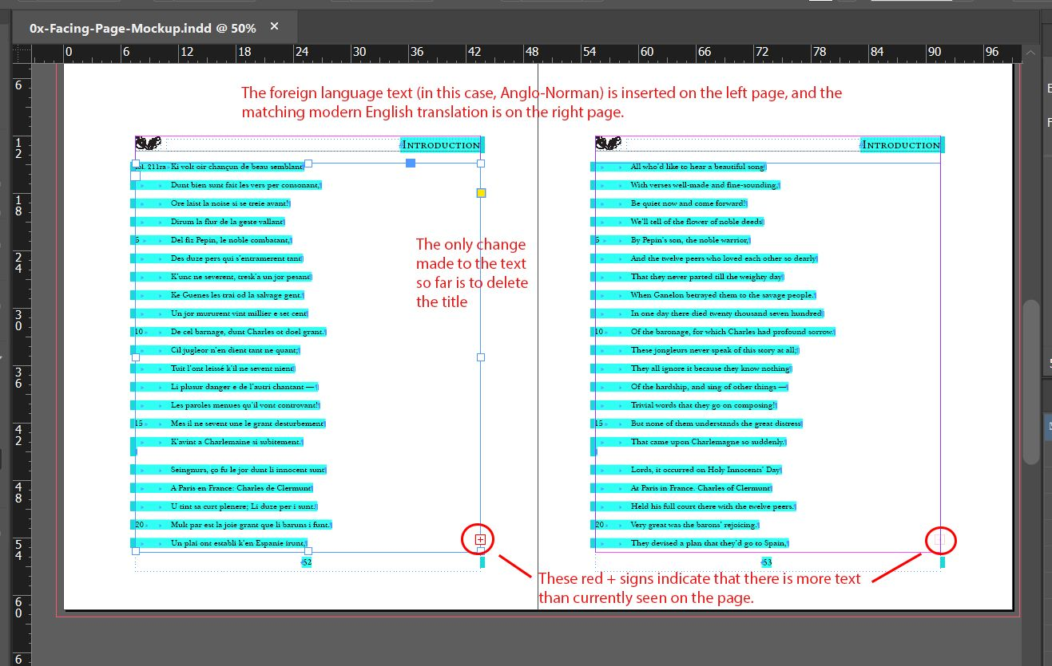

Inserting Additional Pages

- You need to manually insert the rest of the pages of your document. Make sure you have the Selection Tool selected (the black arrow) and click into the textbox on your InDesign document; it doesn’t matter where.
- In the Pages menu on the right, there are a series of icons at the very bottom of the menu. Click on the one that says Create New Page when you hover over it. It looks like a page with a plus sign (+) inside.
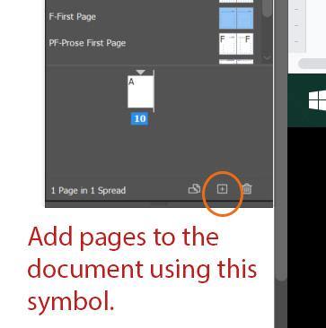
- This should insert a new page after your first one. This is a little finicky. If it doesn’t work, do Ctrl+Z to undo and try it again.
- For the new pages, set the Parent Page as B-Body. If you are working on prose, choose the PB-Prose Body Parent Page.
- If you know your Text is very long, you may not want to add pages one-by-one.
  - Click Hamburger Menu > Insert Pages
  - Enter an even number. This will always be an estimation; you can always clean up pagination later if you need to add more pages or delete extra empty ones.
  - Set Parent page to either B-Body or PB-Prose Body, as needed.
  - Click Ok.

Threading the Original Language: Verso Pages Only
You will need to thread the text boxes together manually in order to make sure the Original Language stays on the verso pages.
- Click on the text box on the first left page, then click on the red + box. Your cursor will be replaced by a floating mini-text. Scroll to the next left page and click on the top left corner right at the dotted line. This will create a text box for only this page filling in the next 30 or so lines of the text. This action links these two text boxes together, so if you have to insert a hard return into the first page, the text will carry over onto the next left page, keeping all the original language on the same side of the book.
- Keep threading together text boxes on verso pages until all the Original Language of the Text is visible on the pages.
  - If you run out of pages, keep adding more B-Parent pages or PB-Prose Body Parent pages and clicking the red + box until you have the entire text displayed.

Threading the Translation: Recto Pages Only
You still need to thread the text boxes together manually in order to make sure the Translation stays on the recto pages.
- Click on the text box on the first right page, then click on the red + box. Your cursor will be replaced by a floating mini-text. Scroll to the next right page and click on the top right corner right at the dotted line. This will create a text box for only this page filling in the next 30 or so lines of the text. This action links these two text boxes together, so if you have to insert a hard return into the first page, the text will carry over onto the next right page, keeping all the translation on the same side of the book.
- Keep threading together text boxes on verso pages until all the Original Language of the Text is visible on the pages.
  - If you run out of pages, keep adding more B-Parent pages or PB-Prose Body Parent pages and clicking the red + box until you have the entire text displayed.
If you are formatting a Facing Page Prose Text with Chapters: You will want to follow these initial instructions for Chapter 1 only. You will need to format the entirety of a chapter before importing the text of any following chapters.

Formatting Your Text: Original Language and Translation

Once the initial pages are set, and after referring to Initial Steps all Documents, you’ll proceed to follow the workflow for the particular text type contained within.
- For Verse: 06a. Verse Instructions – Long Stanzas; 06b. Verse Instructions – Short Stanzas
- For Drama: 07. Drama Instructions
- For Prose: 03b. Making New InDesign Documents – Prose; 08. Prose Instructions
It is highly recommended that you format the Text’s Original Language side first and the Translation side second.
It is up to you whether you want to format the Original Language side in its entirety first, then return to the Translation, or whether you want to work through the document spread by spread, formatting the Original Language page first, then its matching Translation side page.

Formatting the Original Language side
The Original Language side receives all initial formatting and semantic tagging, as is instructed in the text-specific workflow.
- N.B.: When applying Semantic Tags to the Original Language, you may use the Translation as a guide to locating where a tag may need to be applied, but you should follow the Original Language’s wording and grammar when actually applying the tag.
- The only exception to this is if you are formatting an Appendix file. We do not apply semantic tagging to Appendix files.

Formatting the Translation side
The Translation side needs less markup in InDesign because we do not provide data-enriched TEI-XML files for anything in Modern English.
- We will need to apply any Styles that are necessary to create the right structure in our TEI-XML files.
- We do not need to apply any Styles that are there primarily to enrich the TEI with additional data.
- Some Styles that enrich the TEI with additional data have some styling information built into them. If applied in the Original Language side, you will need to make sure the styling matches in the Translation side.

Include (if applicable)
- All Paragraph Styles
- Line Number Character Style
- Foliation Character Style
- Footnote Number Character Style
- Footnote Gloss Character Style
- Caesura Character Style
- Speaker Character Style
- Any basic styling Character Styles that are deemed necessary, such as:
  - Bold
  - Italic
  - Fraction
  - Subscript
  - Superscript
  - Etc.

Match styling (if applicable)
Apply Italic instead of the following Character Styles:
- Title
- Anglo-Norman
- Middle French
- Old French
- Latin
- Greek
- Person Name Latin
- Person Name Italic
Apply Bold Italic instead of:
- Latin Prose Rubric

Do not include (if applicable)
The following styles are purely present for enriching the TEI and do not need to be replicated in the Translation:
- Animal Name
- Person Name
- Place
- Date

Specify languages in oXygen Interventions

In Sheet 3: Additional Changes to TEI of your edition’s oXygen Interventions spreadsheet, specify which language is the original language (verso side) and which is the translation language (recto side). We’ll need to add this information back into the XML file.
- You can find the language information for Texts in the METS-Editions-Categories-Metadata spreadsheet

Next Steps

Before you move onto the file-specific workflow, review the Initial Steps for All InDesign Documents.

